**PLACEMENT EMPOWERMENT PROGRAM**

**CLOUD COMPUTING AND DEVOPS CENTRE**

Git Branching

NAME: Subiksha J

DEPT: ADS-ENGG

Step 1:

Open an existing code which has already been uploaded in github by you, and add a new feature

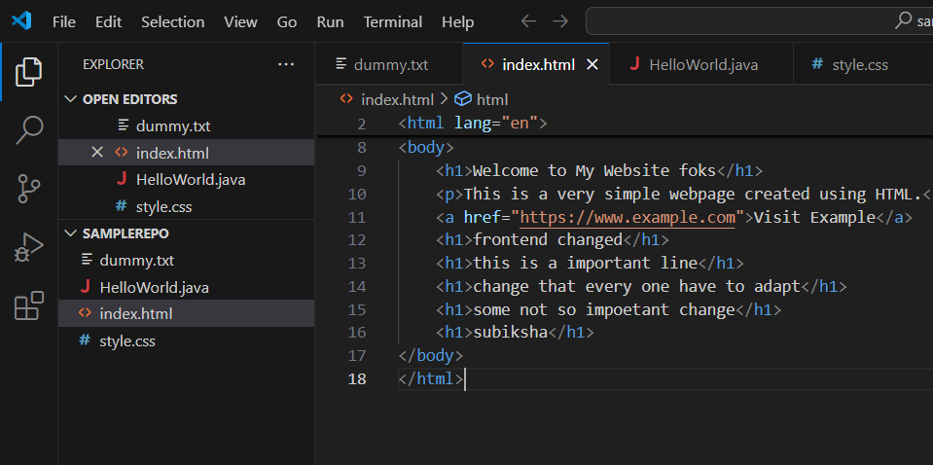

Step 2:

Open Terminal and ensure that it is in the main branch using : git branch.

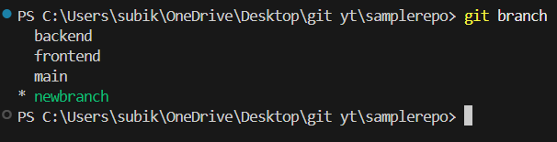

Step 3:

After ensuring that the code is in main branch , create a new branch using: git checkout -b newbranch



Step 4:

After creating a new branch, add and commit the files with proper descrition of what changes made



Step 5:

Now, push the changes to the github repo using the below command: git push origin newfeature

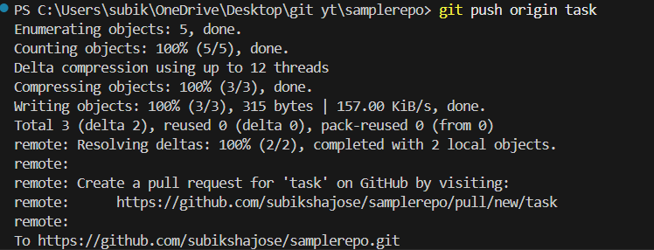

Step 6:

Now go to the github repo, you can see a new pull request option , create a pull request.

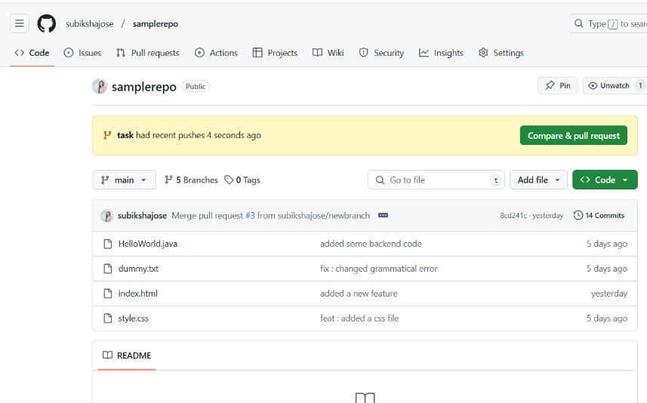

Step 7:

After ensuring the changes made, Merge the pull request.The file now gets updated with new feature

