**PLACEMENT EMPOWERMENT PROGRAM**

**CLOUD COMPUTING AND DEVOPS CENTRE**

Simple Backup Script

NAME: Subiksha J

DEPT: ADS-ENGG

STEPS:

Step1:

Create an empty folder for backup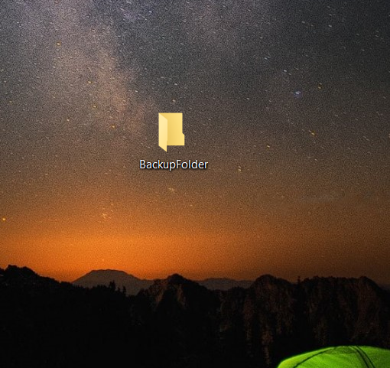

Step2:

Open Notepad and type the below code. Ensure that the REPO URL: is the url of the repo you need t backup and Backup is the path of the folder.

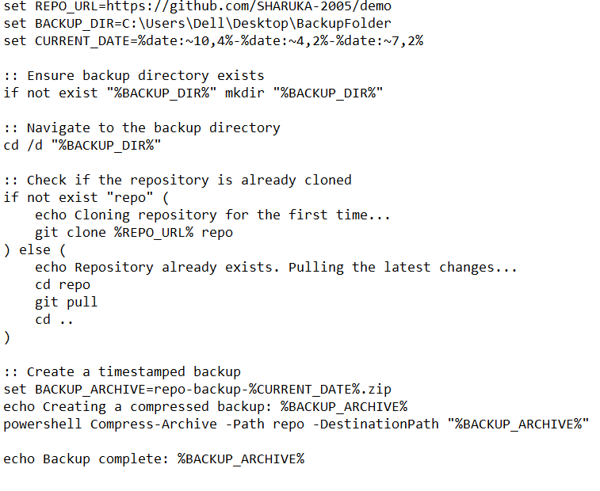

Step 3:

Click Win + R on keyboard. A dialog box will appear, Type taskschd.msc in it and click ok.

The Task Scheduler will open. Select “Create Basic Task’’ in it.

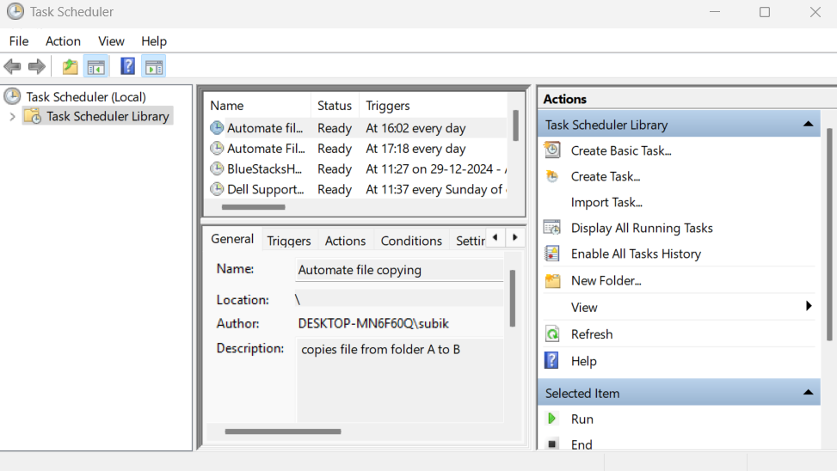

Step 4:

Enter the Name (ex: GitBackup) and description of the task,click next, choose the schedule of backup (ex:daily) and click next.

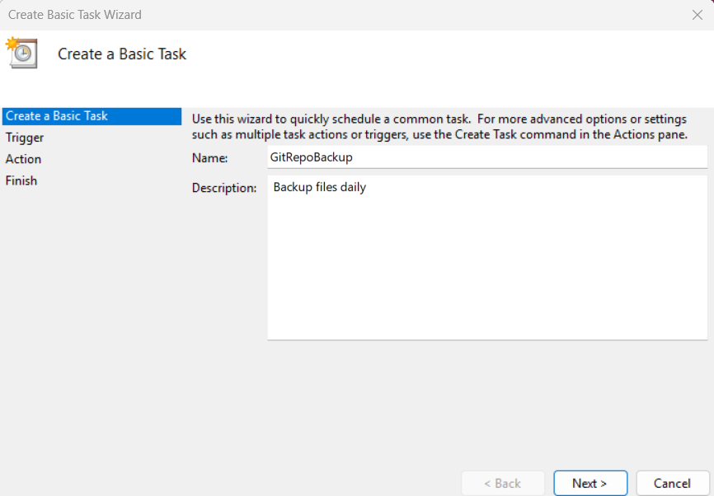

Step 5:

Start the program , browse and select the path of .bat file you saved.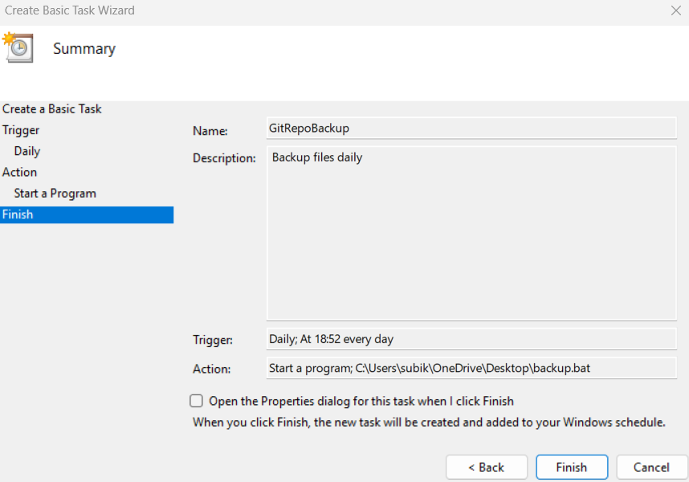

Step 6:

Go to the task scheduler library, find the basic task you created (ex: GitBackup) , Right click, select Run.

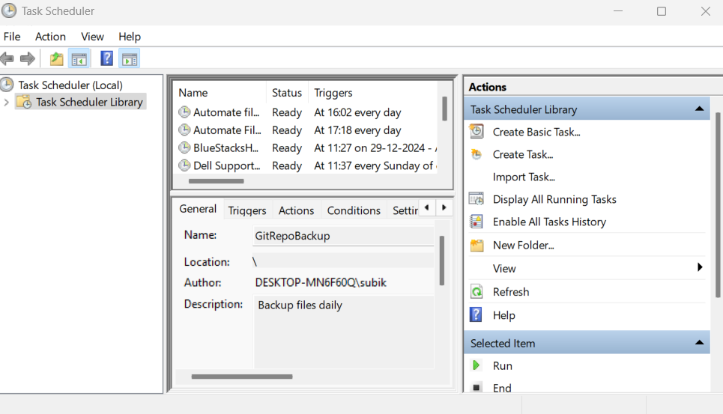

Step 7:

The Command line opens and backups the repo into the backup folder you created.

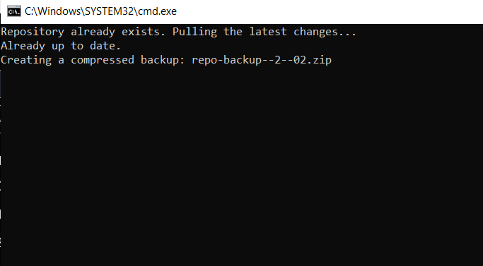

Step 8:

Check the folder you created , the repo files are backed up here.

