**PLACEMENT EMPOWERMENT PROGRAM**

**CLOUD COMPUTING AND DEVOPS CENTRE**

Write the Shell Script to Monitor Logs

NAME: Subiksha J

DEPT: ADS-ENGG

STEPS:

Step 1:

Create a folder and name it as logs.

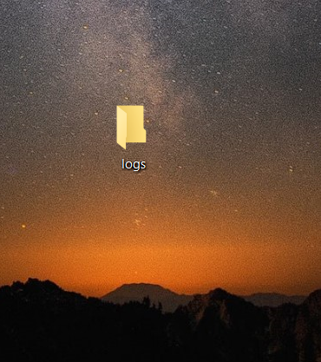

Step 2:

Open notepad and write the following code. Save the file as .log within the folder

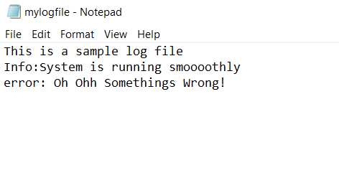

Step 3:

Open another notepad and type the following, ensure to give the logfile path , save the file within the same folder

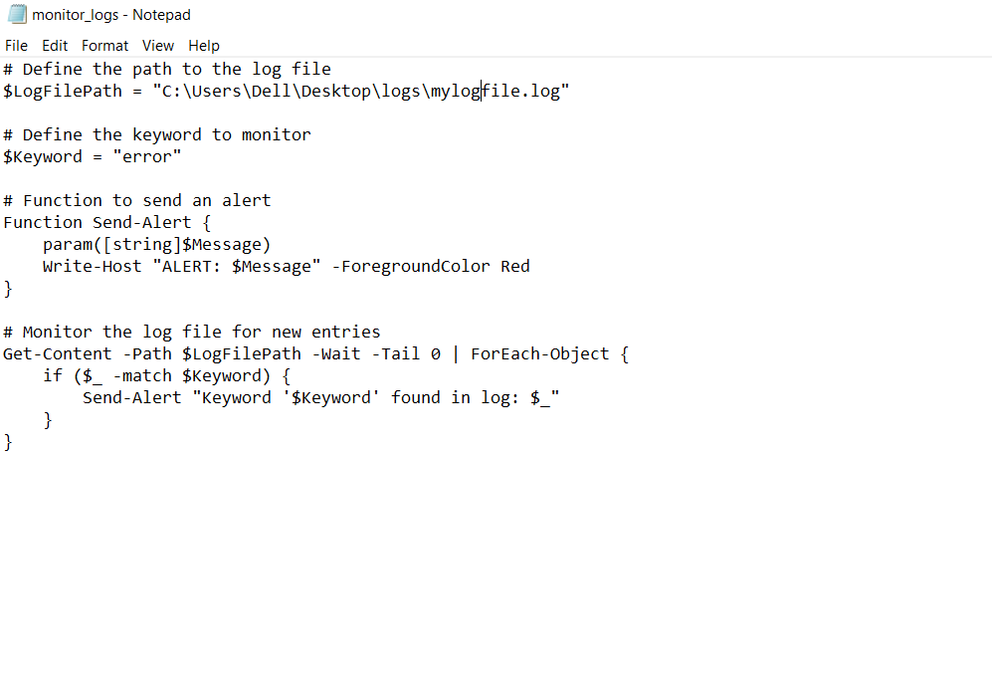

Step 4:

Open Windows Powershell and Run ad administrator. Type the following command > Enter>type Y>Enter

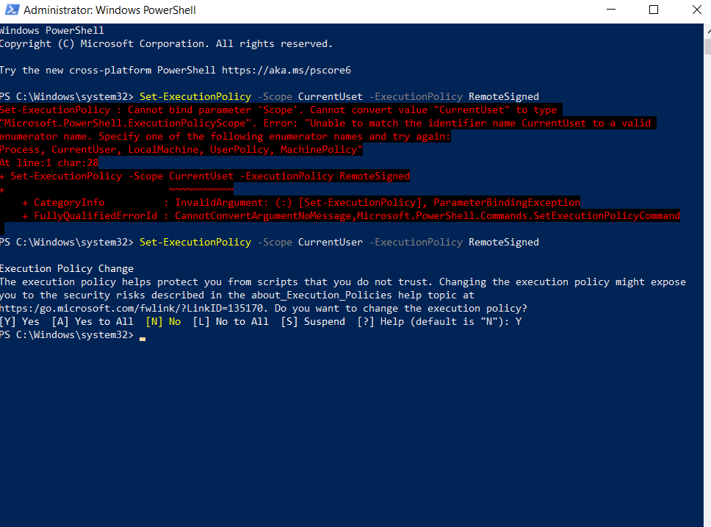

Step 5.

Navigate to the folder and run the script

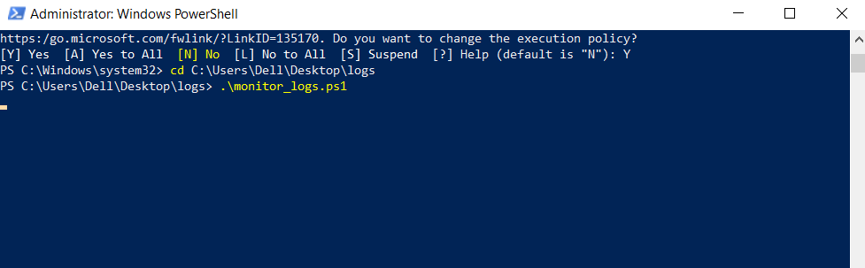

Step6.

Go to the logs file and add a error statement

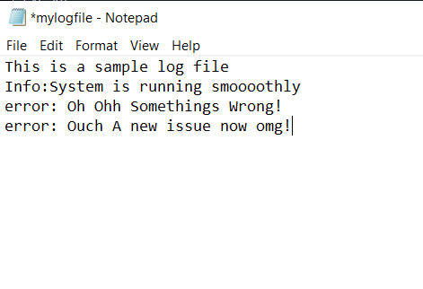

Now go to the powershell, you will see an Error Alert displaying.