**PLACEMENT EMPOWERMENT PROGRAM**

**CLOUD COMPUTING AND DEVOPS CENTRE**

Deploy Static Website using Github Pages

NAME: Subiksha J

DEPT: ADS-ENGG

STEPS:

Step 1:

Create a new repository in github , ensure it is public because github pages works only if it is public.



Step 2:

Create an html file in vs code. Store it within a folder.

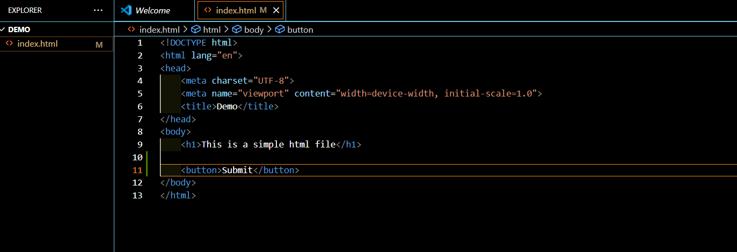

Step 3:

Open command prompt and navigate to the folder where the html file exists.Initialize git using “git init” command.

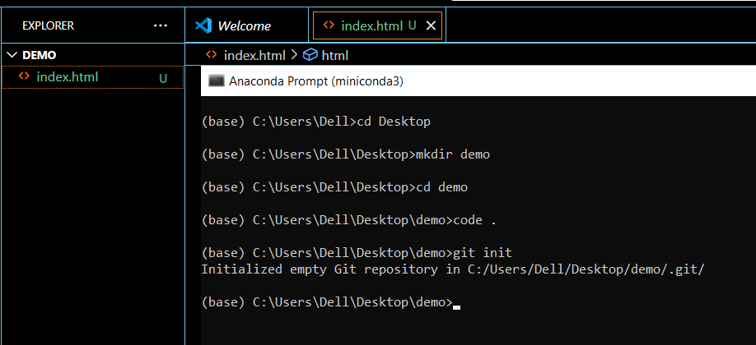

Step 4:

Add and commit the file to local repo, copy the link of the github repo and paste it in the below commands.Follow the commands in the image to upload the file in the github repository

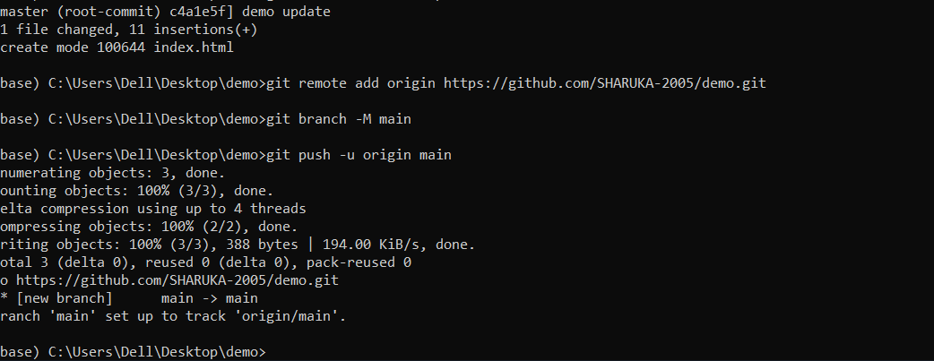

Step 5:

Open the repository > Settings > Pages

Set the branch to main and root.

Refer below image

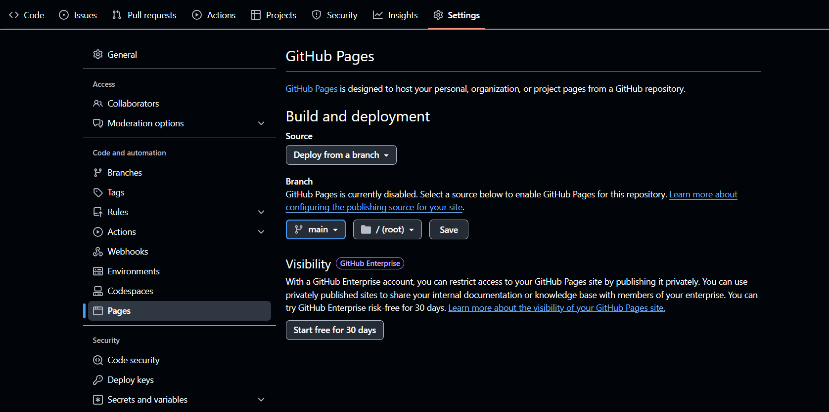

Step 6:

Open Chrome browser and type this format:

https://<yourusername>.github.io/<yourrepository>

You can find the static file deployed.

