# **BUILD AN EVENT MANAGEMENT USING SALESFORCE**

## **1 INTRODUCTION**

### **Overview**

Event management is the process of creating and maintaining an event. This process spans from the very beginning of planning all the way to post-event strategizing.

At the start, an event manager makes planning decisions, such as the time, location, and theme of their event. During an event, event managers oversee the event live and make sure things run smoothly. After an event, event managers are tasked with reviewing event data, submitting KPI and ROI findings, and staying on the ball for any post-event offerings.

## **1.2 Purpose**

The project aim is to provide real-time knowledge for all the students who have basic knowledge of Salesforce and Looking for a real-time project. This project will also help to those professionals who are in cross -technology and wanted to switch to Salesforce with the help of this project they will gain knowledge and can include into their resume as well.

What you’ll learn

1. Real Time Salesforce Project

2. Object & Relationship in Salesforce

3. Create Salesforce Org

## **2 PROBLEM DEFINITIONS & DESIGN THINKING**

### **2.1 Empathy map**

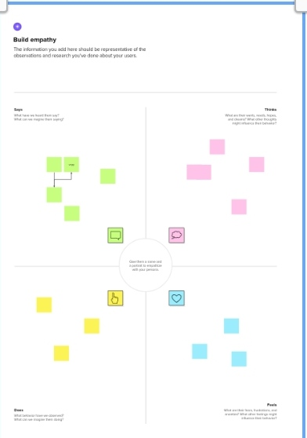

### **Identation & Brainstorming Map**

## **RESULT**

### **3.1 Data Model:**

|  |  |
| --- | --- |
| **OBJECT NAME** | **FIELD IN THE OBJECT** |
| Event | |  |  | | --- | --- | | **FIELD LABEL** | **DATA TYPE** | | Start date | Date/time | | End date | Date/time | |
| Attendee | |  |  | | --- | --- | | **FIELD LABEL** | **DATA TYPE** | | Phone | Phone | | Tickets | Picklist | |
| Speaker | |  |  | | --- | --- | | **FIELD NAME** | **DATA TYPE** | | Bio | Text area | | e-mail | Email | |

## **3.2 Activity & Screenshot**

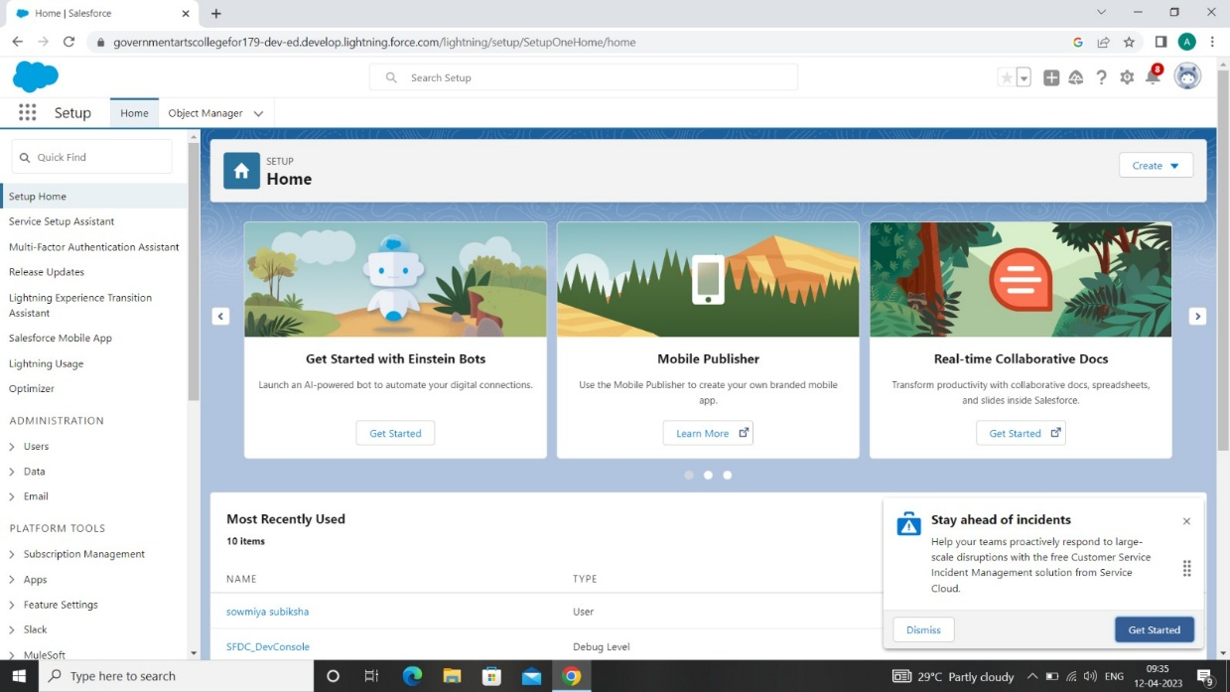

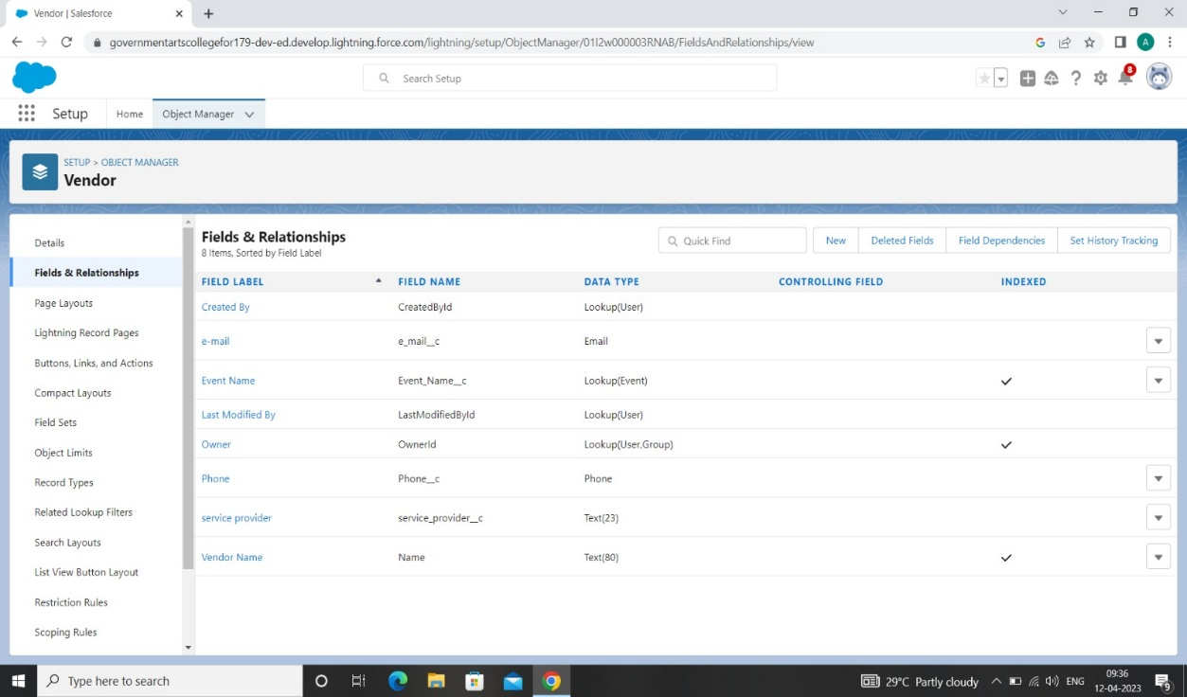

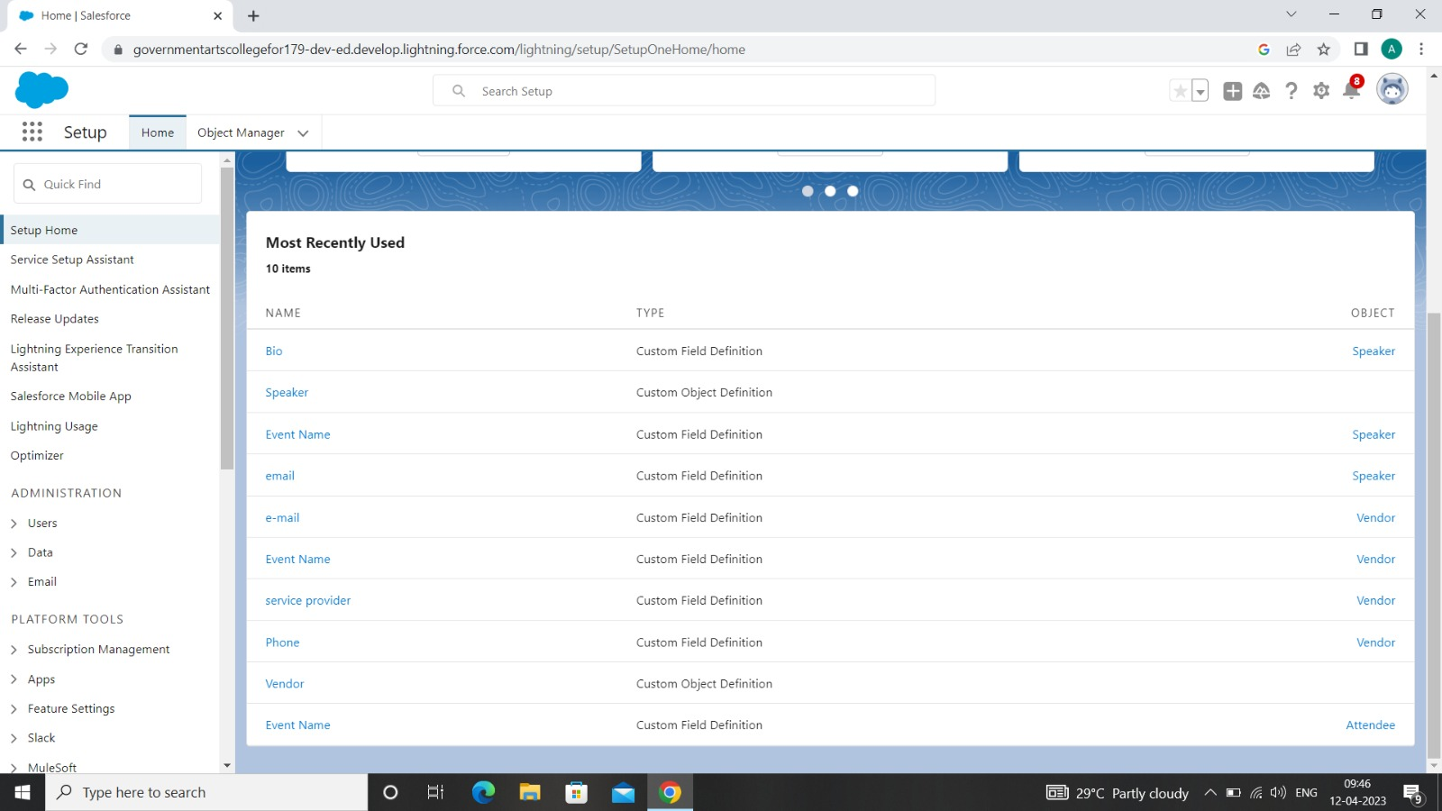

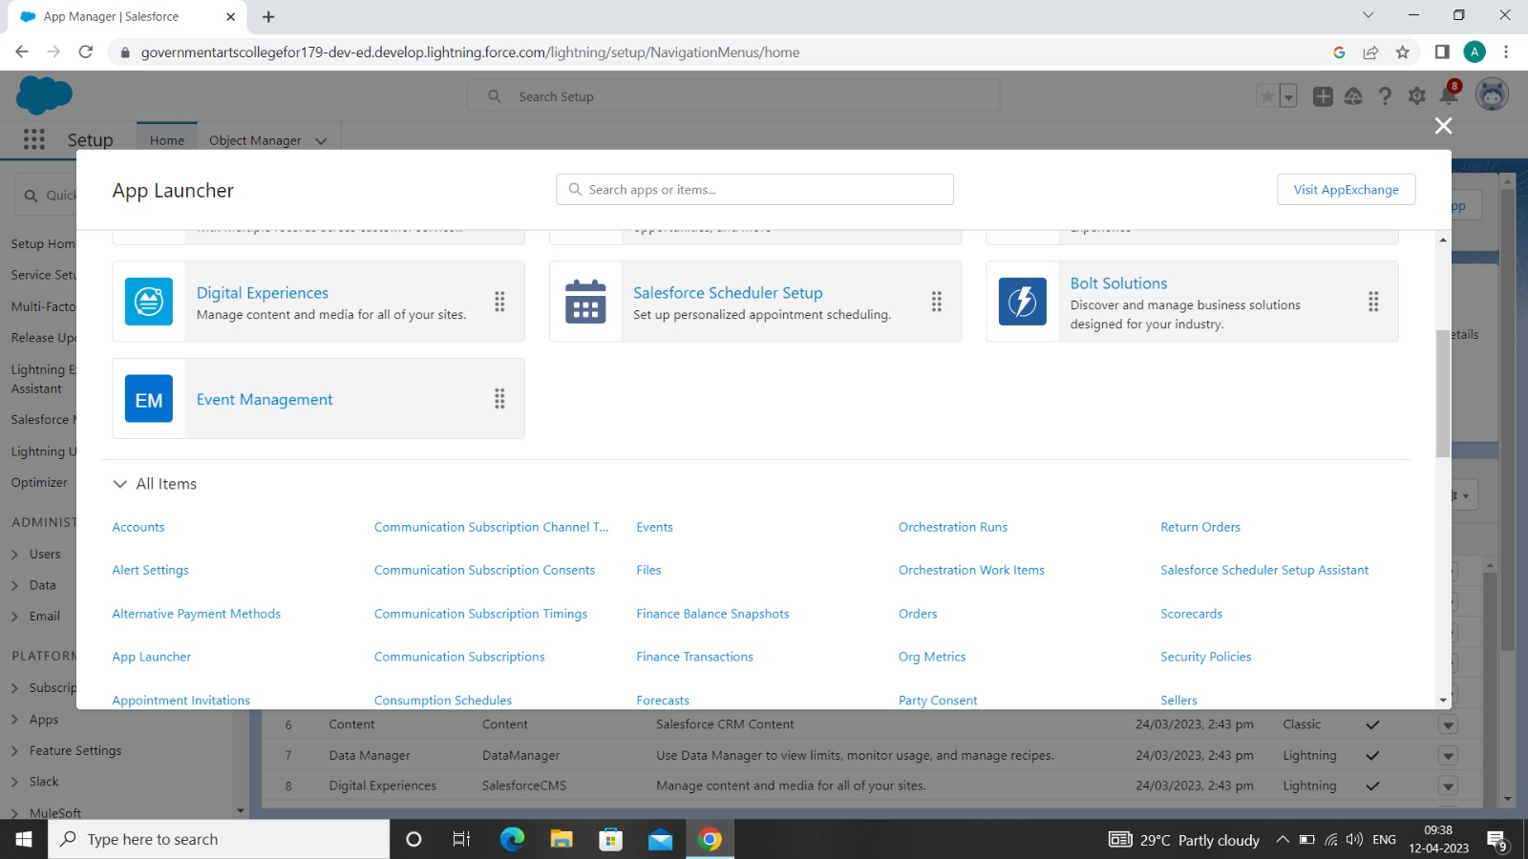

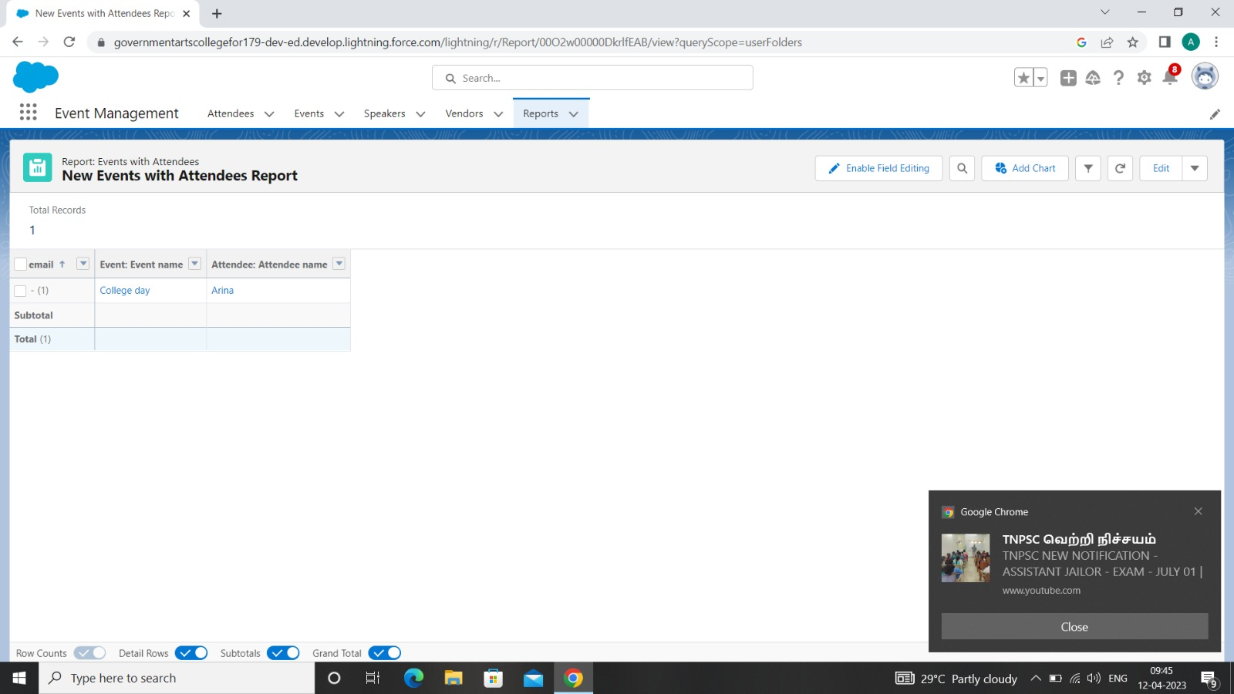

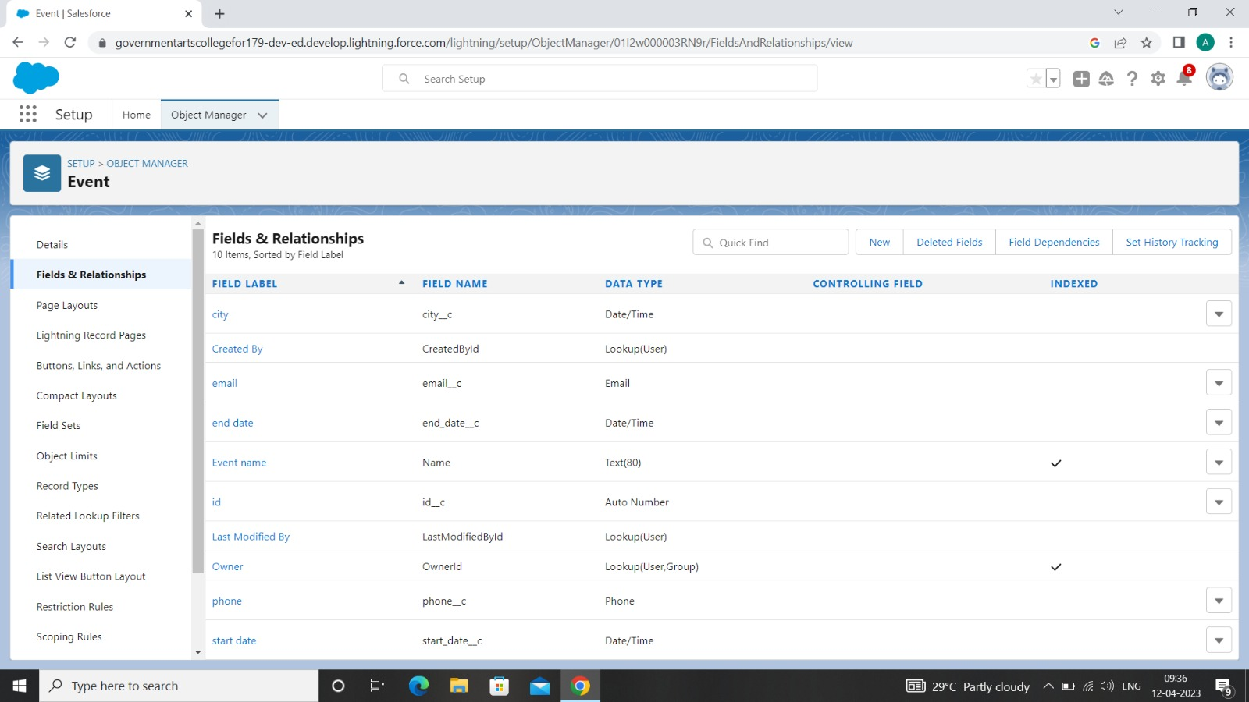

## **TRIAL HEAD PROFILE PUBLIC URL**

Team Lead - <https://trailblazer.me/id/subis22>

Team Member 1 - <https://trailblazer.me/id/spapa71>

Team Member 2 - <https://trailblazer.me/id/rmozhi>

Team Member 3 - <https://trailblazer.me/id/cthilaga>

## **ADVANTAGES & DISADVANTAGES**

### **ADVANTAGES**

* Opportunities for creativity
* Ability to work on different events
* Chance to work with diverse clients
* Collaborative work environment
* High projections for job growth

### **DISADVANTAGES**

* Multiple events at the same time
* Harder to Hold Attendees’ Attention
* No Face-to-Face Interactions
* Distractions
* Handling diverse needs and requirements

## **APPLICATIONS**

All different branches of planning go into event management, including various types of sourcing, designing, regulation checks, and on-site management. In event management, you could be in the process of creating a conference, a product launch, an internal sales kick-off, or even a wedding. Really, any event that requires considerable planning and execution is event management.

## **CONCLUSION**

The scope of event management as a career in India is vast. It’s a thriving industry and is home to a million people. So, if you have a knack for creativity and want to redesign the perceptions of society, the event management industry is all for you.

## **FUTURE SCOPE**

Several job designations that you can hold in the event management and exhibition industry are as follows:

* Event planner
* Creative conceptualizer
* Creative director
* Event coordinator
* Event manager
* Public relations officer
* Event legal executive
* Event executive
* Finance manager