#### Transport Management System Detailed Class Documentation

# PROJECT STRUCTURE

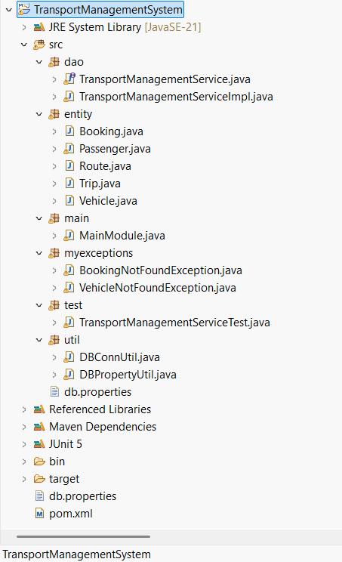

# Class: Booking

This class represents the booking entity used in the Transport Management System.

**Fields:**

* private int bookingId
* private int tripId
* private int passengerId
* private String bookingDate
* private String Status

**Constructor:**

public Booking(int bookingId, int tripId, int passengerId, String bookingDate, String status) {

**Methods:**

1. public int getTripId()
2. public void setTripId(int tripId)
3. public int getPassengerId()
4. public void setPassengerId(int passengerId)
5. public String getStatus()
6. public void setStatus(String status)

**Sample Input:**

Booking booking = new Booking(1, 101, 202, "2025-04-11", "Confirmed");

**Sample Output:**

System.out.println(booking); // Booking{bookingId=1, tripId=101, passengerId=202, bookingDate='2025-04-11', status='Confirmed'}

**Source Code:**

package entity;  
  
public class Booking {  
 private int bookingId;  
 private int tripId;  
 private int passengerId;  
 private String bookingDate;  
 private String Status;  
 public int getBookingId() {  
 return bookingId;  
 }  
  
 public void setBookingId(int bookingId) {  
 this.bookingId = bookingId;  
 }  
  
 public int getTripId() {  
 return tripId;  
 }  
  
 public void setTripId(int tripId) {  
 this.tripId = tripId;  
 }  
  
 public int getPassengerId() {  
 return passengerId;  
 }  
  
 public void setPassengerId(int passengerId) {  
 this.passengerId = passengerId;  
 }  
  
 public String getBookingDate() {  
 return bookingDate;  
 }  
  
 public void setBookingDate(String bookingDate) {  
 this.bookingDate = bookingDate;  
 }  
  
 public String getStatus() {  
 return Status;  
 }  
  
 public void setStatus(String status) {  
 Status = status;  
 }  
  
 public Booking(int bookingId, int tripId, int passengerId, String bookingDate, String status) {  
 super();  
 this.bookingId = bookingId;  
 this.tripId = tripId;  
 this.passengerId = passengerId;  
 this.bookingDate = bookingDate;  
 Status = status;  
 }  
  
  
  
  
}

# Class: Passenger

This class represents the passenger entity used in the Transport Management System.

**Fields:**

* private int passengerId
* private String name
* private String email
* private String phone

**Constructor:**

public Passenger(int passengerId, String name, String email, String phone) {

**Source Code:**

package entity;  
  
public class Passenger {  
 private int passengerId;  
 private String name;  
 private String email;  
 private String phone;  
  
 public Passenger() {}  
  
 public Passenger(int passengerId, String name, String email, String phone) {  
 this.passengerId = passengerId;  
 this.name = name;  
 this.email = email;  
 this.phone = phone;  
 }  
  
 // Getters and Setters  
}

# Class: Route

This class represents the route entity used in the Transport Management System.

**Fields:**

* private int routeId
* private String source
* private String destination
* private double distance

**Constructor:**

public Route(int routeId, String source, String destination, double distance) {

**Source Code:**

package entity;  
  
public class Route {  
 private int routeId;  
 private String source;  
 private String destination;  
 private double distance;  
  
 public Route() {}  
  
 public Route(int routeId, String source, String destination, double distance) {  
 this.routeId = routeId;  
 this.source = source;  
 this.destination = destination;  
 this.distance = distance;  
 }  
  
 // Getters and Setters  
}

# Class: Trip

This class represents the trip entity used in the Transport Management System.

**Fields:**

* private int tripId
* private int vehicleId
* private int routeId
* private String departureDate
* private String arrivalDate

**Constructor:**

public void setTripId(int tripId) {

**Methods:**

1. public int getVehicleId()
2. public void setVehicleId(int vehicleId)
3. public int getRouteId()
4. public void setRouteId(int routeId)
5. public String getDepartureDate()
6. public void setDepartureDate(String departureDate)
7. public String getArrivalDate()
8. public void setArrivalDate(String arrivalDate)

**Source Code:**

package entity;  
  
public class Trip {  
 private int tripId;  
 private int vehicleId;  
 private int routeId;  
 private String departureDate;  
 private String arrivalDate;  
  
 public Trip() {}  
  
 public Trip(int tripId, int vehicleId, int routeId, String departureDate, String arrivalDate) {  
 this.tripId = tripId;  
 this.vehicleId = vehicleId;  
 this.routeId = routeId;  
 this.departureDate = departureDate;  
 this.arrivalDate = arrivalDate;  
 }  
  
 public int getTripId() {  
 return tripId;  
 }  
  
 public void setTripId(int tripId) {  
 this.tripId = tripId;  
 }  
  
 public int getVehicleId() {  
 return vehicleId;  
 }  
  
 public void setVehicleId(int vehicleId) {  
 this.vehicleId = vehicleId;  
 }  
  
 public int getRouteId() {  
 return routeId;  
 }  
  
 public void setRouteId(int routeId) {  
 this.routeId = routeId;  
 }  
  
 public String getDepartureDate() {  
 return departureDate;  
 }  
  
 public void setDepartureDate(String departureDate) {  
 this.departureDate = departureDate;  
 }  
  
 public String getArrivalDate() {  
 return arrivalDate;  
 }  
  
 public void setArrivalDate(String arrivalDate) {  
 this.arrivalDate = arrivalDate;  
 }  
  
 // Getters and Setters  
}

# Class: Vehicle

This class represents the vehicle entity used in the Transport Management System.

**Fields:**

* private int vehicleId
* private String model
* private double capacity
* private String type
* private String status

**Constructor:**

public void setVehicleId(int vehicleId) {

**Methods:**

1. public String getModel()
2. public void setModel(String model)
3. public double getCapacity()
4. public void setCapacity(double capacity)
5. public String getType()
6. public void setType(String type)
7. public String getStatus()
8. public void setStatus(String status)

**Source Code:**

package entity;  
  
public class Vehicle {  
 private int vehicleId;  
 private String model;  
 private double capacity;  
 private String type;  
 private String status;  
  
 public Vehicle() {}  
  
 public Vehicle(int vehicleId, String model, double capacity, String type, String status) {  
 this.vehicleId = vehicleId;  
 this.model = model;  
 this.capacity = capacity;  
 this.type = type;  
 this.status = status;  
 }  
  
 public int getVehicleId() {  
 return vehicleId;  
 }  
  
 public void setVehicleId(int vehicleId) {  
 this.vehicleId = vehicleId;  
 }  
  
 public String getModel() {  
 return model;  
 }  
  
 public void setModel(String model) {  
 this.model = model;  
 }  
  
 public double getCapacity() {  
 return capacity;  
 }  
  
 public void setCapacity(double capacity) {  
 this.capacity = capacity;  
 }  
  
 public String getType() {  
 return type;  
 }  
  
 public void setType(String type) {  
 this.type = type;  
 }  
  
 public String getStatus() {  
 return status;  
 }  
  
 public void setStatus(String status) {  
 this.status = status;  
 }  
  
}

SAMPLE I/P AND O/P:

===== Transport Management Menu =====

1. Add Vehicle

2. Update Vehicle

3. Delete Vehicle

4. Schedule Trip

5. Cancel Trip

6. Book Trip

7. Cancel Booking

8. View Bookings by Passenger

9. View Bookings by Trip

10. Exit

Enter your choice: 6

Trip ID: 2

Passenger ID: 1

Booking Date (YYYY-MM-DD HH:MM:SS): 2025-02-02 08:45:34

Trip booked.

---------------------------------------------------------------------------------------------------------------------- ===== Transport Management Menu =====

1. Add Vehicle

2. Update Vehicle

3. Delete Vehicle

4. Schedule Trip

5. Cancel Trip

6. Book Trip

7. Cancel Booking

8. View Bookings by Passenger

9. View Bookings by Trip

10. Exit

Enter your choice: 8

Passenger ID: 1

Booking{bookingId=13, tripId=2, passengerId=1, bookingDate='2025-02-02 08:45:34', status='Confirmed'}

===== Transport Management Menu =====

1. Add Vehicle

2. Update Vehicle

3. Delete Vehicle

4. Schedule Trip

5. Cancel Trip

6. Book Trip

7. Cancel Booking

8. View Bookings by Passenger

9. View Bookings by Trip

10. Exit

Enter your choice: 9

Trip ID: 2

Booking{bookingId=13, tripId=2, passengerId=1, bookingDate='2025-02-02 08:45:34', status='Confirmed'}