
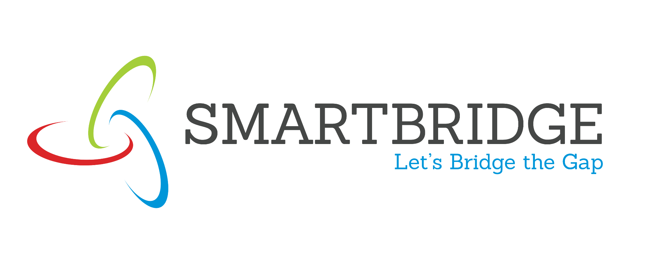

Date | 30 September 2026
Team ID | xxxxxx
Project Name | EduGenie: Google Gemini Powered Learning Assistant
Maximum Marks | 5 Marks

Problem-Solution Fit Canvas:
Use the framework below to ensure your proposed solution accurately addresses the root causes, behaviors, and limitations of your target audience. Fill out the canvas in the respective boxes just like the original visual template.

1. CUSTOMER SEGMENT(S) [CS]  • Students of all academic levels  • School and college learners  • Self-learners and beginners  • Learners studying technical and academic subjects  • Educational institutions and content platforms | 6. CUSTOMER LIMITATIONS [CL]  • Limited time for studying  • Difficulty understanding complex topics  • Limited access to personalized tutoring  • Different learning levels and backgrounds  • Limited hardware resources  • Need for simple and accessible learning support | 5. AVAILABLE SOLUTIONS – PROS & CONS [AS]  • Textbooks and notes – detailed, but can be difficult to understand quickly  • Search engines – broad information, but results are not personalized  • Online tutorials – useful explanations, but may be time-consuming  • Traditional tutoring – personalized, but may cost more and depend on availability  • Generic AI tools – fast responses, but may not be focused on structured learning
2. PROBLEMS / PAINS + ITS FREQUENCY [PR]  • Difficulty understanding complex concepts – frequent  • Need for quick answers to academic questions – frequent  • Long passages are difficult to revise – frequent  • Creating practice quizzes takes time – occasional/frequent  • Learners need guidance on what to study next – frequent | 9. PROBLEM ROOT / CAUSE [RC]  • Educational content is often lengthy or technically complex  • One-size-fits-all learning does not match individual levels  • Students may lack immediate access to a tutor  • Study materials are spread across different sources  • Learners may not know how to organize a topic from beginner to advanced level | 7. BEHAVIOR + ITS INTENSITY [BE]  • Searches online for explanations and answers – high  • Reads notes, textbooks, and online resources – high  • Uses quizzes to check understanding – medium/high  • Requests summaries before revision – high  • Looks for step-by-step learning guidance – medium/high  • Uses digital tools for self-learning – high
3. TRIGGERS TO ACT [TR]  • Upcoming exams or assessments  • Difficulty understanding a topic  • Need for an immediate answer  • Need to revise a long passage quickly  • Desire to test knowledge through a quiz  • Starting a new subject or technical topic  • Need for a structured learning plan | 10. YOUR SOLUTION [SL]  EduGenie connects the learner's problem directly to an AI-powered learning workflow:  Question → Answer  Complex topic → Simple explanation  Study passage → Summary  Topic/passage → Quiz  Learning goal → Personalized learning path  It combines cloud-based Gemini intelligence with a lightweight web interface to make learning simpler, interactive, and accessible. | 8. CHANNELS OF BEHAVIOR [CH]  ONLINE  • Web browser  • Search engines  • Online educational resources  • Digital notes and study materials  • AI-powered learning platforms  OFFLINE  • Textbooks  • Classroom notes  • Printed study materials  • Personal study sessions
4. EMOTIONS BEFORE / AFTER [EM]  BEFORE  • Confused  • Overwhelmed by complex content  • Unsure what to study next  • Time pressure during revision  AFTER  • Clearer understanding  • More confident in the topic  • Better-organized learning path  • Faster revision  • More interactive practice |  | OFFLINE  • Textbooks and reference books  • Classroom teaching  • Printed notes  • Offline self-study  • Discussions with teachers or peers

