CS425 – Computer Networks
Project 1

Date: 19 August, 2016

Name: Shubham Agrawal

Roll No.: 13674

Email: subm@iitk.ac.in

List of implemented options:
- Allow the server port to be initialized at start up
- Allow the document base directory to be initialized at start up, for example via a command line argument or an initialization file.
- Include the Date and Server fields in the Response message header.
- Reply with a hyperlinked directory listing if a directory is the requested resource.

Implementation Details:
- Server Port and Base directory initialization via command line argument:
  - Usage: ./server port-number [base directory ending with ‘/’]
  - Server port read from command line
  - Base directory is optional, i.e.,If base directory is not provided, current directory is used as base directory
- Date and Server Field in Response Headers
  - Date is served in the format used by most websites like facebook, wikipedia.
Date: Thu, 18 2016 21:52:19 GMT
Current time is calculated using gmtime function in ctime library.
  - Server is served in following format using gethostname() in the following format.
Server: subm-Inspiron-5537
- Hyperlinked directory listing
  - Checked if the given path is a directory or not.
  - If yes, extracted content of directory and formatted them in a list tag of html
  - Hyperlniks are created by appending name of the files with original url.
  - Resultant html is served

Testing

Browser Used: Google Chrome
- Working testfiles:
  - All links were tested and found working. This include page redirection, images, pdfs, gifs etc.
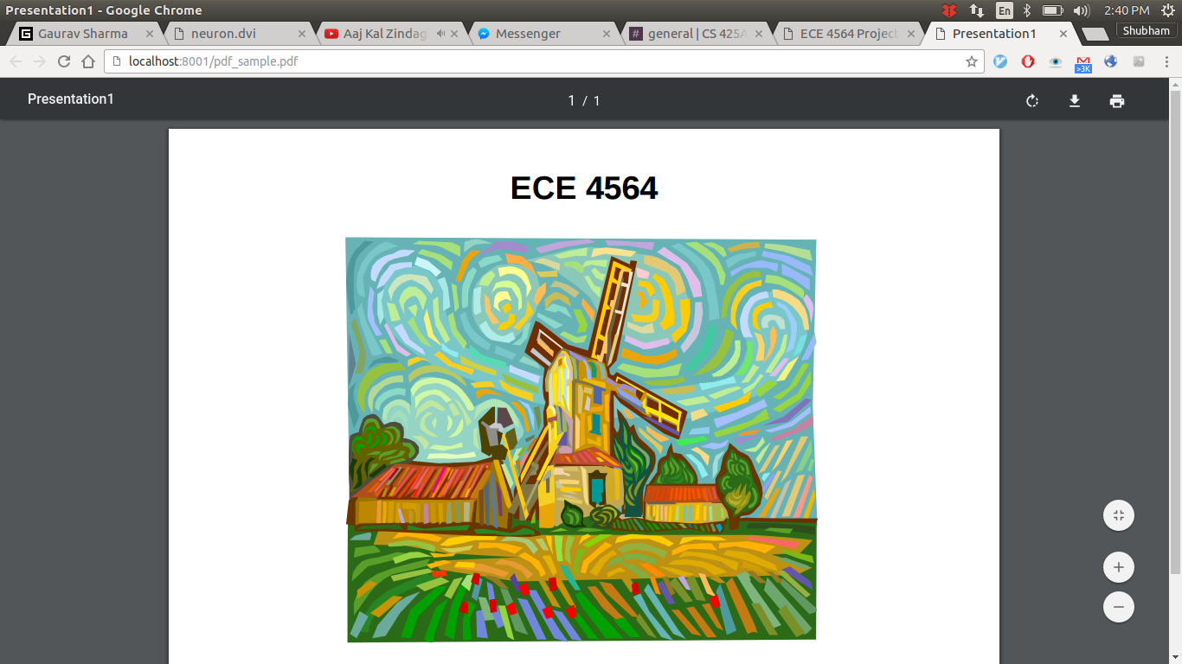
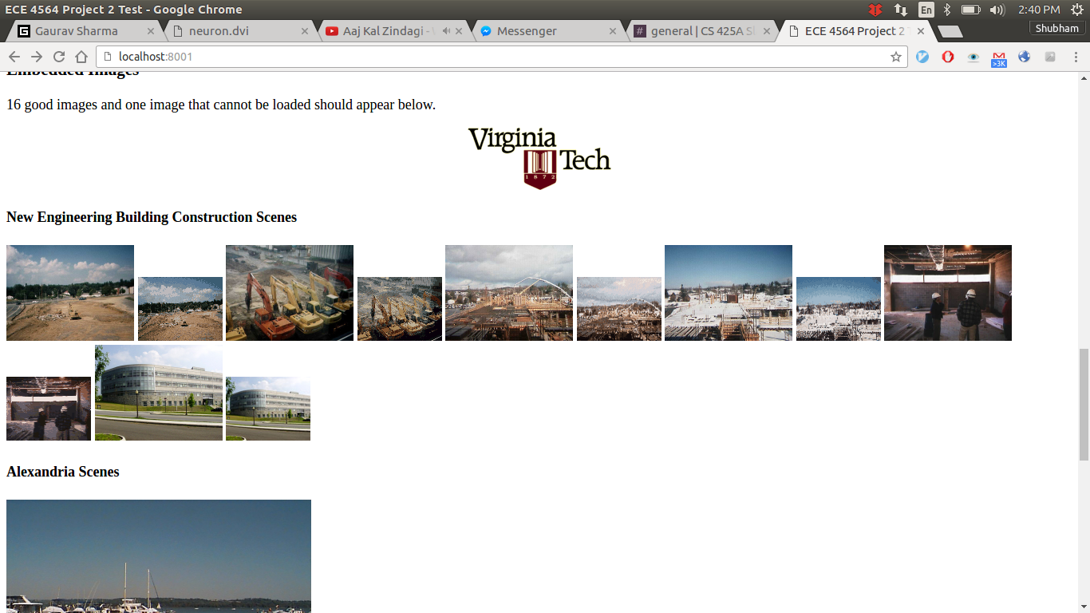

- Working error messages:
  - Error messages were handled for :
    - Invalid request format[400]
    - Invalid method [501]
    - File not found [404]
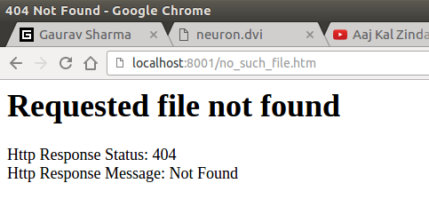
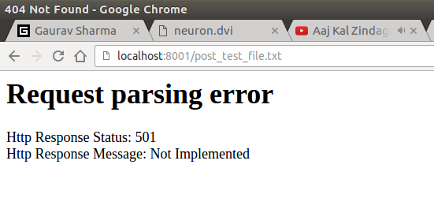

- Persistant connection :
  - Multiple clients were able to send requests at the same time.
  - All requests from client are served by a single thread only. This was tested by printing pid.
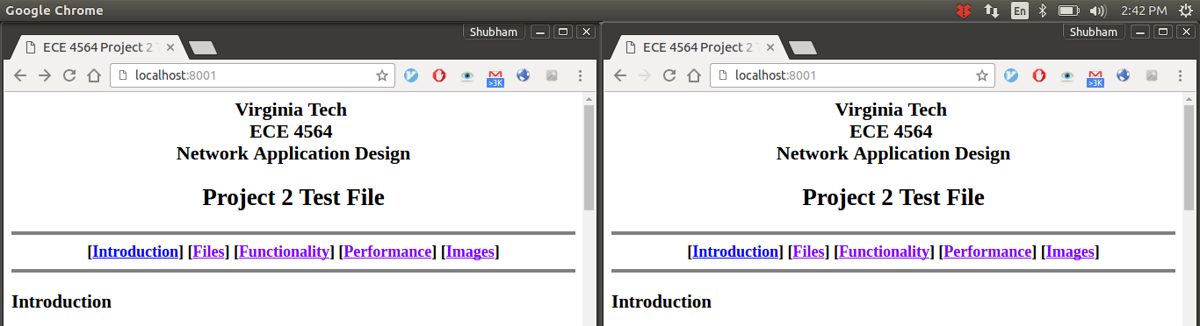

- Directory Listing
  - Created a directory inside directory for testing. Found working
  - All contents of directory were listed including ‘..’ , ‘.’ and other directories.
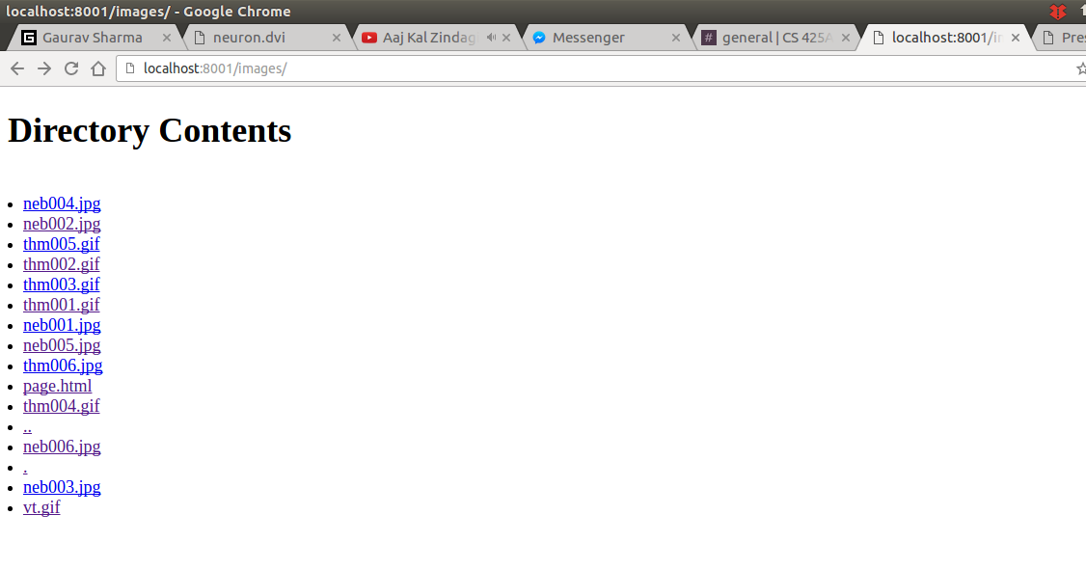

- Server, Port Number, Base directory
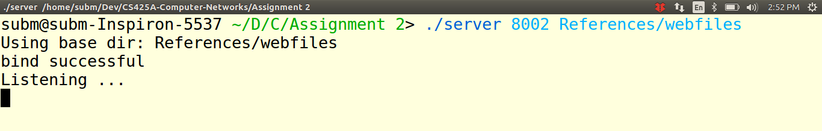
  - Files were being served according to base directory.

- Summary: All mentioned features were found working correctly.
- Reference code used from internet:
  - http://stackoverflow.com/questions/4553012/checking-if-a-file-is-a-directory-or-just-a-file : Checking if a path is directory or not
  - http://stackoverflow.com/questions/5309471/getting-file-extension-in-c: Getting extension of a file in c
  - http://stackoverflow.com/questions/5840148/how-can-i-get-a-files-size-in-c: Getting size of file

Appendix:
- Source File: server.cpp

