Project – Unit 5
We now have a client-server system where the end users, mostly non-programmers, can easily add new car models to the system with over writing each other’s data entry.

We now need to extend this system so the user can be provided with a form
- Users select options for their cars and submit them.

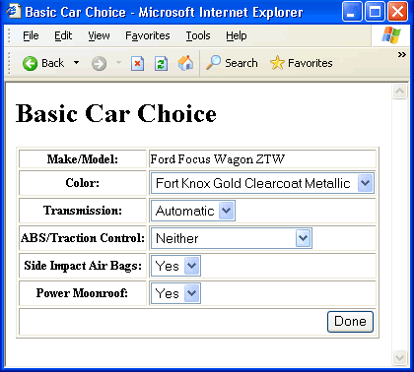

- Page will display the details of their choice as shown below.

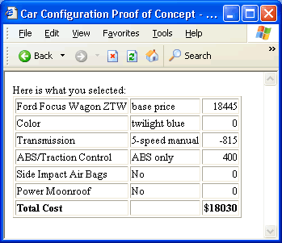
Use these screen shots as a design reference on which to model the interface of your own page.
Our first goal here is to develop the layout of the forms page, as well as to set up choices for users to select. Then we need to update the page to reflect choices made on the forms page.
Also, as you begin development, be sure to use the same configuration options that you used in previous unit. Specifically, I'm referring to the choices regarding the moonroof, color, transmission, brakes, and airbags.
Technical Concepts Applied: Java Server Pages For this task, you must create two web pages:
- An HTML form page for selecting and submitting options.
- A JSP report page that shows which options were selected.
The usual approach is to implement the form page first, test it, then implement and test the report page. The options page should be built dynamically using any data files you might have saved in previous unit using JSP and HTML. The report page, however, is dynamic and must be developed using JSP.

