XAMPP

File: PHP.ini

/*

Uncomment the following

*/

sendmail_path = "\"D:\xampp\sendmail\sendmail.exe\" -t"

/*

Comment the following:

*/

;sendmail_path="D:\xampp\mailtodisk\mailtodisk.exe"

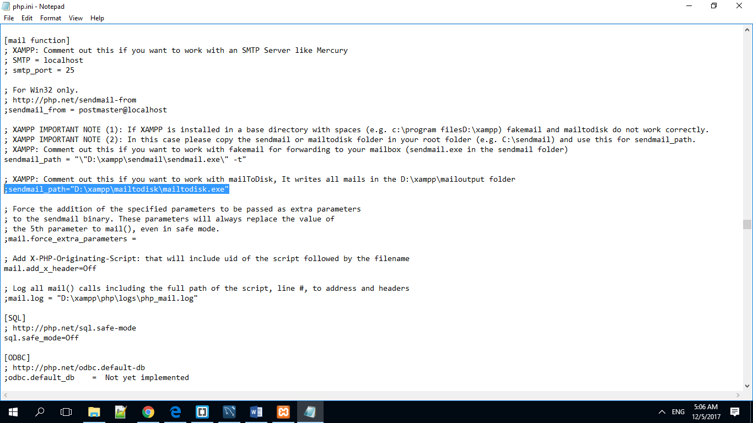

File: sendmail.ini

Setup email smtp, port, and credential.

