Q1.

Code:

|  |
| --- |
| ***package Q1;***    ***import javax.swing.*;***  ***public class SampleWindow {***  ***public static void main(String[] args) {***  ***JFrame myWindow;***  ***myWindow = new JFrame();***  ***myWindow.setSize(300, 200);***  ***myWindow.setTitle("My Window");***  ***myWindow.setVisible(true);***  ***}***  ***}*** |

Output:

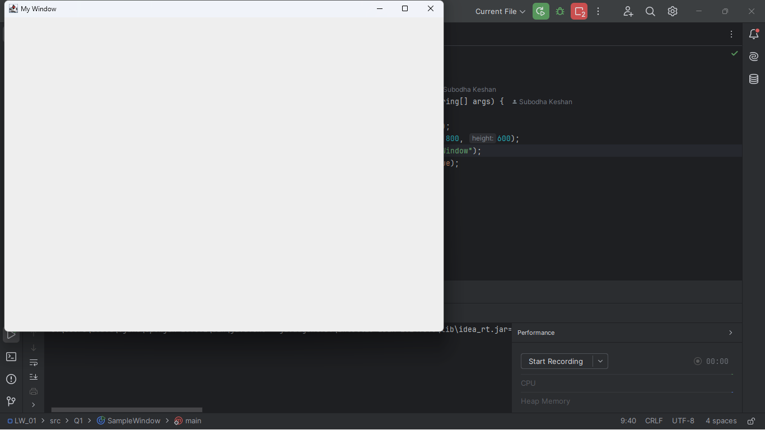

Q2

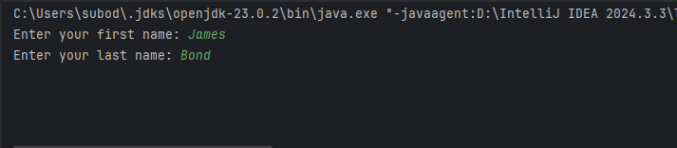Code:

Output:

|  |
| --- |
| ***package Q2;  import javax.swing.*; import java.util.Scanner;  public class FullName {  public static void main(String[] args) {  Scanner text;  text = new Scanner(System.in);   System.out.print("Enter your first name: ");  String firstName = text.nextLine();   System.out.print("Enter your last name: ");  String lastName = text.nextLine();   String fullName = firstName + " " + lastName;   JFrame frame = new JFrame();  frame.setTitle(fullName);  frame.setSize(800, 600);  frame.setVisible(true);  } }*** |

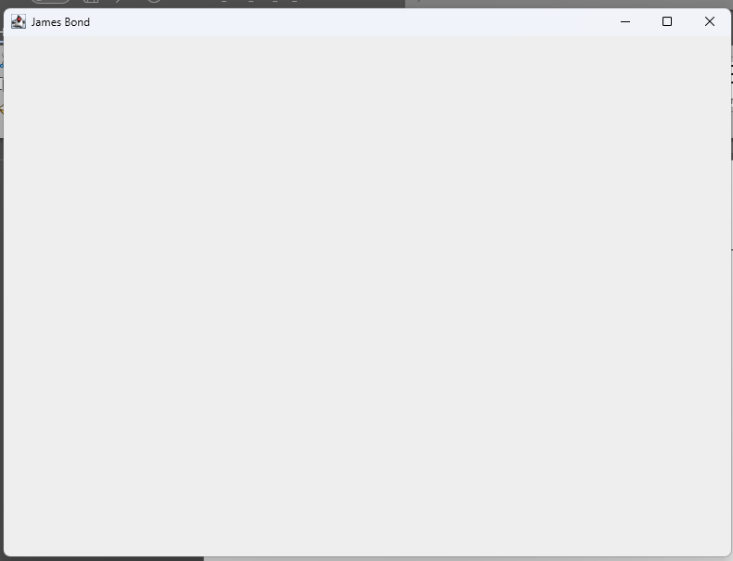

Q3 Code:

Output:

|  |
| --- |
| ***package Q3;  import java.util.Scanner;  public class FullNameOutput {  public static void main(String[] args) {  Scanner text;  text = new Scanner(System.in);   System.out.print("Enter your first name: ");  String firstName = text.nextLine();   System.out.print("Enter your middle name: ");  String middleName = text.nextLine();   System.out.print("Enter your last name: ");  String lastName = text.nextLine();   char middleInitial = middleName.charAt(0);  String fullName = firstName + " " + middleInitial + ". " + lastName;   System.out.println(fullName);  } }*** |

Output:

Q4 Code:

|  |
| --- |
| ***package Q4;  import java.time.LocalDate; import java.time.format.DateTimeFormatter;  public class DisplayDate {  public static void main(String[] args) {    LocalDate today = LocalDate.now();   DateTimeFormatter formatter = DateTimeFormatter.ofPattern("d MMM yyyy");     String formattedDate = today.format(formatter);     System.out.println(formattedDate);  } }*** |

Output:

Q5 Code:

|  |
| --- |
| ***package Q5;  import java.time.LocalDate; import java.time.format.DateTimeFormatter;  public class NewDateFormat {  public static void main(String[] args) {    LocalDate today = LocalDate.now();   DateTimeFormatter formatter = DateTimeFormatter.ofPattern("EEEE, MMMM d, yyyy");    String formattedDate = today.format(formatter);     System.out.println(formattedDate);  } }*** |

Output:

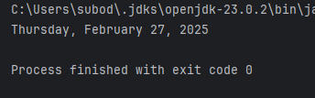

Q6 Code:

|  |
| --- |
| ***package Q6;  import javax.swing.*; import java.util.Scanner;  public class CustomFrame {  public static void main(String[] args) {  Scanner text;  text = new Scanner(System.in);   System.out.print("Enter the width (W) of the frame: ");  int width = text.nextInt();   System.out.print("Enter the height (H) of the frame: ");  int height = text.nextInt();     text.nextLine();   System.out.print("Enter the title of the frame: ");  String title = text.nextLine();   JFrame frame = new JFrame(title);  frame.setSize(width, height);  frame.setVisible(true);  } }*** |

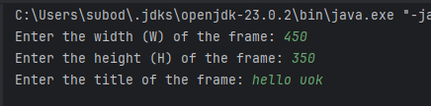Output:

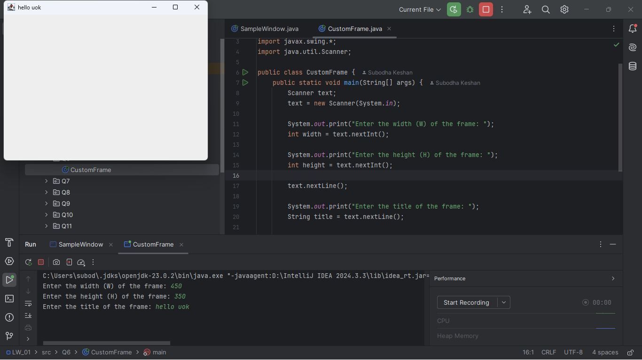

Q7 Code:

|  |
| --- |
| ***package Q7;  import javax.swing.*; import java.time.LocalTime; import java.time.format.DateTimeFormatter;  public class TimeTitleFrame {  public static void main(String[] args) {   LocalTime now = LocalTime.now();   DateTimeFormatter formatter = DateTimeFormatter.ofPattern("hh:mm:ss a");  String timeString = now.format(formatter);   JFrame frame = new JFrame();  frame.setTitle(timeString);   frame.setSize(800, 600);   frame.setVisible(true);  } }*** |

Output:

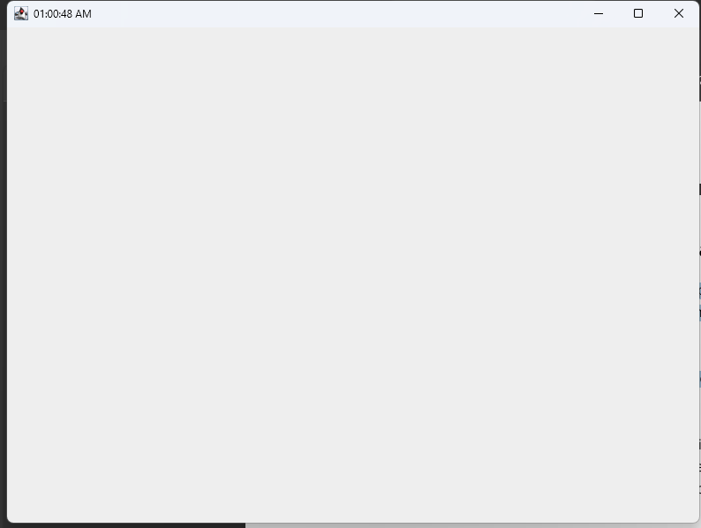

Q8 Code:

|  |
| --- |
| ***package Q8;  import java.util.Scanner;  public class SplitAtExclamation {  public static void main(String[] args) {  Scanner text;  text = new Scanner(System.in);   System.out.println("Enter a string with a single exclamation mark:");  String input = text.nextLine();     int index = input.indexOf("!");   if (index != -1) {    String before = input.substring(0, index).trim();  String after = input.substring(index + 1).trim();     System.out.println(before);  System.out.println(after);  } else {  System.out.println("The input does not contain an exclamation mark.");  }  } }*** |

Output:

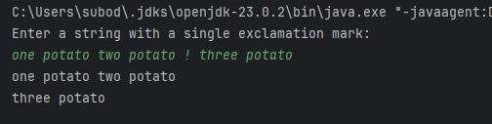

Q9 Code:

|  |
| --- |
| ***package Q9;  import java.util.Scanner;  public class StringInfo {  public static void main(String[] args) {  Scanner text;  text = new Scanner(System.in);   System.out.println("Enter a string:");  String input = text.nextLine();   int length = input.length();  char firstChar = input.charAt(0);  char lastChar = input.charAt(length - 1);   System.out.println(length);  System.out.println(firstChar);  System.out.println(lastChar);  } }*** |

Output:

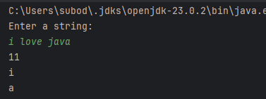

Q10 Code:

|  |
| --- |
| ***package Q10;  import java.util.Scanner;  public class MiddleChar {  public static void main(String[] args) {  Scanner text;  text = new Scanner(System.in);   System.out.print("Enter an odd-length word: ");  String word = text.nextLine();   if (word.length() % 2 == 1) {  int middleIndex = word.length() / 2;  char middleChar = word.charAt(middleIndex);  System.out.println(middleChar);  } else {  System.out.println("The word is not of odd length.");  }  } }*** |

Output:

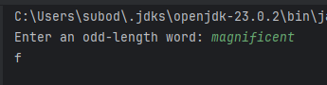

Q11 Code:

|  |
| --- |
| ***package Q11;  import java.util.Scanner;  public class NameFormatter {  public static void main(String[] args) {  Scanner text;  text = new Scanner(System.in);   System.out.print("Enter your full name (first middle last): ");  String fullName = text.nextLine();     String[] parts = fullName.split(" ");     if (parts.length != 3) {  System.out.println("Please enter your name in the format: first middle last.");  } else {  String first = parts[0];  String middle = parts[1];  String last = parts[2];   String formattedName = last + ", " + first + " " + middle.charAt(0) + ".";  System.out.println(formattedName);  }  } }*** |

Output:

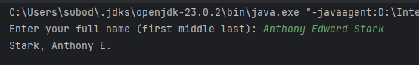

Q12 Code:

|  |
| --- |
| ***package Q12;  import javax.swing.*;  public class MyFirstFrame {  public static void main(String[] args) {  JFrame frame = new JFrame();  frame.setSize(300, 200);  frame.setTitle("My First Frame");  frame.setLocation(100, 50);  frame.setVisible(true);  } }*** |

Output:

