**Q1.**

Code:

|  |
| --- |
| ***package Q_01;   public class MathExpressions {  public static void main(String[] args) {   double A = 10.0;  double B = 8.25;  double C = 6.2;  double X = 25.75;  double Y = 10.0;  double radius = 21.0;   double resultA = Math.sqrt(Math.pow(B, 2) + 4 * A * C);  System.out.println("a. √(B² + 4AC) = " + resultA);   double resultB = Math.sqrt(X + 4 * Math.pow(Y, 3));  System.out.println("b. √(X + 4Y³) = " + resultB);   double resultC = Math.cbrt(X * Y);  System.out.println("c. ∛(X * Y) = " + resultC);   double areaOfCircle = Math.PI * Math.pow(radius, 2);  System.out.println("d. Area of circle with radius " + radius + " = " + areaOfCircle);  } }*** |

Output:

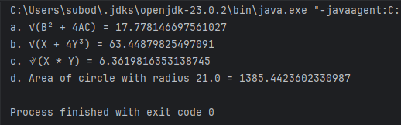

**Q2**

Code:

|  |
| --- |
| ***package Q_02;  import java.util.Scanner;  public class CentimetersToFeetInches {  public static void main(String[] args) {  Scanner input = new Scanner(System.in);  System.out.print("Enter length in centimeters: ");  double cm = input.nextDouble();   double inches = cm / 2.54;  int feet = (int)(inches / 12);  double remainingInches = inches % 12;   System.out.printf("%.2f cm is %d feet and %.2f inches", cm, feet, remainingInches);  input.close();  } }*** |

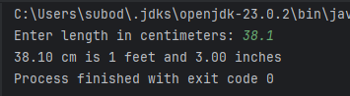

Output:

**Q3**

Code:

|  |
| --- |
| ***package Q_03;  import java.util.Scanner;  public class CelsiusToFahrenheit {  public static void main(String[] args) {  Scanner input = new Scanner(System.in);  System.out.print("Enter temperature in Celsius: ");  double celsius = input.nextDouble();   double fahrenheit = (1.8 * celsius) + 32;   System.out.printf("%.2f°C is equal to %.2f°F", celsius, fahrenheit);  input.close();  } }*** |

Output:

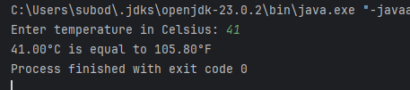

**Q4**

Code:

|  |
| --- |
| ***package Q_04;  import java.util.Scanner;  public class CalorieCal {  public static void main(String[] args) {  Scanner input = new Scanner(System.in);  System.out.print("Enter your weight in pounds: ");  double weight = input.nextDouble();   double calories = weight * 19;   System.out.printf("You need %.2f calories per day", calories);  input.close();  } }*** |

Output:

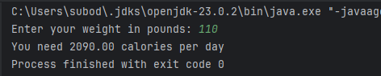

**Q5**

Code:

|  |
| --- |
| ***package Q_05;  import java.util.Scanner;  public class FahrenheitToCelsius {  public static void main(String[] args) {  Scanner input = new Scanner(System.in);  System.out.print("Enter temperature in Fahrenheit: ");  double fahrenheit = input.nextDouble();   double celsius = (5.0/9.0) * (fahrenheit - 32);   System.out.printf("%.2f°F is equal to %.2f°C", fahrenheit, celsius);  input.close();  } }*** |

Output:

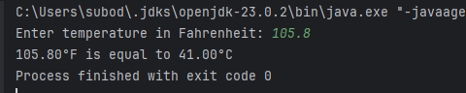

**Q6**

Code:

|  |
| --- |
| ***package Q_06;  import java.util.Scanner; import java.time.Year;  public class AgeCalculator {  public static void main(String[] args) {  Scanner input = new Scanner(System.in);  System.out.print("Enter your birth year: ");  int birthYear = input.nextInt();   int currentYear = Year.now().getValue();  int age = currentYear - birthYear;   System.out.println("You were born in " + birthYear + " and will be (are) " + age + " this year.");  input.close();  } }*** |

**Output**:

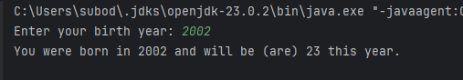

**Q7**

Code:

|  |
| --- |
| ***package Q_07;  import java.util.Scanner;  public class BMICal {  public static void main(String[] args) {  Scanner input = new Scanner(System.in);  System.out.print("Enter weight in kilograms: ");  int weight = input.nextInt();   System.out.print("Enter height in centimeters: ");  int height = input.nextInt();   double bmi = weight / Math.pow(height / 100.0, 2);   System.out.printf("Your BMI is %.2f", bmi);  if (bmi >= 20 && bmi <= 25) {  System.out.println(" (Normal)");  } else {  System.out.println();  }  input.close();  } }*** |

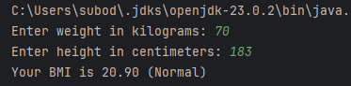Output:

**Q8**

Code:

|  |
| --- |
| ***package Q_08;  import java.util.Scanner;  public class SphereVolumeCal {  public static void main(String[] args) {  Scanner input = new Scanner(System.in);  System.out.print("Enter the radius of the sphere: ");  double radius = input.nextDouble();   double volume = (4.0/3.0) * Math.PI * Math.pow(radius, 3);   System.out.printf("The volume of the sphere is %.2f cubic units", volume);  input.close();  } }*** |

Output:

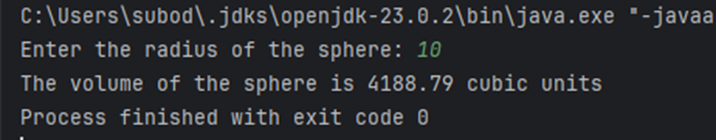

**Q9**

Code:

|  |
| --- |
| ***package Q_09;  import java.util.Scanner;  public class InvestmentCal {  public static void main(String[] args) {  Scanner input = new Scanner(System.in);   System.out.print("Enter principal amount: ");  double principal = input.nextDouble();   System.out.print("Enter annual interest rate (%): ");  double rate = input.nextDouble();   System.out.print("Enter number of years: ");  int years = input.nextInt();   double finalAmount = principal * Math.pow(1 + (rate/100), years);  double earnings = finalAmount - principal;   System.out.printf("After %d years, your investment will grow to $%.2f\n", years, finalAmount);  System.out.printf("Total earnings: $%.2f", earnings);  input.close();  } }*** |

Output:

**Q10**

Code:

|  |
| --- |
| ***package Q_10;  import java.util.Scanner;  public class LoanCal {  public static void main(String[] args) {  Scanner input = new Scanner(System.in);  final int MONTHS_IN_YEAR = 12;   System.out.print("Enter loan amount: $");  double loanAmount = input.nextDouble();   System.out.print("Enter annual interest rate (%): ");  double annualInterestRate = input.nextDouble();   System.out.print("Enter loan period (years): ");  int loanPeriod = input.nextInt();   double monthlyInterestRate = annualInterestRate/100.0/MONTHS_IN_YEAR;  int numberOfPayments = loanPeriod * MONTHS_IN_YEAR;   double monthlyPayment = (loanAmount * monthlyInterestRate) /  (1 - Math.pow(1/(1 + monthlyInterestRate), numberOfPayments));   double totalPayment = monthlyPayment * numberOfPayments;   System.out.printf("Monthly payment: $%.2f\n", monthlyPayment);  System.out.printf("Total payment: $%.2f\n", totalPayment);  System.out.printf("Total interest: $%.2f", (totalPayment - loanAmount));  input.close();  } }*** |

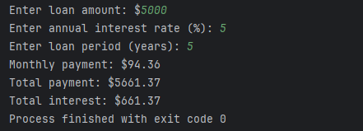Output: