Whooping Cough — Clinical Trial Site Analysis

By- Subodh Bharti, Data Scientist (Cogneus pvt ltd)

Executive summary
- Clinical trial site analysis is a critical component of clinical research management that ensures the efficient, ethical, and successful execution of trials. It involves evaluating and monitoring trial sites based on performance, patient recruitment, geographic distribution, compliance, and operational efficiency. The primary objective is to enable data-driven decision-making for optimizing trial outcomes and resource allocation.

Table of contents
- Data & methods
- Dashboard highlights (charts & interpretation)
- Site-level analysis & hotspot detection
- Limitations & assumptions
- Actionable recommendations
- Code snippets

Data & Methods
- Data sources: clinical trials dataset taken from API "https://clinicaltrials.gov/api/v2/studies" for our analysis case reports.
- Columns are:
nct_id, site, title, official_title, status study_type, phase, conditions, enrollment, start_date, completion_date, primary_outcome, summary, eligibility_criteria, sex, min_age, max_age, officials, locations, therapeutic_areas.
- Inclusion: trials with query condition ‘Whooping cough’ in indication/condition. Fetched 713 rows as raw data.
- Key cleaning steps: phase parsing (split multi-phase values into Phase I/II/III/IV columns), normalize status (Completed/Active/Suspended), deduplicate sites by site_id, impute missing enrollment dates only where safe.
- Match score = 0.4 * 'condition_sim' +0.3* 'phase_sim' +0.2* 'region_sim' +0.1* 'intervention_sim'

Dashboard highlights
- Used the Streamlit UI for dashboard & charts. For each chart below provide: visual, short interpretation, and key highlights.

Site-level analysis & hotspot detection
- Top 10 performing sites (table):
  - Total Sites 201, Total Studies 713, Avg Completion Rate for studies 56.87%, Avg Data Quality 0.87.
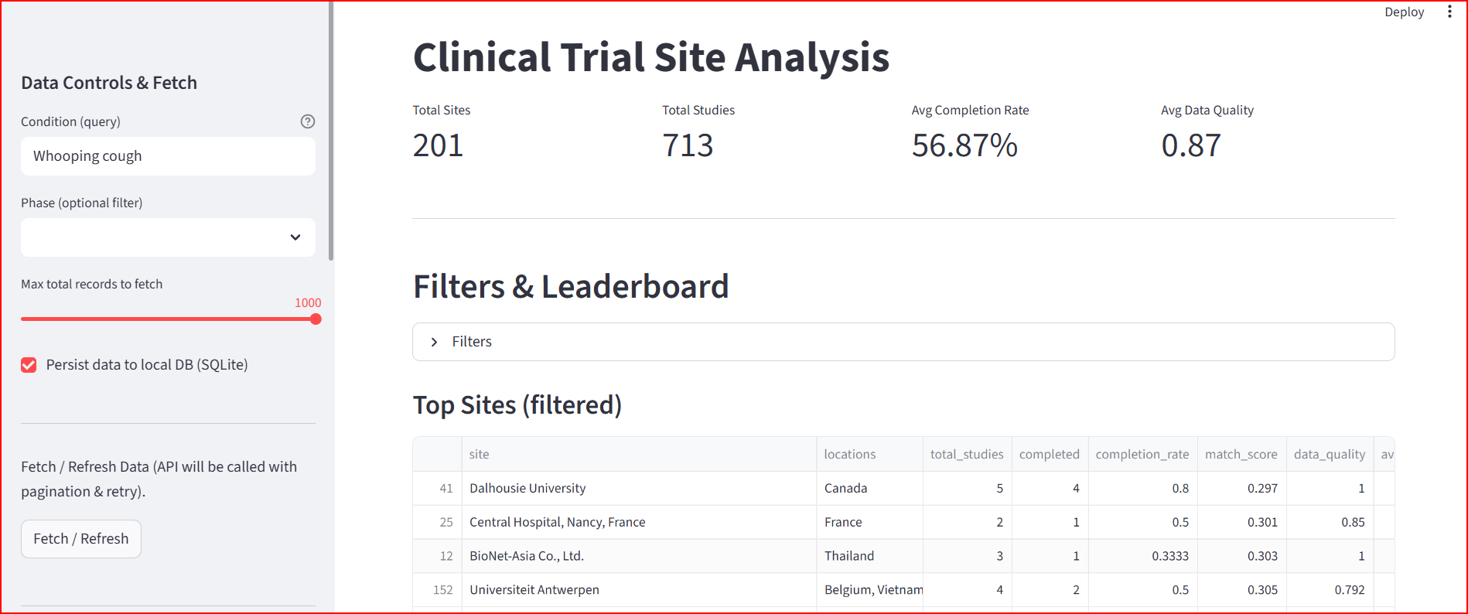

- Filters & Leaderboard (filter settings)

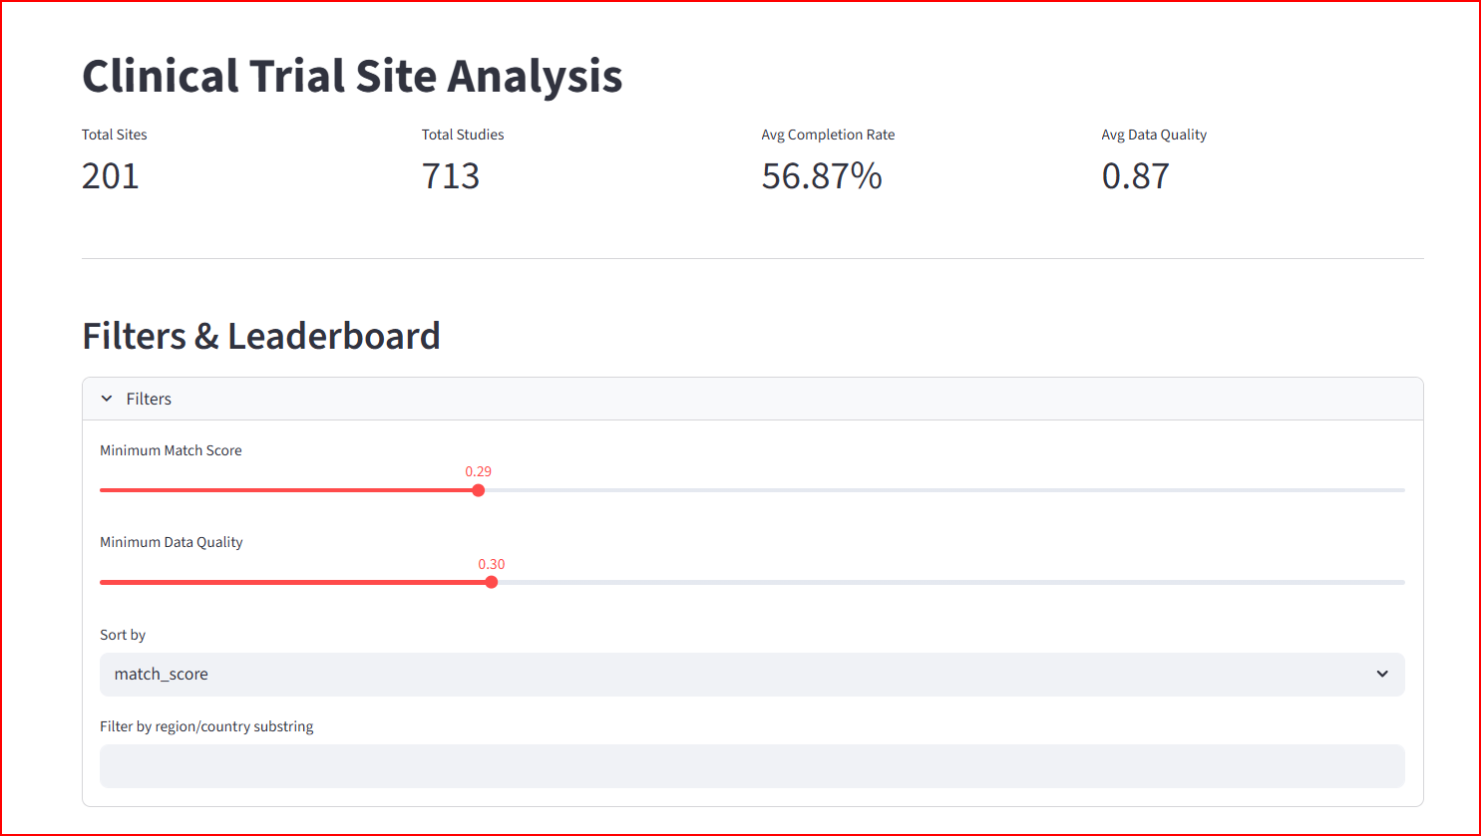

- Filtered Data Leaderboard (table): sort by studies completed, studies completion rate, match score, data quality.
  - GlaxosmithKline (Thailand), Sanofi (India), Merck Sharp & Dohme LLC, Novartis are top sites for target disease Whooping cough.
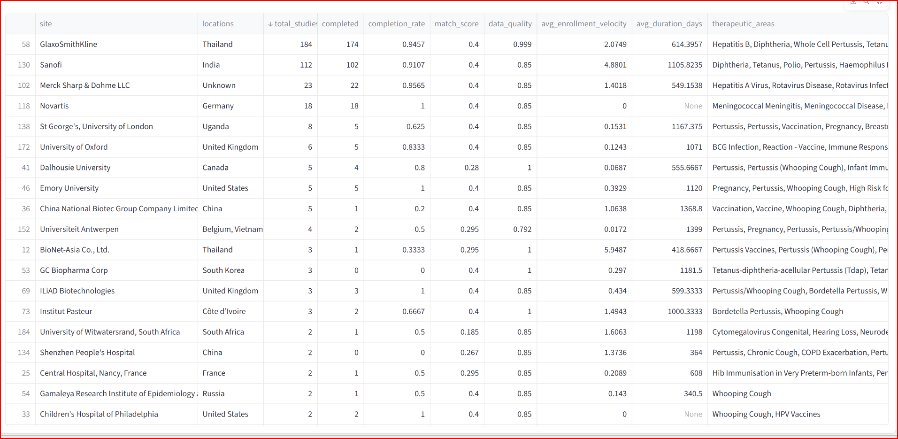

- Top 20 performing sites (table): Filtered Data with Sites vs Match Score.
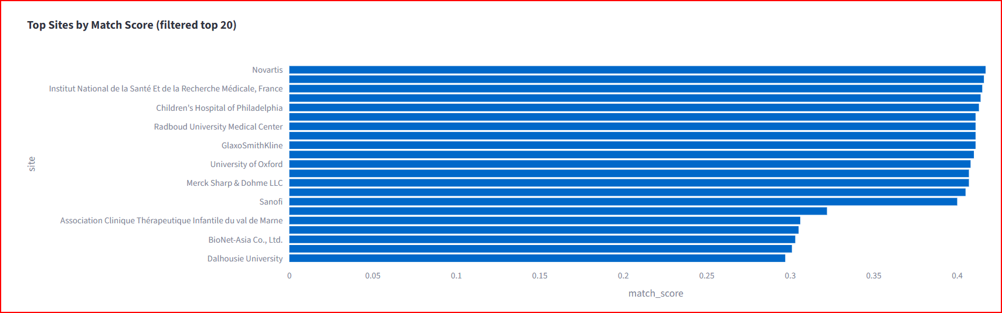

- Completion Rate vs Data Quality (Bubble chart):
  - Most sites tend to lie between 8 to 1 data quality for study completion and Most study completion rate lie between 8 to 1.
  - Top sites with biggest bubble means highest number of study completion with highest data quality are GlaxosmithKline (Thailand), Sanofi (India).
  - Centre Hospitalier Universitaire Dijon site has the lowest data quality and lowest study completion rate.
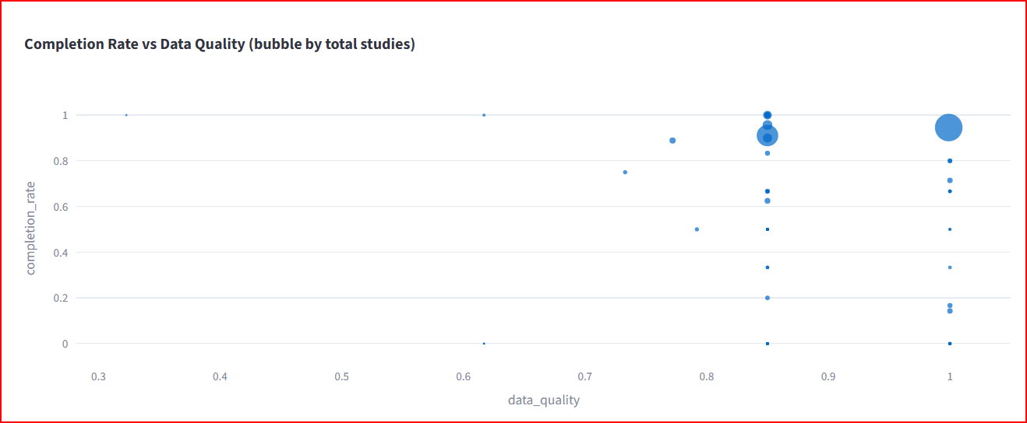

- Therapeutic Condition vs Count of Sites (Bar chart):
  - It states Therapeutic condition Diptheria (160 sites), Pertusis, Poliomyelitis have highest count of sites to study that. Most of the therapeutic conditions lies between 0 to 60 count (of sites).

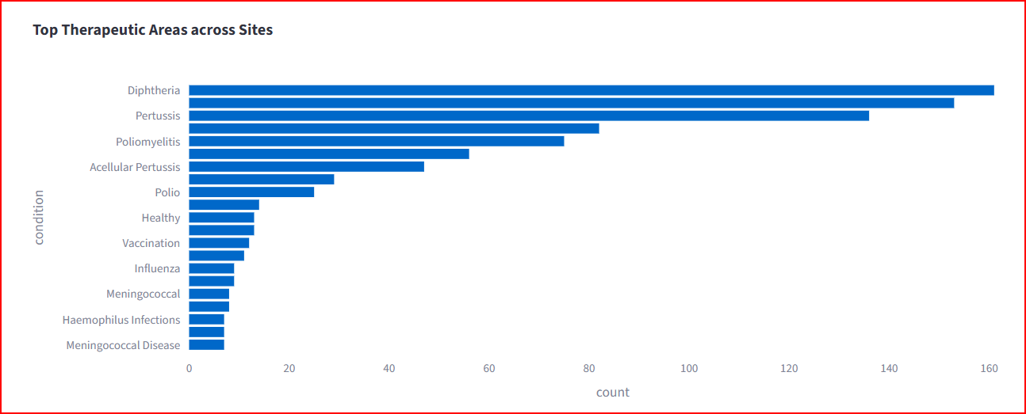

- Completion Rate vs Data Quality (Pie chart):
  - It states that more than 77% studies have completion status, Unknown or NA study status has second highest percentage and third highest percentage i.e., 5.3% for status Recruiting. Only 0.14% percentage of study is being withdrawn.

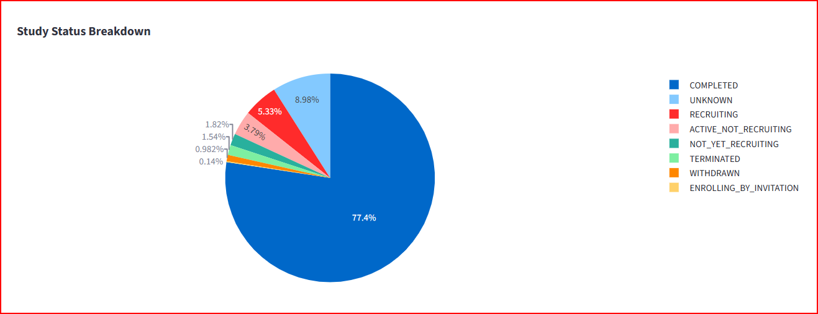

- Country vs Sites count (Table):
  - It states that Unites States is the top country with highest number of sites available for studies i.e., 44 followed by unknown (or NA), France, China and Germany.
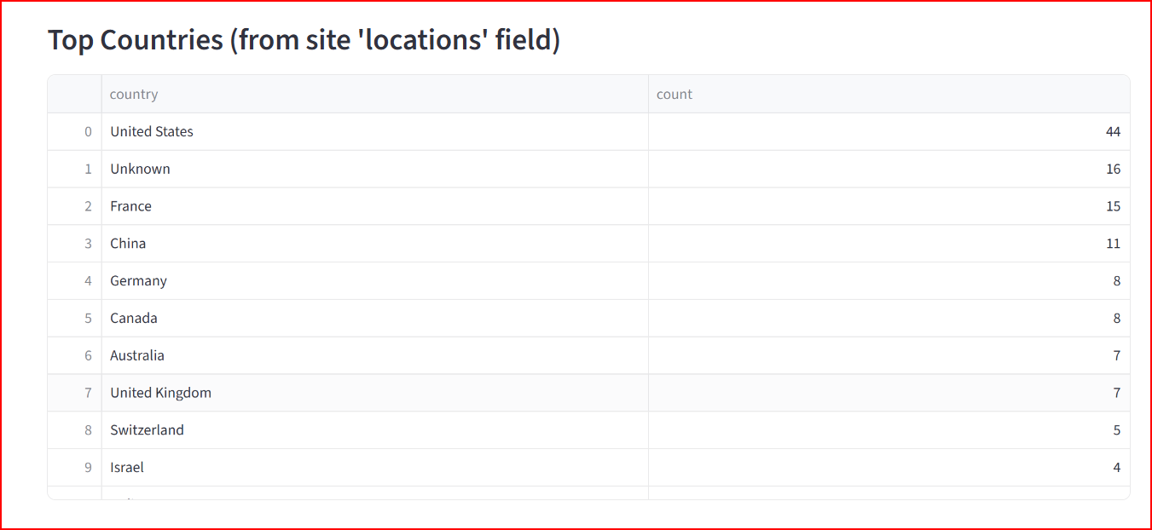

- Country vs Sites count (Bar chart):
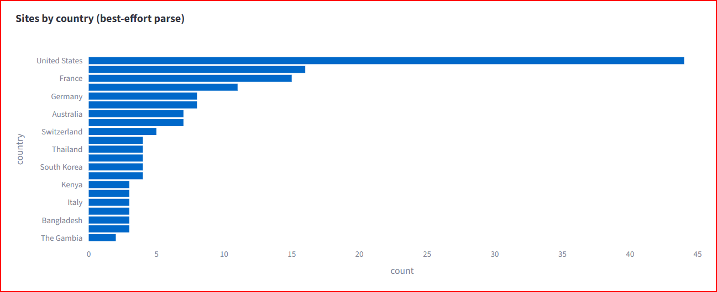

- Country vs Sites count (Histogram chart):
  - GlaxosmithKline (Thailand), Sanofi (India), Merck Sharp & Dohme LLC, Novartis are top sites for target disease Whooping cough for overall highest number of all phase completion alongwith highest number of phase III completion.
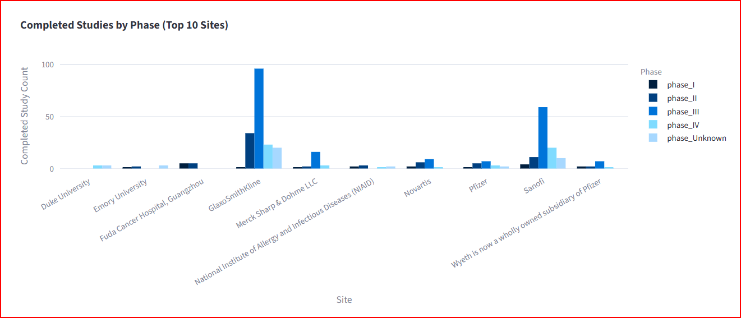

- Site Drilldown (Table for selected site GlaxosmithKline): Select any site of your choice to know further. Such as here in case of whooping cough can consider to know further about GlaxosmithKline site.
  - Trial timelines chart suggest that most trials lies between 2005 to 2025.
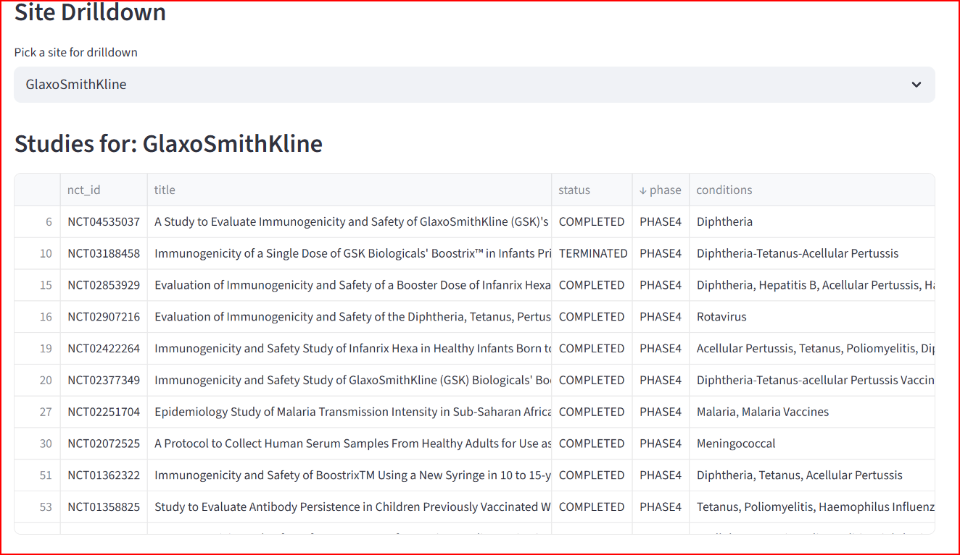

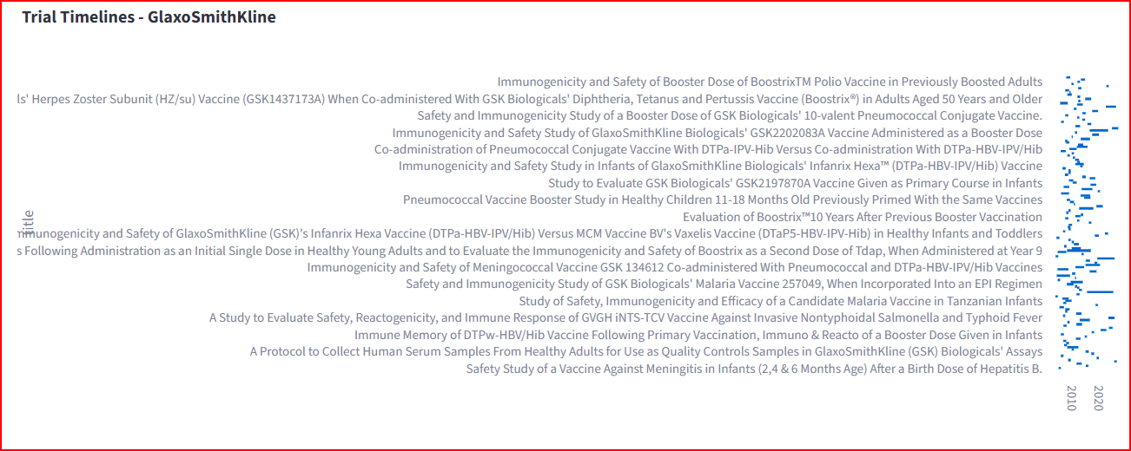

- Site Drilldown (Table for selected site Sanofi): Selected Sanofi (India) site.
  - Trial timelines chart suggest that most trials lies between 2005 to 2020.

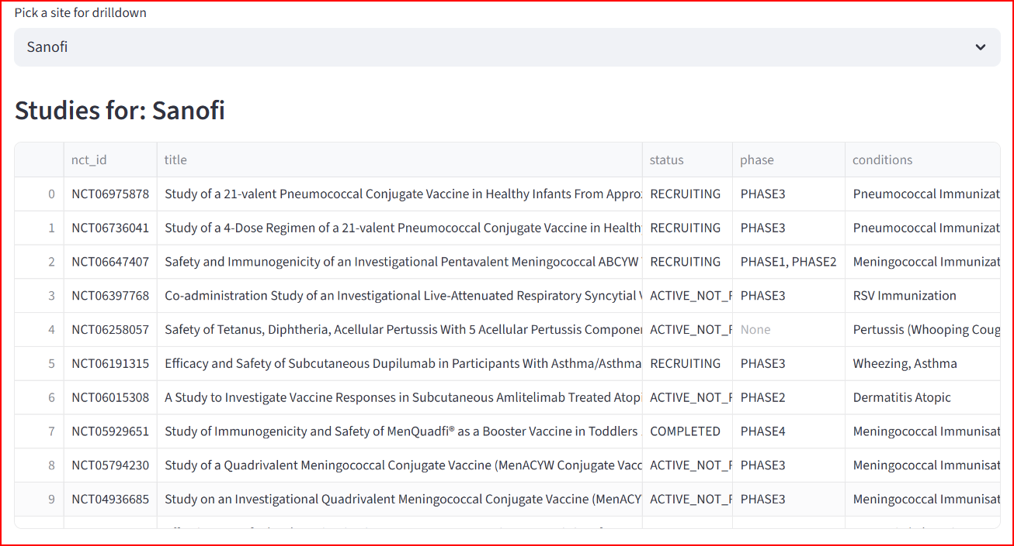

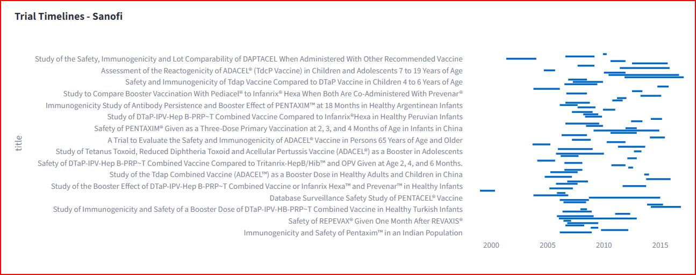

Limitations & assumptions
- Missing or delayed reporting from sites
- Condition mapping relies on text-match; recommend clinical coding (MedDRA) for production.

Actionable recommendations
- Using the interpretaions from Site-level analysis & hotspot detection we observe that query condition ‘Whoopin Cough’ GlaxosmithKline (Thailand), Sanofi (India), Merck Sharp & Dohme LLC, Novartis are top sites for our interest.

Code snippets
code snippets can be found at my github public repo - “https://github.com/subodhbhartismiley/clinical_trial_site_analysis”

