LUNG CANCER DETECTION USING ARTIFICIAL NEURAL NETWORKS

ABSTRACT
“A computer would deserve to be called intelligent if it could deceive a human into believing that it was human.”
- ALAN TURING
Artificial Neural Networks are inspired by the function of the basic part of the Human Neural System the Neuron. In this approach we attempt replicate the human intelligence with the help of machine learning. Given a set of numerical data a machine trained for recognizing it should predict the probable output. This report includes the study of different training models for Artificial Neural Networks to detect lung cancer. Both real and synthetic data has been used to conduct several experiments on a multiprocessor architecture and made attempts to optimize the performance.

1. INTRODUCTION
The neural network architecture is similar to human nervous system. This is a set of neurons connected to each other by a synapse, which has a weight associated to it. The neurons interact with each other through the synapse. There are three layers the input layer, hidden layer and the output layer. The input layer has some neurons depending on the number of attributes in the dataset, and they are connected to a set of neurons in the hidden layer. The number of neurons in the hidden layer decides the number of the calculation to be performed. The wider the layer the more number of computations can be performed. There are some deep-learning neural networks which have more than one hidden layer in them this increases the complexity of the calculations, these are mostly used in image processing and pattern recognition applications. The hidden layer is connected to output layer which is the predicted output. The number of neurons in output layer depends on the dataset output and the application goals. The figure 1 illustrates the simple and deep neural network architecture.

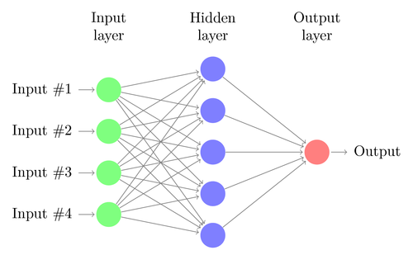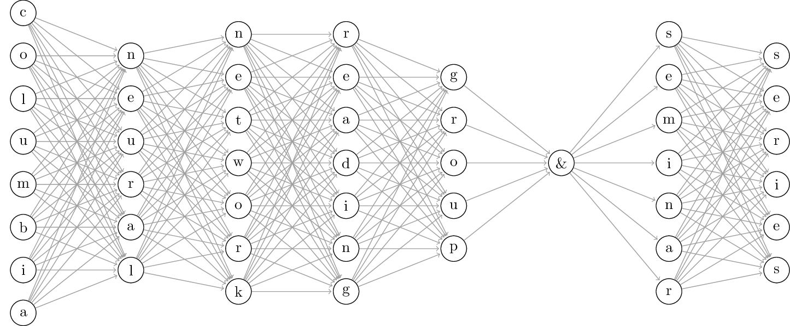
Figure 1
  - FORWARD FEED
The value of neurons in the previous layer is feed to neurons in the next layer through the synapse this is called as forward feed, also referred to as forward propagation. The value of the neuron multiplied by it weight is passed as input the next layer. Then neuron takes all its inputs and applies an activation function and threshold function to it. The activation function is the sum of product of the previous neuron value and weight of the synapse.

Z (Activation function)

(Threshold function)

First the activation function value is calculated and passed to the threshold function. Discreet threshold function cannot be used for this as the output values of the activation function are continuous. We need something like sigmoid function.

  - BACK PROPAGATION
The weights need to be modified to get better performance and we use curve fitting technique to calculate the approximate solution of the weights. The two techniques used in the implementation are the scaled conjugate gradient function and the BFGS algorithm.
2. RESULTS
The comparison of the performance of the training of the network using 3neurons in the hidden layer for the synthetic data using naïve scaled gradient function and the BFGS algorithm in the SciPy library.
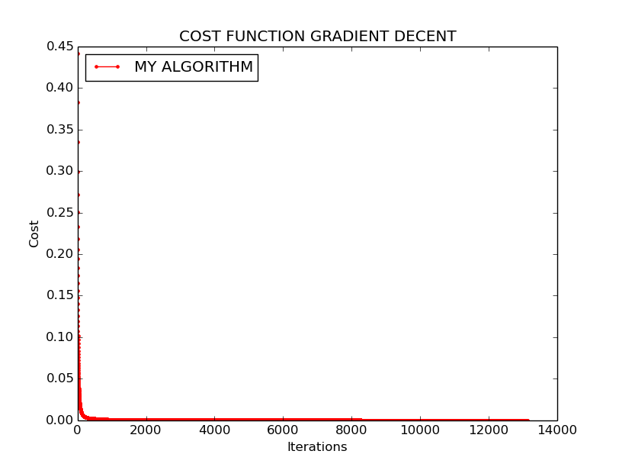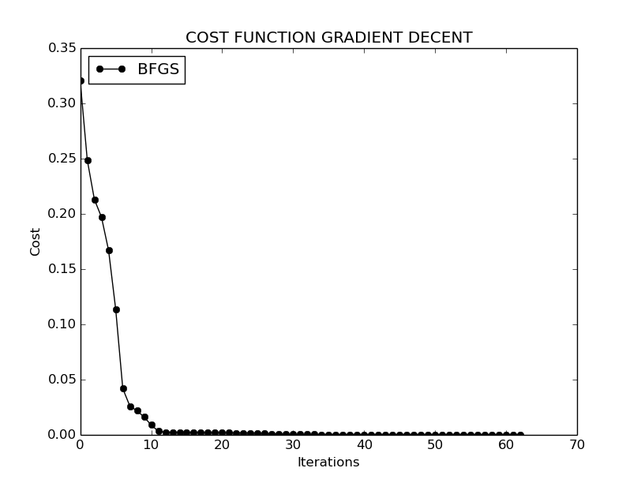

Current function value: 0.000100 Current function value : 0.000000
Iterations: 5351 Iterations : 99
Function evaluations: 5351 Function evaluations: 104
Gradient evaluations: 5351 Gradient evaluations: 104
Execution Time: 682 milli-seconds Execution Time: 31 milli-seconds

SAMPLE COMAND LINE OUTPUT
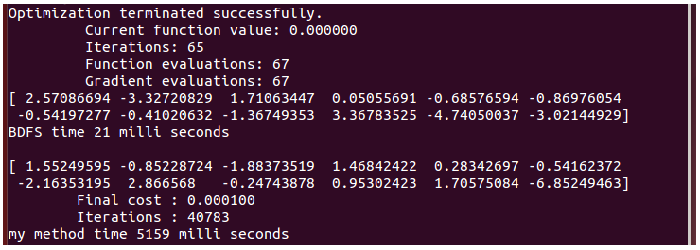

The below shows the performance results of the two training methods. The BFGS performs more operations per iteration but compleats with better accuracy in less time. My naïve scaled congugate gradient method is simple so takes less time per iteration compared to BFGS but need to run iterations in the order of 10^3 to compleate with less accuracy.

NETWORK TRAINING EVALUATION
BFGS |  | Gradient Decent
Iterations | Time (ms) | Iterations | Time (ms)
70 | 77 | 1034 | 8351
67 | 200 | 861 | 6701
30 | 95 | 728 | 5625
32 | 111 | 719 | 5529
36 | 123 | 583 | 4465

Analyzing the real dataset with 56 attributes of 32 elements which are classified into 3 classes from UCI Archive ( http://archive.ics.uci.edu/ml/datasets/Lung+Cancer ) for classification problem the following results were obtaind by using the neural network toolkit in MATLAB. As this was a classification problem pattern recognition tool with 10 neurons in hidden layer. The default division rate of 70% for training, 15% for validation, and 15% for testing is used. Here the validation is used to avoiding overfitting in the local minumum. The compleation of the training can be calculated by using validation data as inputs and applying the cost function to the output and the training is terminated after there is no much improvement in the accuracy of predicting validation data output. The validation should data is not used in the the training else it will also lead to termination at the local minimum.

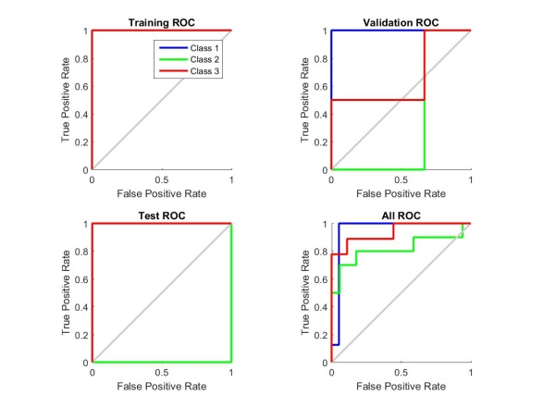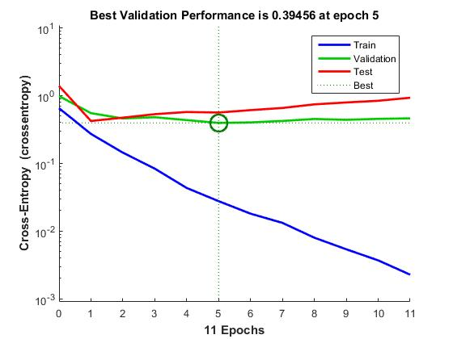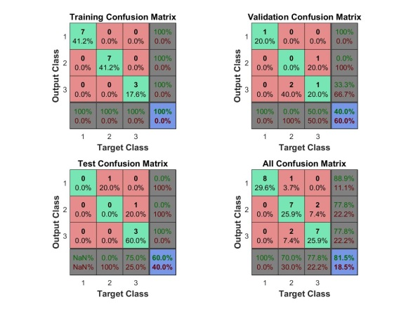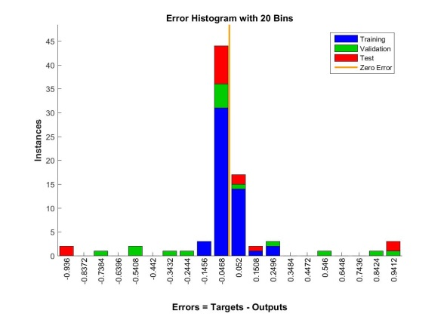

3. CONCLUSION
Artificial Neural Network are used today in different applications like character recognition, image compression, stock market prediction… With the help of available hardware like FPGA’s and GPU’s we can build a highly efficient and accurate ANN. Many real time problems can be solved by integrating neural network with computing, Artificial Intelligence and Fuzzy logic. Finally, I would like to state there is a huge pottential for neural networks.

INSTRUCTIONS TO RUN THE CODE
- Implemented in python nn.py
- Need numpy and scipy to run the code

APPENDIX

import numpy as np
import time
from scipy import optimize
import matplotlib.pyplot as plt

# X = (smoke tobacco, smoke cannnibis, drink alchol), y = chances of getting lung cancer
X = np.array(([0,0,0], [0,0,1], [0,1,0],[0,1,1],[1,0,0],[1,0,1],[1,1,0],[1,1,1]), dtype=float)
y = np.array(([10], [22], [32], [45], [60], [75], [72], [86]), dtype=float)
X = X/np.amax(X, axis=0)
y = y/100 #Max is 100

class Neural_Network(object):
def __init__(self):
#Define Hyperparameters
self.NetworkInputLayerSize = 3
self.NetworkOutputLayerSize = 1
self.NetworkHiddenLayerSize = 3

#Weights (parameters)
self.W1 = np.random.randn(self.NetworkInputLayerSize,self.NetworkHiddenLayerSize)
self.W2 = np.random.randn(self.NetworkHiddenLayerSize,self.NetworkOutputLayerSize)

def forwardNetwork(self, X):
#one run
self.z2 = np.dot(X, self.W1) #compute activation values for neurons in hidden layer
self.a2 = self.sigmoid(self.z2) #apply sigmoid function to hiddenlayer neuron
self.z3 = np.dot(self.a2, self.W2) #compute activation value for output neuron
yprime = self.sigmoid(self.z3) #apply sigmoid for the output
return yprime

def sigmoid(self, z):
#Threshold function
return 1/(1+np.exp(-z))

def sigmoidGradient(self,z):
#Gradient of sigmoid
return np.exp(-z)/((1+np.exp(-z))**2)

def performanceFunction(self, X, y):
#Compute cost for given X,y, use weights already stored in class.
self.yprime = self.forwardNetwork(X)
J = 0.5*sum((y-self.yprime)**2)
return J

def performanceFunctionPrime(self, X, y):
#Compute derivative with respect to W1 and W2 for a given X and y:
self.yprime = self.forwardNetwork(X)
d2 = np.multiply(-(y-self.yprime), self.sigmoidGradient(self.z3))
dPdW2 = np.dot(self.a2.T, d2)
d1 = np.dot(d2, self.W2.T)*self.sigmoidGradient(self.z2)
dPdW1 = np.dot(X.T, d1)
return dPdW1, dPdW2

#Helper Functions for interacting with other classes fetching and setting the wights for training:
def getParams(self):
#Get W1 and W2 unrolled into vector:
params = np.concatenate((self.W1.ravel(), self.W2.ravel()))
return params

def setParams(self, params):
#Set W1 and W2 using single paramater vector.
W1_start = 0
W1_end = self.NetworkHiddenLayerSize * self.NetworkInputLayerSize
self.W1 = np.reshape(params[W1_start:W1_end], (self.NetworkInputLayerSize , self.NetworkHiddenLayerSize))
W2_end = W1_end + self.NetworkHiddenLayerSize*self.NetworkOutputLayerSize
self.W2 = np.reshape(params[W1_end:W2_end], (self.NetworkHiddenLayerSize, self.NetworkOutputLayerSize))

def findGradients(self, X, y):
dPdW1, dPdW2 = self.performanceFunctionPrime(X, y)
return np.concatenate((dPdW1.ravel(), dPdW2.ravel()))

class back_prop(object):
def __init__(self, N):
#Make Local reference to network:
self.N = N

def callbackF(self, params):
self.N.setParams(params)
self.J.append(self.N.performanceFunction(self.X, self.y))

def functionWrapper(self, params, X, y):
self.N.setParams(params)
cost = self.N.performanceFunction(X, y)
grad = self.N.findGradients(X,y)
return cost, grad

def train(self, X, y):
#Make an internal variable for the callback function:
self.X = X
self.y = y
#Make empty list to store costs:
self.J = []
params0 = self.N.getParams()
options = {'maxiter': 200, 'disp' : True}
# using the SciPy function to calculate approximate solution for the system of equations
_res = optimize.minimize(self.functionWrapper, params0, jac=True, method='BFGS', \
args=(X, y), options=options, callback=self.callbackF)
self.N.setParams(_res.x)
#print the final solution fo the weights
print (_res.x)
self.optimizationResults = _res

def selftrain(self,X,y):
learningrate = 0.7 #scaling value for the gradient to avoid local minimum
count = 1
threshold = 0.0001 #cost we want to achice
self.X = X
self.y = y
#Make empty list to store costs:
self.J = []
params0 = self.N.getParams()
self.J.append(self.N.performanceFunction(X,y))
#initialize with the random weights and forwardNetwork the network
while True:
dPdW1, dPdW2 = self.N.performanceFunctionPrime(X,y)
self.N.W1 = self.N.W1 - learningrate*dPdW1
self.N.W2 = self.N.W2 - learningrate*dPdW2
self.N.forwardNetwork(X)
self.J.append(self.N.performanceFunction(X,y))
#print(self.J[count])
if (abs(self.J[count]) < 0.0001):
break
count = count +1
params = self.N.getParams()
print (params)
print ("\tFinal cost : %f"%self.J[count-1])
print ("\tIterations : %d"%(count-1))

msec = lambda: int(round(time.time() * 1000))

#Instance 1 for training using the BFGS algorithm
NN1 = Neural_Network()
T1 = back_prop(NN1)
starttime1 = msec() #start timer
T1.train(X,y) #train the network
endtime1 = msec() #end timer
tottime1 = endtime1 - starttime1
#print("Final COst %f\n"%T1.optimizationResults.x)
print ( "BDFS time %d milli seconds\n"%tottime1)

#Instance 1 for training using the my algorithm
NN2 = Neural_Network()
T2 = back_prop(NN2)
starttime = msec() #start timer
T2.selftrain(X,y) #train the network
endtime = msec() #end timer
tottime = endtime - starttime
print ( "my method time %d milli seconds\n"%tottime)

x1 = range(len(T1.J))
x2 = range(len(T2.J))

plt.plot(x2,T2.J,'r.-', label="MY ALGORITHM")
plt.title('COST FUNCTION GRADIENT DECENT')
plt.ylabel("Cost")
plt.legend(loc='upper left')
plt.xlabel("Iterations")
plt.show()

plt.plot(x1,T1.J,'ko-', label="BFGS")
plt.title('COST FUNCTION GRADIENT DECENT')
plt.ylabel("Cost")
plt.legend(loc='upper left')
plt.xlabel("Iterations")
plt.show()

