Wafer Fault Detection
- Problem Statement:
The inputs of various sensors for different wafers have been provided. In electronics, a wafer (also called a slice or substrate) is a thin slice of semiconductor used for the fabrication of integrated circuits. The goal is to build a machine learning model which predicts whether a wafer needs to be replaced or not(i.e., whether it is working or not) based on the inputs from various sensors. There are two classes: +1 and -1.
- +1 means that the wafer is in a working condition and it doesn’t need to be replaced.
- -1 means that the wafer is faulty and it needs to be replaced.

- Architecture Diagrams:
  - Functional Architecture

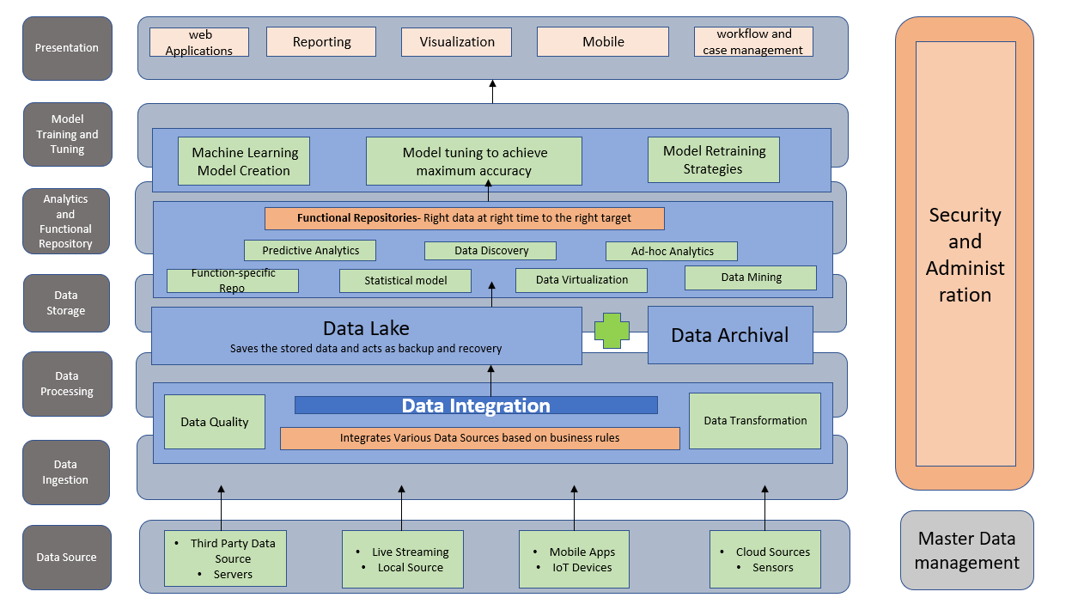

  - Technical Stack
