Rungta College of Engineering & Technology, Bhilai
Department of Computer Science & Engineering
Project Synopsis – Semester 6
1. Project Title:
Modeling and Mitigation of Lateral Movement in Docker-Based Microservice Architectures
2. Project Type:
Cybersecurity Research and Software Development
3. Project Overview / Abstract:
This project focuses on analyzing, modeling, and mitigating lateral movement attacks within Docker-based microservice architectures. Modern applications increasingly rely on containerized environments and microservices, which improve scalability and deployment flexibility. However, these environments also introduce new security challenges, especially the risk of attackers moving laterally between containers after compromising one service.
The project simulates a Dockerized microservice environment to study attack paths, privilege escalation techniques, and inter-container communication vulnerabilities. Different attack scenarios are modeled to identify weaknesses in network segmentation, container isolation, and access control mechanisms. Mitigation techniques such as least-privilege policies, Docker security hardening, firewall rules, container isolation, monitoring, and intrusion detection are implemented and evaluated.
The primary goal is to enhance the security posture of microservice architectures by reducing attack surfaces and limiting unauthorized movement across services.
4. Problem Statement:
Containerized microservice architectures are widely adopted due to their scalability and efficiency, but they are vulnerable to lateral movement attacks once an attacker gains access to a compromised container. Weak isolation mechanisms, insecure container configurations, exposed APIs, and unrestricted network communication can allow attackers to move between services and gain unauthorized access to sensitive resources.
Existing security implementations often focus only on perimeter defense and fail to adequately address internal lateral movement threats. Therefore, there is a need for a practical framework to model such attacks and implement effective mitigation strategies in Docker-based microservice environments.
5. Objective:
• To study the security challenges in Docker-based microservice architectures.
• To model lateral movement attack scenarios in a containerized environment.
• To analyze vulnerabilities related to inter-container communication and privilege escalation.
• To implement mitigation techniques such as container isolation, network segmentation, and least-privilege access.
• To evaluate the effectiveness of different security controls against lateral movement attacks.
• To create a secure and monitored Docker-based microservice test environment.
6. Methodology:
The project follows a structured methodology:
• Environment Setup:
Creation of a Docker-based microservice architecture with multiple interconnected services.
• Threat Modeling:
Identification and simulation of possible lateral movement attack paths and vulnerabilities.
• Attack Simulation:
Execution of controlled attack scenarios such as container compromise, privilege escalation, and unauthorized access attempts.
• Mitigation Implementation:
Application of Docker security best practices, network policies, access restrictions, firewall configurations, and monitoring tools.
• Evaluation and Analysis:
Assessment of attack success rates before and after mitigation to measure security improvements.

7. Flow Chart / DFD / ER Diagram:
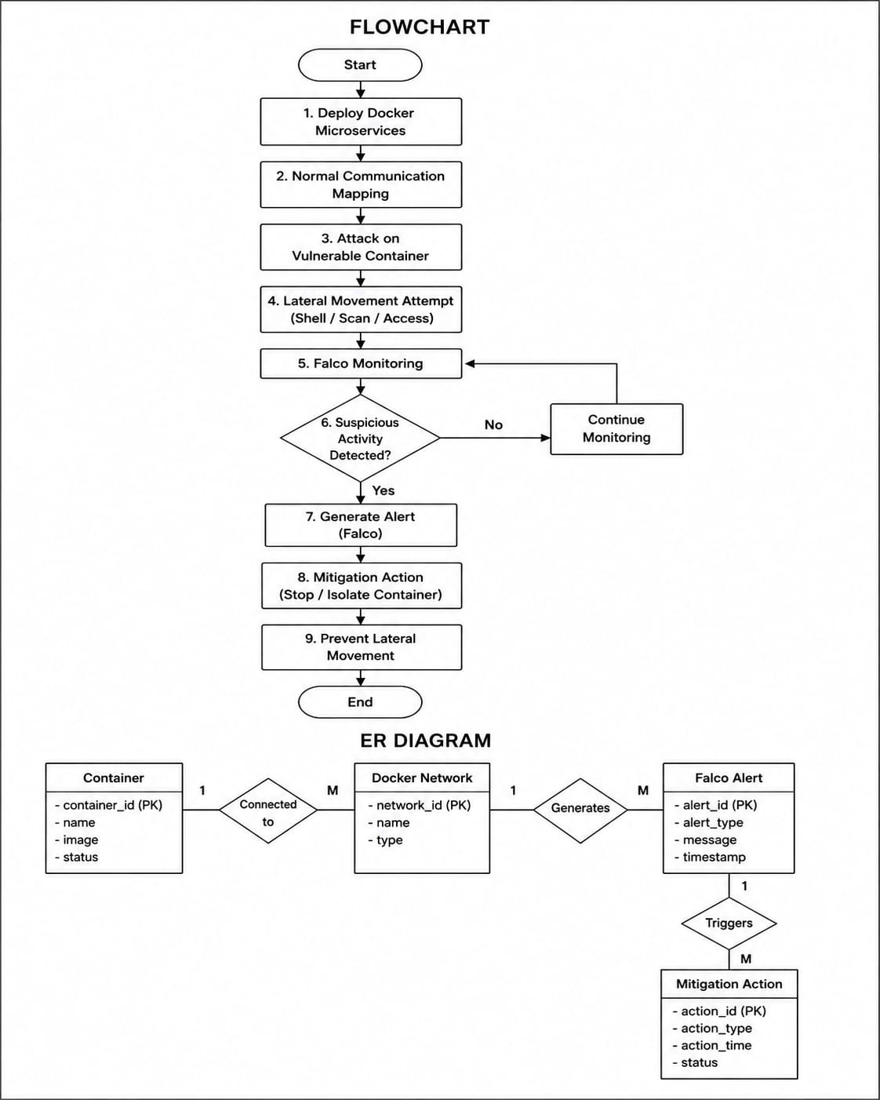

8. Technical Details:
• Platform Type: Docker-based Microservice Security Framework
• Technologies Used:
- Docker & Docker Compose
- Linux Environment
- Python / Bash Scripting
- Network Security Tools
- Logging and Monitoring Utilities
• Core Features:
- Simulation of lateral movement attacks
- Docker container hardening
- Network segmentation and firewall rules
- Real-time monitoring and logging
- Security analysis and mitigation reporting
9. Team Members:
SN | Name of Projectee | Enrollment | Univ.Roll No. | ERP | Contact No.
1 | SUBODH PUN | CD1853 | 301302223171 | 6604306 | 8109869124
2 | BHAVESH VERMA | CD1752 | 301302223052 | 6604319 | 7828699115
Signature of Project Guide:
Prof. Jyoti Singh Kanwar
Signature of Project Coordinator:
Prof. Bhumika Dewangan
Head of Department
Dr. Tripti Sharma

