**Git Account** - https://github.com/subodhsubhedar/

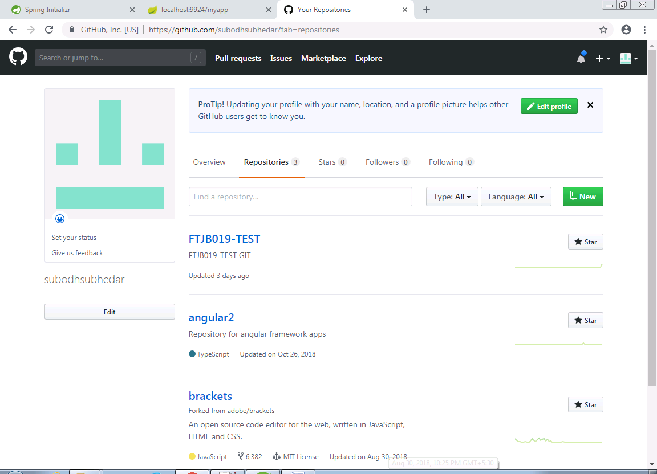

Spring boot sample project - 