#### X-Linux-NFC5



Linux® driver for the ST25R3911B high performance NFC frontends

Data Brief

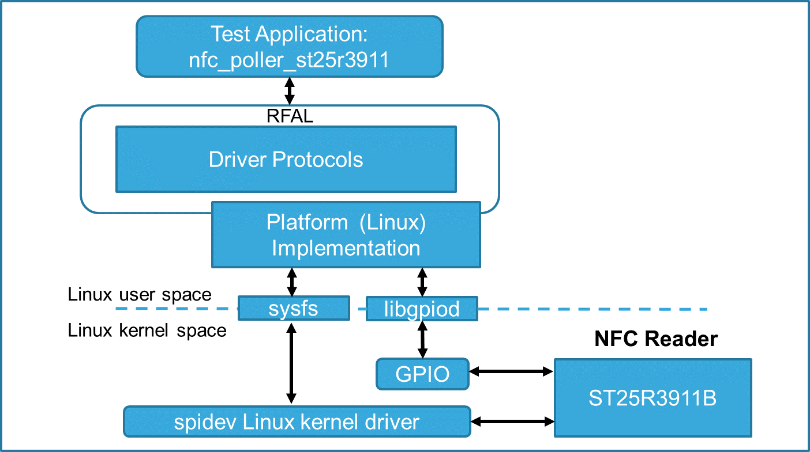

# Features

* Easy portability across different Linux based platforms with compatible hardware interface.
* UID and type of the NFC-Tag is displayed on screen till the tag is paced in vicinity of the NFC antenna of X-NUCLEO-NFC05A1
* Demo application detect NFC Tag types: NFC-A, NFC-B, NFC-V and other types supported by ST’s RFAL

# Description

The software package enables the STM32MP157C-DK2 to operate with the X-NUCLEO-NFC05A1.

This package ports the RF abstraction layer (RFAL) onto a STM32MP157C-DK2 based Linux platform to operate with X-NUCLEO-NFC05A1 which contains the ST25R3911B high-performance NFC frontend IC. The package contains a sample Linux application that detects different types of NFC tags.

The RFAL is the ST standard driver for ST25R NFC/RFID Reader ICs ST25R3911B, ST25R3912, ST25R3913, ST25R3914 and ST25R3915. This software package supports all the ST25R3911B lower-layer protocols and also some higher layer protocols to abstract RF communication.



**Revision History**

|  |  |  |
| --- | --- | --- |
| **Date** | **Version** | **Changes** |
| 01-June,2020 | V1.0.0 | Initial Release |

**IMPORTANT NOTICE – PLEASE READ CAREFULLY**

STMicroelectronics NV and its subsidiaries (“ST”) reserve the right to make changes, corrections, enhancements, modifications, and

improvements to ST products and/or to this document at any time without notice. Purchasers should obtain the latest relevant information on ST products before placing orders. ST products are sold pursuant to ST’s terms and conditions of sale in place at the time of order

acknowledgement.

Purchasers are solely responsible for the choice, selection, and use of ST products and ST assumes no liability for application assistance or the

design of Purchasers’ products.

No license, express or implied, to any intellectual property right is granted by ST herein.

Resale of ST products with provisions different from the information set forth herein shall void any warranty granted by ST for such product.

ST and the ST logo are trademarks of ST. All other product or service names are the property of their respective owners.

Information in this document supersedes and replaces information previously supplied in any prior versions of this document.

© 2018 STMicroelectronics – All rights reserved