DDT Training Day
DDT Hands on at SC11

Reading Materials and Exercises



Session 0 – Getting Started
DDT will have been configured to work with your system already. Your tutor today will tell you what to do to get DDT started, if you do not already know.
The examples in this course all have a makefile, which should work on most systems.
If your command for MPI source compilation is “mpicc” or “mpif90” then to make an example, use “make” alone.
make
NOTE: if your MPI compilation command is different you will need to set the CC or F90 variables – the following will work on a Cray XT or XE system for example.
make CC=cc
make F90=ftn
Some platforms may require additional flags to enable memory debugging during compilation – notably AIX and the Cray XT systems both use static linking. There is information in the userguide about how to link in memory debugging support on those two systems – other systems do not require you to do anything.

Session 1: Straightforward Crashes
First let's look at debugging crashes – the kinds of crashes or errors that happen repeatedly. These are often segmentation faults or aborts, or even exiting with an error code.
This form of bug is very common – and very easy to fix with a debugger, but much harder without one!
We'll all walk through one case using the cstartmpi example together. This is a messy, confusing C program, with some bugs.
Afterwards, there's another crash for you to solve on your own or with your neighbour.

Walkthrough
First we will compile the application cstartmpi. There is a makefile for this in the cstartmpi directory.
cd cstartmpi
make
Run with 4 processes - it's ok
mpirun -np 4 ./cstartmpi.exe
Now try again with some arguments
mpirun -np 4 ./cstartmpi.exe some input arguments
The program will abort as there has been a problem:
rank 0 in job 52 tenku_60773 caused collective abort of all ranks
The next step is to bring this up in DDT and find out what happened. The quickest way to start is to run DDT almost identically to the way you launched MPI.
ddt -start -np 4 ./cstartmpi.exe some input arguments
The DDT GUI will appear - and it will have started your program. You can see the source code, and there is a colour highlighted line. This is the current location that processes are at. Initially all processes are paused after MPI_Init.
At the top of DDT you will see a number of control buttons, a bit like a VCR (or PVR for the modern reader). If you hover the mouse over the control buttons, a tooltip will appear that gives the name of the button.
- Play – make the processes in the current group run until they are stopped.
- Pause – cause the processes in the current group to pause, allowing you to examine them.
- Add Breakpoint – adds a breakpoint at a line of code, or a function, that will cause processes to pause as soon as they reach that location.
- Step Into – will either step the current process group by a single line, or if the line involves a function call, it will step into the function instead.
- Step Over – will step the current process group by a single line.
- Step Out – will run the current process group to the end of their current function, and return to the calling location.
Press play to run the program.
DDT stops with an error message – indicating a segmentation fault.

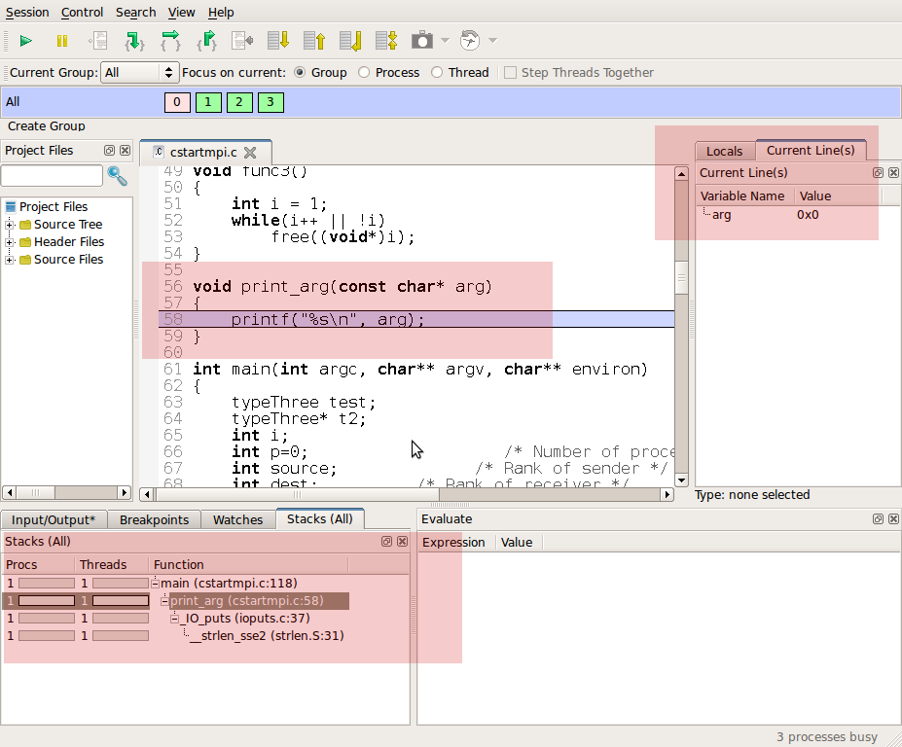Illustration 1: DDT display after dismissing the dialog
The screenshot shows DDT after the dialog has been dismissed – we've colour highlighted the most important parts.
At the bottom of the GUI you can see the Stacks view (you may need to raise the tab by clicking on it to see it). This is tightly connected to the source code, also highlights in the screenshot. and shows where all the paused processes are: all the current function calls – higher points of the tree call the lower branches.
Often just looking at the variables at different points in the stack is enough to tell you why the program crashed.
In this case – you can see arg is the null pointer (0x0) which is invalid for its usage in the printf statement in the code. Hence, the program crashed because print_arg was called with the wrong thing.
Click on the “main” directly above the print_arg function in the Stack View.
This takes you to main which lets you see where that arg value comes from.
Now click on the “Locals” tab (on the right-hand side of the GUI) – you are seeing all the local variables.
Click on the “Current Line” tab to simplify and show only the variables on that line.
Click and drag between lines 113 and 118 in the source code to show all the variables in that region.
You can now see y is clearly incorrect - there aren't that many arguments (argc).
To find why is it wrong, examine the line 117: x is being checked against argc but y is being incremented.
Fix the for loop condition in your favourite editor to read “y < argc” then recompile and re-run - now it works!

Exercise
Our cstartmpi program has another bug: it runs fine for 4 processes, as we've just seen, but at larger numbers it segfaults again.
mpirun -np 5 ./cstartmpi.exe
rank 4 in job 60 tenku_60773 caused collective abort of all ranks
Now it's up to you to find out why – you can join with your neighbour at one computer to run the program with DDT and work out what's going wrong and whether you can fix it!

Hints
- To start debugging with DDT
ddt -start -np 5 ./cstartmpi
- Click 'Play' to run a program
- Use the stack view to see which sequence functions called each other in
- Click and drag to show variables from many lines in the current line view
- Why didn't the loop terminate? Why did it terminate for the other processes?

Session 2: Memory Errors
Memory errors often result in a segmentation fault but can be complex to track down – as a problem will not always be triggered – it depends often on the data set for example. Sometimes they simply cause subtly incorrect results – the worst outcome in a scientific application. Overwriting memory can also cause errors to be reported later in execution, or another problem is freeing memory twice.
DDT comes with built-in memory debugging, which we'll use in a moment.
We'll start with a step-by-step walkthrough.
Then move on to an exercise again.

Session 2: Walkthrough
In this example we will use the trisol code in the trisol directory.
cd trisol
make
Run it:
mpirun -np 4 ./trisol.exe
The application will – most probably – crash, although being a memory error you might be running on a system that does not trigger the problem.
Let's try it in DDT (with memory debugging disabled).
ddt -start -np 4 trisol.exe
DDT will start the code as expected.
Click on 'Play'
Depending on your luck, DDT may or may not be able to run the code through to completion successfully. You may see no error – in which case the code runs to the end, or you may find an error triggered.
This is often the case when a memory error is at work; but fear not, we just need to turn up the dial on DDT's memory debugging.
Let's start again.
Click on the “Session” menu, and select “New Session/Run”.
Before we start the new session, we need to configure the memory debugging settings for this run.
Click on the “Advanced” button on the “run” dialog.
Tick to enable memory debugging, and then click on “Settings”.
There are now some further options to choose from to get the right amount of debugging help. The higher levels use more memory and are slower than the lower levels.
Ensure that the options to “Preload” the memory debugging library, and for Fortran/C are selected.
Choose “High” for the level of checking. Leave “Guard Pages” unchecked.
Click “Ok” to confirm your settings.
We're now ready to debug again.
Click “Run” to start your code.
Click “Play” to run through to the end, or first error.
You should now see a memory error appears.
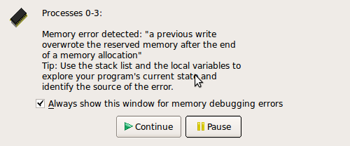Illustration 2: DDT detects something has overwritten a value
DDT explains that at some point, some reserved memory that DDT added beyond your array has been changed unexpectedly,
So, we have an array overflow error, then. But where?
To find out, we need to turn on an advanced feature: Guard Pages. As before let's get the settings ready and restart.
From the Session menu, click New session/Run.
Change the Memory Debugging Settings and enable the Heap Overflow/Underflow detection option. A setting of “1” and “After” is appropriate for this example.
Now run the application as before and click “Play” once it has started.
The Heap overflow/underflow detection adds an extra buffer beyond allocated memory (or before, but not both at the same time!) and then DDT can detect any writes or reads in this zone.
DDT should now detect a memory error – that a process tried to read/write after the end of the array!
Click “Pause”
Now we see the line the problem occurred on.
Click on res in current line.
The type of “res” is shown as size 4095, but we're trying to set element 4096. This didn't cause problems until the MPI_Reduce, but we trapped it at the cause with Allinea DDT.

Session 2: Exercise
Fix the bug in trisol around line 27 of check.f90 as follows:
DO k = 1, block_size
res(k) = k
END DO

Run the program – it may seems to work and print out “Solution correct”, but there is actually still a particularly subtle memory bug still present.
Now run again in DDT, with the same memory settings as before: what happens? DDT reports there is a read after the end of the array in matnrm.f line 30.

Hint
Examine variables k and then j2, can you solve the problem?

Session 3: Deadlock in MPI
Early versions of MPI programs often get into deadlock – things such as each process waiting for another, communicators are not matched up or tags not matched. In some cases, livelock happens too – where processes are communicating but not proceeding in any useful way.
DDT can inspect the message queues to show which processes are waiting and why, in addition, simply pausing processes is a good way of finding where processes are.
We'll start with a step-by-step walkthrough and then move on to an exercise again!

Walkthrough
First we will build the cpi example.
cd cpi
make
Run it with 4 processes
mpirun -np 4 ./cpi
It works fine
. . . .
pi is approximately 3.1416009869231249, Error is 0.0000083333333318
wall clock time = 1.268749
Now we run with 10 processes and it also works fine.
mpirun -np 10 ./cpi
The next test is to try 8 processes.
mpirun -np 8 ./cpi
It locks up!
Process 7 on localhost
Process 5 on localhost
Process 6 on localhost
Process 3 on localhost
Process 2 on localhost
Process 0 on localhost
Process 1 on localhost
Process 4 on localhost
Press ctrl-c to abort, and let's try it under DDT.
ddt -start -np 8 ./cpi
When DDT returns with your code begin running the program
Press the play button.
After a while, the program has still not terminated – but the debugger has still not helped yet.
Press the pause button.
Examine the source code view and the stacks view. Both are showing that half of the processes are at one location and half at another. Half are in an MPI_Barrier and the other half are in MPI_Bcast.
The next challenge is to find out why this has happened.
Let's look at the loop with the barrier. Did every process execute it the same number of times?
Open the View Menu, and select the Cross Process Comparison tool.
Ask DDT to evaluate “i <= n ” in this dialog.
Sure enough, the “barrier” processes are still trying to loop and the rest have already exited.
How many times should each process execute this loop?
Use the Cross Process Comparison to evaluate (n - (myid + 1))/numprocs
We see that processes 0-3 execute the loop one extra time. Possible solutions are to move the Barrier out of the loop to a place where it's executed the same number of times by every process, or to modify the loop to make sure all processes execute it the same number of times

Exercise
Let's look at a new program that also deadlocks. Compile and run the Loop example.
cd Loop
make
mpiexec -np 8 ./loop
It's supposed to pass a message around the loop, but it never finishes!
Kill it and debug it with DDT – try to find what the problem is.

Hints
- A small job is ample to find the cause
ddt -start -np 8 ./loop
- Try using the message queue window (a red arrow is a send that the other end isn't receiving) - “View/Message Queues”
- Investigate the odd process out; what should it have done?
- Think of the example as passing a token around a loop 'max' times. Where does the token start? Where does it stop? What should happen to it at the end?
- Look at the “received” variable in Cross Process Comparison tool, which is the number of times the token has been received.
For an example of MPI ambiguity, replace the BUFSIZE definition with a smaller quantity (~100 instead of 1024x1024) – on most MPIs an MPI_Send of small volumes of data is completed asynchronously! This means the code would terminate successfully, even though we know there is a bug, for smaller message payloads.

