**P2: Installation and configure Google App Engine:**

* Search Google Cloud Platform in a any search engine.
* Click on Console:



* This window opens:

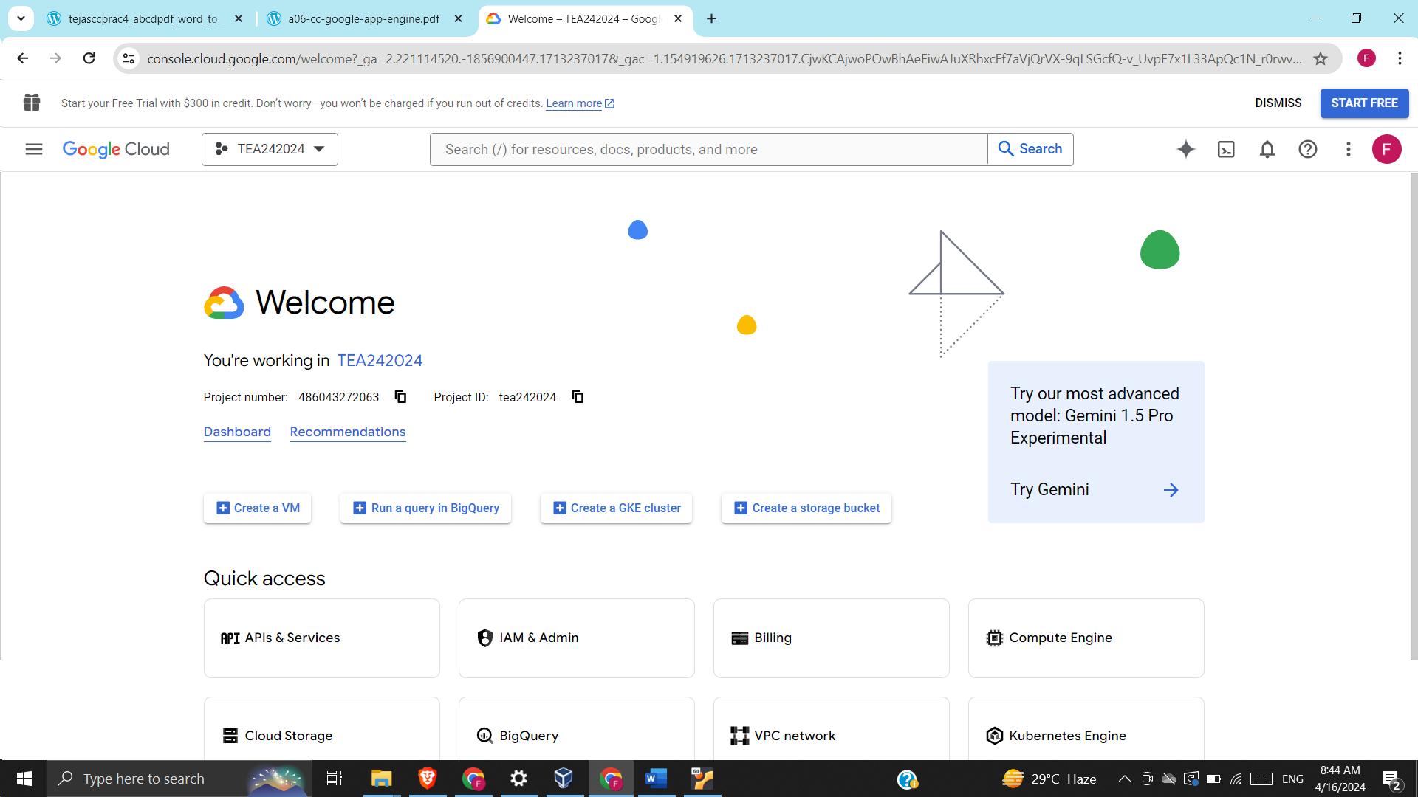

* Click on this:



* This window opens:

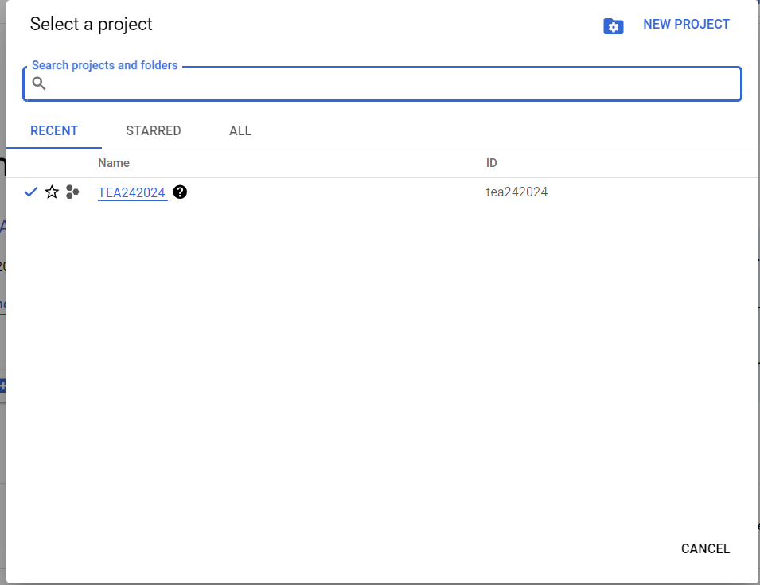

* Click on New Project
* Give project name and click on Create:

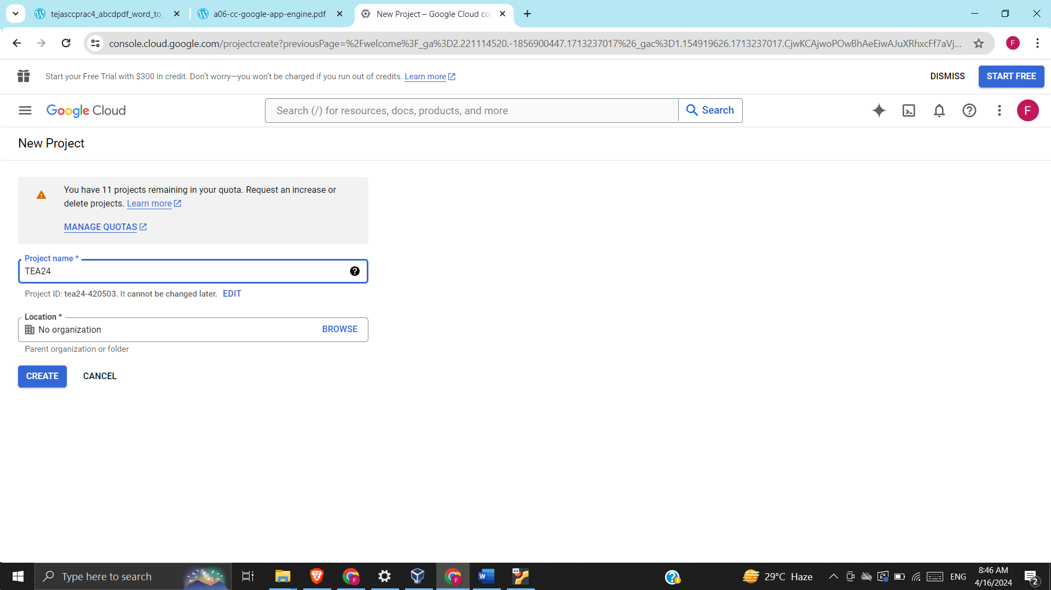

* This notification starts:

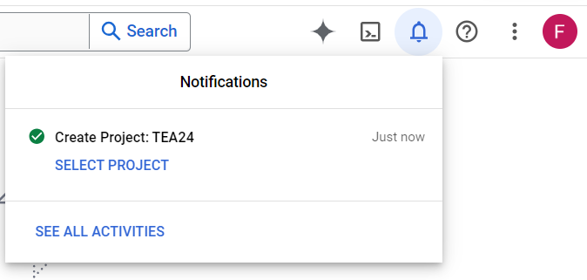

* Click on Select Project
* In the search bar, type App Engine:

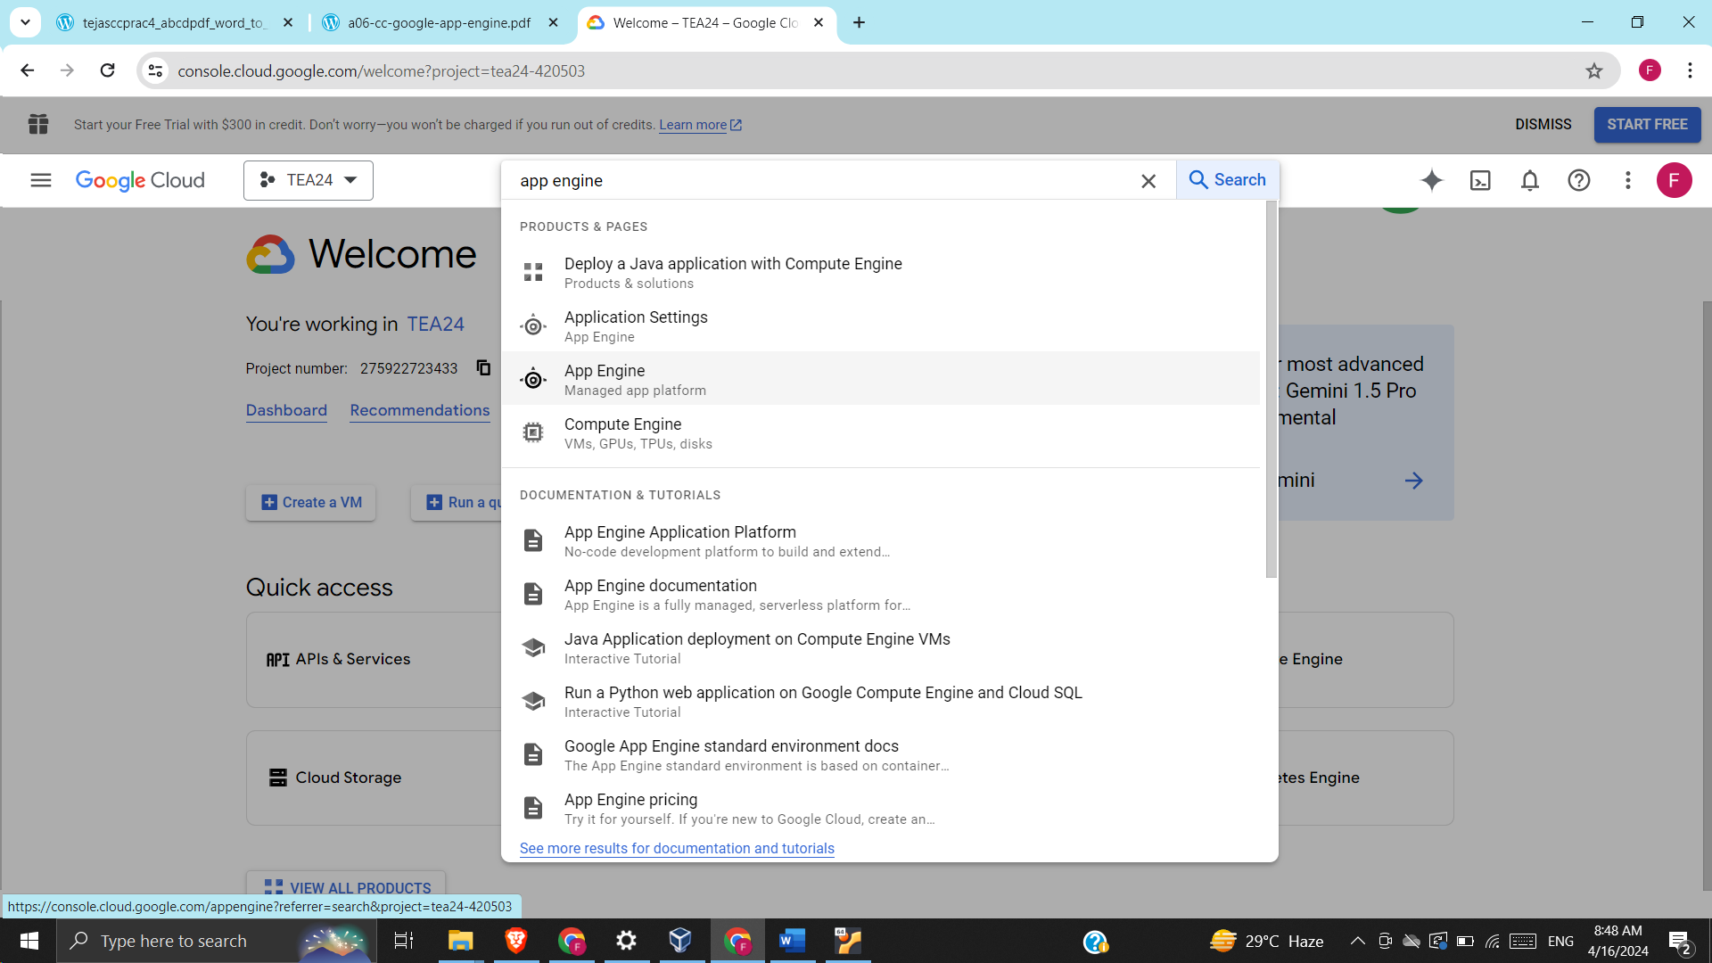

* Click on Create Application:

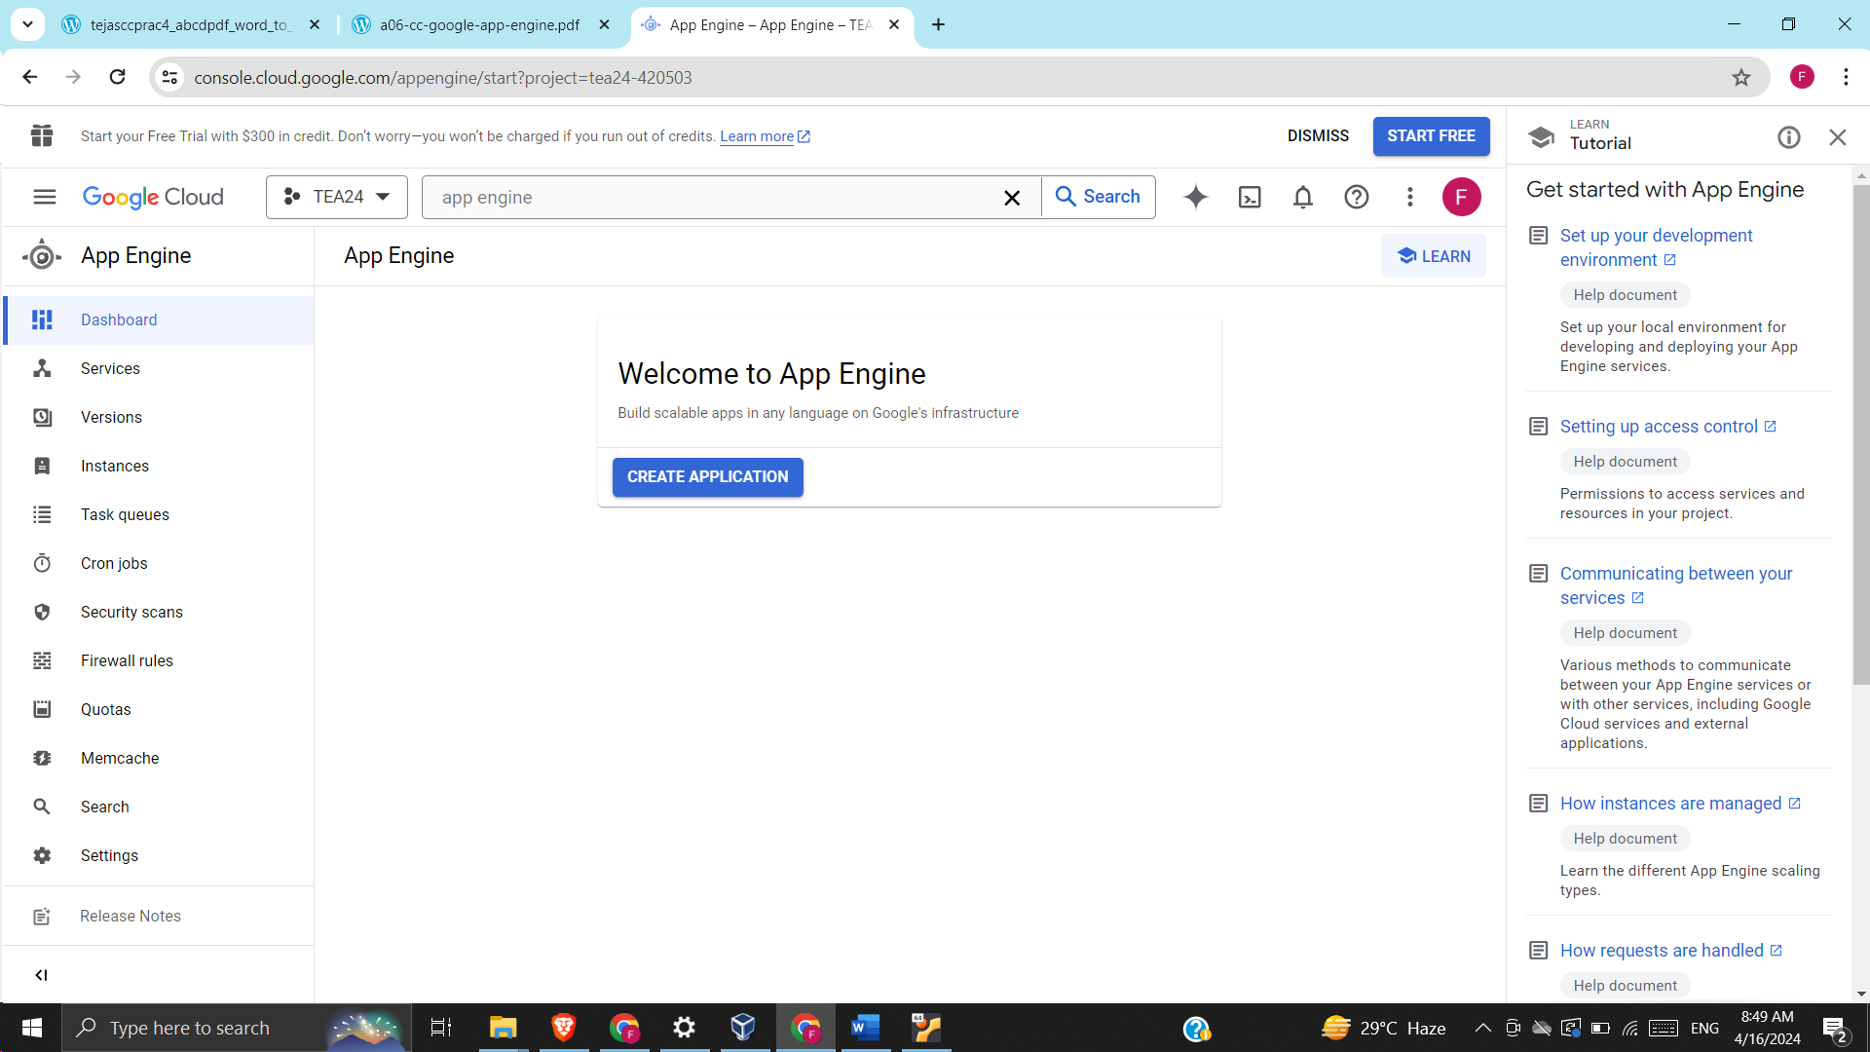

* This window opens:

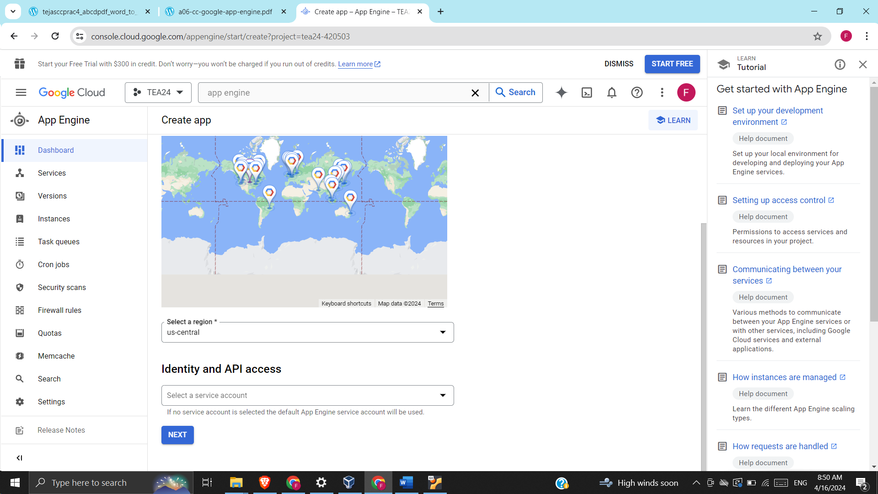

* Click Next
* This error appears:

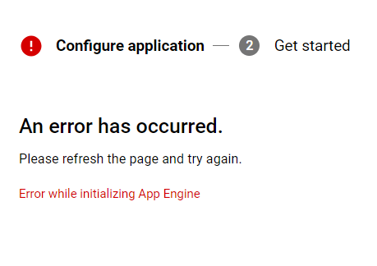

* Now, in the search bar, type App Engine Admin API:

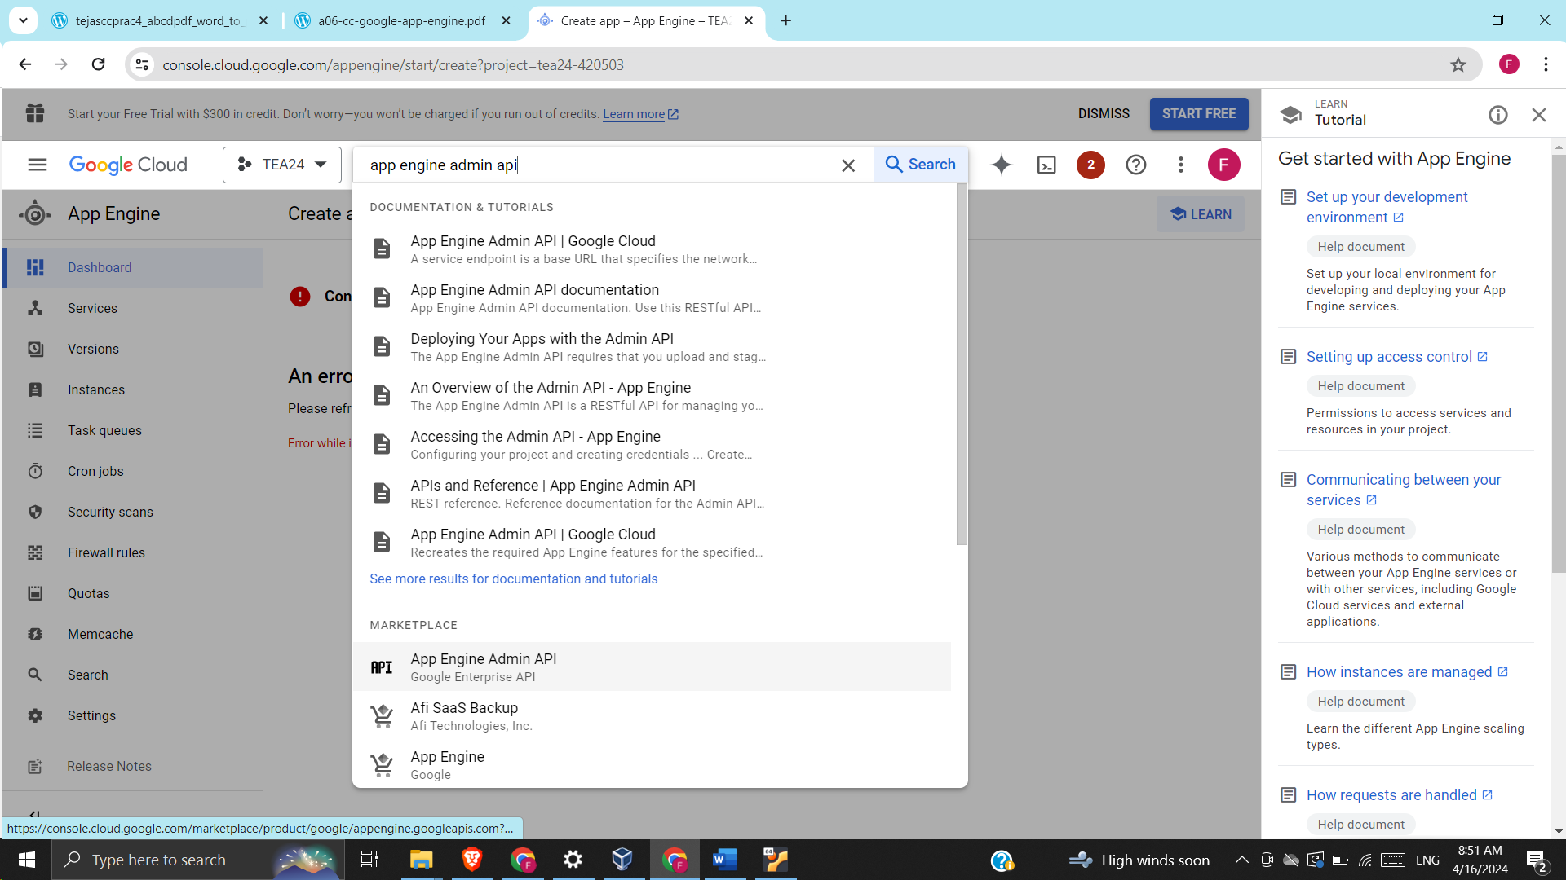

* Click Enable:

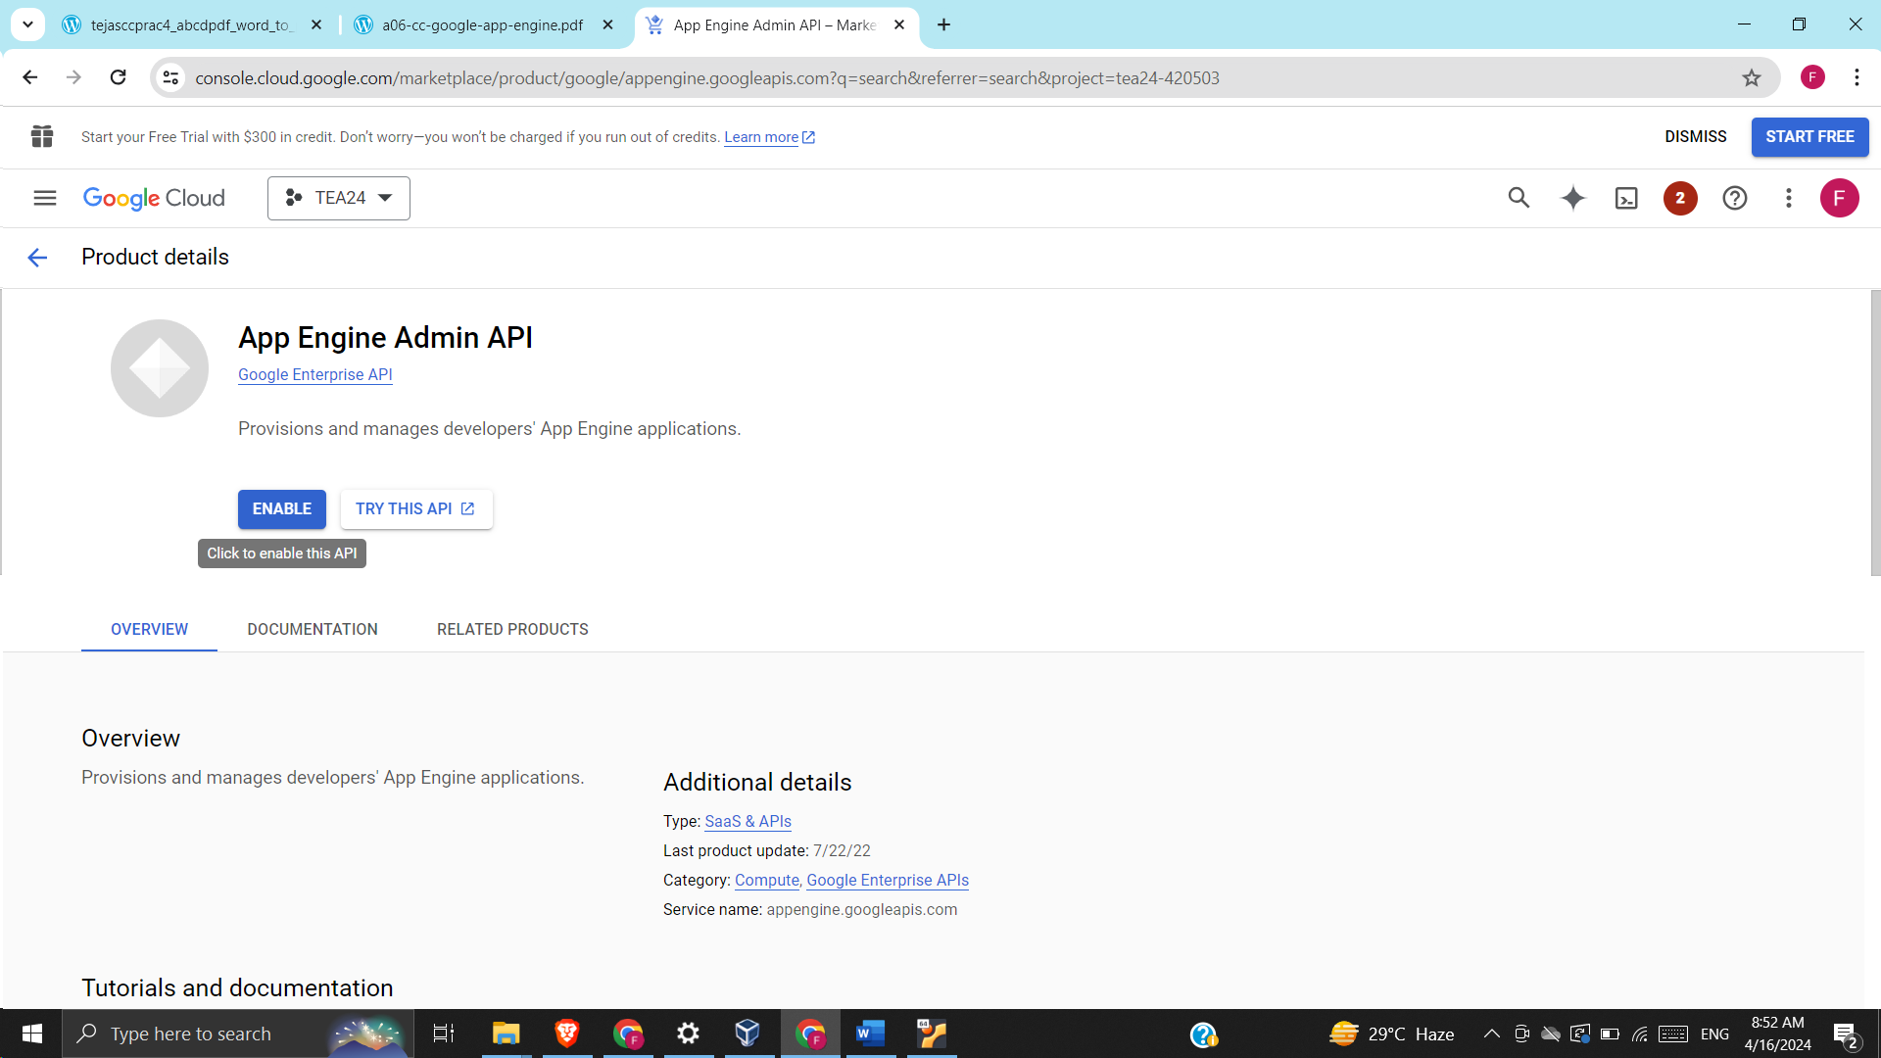

* This window appears:

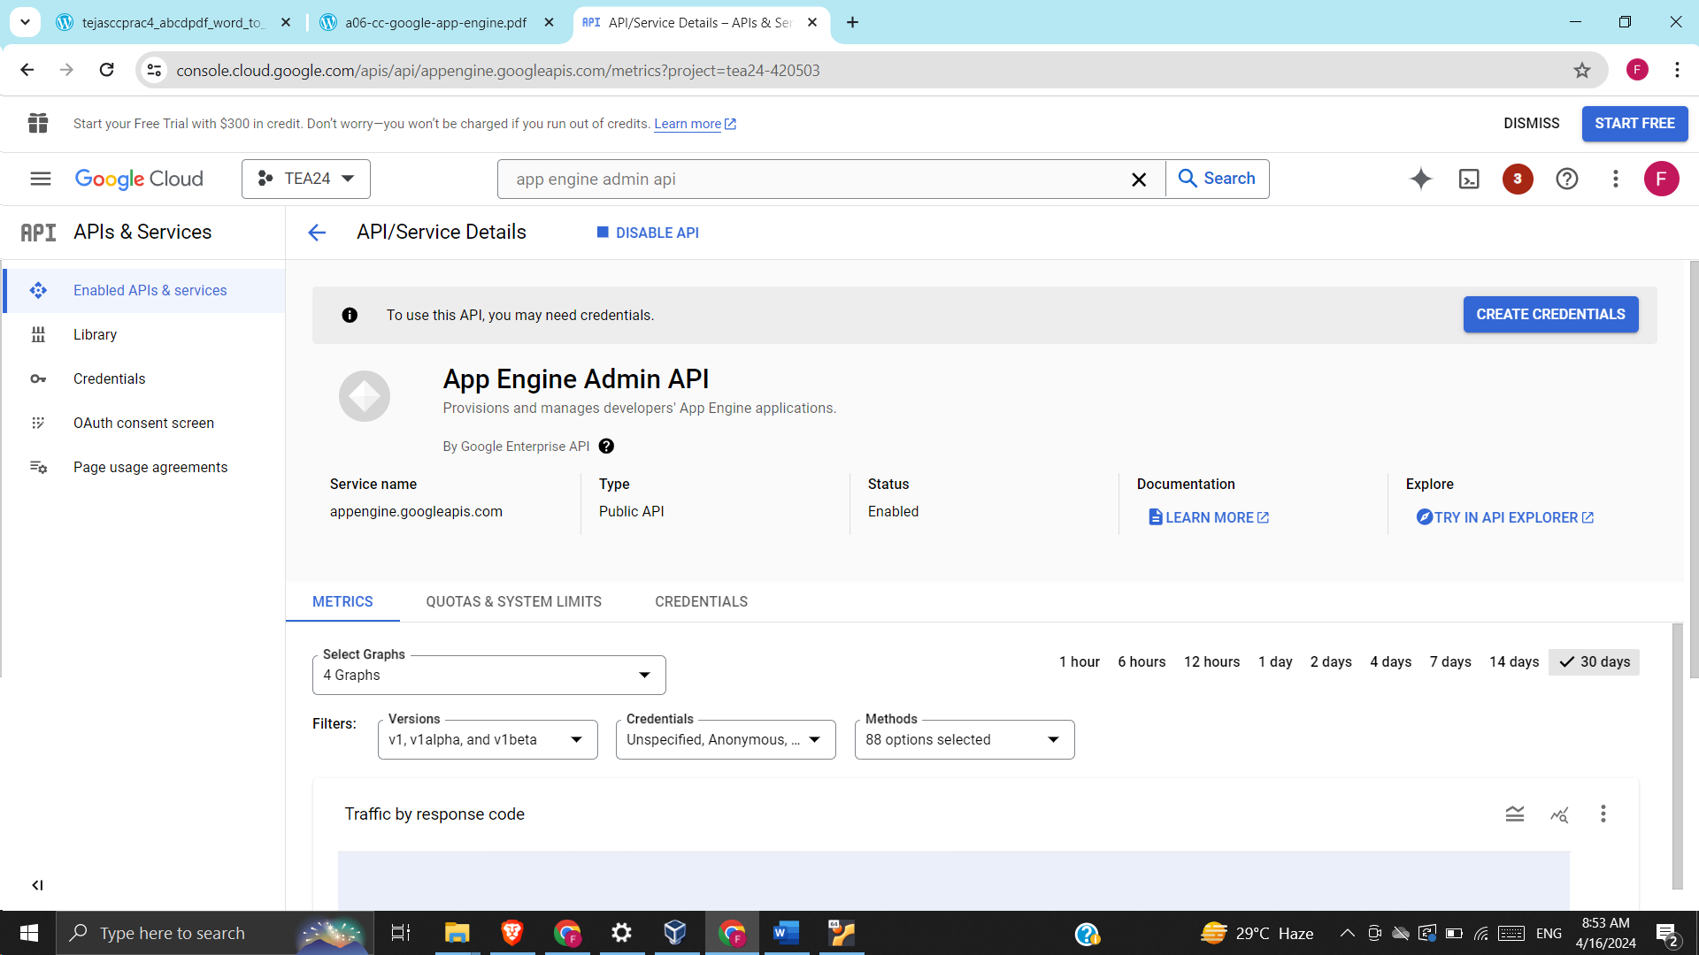

* Click Activate Cloud Shell:

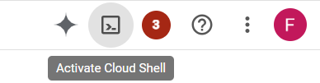

* This will appear:

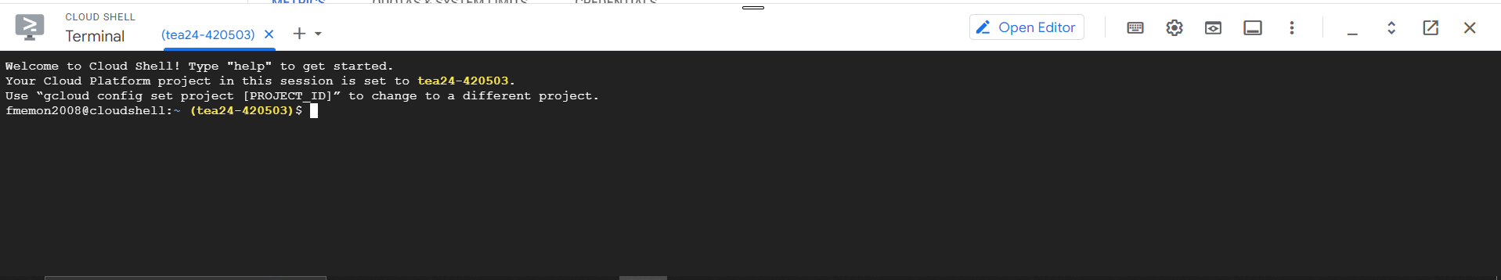

* Login to Github and create a new repository:

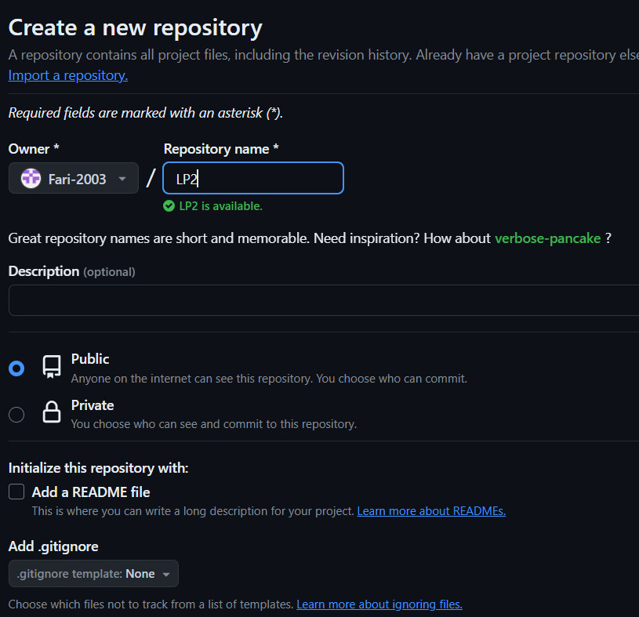

* Create a new file and enter python code. Give a file name (with .py extension). Click on commit changes.

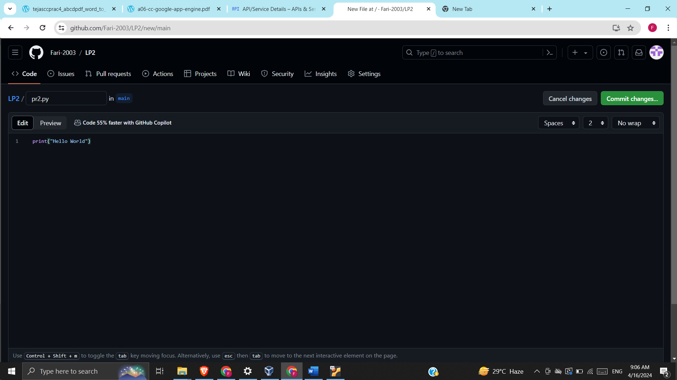

* Click on Code and copy URL:

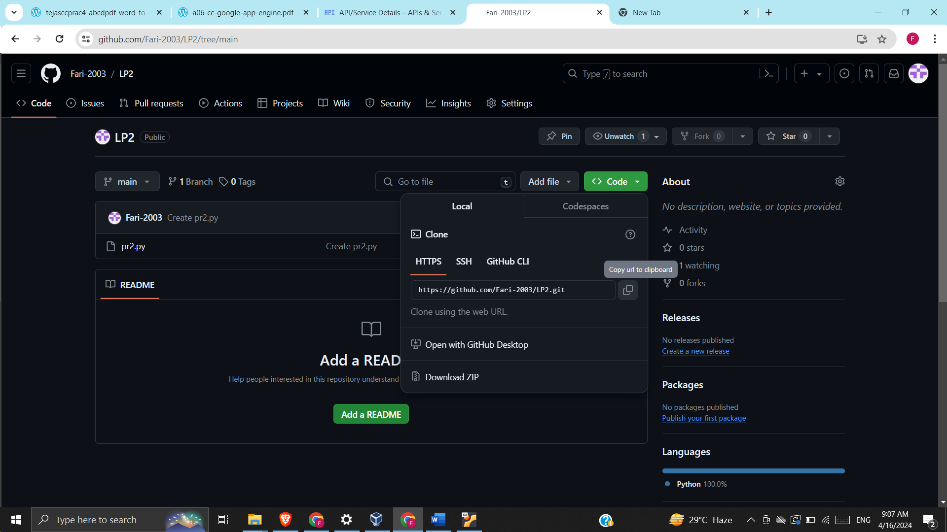

* Go back to google app engine and type the following:

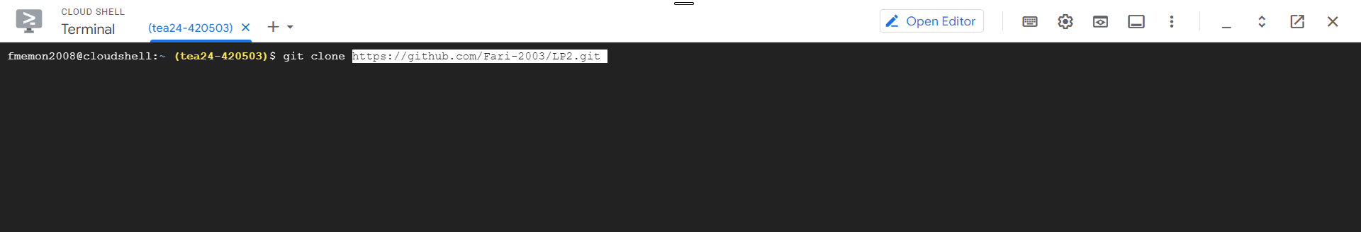

* Now, type ls to showcase all the directories:

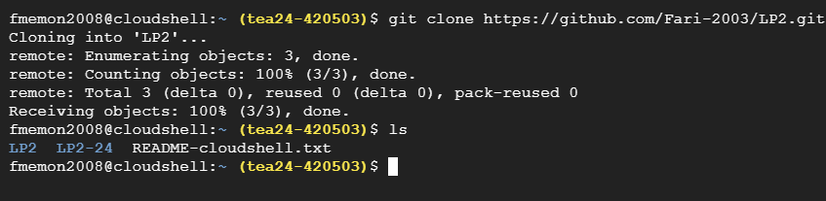

* Type cd LP2 (repository name). Type ls to view the files and then type python file_name to execute it.

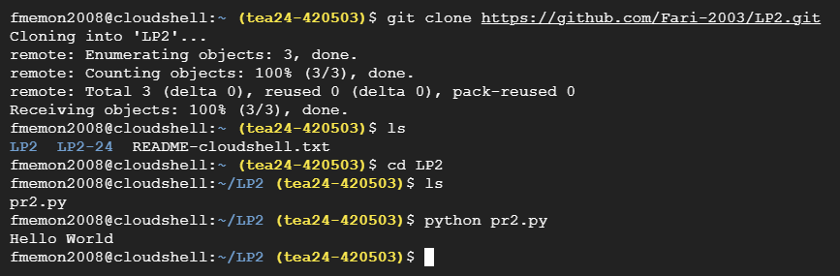

**P3: Creating an Application in SalesForce.com using Apex programming Language:**

* Create new salesforce account on: <https://developer.salesforce.com/signup>
* You will get a verification mail
* Click on verify
* Set a password
* Log-in at: https://login.salesforce.com/

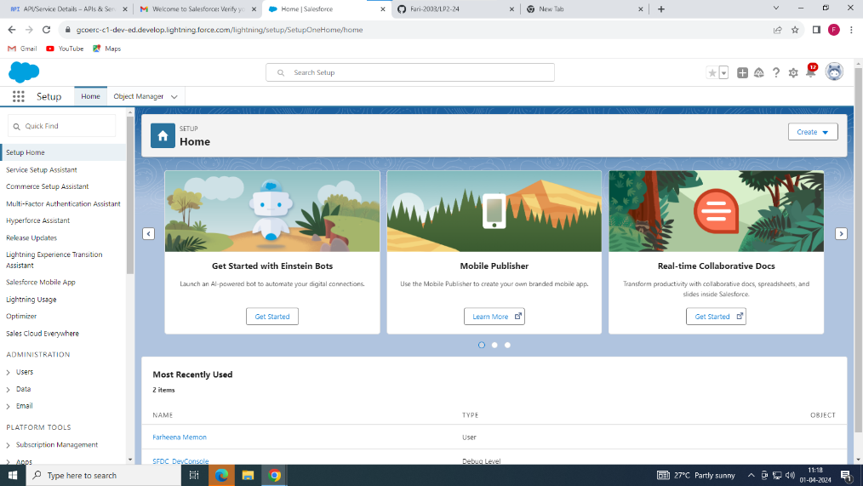

* This window opens
* Choose the settings button on this side:



* Choose developer console:

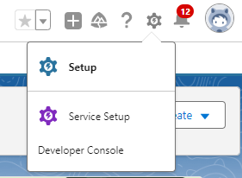

* This window will open:

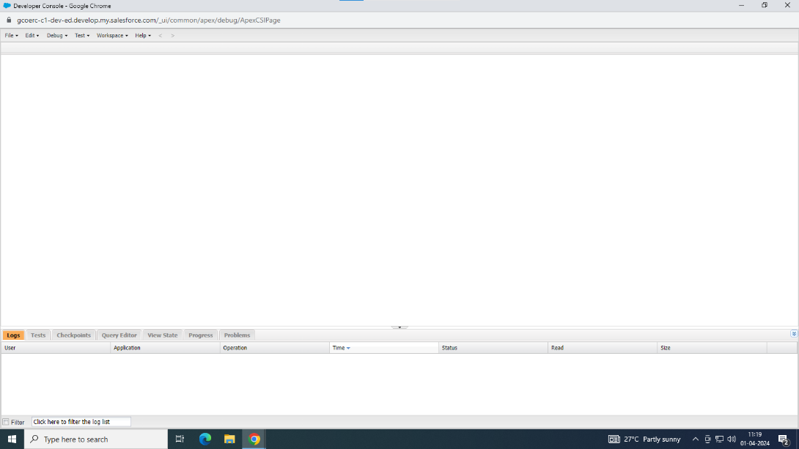

* Go to File->New->Apex Class
* Set a program name
* Type the program and save it:

public class lp2_3_2 {

    public static void Add()

    {

        Integer a = 4, b = 5;

     Integer c;

     Double d, e;

      c = a + b;

        d = 4.5 + 9.2;

        e = a + b;

        System.debug('Add 4 and 5: ' + c);

        System.debug('Add 4.5 and 9.2: ' + d);

        System.debug('Add 4 and 5: ' + e);

    }

    public static void Sub()

    {

        Integer a = 4, b = 5;

     Integer c;

     Double d, e;

      c = a - b;

        d = 4.5 - 9.2;

        e = a - b;

        System.debug('Sub 4 and 5: ' + c);

        System.debug('Sub 4.5 and 9.2: ' + d);

        System.debug('Sub 4 and 5: ' + e);

    }

    public static void Mul()

    {

        Integer a = 4, b = 5;

     Integer c;

     Double d, e;

      c = a * b;

        d = 4.5 * 9.2;

        e = a * b;

        System.debug('Mul 4 and 5: ' + c);

        System.debug('Mul 4.5 and 9.2: ' + d);

        System.debug('Mul 4 and 5: ' + e);

    }

    public static void Div()

    {

        Integer a = 4, b = 5;

     Integer c;

     Double d, e;

      c = a / b;

        d = 4.5 / 9.2;

        e = a / b;

        System.debug('Div 4 and 5: ' + c);

        System.debug('Div 4.5 and 9.2: ' + d);

        System.debug('Div 4 and 5: ' + e);

    }

}

* Go to Debug->Open Exeute Ananymous Window:

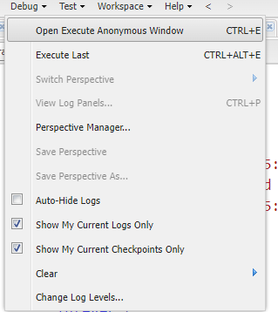

* Write name of functions:

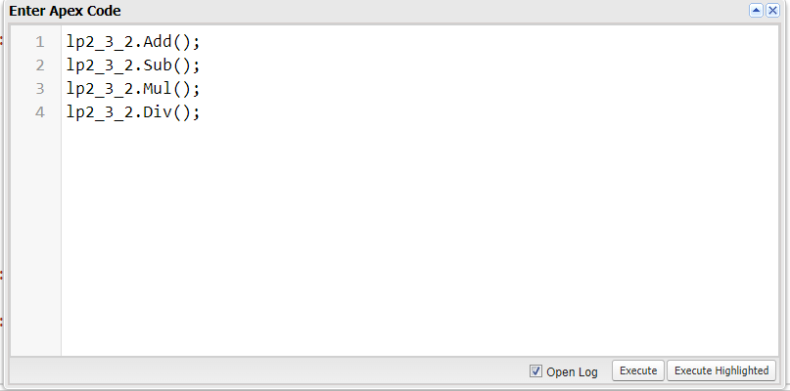

* Select Open Log and click Execute
* This window will open:

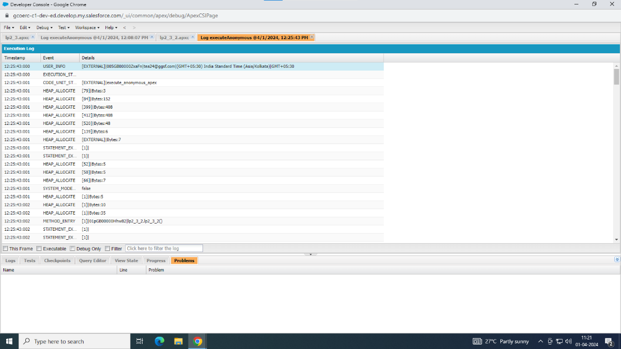

* Choose debug only:



* The output opens:

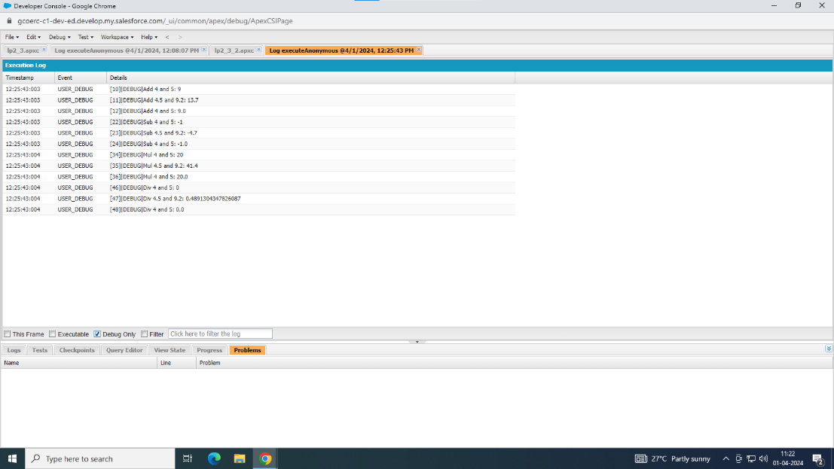

**P4: Design and develop custom Application (Mini Project) using Salesforce Cloud:**

* Login in to salesforce account.
* This window opens:

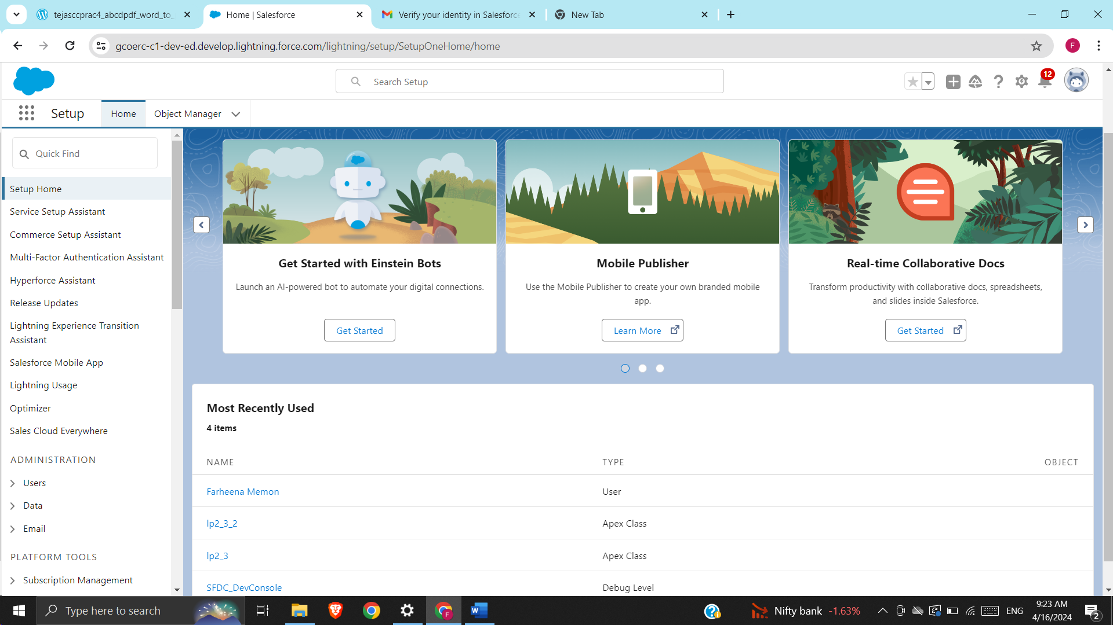

* Go to Apps->App Manager->

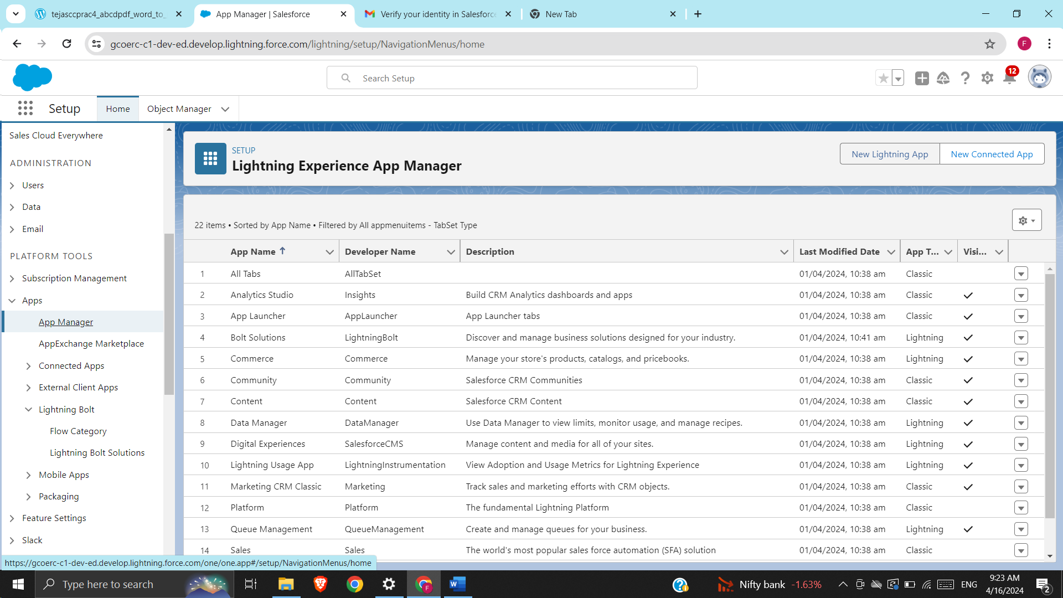

* Select New Lighting App
* Enter the details and click Next:

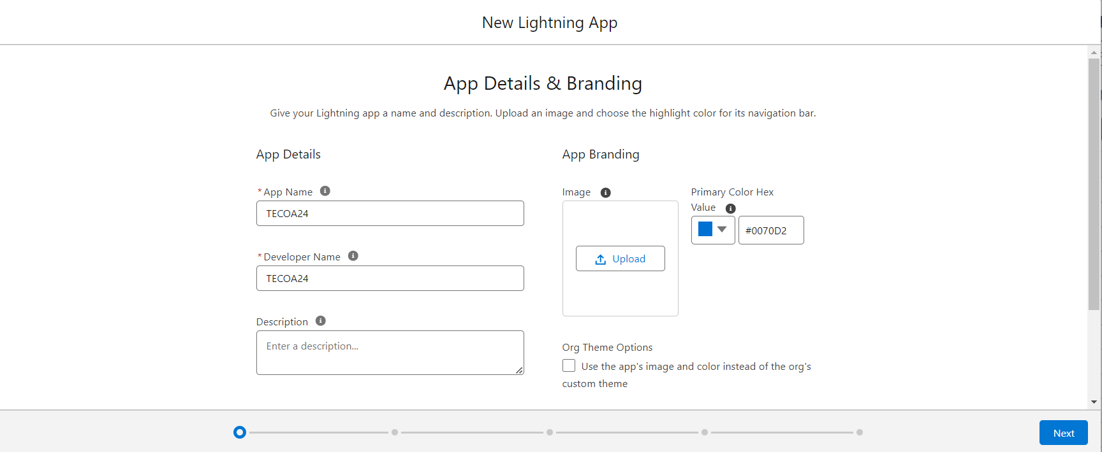

* Click Next on App and Utility Options.
* Choose the Navigation Items needed and click Next:

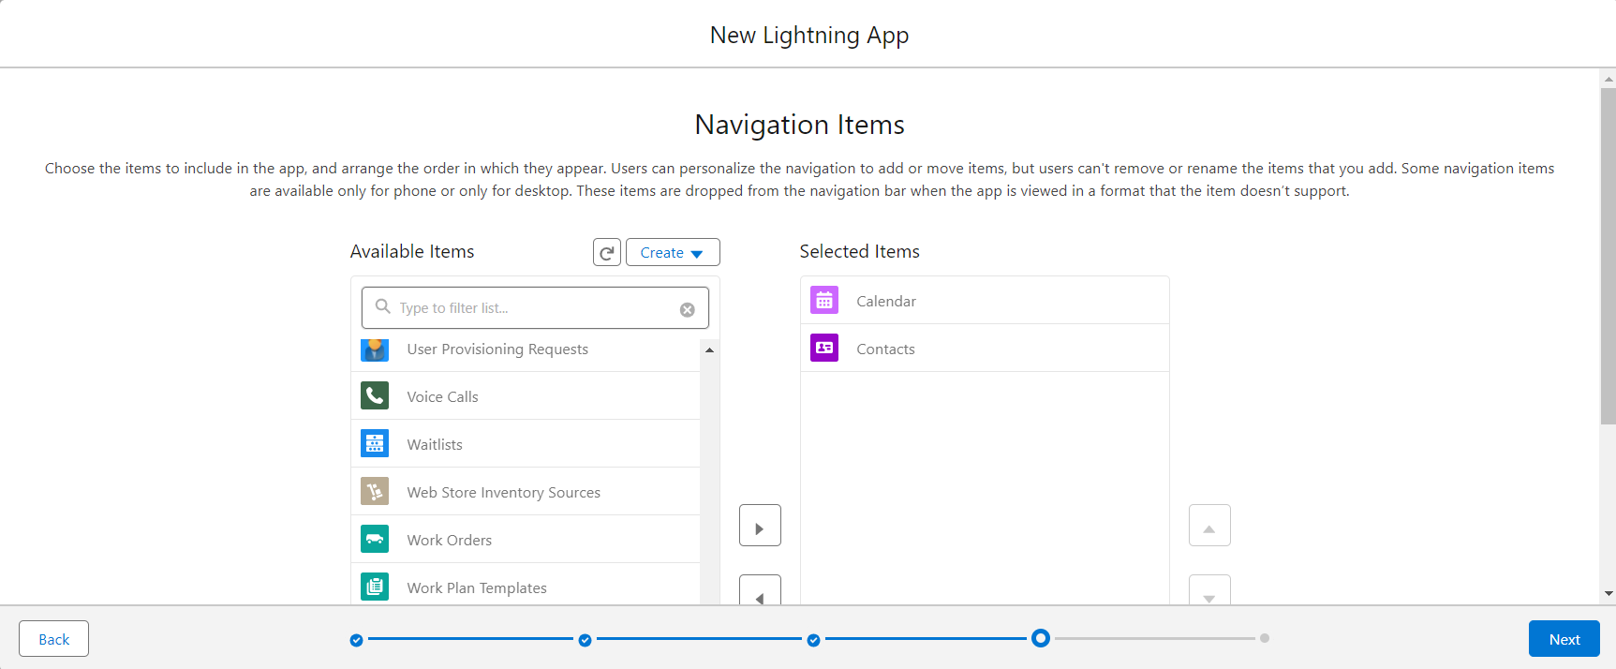

* Choose the user profiles that can access the app:

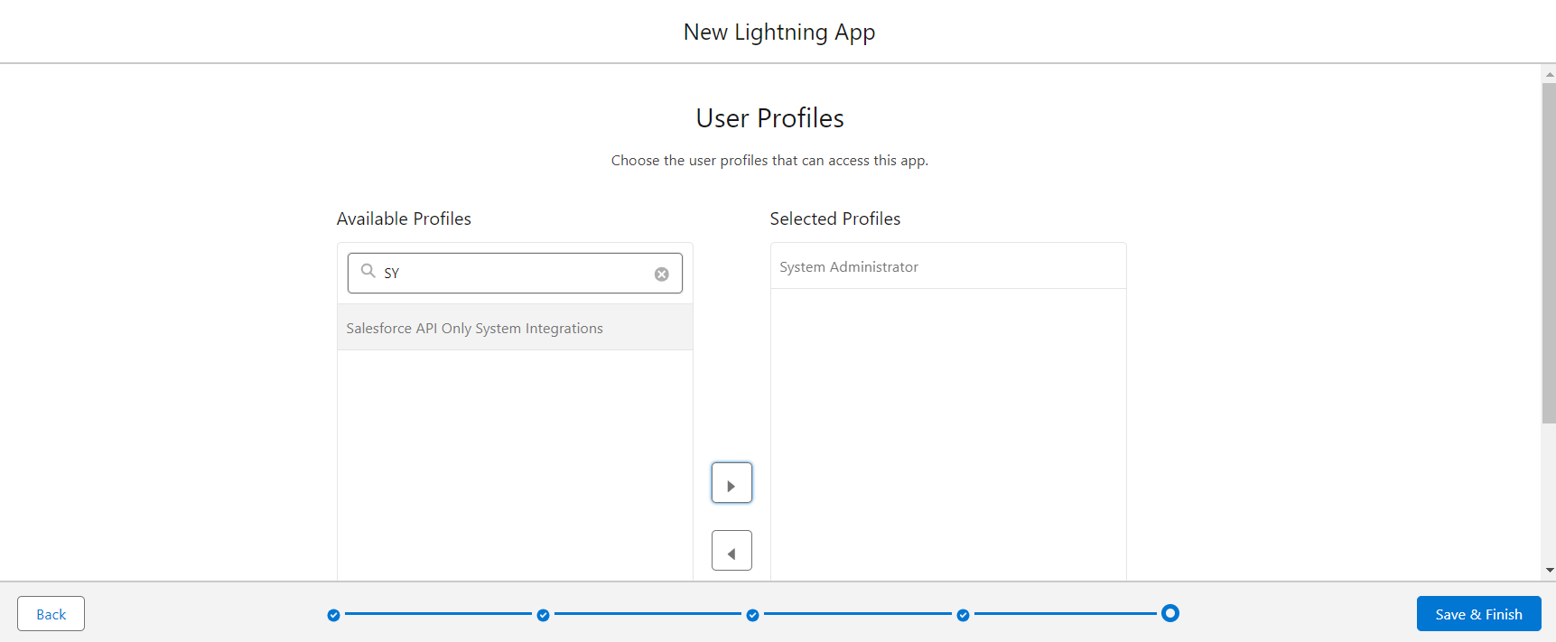

* Search by application name in App Launcher:

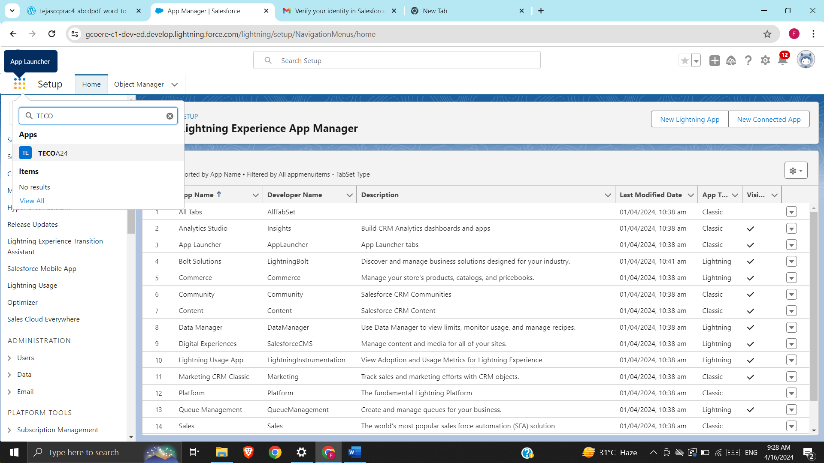

* Click on the app and it will open:

