

Department of Computer Science & Engineering

SOUTHEAST UNIVERSITY

CSE4000: Research Methodology

On

A Corporate File Management System

*A dissertation submitted to the Southeast University in partial fulfillment of the requirements for the degree of B. Sc. in Computer Science & Engineering*

## Submitted by

Tamanna Sikder Bristy ID: 2015000000126

Mohammad Shohel ID: 2015000000045

Amena Akter ID: 2015100000027

## Supervised by

Md. A. M. Reza Khan Lecturer

Department of CSE Southeast University

Copyright c Year 2020 January, 2020

*§*

## Letter of Transmittal

January 20, 2020 The Chairman,

Department of Computer Science & Engineering, Southeast University,

Banani, Dhaka.

Through: Supervisor, Md. A. M. Reza Khan

Subject: Submission of CSE4000 Research Report

Dear Sir,

With due respect, we are submitting our research report on **A Corporate File Management System**. It was a great pleasure and experience for us to work on this effective and useful topic. The research work has been accomplished as per the requirement of the Southeast University and following your instruction.

So, we try our level best to complete our project. We have given our best effort to complete the research. We are requesting for your kind approval this report. Hope you will appreciate our hard work and excuse the minor error.

Thank you.

Sincerely yours, Supervisor:

Tamanna Sikder Bristy

ID: 2015000000126

Mohammad Shohel

ID:2015000000045

Amena Akter

ID: 2015100000027

Md. A. M. Reza Khan

Lecturer Department of CSE Southeast University

## Certificate

This is to certify that the research report **A Corporate File Management System** is the record of research work done by Mohammad Shohel, Amena Akter, Tamanna Sikder Bristy for the partial fulfillment of the requirements for B.Sc. in Computer Science Engineering (CSE) from Southeast University

This paper was carried out under my supervision and is record of the work carried out successfully.

### Author: Approved by the Supervisor:

Tamanna Sikder Bristy

ID: 2015000000126

Mohammad Shohel

ID: 2015000000045

Amena Akter

ID: 2015100000027

Md. A. M. Reza Khan

Lecturer

Department of CSE

Southeast University

The major part of the research covers the development of a project is **A Corporate File Management System** for workspace any corporate business in Bangladesh using different languages, tools and MySQL database has been used to achieve the goal. Language like: HTML, CSS, JavaScript, Bootstrap, PHP, MySQL(Database), Xampp Serve. The main backbone of the project was PHP language. The Corporate File Management System module contains section are admin, user, file upload, file view, file download. Firstly all user are registration, then every user are login there username and password. If a user are used invalid username and password he or she can’t access next page. Valid register user will can successfully login then the user see upload page. He will upload file (jpeg, jpg, png, gif, doc, xls, pdf, ppt). After successfully upload file store in view page, user see this file in view page and download the file. User complete use in file management system if no need in this time he will can logout.

This research report will describe the activities-objectives-challenges acquired knowledge of ours. At the end of the report, we mention some key differences about the distances between the academic course work and the professional life assignments which said that most of the students faces difficulty when they enter into the job sector after finishing the academic course.

First of all we would like to express our deepest gratitude to Almighty Allah for helping us and making us able to complete our research work successfully. We want to give specially thanks to our honorable Supervisor Md. A. M. Reza Khan, Lecturer, Department of CSE, Southeast University for giving us the idea for making our research work successful and for guiding us with a lot of patience and encouragement as wel.

We would also like to thank all of my friends for their valuable suggestions and comments. Last but not the least, we would like to thank our parents who always give us mental support an encouragement. And finally, we are really grateful having such a great group member for the stimulating discussions, passing sleepless nights together for completing this project before deadline and all the moments. For all these supports and encouragement, we are able to complete this report within deadline.

|  |  |  |  |
| --- | --- | --- | --- |
| **Executive Summary**  **Acknowledgements**  **1 Introduction** | |  | **I**  **ii 1** |
| 1.1 Motivation | | . . . . . . . . . . . . . . . . . . . . . . . . . . . . | 3 |
| 1.2 | Objective  . . . . . . . . . . . . . . . . . . . . . . . . . . | | 4 |
| **2 File** | **Management System** | | **5** |
| 2.1 | Definition of file management system . . . . . . . . . . . . . . . . . . . . . | | 5 |
| 2.2 | File System . . . . . . . . . . . . . . . . . . . . . . . . . . . . . . . . . . . | | 6 |
| 2.3 | Distributed file system . . . . . . . . . . . . . . . . . . . . . . . . . . . . . | | 7 |
| 2.4 | File Management Functions . . . . . . . . . . . . . . . . . . . . . . . . . . | | 8 |
| 2.5 | Importance of file management system . . . . . . . . . . . . . . . . . . . . | | 8 |
| **3 The** | **Proposed Design of File Management System** | | **10** |
| 3.1 | HTML . . . . . . . . . . . . . . . . . . . . . . . . . . . . . . . . . . . . . . | | 10 |
| 3.2 | CSS . . . . . . . . . . . . . . . . . . . . . . . . . . . . . . . . . . . . . . . | | 11 |
| 3.3 | JavaScript . . . . . . . . . . . . . . . . . . . . . . . . . . . . . . . . . . . . | | 11 |
| 3.4 | Bootstrap . . . . . . . . . . . . . . . . . . . . . . . . . . . . . . . . . . . . | | 11 |
| 3.5 | PHP . . . . . . . . . . . . . . . . . . . . . . . . . . . . . . . . . . . . . . . | | 12 |
| 3.6 | MySQL . . . . . . . . . . . . . . . . . . . . . . . . . . . . . . . . . . . . . | | 13 |
| 3.7 | Activity Diagram . . . . . . . . . . . . . . . . . . . . . . . . . . . . . . . . | | 13 |
| 3.8 | The Proposed Architecture . . . . . . . . . . . . . . . . . . . . . . . . . . . | | 14 |

1. Working procedure in file management system 14
   1. Implementing User Authentication Mechanism 14

CONTENTS

* 1. Creating the Database 15
  2. Connecting to MySQL server 16
  3. Admin Dashboard 16
  4. Login view 17
  5. Create Role Base New User 18
  6. Edit or Delete and See all users 19
  7. View all file 19
  8. Employee user home page with file upload view 20
  9. Report Box 21

1. Security of corporate file management system 23
2. Conclusion 25

References 27

# Chapter 1 Introduction

When every business organization are focusing on to giving the best customer experience they could offer with the limited resources, to meet those requirement Data mining, Data Science, Machine learning and AI are playing big role. This modern technologies can analysis customer behavior and can give the prediction of customer future activities and also can give the recommendation for the companies betterment which help benefits the organization the most now a days to sustain in the market. To be benefited by this technologies it require huge amount of relevant data. This is where a corporate file management system idea came in.

The organizations who have its file management system they always have all data they require in their database no matter what kind of data and how old data you need.

Its helps organizations employees time, heastel about maintain data related problem.

For data analysis it will provide big data in no time which is a big required step in data analysis and machine learning to have a relevant data set to analyze and make prediction of future.

File management system gives all employees a séance of comfort as they can store their older or newer official data file on it. Sometimes they need to find old data file immediately. In this case file management system helps to find out that file and download the needy file from the uploaded folder. getting corrupted or lost.

1

Securing information and maintaining data integrity is one of the primary challenges for organizations around the world and with new emerging threats, the financial institutions are seeking Infrastructure and Technology services that not only protects sensitive data, with robust security solutions, but also protects them from future threats, risks and vulnerabilities.

The file management system effectively within an organization ensures that data and knowledge is safe, accurate, and accessible. Mainly use for private file sharing system with proper security. Employees can share file in short time and store important file on the file management system.

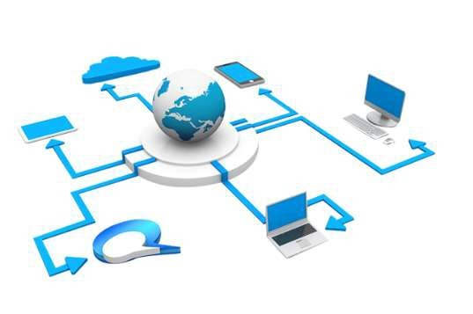

2

## Motivation

Every day your company is creating and managing massive amounts of business documents, contracts, proposals, marketing material, HR guidelines, training manuals, onboarding material, etc. These files are often scattered all over the place on your digital devices- you may have stored in cloud apps like Dropbox, Google Drive etc. What happens when your manager immediately needs that important document, but he cannot remember where you stored it? So Every organization use private file management system according to their activities. *Also A company has many branches. All branch can use this file management system together by uploading and downloading file through their ID and password.*

The project is based on a corporate company’s need. A leading company has many documental issue. If we use file management system, we can store our older or newer official data file on it. Sometimes we need to find old data file immediately. In this case we can find out that file and download the needy file from the uploaded folder. Thus there is no opportunity of files getting corrupted or lost.

3

## Objective

* Creating a software where the Current employs can easily enter with the help of ID and password which is given by their admin.
* There Is a login Option Both Employ and Admins. Every role will have their own different home page
* Multiple department works can be safely stored and accessed based on officer management architecture
* Current user can upload their selected files, and admins can checkout their profiles,see the uploaded documents and download them if they needed.
* Admins from each department can add their own employs by their own

4

# Chapter 2

**File Management System**

## Definition of file management system

A file management system is a type of software that manages data files in a computer system. It has limited capabilities and is designed to manage individual or group files, such as special office documents and records. It may display report details, like owner, creation date, state of completion and similar features useful in an office environment. A file management system is also known as a file manager.

A file management system should not be confused with a file system, which manages all types of data and files in an operating system (OS), or a database management system (DBMS), which has relational database capabilities and includes a programming language for further data manipulation.

A file management system is an application that is used to store, arrange, and access files stored on a disk or other storage location. The main purpose of a file manager is to enable users to create and store new files on a device (laptop or desktop), view all the

5

files stored on the device, and to organize files in different hierarchical arrangements, such as folders, for easy classification. The basic operations possible with a file management system include:

* + - Creating new files
    - Displaying all stored files
    - Moving files between locations
    - Sorting files based on criteria, such as date modified, date created, file size.

A file management system provides you with a simple interface that can be used to browse through folders and access different files using dedicated applications, such as Excel for

.xls, Acrobat for .pdf, and Word for .doc etc. The default file management system provided for the users of Microsoft Windows computers is Windows Explorer.



## File System

A file system is a process that manages how and where data on a storage disk, typically a hard disk drive (HDD), is stored, accessed and managed. It is a logical disk component that manages a disk’s internal operations as it relates to a computer and is abstract to a human user.

Regardless of type and usage, a disk contains a file system and information about where

6

-disk data is stored and how it may be accessed by a user or application. A file system typically manages operations, such as storage management, file naming, directories/folders, metadata, access rules and privileges.

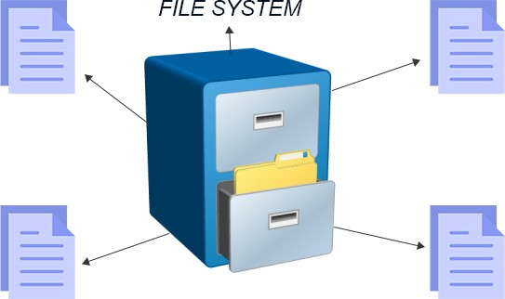

## Distributed file system

Distributed file system (DFS) is a method of storing and accessing files based in a client/server architecture. In a distributed file system, one or more central servers store files that can be accessed, with proper authorization rights, by any number of remote clients in the network.

Much like an operating system organizes files in a hierarchical file management system, the distributed system uses a uniform naming convention and a mapping scheme to keep track of where files are located. When the client device retrieves a file from the server, the file appears as a normal file on the client machine, and the user is able to work with the file in the same ways as if it were stored locally on the workstation. When the user finishes working with the file, it is returned over the network to the server, which stores the now-altered file for retrieval at a later time.

7

Distributed file systems can be advantageous because they make it easier to distribute documents to multiple clients and they provide a centralized storage system so that client machines are not using their resources to store files.

## File Management Functions

Application programs Users interact with the file system to create and delete files and for performing operations on files. File system first identify and locate the selected file before performing any operation. Directories are used to describe location of all files their attributes. Most shared systems implements access control policies. Only authorized users can have access to particular files.

The basic operations that a user or application may perform on a file are performed at the record level. The file is viewed by user as structure of records. Access methods are used to map user commands into specific file manipulation commands. I/O operation is done on block basis. The records are organized as a blocks of output. In order to perform the operation files must be allocated to free blocks on the secondary storage. Also free storage must be managed so as to know what blocks are available for new files and growth in existing files.

File Organization: Several criteria affect the selection of file organization. Some of these factors can be listed as follows. The suitability depends on the application which will be using the file.

## Importance of file management system

File management is essential for keeping company information private and secure. This file management system used to share file safely. So Every organization used to private file management system. However, not all businesses maintain an ongoing file management process with their employees. Efficient file management involves having a well-written, strong, and clear policy as well as a computer system (or in some cases several systems) that can index information for easy retrieval and allow for varying levels of security in

8

accessing the documents. Sharing sensitive information with unauthorized third party. Every day your company is creating and managing massive amounts of business documents, contracts, proposals, marketing material, HR guidelines, training manuals, on boarding material, etc.

These files are often scattered all over the place on your digital devices- you may have Word files, files stored in cloud apps like Dropbox, Google Drive, OneDrive, Box, files stored on your desktop, email attachments and so on. What happens when you can’t find a file in the middle of a meeting? Or when your manager immediately needs that important document, but you cannot seem to remember where you stored it? Organization of your digital files has always been an often overlooked aspect of being organized. Since you really cannot see or feel the digital mess you have created unlike the paper mess during the old-file cabinets-time, you may not feel like you have a problem, until you cannot find a particular file. Have you ever wasted precious time searching for a document on your computer, in chat messages, in your email attachments, etc.? Browsing through hundreds of folders, searching in your disorganized and massively populated inbox, searching through your cloud files, etc., all ends up being a search mission that’s’ impossible to crack.

9

# Chapter 3

**The Proposed Design of File Management System**

This file management system web application is developed by using tools in HTML5, CSS, Bootstrap, JavaScript, PHP, MySQL.

## HTML

HTML is the abbreviation of Hyper Text Markup Language, is the standard markup language to create web pages. Basically an HTML document is a plain text file that contains text nothing else. HTML is the root of the success and it is easy to learn and any device with a basic Web browser can read. Every web page need at least some HTML, it would not be a web page without it. HTML began in the early 1990, as a short document that detailed a handful of elements used to build web pages. HTMLˆ version number has increased as the language has evolved with the introduction or other elements and adjustments its rules. The most current version is HTML 5.

10

## CSS

CSS is referred to Cascading Style Sheets. Now that web has become as popular as it has, the presentation of web content has become almost critical to a success. CSS is the key presentation technology that is used to design websites. Like HTML 5 and its CSS 3 is the most recent version. CSS 3 is more powerful than other versions introduces numerous visual effects, such as drop shadows, text shadows, rounded corners, and gradients.

## JavaScript

JavaScript is a scripting language, which is a lightweight programming language. To interactivity to HTML pages JavaScript was designed. JavaScript code is usually embedded directly into HTML pages. Scripts execute without preliminary compilation as an interpreted language. Designed for creating network- centric applications. JavaScript is open and cross platform. Brendan Eich created JavaScript in May 1990 while he was working at Netscape. The original name of JavaScript was Mocha. With new developments such as the Nodejs platform, allowing us to use JavaScript on the server side, and HTML APIs to control user media.

## Bootstrap

Bootstrap is the most popular HTML, CSS, and JavaScript framework for developing responsive, mobile-first web sites. Bootstrap makes front-end web development faster and easier. It made for folks of all skill levels, devices of all shapes, and projects of all sizes.

11

## PHP

PHP is a recursive acronym of Hypertext Pre-processor. PHP is a server-side scripting language that allows Web site to be truly dynamic. Its flexibility and relatively small learning curve for programmers who have a background in C or Java make it one of the most popular scripting languages around. PHP is designed especially for the web.

Within a HTML page PHP code is embedded and that is executed each time visiting the page. PHP code is interpreted by web server and generate HTML output what visitor sees. PHP is open source product which was originally named Personal Home Page. The current version of PHP 7.3.4. Once of the nice feature of the PHP is that it is available for Microsoft Windows, for many versions of windows and fully functional web server.

12

## MySQL

MySQL is a relational database management system (RDBMS) designed to provide access to data stored in various storage engines using Structured Query Language (SQL). The MySQL source code is available under the GNU General Public License, but can also be provided under a commercial license, which provides enterprise-level support. MySQL has inspired many derivative projects that built on various aspect of the Drizzle, and persona server. Specialized distribution or patch sets are provided by organizations such as Google and Facebook, which add extra scalability options to be standard MySQL distribution. MySQL is available on all air stream operation systems: Linux, Windows, Mac OS etc. MySQL is publicly available since 1996, but has development history since 1997. It has won Linux Journal readers choice three years in a row. MySQL as available under an open Source license, but commercial license also available if required.

## ER Diagram

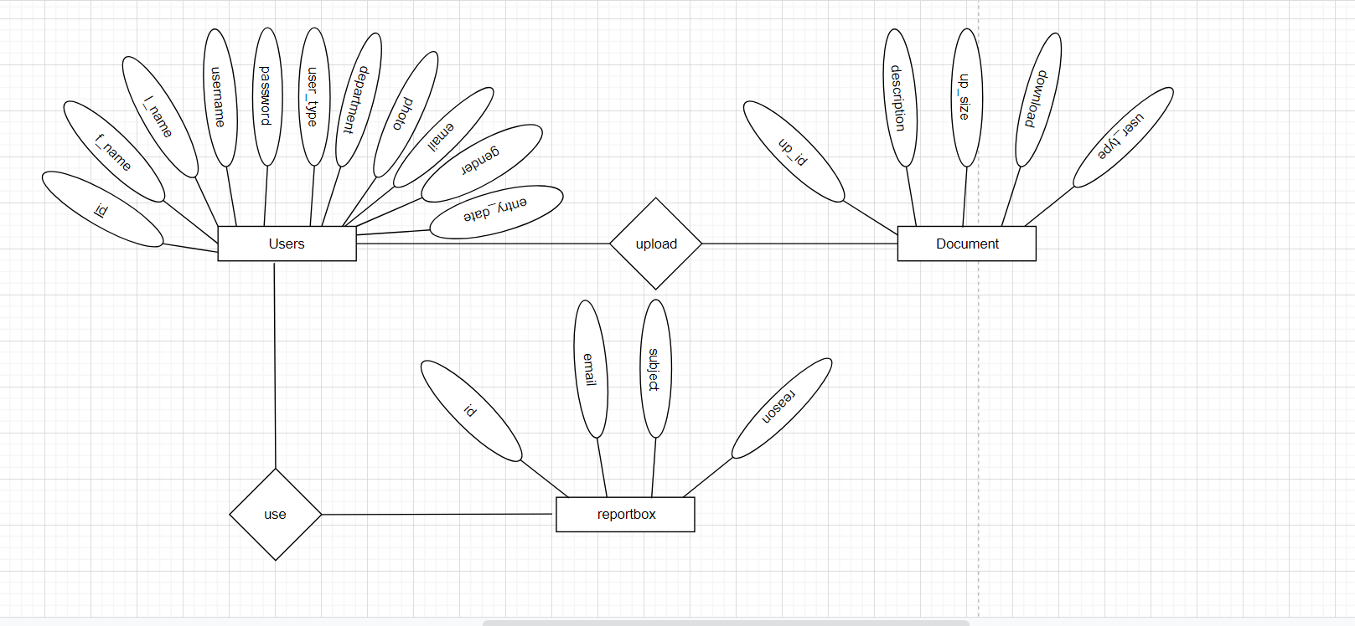

## Activity Diagram

Activity diagrams are graphical representations of workflows of step wise activities and actions with support for choice, iteration and concurrency. In the unified Modeling language, activity diagrams can be used to describe the business and operational step-by-step workflows of components in a system. An activity diagram shows the overall flow of control.

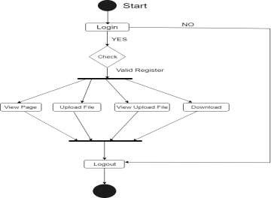

13

## The Proposed Architecture

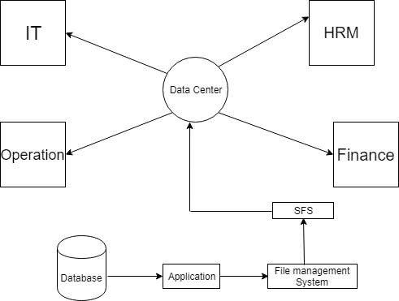Data centers work is centralizing locations where computing and networking equipment is concentrated for the purpose of collecting, storing, processing, distributing or allowing access to large amounts of data. Data comes to the data center then that will create a database. After stored on database, data will be distributed among all departments those can utilize the data in their purpose.

# Chapter 4

**Implementation and Result**

## Implementing User Authentication Mechanism

User authentication is very common in modern web application. It is a security mechanism that is used to restrict unauthorized access to member-only areas and tools on a site. we’ll create a simple registration and login system using the PHP and MySQL. It’s two parts: in the first part we’ll create a user registration form, and in the second part we’ll create a login form, as well as a welcome page and a logout script.

## Creating the Database

Execute the following SQL query to create the users table inside your MySQL database.

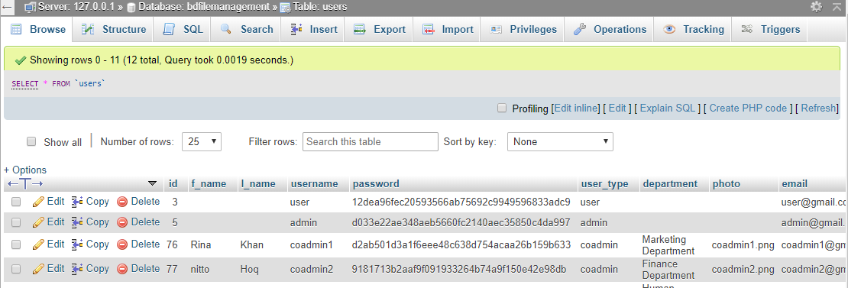

**Figure 4.1**

15

## Connecting to MySQL server

After creating the table, we need create a PHP script in order to connect to the MySQL database server.

## Admin Dashboard

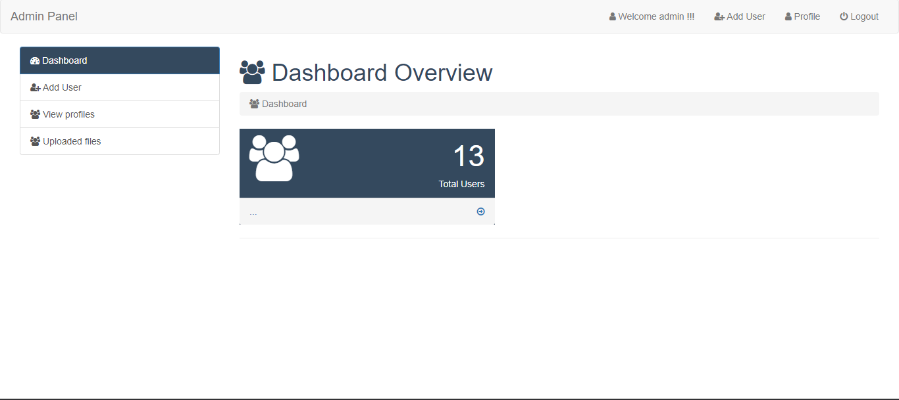

**Figure 4.2**

16

## Login view

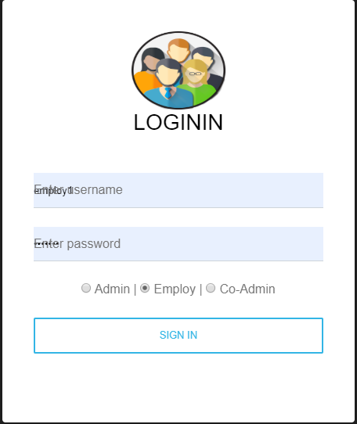

**Figure 4.3**

17

## Create Role Base New User

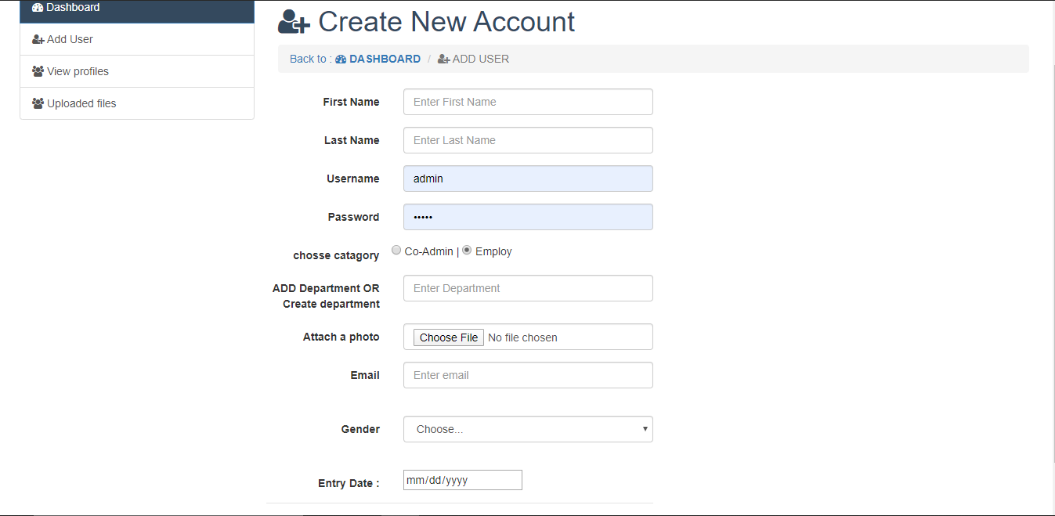

**Figure 4.4**

18

## Edit or Delete and See all users

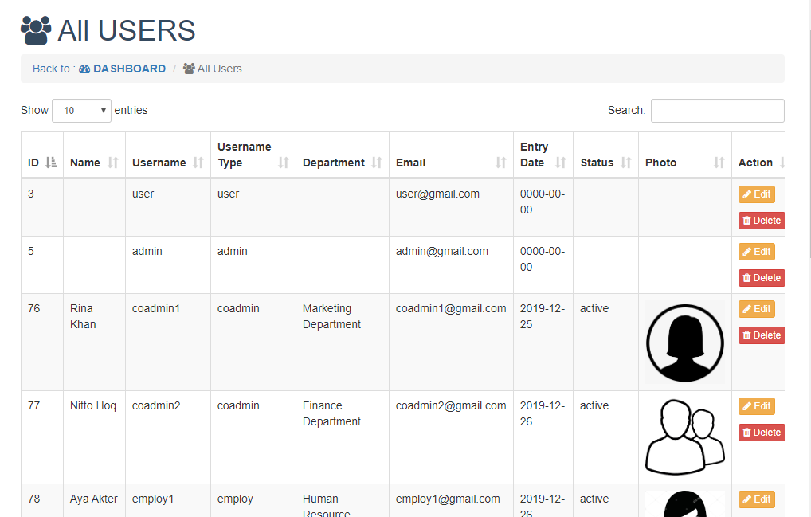

**Figure 4.5**

## View all file

19

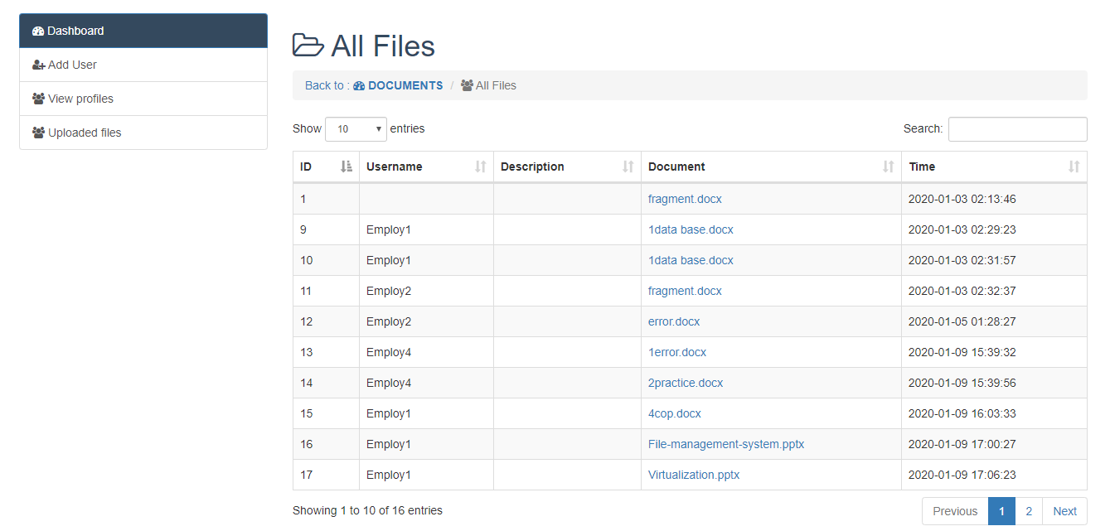

**Figure 4.6**

## Employee user home page with file upload view

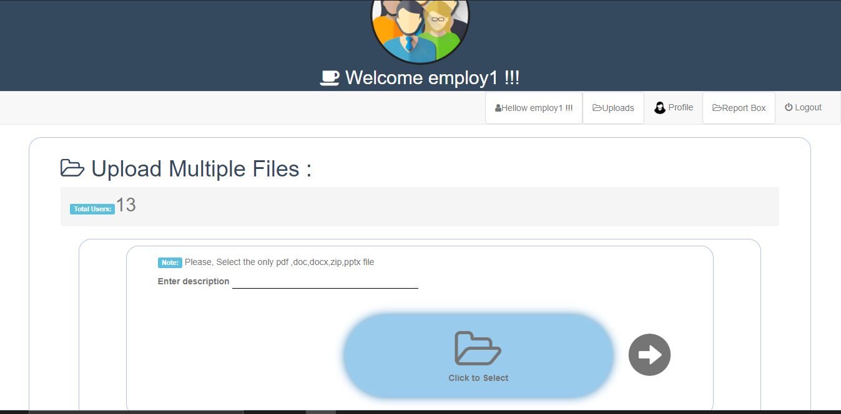

**Figure 4.7**

20

## Report Box

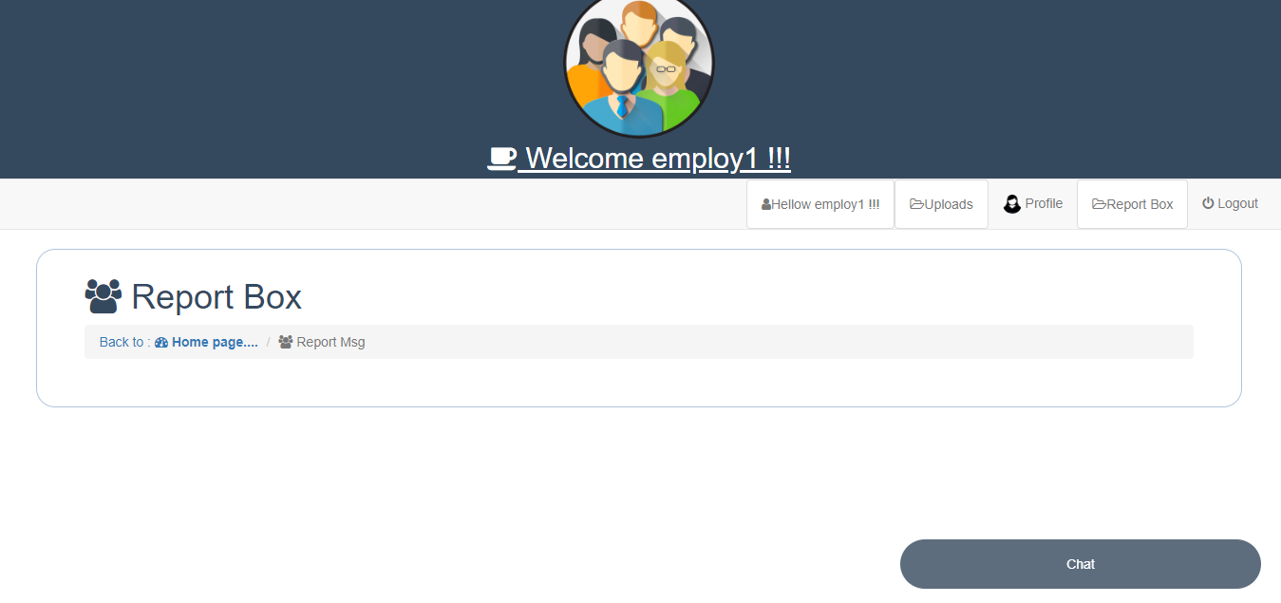

**Figure 4.8**

21

# Chapter 5

**Security of corporate file management system**

Authors, reviewers, and editors deal with submission files from people they don’ t know on a daily basis, and there are some basic precautions that you will want to take to mitigate the possibility of being compromised via one of these files. These steps don’ t different from how you would deal with email or other daily life on the internet, but are worth outlining in general form here.

* + - Ensure the antivirus software is installed and it is up to date.
    - Ensure the operating system and all software (especially Word and Excel) are kept

up to date, ideally by turning on any auto-update features available to you

* + - Practice good password management: donˆat use the same username/password in

OJS, OMP, or OCS as you would for any other online account, and donˆat use an easy to guess password

* + - Treat everything that you get online with the knowledge that you received it from

someone you donˆat know, and act likewise. If a submission appears to be suspicious for any reason (strange email address, suspiciously generic title or abstract, etc.), treat the included files with an additional level of diligence.

23

# Chapter 6 Conclusion

File management is the important of every organization. The file management system effectively within an organization ensures that data and knowledge is safe, accurate, and accessible. Mainly use for private file sharing system with proper security. Employees can share file in short time and store important file on the file management system. file management system can secure them with authentication. It can be a effective part in organization. That paperless communication between employees and online transfer speedup the workflow. Employees will have immediate access to the server and keep run- ning their fearless communication. That file management system offers a digital personal platform for lots of facilities like streaming workflow, storage, paperless communication, sharing mechanisms, less complexity. Every employee can easily cooperate with the server without any longtime professional training activities. Using file management system help us to save the budget, save time, that creative work for create new ideas ,new activities. Designed collaboratively with lots of features and securities. More over, changes are iden- tified by looking at performance and quality control data. A simplest procedure to upload file in server is when an user upload file from applications (Web app/Android/IOS app). Application will communicate with configuration server where information about the stor- age server and cache server’s properties and different types of parameter values are store. After getting the properties value from the configuration file, file can be also stored to the nearest local server to provide faster access to the file to client.

25

CHAPTER 6. CONCLUSION

Cloud Storage Service, the proposed storage service is based on distributed file storage system. File also store to the cloud storage server and the file location and user map will store into database. The encrypted files along with preserving confidentiality and security is highly demanded for organizations and even individuals when storing the files under public third-party cloud storage providers. To getting the file from, user will get information about the located server from the database then if file exist in the local cache it will provided from the cache server or it can be sent from cloud storage server. Some encryption mechanism can be also applied before storing or retrieving data from storage server. We are hoping the Use of That server will be one of the best and useful service for every organization.

26

# References

* + - h[ttps://www.tec](http://www.techopedia.com/definition/1832/file-management-system)hop[edia.com/definition/1832/file-management-system](http://www.techopedia.com/definition/1832/file-management-system)
    - h[ttps://www.tec](http://www.techopedia.com/definition/1832/file-management-system)hop[edia.com/definition/1832/file-management-system](http://www.techopedia.com/definition/1832/file-management-system) h[ttps://www.uk](http://www.ukessays.com/essays/information-technology/objectives-of-filemanagement-)essa[ys.com/essays/information-te](http://www.ukessays.com/essays/information-technology/objectives-of-filemanagement-)c[hnology/objectives-of-filemanagemen](http://www.ukessays.com/essays/information-technology/objectives-of-filemanagement-)t- systems-information-technology-essay.php

*•*

* + - h[ttps://www.csus.edu/aba/records-management/files-managemen](http://www.csus.edu/aba/records-management/files-management/benefits.html)t/b[enefits.h](http://www.csus.edu/aba/records-management/files-management/benefits.html)tml
    - h[ttps://www.tutorialrepublic.com/php-tutorial/php-file-upload.php](http://www.tutorialrepublic.com/php-tutorial/php-file-upload.php)
    - h[ttps://www.ssh.com](http://www.ssh.com/ssh/sftp/)/ssh[/sftp/](http://www.ssh.com/ssh/sftp/)
    - https://en.wikipedia.org/wiki/HTTPS

https://docs.pkp.sfu.ca/admin-guide/en/securing-your-systemMicrosoft. Miguel, Rodel, and Khin Mi Mi Aung. ”HEDup: Secure Deduplication with Homomorphic Encryp- tion.” In Networking, Architecture and Storage (NAS), 2015 IEEE International Conference on, pp. 215-223. IEEE, 2015.

*•*

* + - Secure your site with HTTPS. Google Support. Google, Inc. Retrieved 2018-10-20. What is HTTPS?.Comodo CA Limited. Retrieved 2018-10-20. Hyper Text Transfer Protocol Secure (HTTPS) is the secure version of HTTP

*•*

Network Working Group (May 2000).”HTTP Over TLS”. The Internet Engineering Task Force. Retrieved 2018-10-20.

*•*

* + - HTTPS Everywhere FAQ. Retrieved 2018-10-20.
    - h[ttps://www.scribd.com/do](http://www.scribd.com/document/332416397/Introduction-to-File-Management)cumen[t/332416397/Introduction-to-File-Managemen](http://www.scribd.com/document/332416397/Introduction-to-File-Management)t
    - <http://www.fintechbd.com/the-digital-banking-revolution-in-bangladesh/>

27