Lab Sheet
Experiment 02: Sum of Even Numbers in a List (Recursion in Prolog)
Problem Statement
To write a Prolog predicate sum_even(List, Sum) that finds the sum of all even numbers in a given list using recursion.

What is Recursion?
Recursion in Prolog is when a predicate calls itself to solve a problem step-by-step — just like in other programming languages. But in Prolog, recursion is used to navigate through data like lists, trees, or rule chains.

Why Use Recursion in Prolog?

Because:

Prolog has no loops (no for, while, etc.)
You process data (like lists or relationships) by defining a base case and a recursive rule

General Structure of Recursion

% Base case: simplest condition
predicate(Condition) :- ... .

% Recursive case: predicate calls itself
predicate(X) :-
some_condition(X),
predicate(NewX).

Every recursive rule in Prolog has two parts:
Part | Purpose
Base Case | Stop Recursion
Recursive Case | Reduces problem and calls itself

Basic Idea
In Prolog, recursion is used to process a list step-by-step. We take the first element of the list as H (Head) and the remaining elements as T (Tail). If H is even, we add it. If H is odd, we ignore it.
We process the list one element at a time.
[2, 3, 4, 5, 6, 7]
↑
First element
For each number:
If H is even → add it
If H is odd → ignore it
Then → process the rest of the list
When the list becomes empty, the sum is 0.

Prolog Code
% Base case: empty list has sum 0
sum_even([], 0).
% If the first number is even, add it
sum_even([H|T], Sum) :-
0 is H mod 2,
sum_even(T, Rest),
Sum is H + Rest.
% If the first number is odd, ignore it
sum_even([H|T], Sum) :-
1 is H mod 2,
sum_even(T, Sum).
Explanation of the Code
1. Base Case
sum_even([], 0).
This is the base case. When the list becomes empty, there are no more numbers to check, so the sum is 0. This stops the recursion.
2. Even Number Case
sum_even([H|T], Sum) :-
0 is H mod 2,
sum_even(T, Rest),
Sum is H + Rest.
Here, [H|T] separates the list into H (first element) and T (remaining list). The condition 0 is H mod 2 checks whether H is even. If it is even, sum_even(T, Rest) calculates the sum of the remaining list. Finally, Sum is H + Rest adds the current even number to that result.
3. Odd Number Case
sum_even([H|T], Sum) :-
1 is H mod 2,
sum_even(T, Sum).
If H mod 2 is 1, then H is odd. We do not add the odd number. We simply process the remaining list recursively.
Example Execution
Query:
?- sum_even([1,2,3,4,5,6], Sum).
Step 1: First element = 1
H = 1
T = [2,3,4,5,6]
Check: 0 is 1 mod 2
1 mod 2 = 1 → FALSE
The even rule fails. Prolog backtracks to the next rule:
1 is 1 mod 2
1 mod 2 = 1 → TRUE
1 is odd, so ignore 1 and continue:
sum_even([2,3,4,5,6], Sum)
Step 2: First element = 2
H = 2
T = [3,4,5,6]
Check: 0 is 2 mod 2
2 mod 2 = 0 → TRUE
2 is even, so it will be added after the recursive call returns.
sum_even([3,4,5,6], Rest)
Step 3: First element = 3
H = 3
T = [4,5,6]
Check: 0 is 3 mod 2
3 mod 2 = 1 → FALSE
The even rule fails. Prolog backtracks to the next rule:
1 is 3 mod 2
3 mod 2 = 1 → TRUE
3 is odd, so ignore 3 and continue:
sum_even([4,5,6], Sum)
Step 4: First element = 4
H = 4
T = [5,6]
Check: 0 is 4 mod 2
4 mod 2 = 0 → TRUE
4 is even, so it will be added after the recursive call returns.
sum_even([5,6], Rest)
Step 5: First element = 5
H = 5
T = [6]
Check: 0 is 5 mod 2
5 mod 2 = 1 → FALSE
The even rule fails. Prolog backtracks to the next rule:
1 is 5 mod 2
5 mod 2 = 1 → TRUE
5 is odd, so ignore 5 and continue:
sum_even([6], Rest)
Step 6: First element = 6
H = 6
T = []
Check: 0 is 6 mod 2
6 mod 2 = 0 → TRUE
6 is even. Prolog recursively processes:
sum_even([], Rest)
Step 7: Empty List — Base Case
sum_even([], 0).
Therefore:
Rest = 0
The result now returns upward through the recursive calls.
For 6: 6 + 0 = 6
For 4: 4 + 6 = 10
For 2: 2 + 10 = 12
For 1: 1 is odd, so the returned sum remains 12.
Odd numbers 1, 3 and 5 were ignored.
Final:
Sum = 12.
Complete Execution Flow
sum_even([1,2,3,4,5,6], Sum)
↓ 1 is odd → ignore 1
sum_even([2,3,4,5,6], Sum)
↓ 2 is even
sum_even([3,4,5,6], Rest)
↓ 3 is odd → ignore 3
sum_even([4,5,6], Rest)
↓ 4 is even
sum_even([5,6], Rest)
↓ 5 is odd → ignore 5
sum_even([6], Rest)
↓ 6 is even
sum_even([], 0)
↓ Base case reached → return 0
↑ 6 + 0 = 6
↑ 4 + 6 = 10
↑ 2 + 10 = 12
↑ 1 is odd, so Sum remains 12
Final: Sum = 12
Execution Table

Step | H | Tail | Even/Odd | Action | Running Return
1 | 1 | [2,3,4,5,6] | Odd | Ignore 1 | waiting
2 | 2 | [3,4,5,6] | Even | Add 2 | waiting
3 | 3 | [4,5,6] | Odd | Ignore 3 | waiting
4 | 4 | [5,6] | Even | Add 4 | waiting
5 | 5 | [6] | Odd | Ignore 5 | waiting
6 | 6 | [] | Even | Add 6 | 6+0=6
7 | - | [] | Base case | Return 0 | 0
8 | 4 | - | - | Return | 4+6=10
9 | 2 | - | - | Return | 2+10=12
Trace
Turn trace on:
?- trace.
Then execute:
?- sum_even([1,2,3,4,5,6], Sum).
The exact SWI-Prolog trace numbering may differ by version. Conceptually, Prolog first tries the even rule. If it fails for an odd number, it backtracks to the odd rule.
Call: sum_even([1,2,3,4,5,6], Sum)
Call: 0 is 1 mod 2
Fail: 0 is 1 mod 2
Call: 1 is 1 mod 2
Exit: 1 is 1 mod 2
Call: sum_even([2,3,4,5,6], Sum)
...
Call: sum_even([], 0)
Exit: sum_even([], 0)
...
Exit: sum_even([1,2,3,4,5,6], 12)
Sum = 12.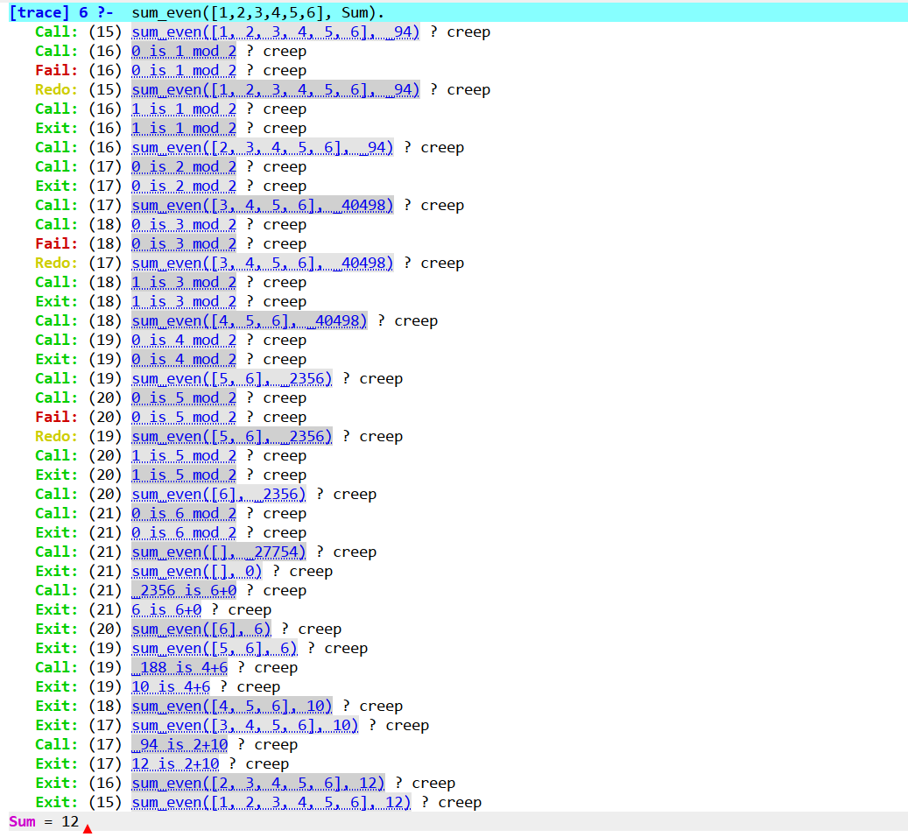
Unwinding Step-by-Step
After reaching the base case, the recursive calls return one by one. This return process is called unwinding. The calculation is completed while returning to the previous calls.
Step 1: Base Case
sum_even([], 0)
There are no elements left, so the result is 0.
Return = 0
Step 2: Return to [6]
H = 6, Rest = 0
Sum is 6 + 0 = 6
So, sum_even([6], 6)
Step 3: Return to [5,6]
H = 5 is odd, so 5 is ignored.
The recursive result from [6] is 6.
So, sum_even([5,6], 6)
Step 4: Return to [4,5,6]
H = 4, Rest = 6
Sum is 4 + 6 = 10
So, sum_even([4,5,6], 10)
Step 5: Return to [3,4,5,6]
H = 3 is odd, so 3 is ignored.
The recursive result from [4,5,6] is 10.
So, sum_even([3,4,5,6], 10)
Step 6: Return to [2,3,4,5,6]
H = 2, Rest = 10
Sum is 2 + 10 = 12
So, sum_even([2,3,4,5,6], 12)
Step 7: Return to [1,2,3,4,5,6]
H = 1 is odd, so 1 is ignored.
The recursive result is 12.
So, sum_even([1,2,3,4,5,6], 12)
Unwinding sequence: 0 → 6 → 6 → 10 → 10 → 12 → 12
Recursive Call Tree
The recursive call tree shows how sum_even/2 calls itself with a smaller list until the base case is reached. The return values then move upward during unwinding.
sum_even([1,2,3,4,5,6], Sum)
|
+-- H = 1, odd → ignore 1
| +-- sum_even([2,3,4,5,6], Sum)
| +-- H = 2, even
| | +-- sum_even([3,4,5,6], Rest)
| | +-- H = 3, odd → ignore 3
| | +-- sum_even([4,5,6], Rest)
| | +-- H = 4, even
| | | +-- sum_even([5,6], Rest)
| | | +-- H = 5, odd → ignore 5
| | | +-- sum_even([6], Rest)
| | | +-- H = 6, even
| | | +-- sum_even([], 0) <- Base Case
|
+-- Unwinding: 0 → 6 → 6 → 10 → 10 → 12 → 12
Tree Explanation
Start with [1,2,3,4,5,6]. Prolog processes 1 and ignores it because it is odd. It then recursively processes [2,3,4,5,6]. The same pattern continues until the empty list is reached. On the way back, 6 contributes 6, 4 contributes 4, and 2 contributes 2; odd numbers 1, 3, and 5 do not change the sum. Therefore, the final result is 12.

Result
The Prolog program successfully finds the sum of all even numbers in a list using recursion.
Conclusion
This experiment shows how recursion can be used in Prolog to process a list. The program checks each number, adds the even numbers, ignores the odd numbers, and stops when the list becomes empty.

