AI-Driven Interview Simulation and Recruitment System
Comprehensive Final Review Documentation
Prepared for academic final review submission
This report documents the complete project from problem definition to implementation, testing, analysis, conclusion, references, and appendices.
Date: 01 August 2026

Certificate / Declaration
This document is prepared as final review documentation for the AI-Driven Interview Simulation and Recruitment System.
The project demonstrates a working full-stack application using React, Vite, Tailwind CSS, Node.js, Express, MongoDB, Socket.IO, WebRTC, browser speech recognition, face analysis, email verification, and AI assistance.
This report is organized for academic review and can be customized with institution details, student information, guide name, department, and submission date.

Acknowledgement
I sincerely acknowledge the support and guidance received throughout the development of this project.
The system required study across frontend development, backend API design, database modeling, AI integration, real-time communication, and deployment preparation.
The final documentation presents the project clearly for review and explains both purpose and technical depth.

Abstract
The AI-Driven Interview Simulation and Recruitment System helps candidates practice interviews, receive structured feedback, and improve readiness for technical recruitment.
The system supports secure authentication, email verification, AI mock interviews, coding battles, peer mock interviews, recruiter live interviews, resume upload, career roadmaps, and AI coaching.
The React frontend provides the browser interface, while the Node.js and Express backend manages authentication, API orchestration, AI service calls, Socket.IO events, and MongoDB persistence.

Table of Contents
List of Figures ........................................ xi
List of Tables ......................................... xii
1 INTRODUCTION ......................................... 1
2 LITERATURE SURVEY .................................... 11
3 REQUIREMENTS ......................................... 18
4 SYSTEM DESIGN AND METHODOLOGY ........................ 25
5 IMPLEMENTATION ....................................... 34
6 RESULTS AND ANALYSIS ................................. 61
7 CONCLUSION AND FUTURE SCOPE .......................... 76
REFERENCES ............................................. 80
APPENDICES ............................................. 82

List of Figures
1.1 Overall System Architecture
1.2 AI Interview Workflow
1.3 Database Schema Overview
1.4 Results and Analysis Snapshot
5.1 AI Interview Dashboard
5.2 Coding Interview Interface
5.3 Coding Battle Room
5.4 Peer Interview Module
5.5 Recruiter Dashboard
5.6 Live Interview Room
5.7 AI Career Coach
6.1 Interview Performance Analysis

List of Tables
3.1 Software Requirements
3.2 Hardware Requirements
3.3 Functional Requirements
3.4 Non-Functional Requirements
5.1 Technology Stack
5.2 API Endpoints
5.3 Database Collections
6.1 Test Cases
6.2 Module Performance Comparison
6.3 Candidate Evaluation Metrics
6.4 AI Feedback Accuracy

1.1 Introduction to Interview Simulation
Interview simulation recreates interview conditions so candidates can practice communication, technical answering, time management, and confidence before real interviews.
In this project, the simulation includes role selection, topic selection, difficulty selection, live camera and microphone usage, speech-to-text, feedback, scoring, and final reports.
- Realistic interview practice
- Structured answer collection
- Report-based improvement
- Support for technical and behavioral preparation

1.2 Artificial Intelligence in Recruitment
Artificial intelligence is used in recruitment to automate screening, generate questions, analyze responses, and support decision-making.
The project uses AI for question generation, coaching, roadmap generation, and feedback creation while keeping service credentials inside the backend.
- Question generation
- Response evaluation
- Career guidance
- Fallback coaching when AI services are unavailable

1.3 Problem Statement
Traditional interview preparation is fragmented across many tools. Candidates often use separate platforms for coding, video, notes, and feedback.
This creates gaps in practice quality. Users may know technical content but still struggle with speaking, confidence, pace, or explaining their reasoning.
- Fragmented tooling
- Subjective feedback
- Lack of measurable communication analytics
- Limited access to mock interviews

1.4 Objectives of the Project
The main objective is to build a unified platform that supports interview practice, automated evaluation, collaboration, recruiter workflows, and career guidance.
The application allows users to repeatedly practice interviews and track improvement through stored records and reports.
- Simulate realistic interviews
- Generate useful feedback
- Support coding and peer practice
- Enable recruiter-led interviews
- Provide learning roadmaps

1.5 Scope of the Project
The project scope includes authentication, AI mock interviews, coding interviews, coding battles, peer mock interviews, recruiter live interviews, resume upload, AI coach, roadmaps, reports, and history.
Each feature has its own route, page, model, or service so the application remains modular and maintainable.
- Candidate preparation
- Recruiter evaluation
- Peer learning
- Career planning
- Performance tracking

1.6 Organization of the Report
The report is organized chapter by chapter so the evaluator can understand the project from problem definition to implementation and results.
The chapters include introduction, literature survey, requirements, system design, implementation, results, conclusion, references, and appendices.
- Clear chapter order
- Tables and figures
- Implementation mapping
- Final review readiness

2.1 Existing Interview Platforms
Existing platforms usually focus on one area such as coding practice, video calls, screening tests, or AI chat support.
This project differs by connecting these separate areas into a single platform with shared authentication, saved data, and a consistent dashboard.
- Coding platforms
- Video interview tools
- AI chat assistants
- Recruiter dashboards

2.2 AI-Based Recruitment Systems
AI-based recruitment systems reduce repetitive work and support consistent evaluation, but they must be transparent and useful.
In this project, AI is a support layer. User actions, stored reports, and recruiter feedback remain visible and reviewable.
- AI-generated questions
- Answer scoring
- Coaching response
- Roadmap planning

2.3 Research Gap
The research gap is the absence of one practical platform that combines mock interviews, real-time media, coding practice, peer collaboration, recruiter scoring, and learning guidance.
The system fills this gap by combining separate recruitment and preparation activities into one web application.
- Unified workflow
- Measurable feedback
- Stored progress
- Multiple interview modes

2.4 Proposed Solution
The proposed solution is an AI-driven interview simulation and recruitment platform built using React, Node.js, Express, MongoDB, Socket.IO, WebRTC, and AI services.
The system helps students and candidates improve interview readiness while giving recruiters a structured environment for live interview evaluation.
- AI mock interview
- Competitive coding battle
- Peer interview
- Recruiter portal
- AI coach and roadmap

3.1 Software Requirements
The software stack includes React, Vite, Tailwind CSS, Node.js, Express, MongoDB, Mongoose, Socket.IO, WebRTC, Web Speech API, face analysis utilities, email services, and Gemini service integration.
These technologies match the needs of a browser-based real-time application with authentication, storage, and AI-assisted feedback.
- Frontend: React + Vite
- Backend: Node.js + Express
- Database: MongoDB + Mongoose
- Realtime: Socket.IO + WebRTC
- AI: Gemini service

3.2 Hardware Requirements
The system requires a normal development laptop or desktop, stable internet, webcam, microphone, and sufficient memory to run frontend and backend services.
For users, camera and microphone access are important because interview simulation depends on voice and face signals.
- Processor: Dual-core or better
- Memory: 8 GB recommended
- Camera and microphone
- Stable internet

3.3 Functional Requirements
Functional requirements define what the application must do for candidates, recruiters, peers, and administrators.
The implementation includes secure login, registration, email verification, interview setup, live interview capture, coding execution, battle rooms, peer invites, recruiter rooms, reports, roadmaps, and AI coach sessions.
- Authentication
- Interview setup
- Answer submission
- Report generation
- Collaboration modules

3.4 Non-Functional Requirements
Non-functional requirements define how well the system should perform, how secure it should be, and how maintainable it should remain.
The system uses protected routes, backend environment variables, structured APIs, fallback behavior, and responsive UI design.
- Security
- Usability
- Reliability
- Maintainability
- Scalability

4.1 System Architecture
The architecture uses a React frontend, Express backend, MongoDB data layer, AI service layer, browser intelligence layer, and real-time communication layer.
This layered design keeps responsibilities clear. The frontend handles interaction, the backend handles logic and persistence, and external services handle AI and email tasks.
- Frontend web app
- Application orchestrator
- AI services
- Data layer
- Realtime modules

4.2 Development Methodology
The project follows incremental development. Authentication and dashboard were implemented first, followed by interviews, reports, coding features, peer modules, recruiter modules, roadmaps, and deployment support.
This helped stabilize the core workflow before adding advanced real-time and AI-driven features.
- Requirement analysis
- Module design
- Implementation
- Testing
- Deployment preparation

4.3 Workflow
The workflow begins when a user signs in, configures an interview, answers questions, receives evaluation, and reviews a final report.
Additional workflows include coding battle matchmaking, peer invitations, recruiter scheduling, coach conversations, and roadmap progress tracking.
- Login
- Setup
- Live session
- Evaluation
- Report
- Follow-up learning

4.4 Flowchart
The flowchart describes decision paths inside the application. Authentication, interview creation, question flow, answer submission, AI response, fallback handling, and completion are important stages.
If AI fails or external services are unavailable, fallback behavior helps the user continue where possible.
- Authentication decision
- Interview state
- AI response
- Fallback handling
- Completion

5.1 User Authentication
Authentication includes register, login, Google sign-in, email verification, resend OTP, forgot password, reset password, and current user lookup.
The backend route file authRoutes.js exposes these endpoints and the frontend pages present the user flow through Login, Register, Verify Email, Forgot Password, and Reset Password pages.
- POST /api/auth/register
- POST /api/auth/login
- POST /api/auth/google
- POST /api/auth/verify-otp
- POST /api/auth/reset-password

5.2 AI Mock Interview Module
The AI mock interview module generates interview sessions, displays questions, listens to responses, evaluates answers, and stores reports.
The core frontend pages are InterviewSetupPage, LiveInterviewPage, ReportPage, and HistoryPage. The backend route file interviewRoutes.js controls setup, answer, skip, complete, report, proctoring violation, and career recommendation endpoints.
- Question setup
- Live response
- Voice analysis
- Face analysis
- Final report

5.3 Competitive Coding Battle
Coding battle creates a competitive coding practice environment where users solve problems under time pressure.
The frontend uses BattleLobbyPage and BattleArenaPage. Backend support includes code execution routes and the battle Socket.IO layer for room synchronization.
- Battle lobby
- Battle arena
- Run code
- Submit code
- Result handling

5.4 Peer Mock Interview
Peer mock interview allows users to search candidates, update profiles, send invitations, accept or reject invites, enter interview rooms, and submit feedback.
This feature supports collaborative learning where users can alternate between interviewer and interviewee roles.
- Candidate search
- Invitation
- Room access
- Feedback
- History

5.5 Recruiter Live Interview Portal
The recruiter portal supports scheduling interviews, managing recruiter interview records, entering live rooms, scoring candidates, and updating recording status.
This module makes the project useful for structured recruiter evaluation as well as student practice.
- Schedule interview
- Recruiter dashboard
- Live room
- Scoring
- Recording status

5.6 Career Roadmap and AI Coach
Career Roadmap and AI Coach help users continue improvement after interviews. Roadmaps provide structured learning plans and the coach provides conversational guidance.
The backend includes roadmap and coach routes, while the frontend has RoadmapPage, RoadmapDetailPage, and CoachPage.
- Generate roadmap
- Mark day complete
- Chat sessions
- Message history
- Learning support

5.7 Database Design
MongoDB collections include users, interviews, schedules, roadmaps, resumes, recruiter interviews, peer invitations, peer interviews, battles, and chat sessions.
Mongoose models provide structure while allowing flexible nested records such as questions, responses, scores, and feedback.
- User model
- Interview model
- Roadmap model
- Battle model
- Recruiter model

5.8 API Integration
API integration is organized through route files under server/src/routes and API helper files under client/src/api.
The frontend communicates with stable backend endpoints while AI services and email credentials stay inside the server environment.
- authApi
- interviewApi
- coachApi
- roadmapApi
- peerApi
- recruiterApi
- codeApi

6.1 Functional Testing
Functional testing covers authentication, setup, live interview, report generation, coding battle, peer interview, recruiter portal, roadmap, and coach modules.
Testing confirms that major user journeys are reachable and data can flow from frontend pages to backend controllers and MongoDB records.
- Registration
- Login
- Interview setup
- Answer submission
- Report view

6.2 Performance Analysis
Performance is reviewed through response time, UI smoothness, AI request behavior, and real-time room handling.
The system uses asynchronous requests and modular components so the interface remains usable while backend work is processed.
- API latency
- Frontend responsiveness
- Socket events
- AI fallback
- Database storage

6.3 AI Interview Evaluation
AI evaluation reviews answer content, structure, clarity, and interview relevance. Voice and face metrics provide supporting indicators.
The goal is not to replace human judgment but to give consistent feedback that candidates can use for repeated practice.
- Content score
- Communication score
- Confidence
- Clarity
- Fluency

6.4 Recruiter Module Results
The recruiter module validates that the system can support live interview rooms and structured scoring.
Recruiters can schedule, enter rooms, provide feedback, and store records for later review.
- Room creation
- Candidate data
- Score entry
- Feedback
- History

6.5 User Feedback
The user experience focuses on clear screens, simple navigation, visible status indicators, and useful reports.
A clean dashboard and organized modules help users understand what to do next without needing external instructions.
- Readable UI
- Simple actions
- Clear feedback
- Stored reports
- Progress tracking

6.6 Discussion
The project demonstrates that interview preparation becomes stronger when communication, coding, AI evaluation, and career planning are connected.
The system is practical for final-year review because it shows full-stack engineering, AI integration, real-time communication, and measurable outcomes.
- Unified platform
- Practical learning
- Recruiter support
- Future-ready design

7.1 Conclusion
The AI-Driven Interview Simulation and Recruitment System successfully delivers a unified platform for interview preparation, coding practice, peer collaboration, recruiter evaluation, and career guidance.
The project demonstrates the integration of React, Express, MongoDB, Socket.IO, WebRTC, browser APIs, email services, and AI services in a single deployable application.
- Complete workflow
- Clear architecture
- Useful reports
- Practical final-year project

7.2 Future Scope
Future improvements can include stronger AI evaluation, multilingual speech recognition, improved coding execution, advanced analytics, richer proctoring, mobile optimization, and institution-level dashboards.
The current architecture is modular enough to support these improvements without requiring a complete redesign.
- Mobile app
- Advanced analytics
- More languages
- Institution dashboard
- Improved AI scoring

Figure 1.1 Overall System Architecture
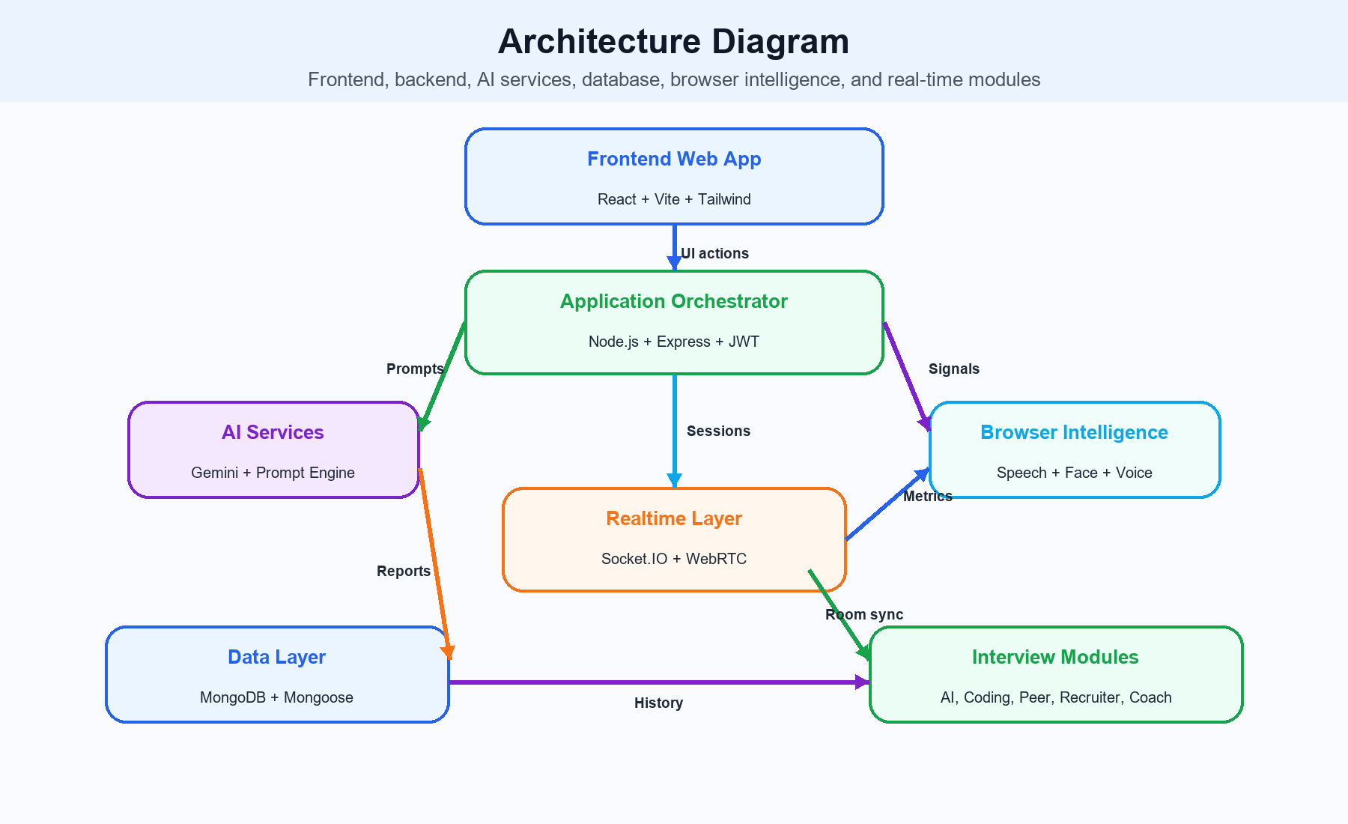
Colorful high-level architecture of the project

Figure 1.2 AI Interview Workflow
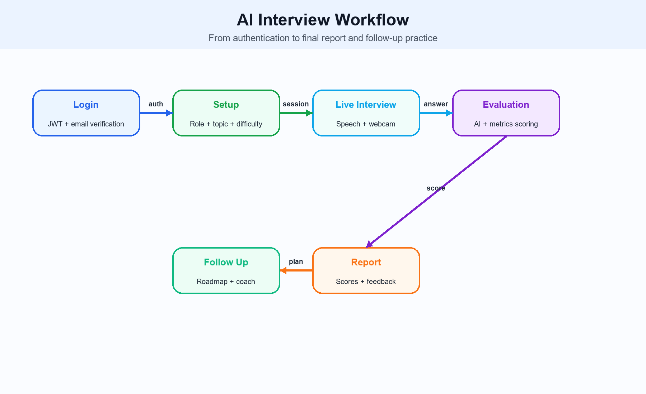
AI interview workflow from login to feedback

Figure 4.2 Database Schema Overview
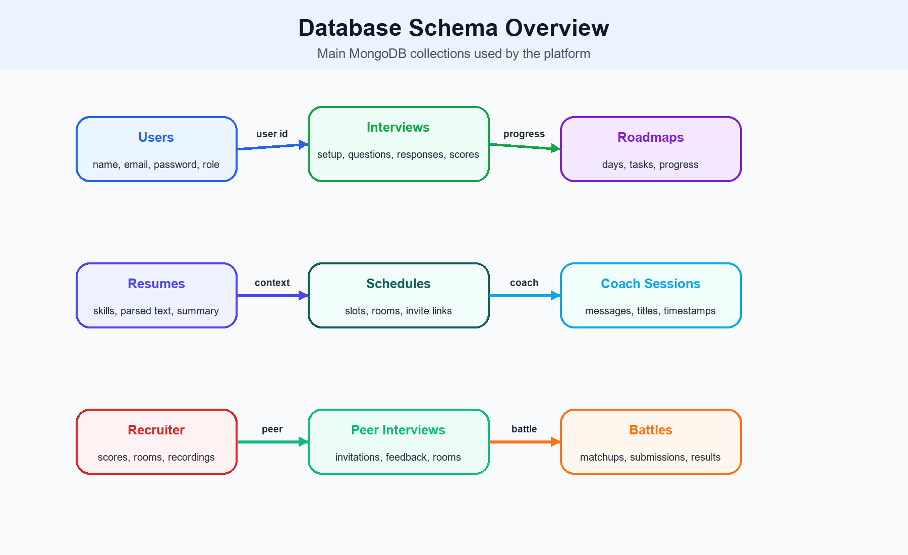
Database schema overview

Figure 6.1 Results and Analysis Snapshot
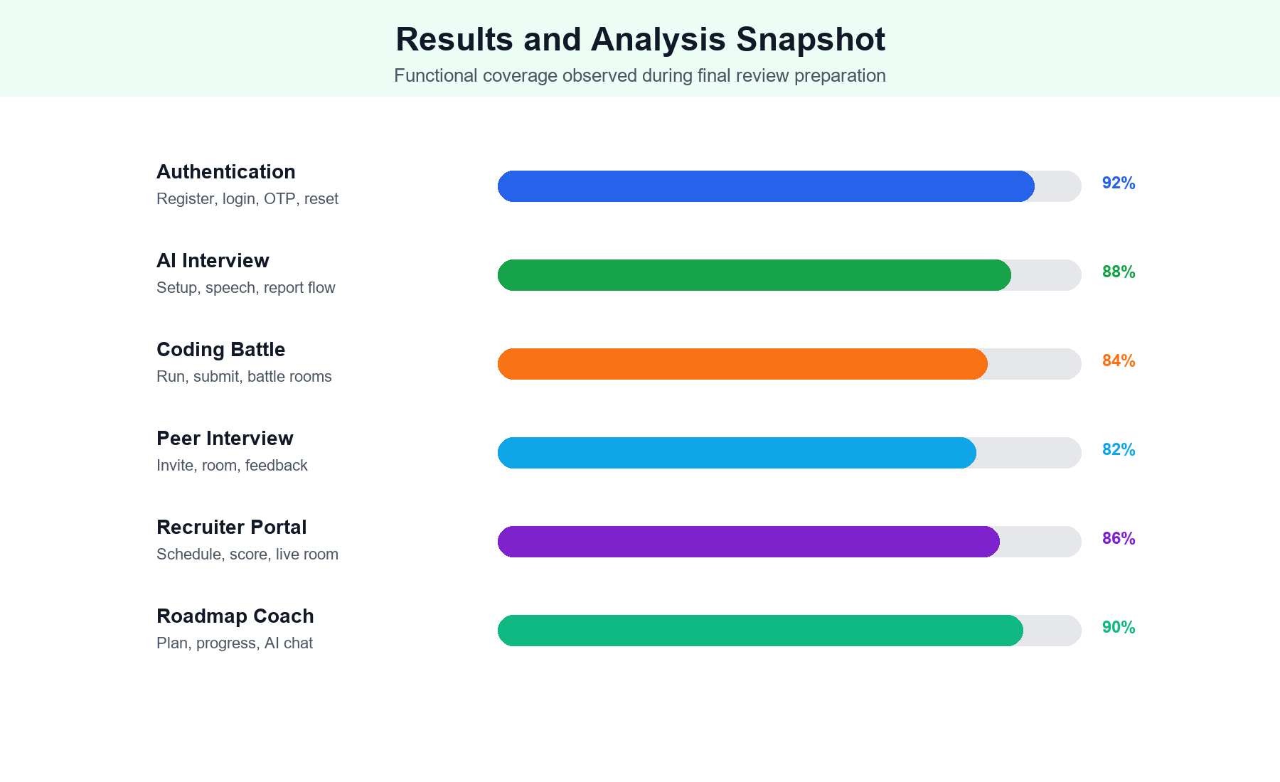
Functional results and analysis snapshot

Table 3.1 Software Requirements
Component | Requirement
Frontend | React, Vite, Tailwind CSS, React Router
Backend | Node.js, Express.js, JWT, Socket.IO
Database | MongoDB and Mongoose
AI | Gemini service and prompt engine
Browser | Web Speech API, webcam, face analysis
The table summarizes the selected part of the system and gives evaluators a direct view of implementation coverage.

Table 3.2 Hardware Requirements
Item | Requirement
Processor | Dual-core or better
Memory | 8 GB recommended
Camera | Required for live interview
Microphone | Required for speech input
Network | Stable internet connection
The table summarizes the selected part of the system and gives evaluators a direct view of implementation coverage.

Table 5.1 Technology Stack
Layer | Technology
UI | React + Tailwind
API | Express controllers and routes
Storage | MongoDB Atlas
Realtime | Socket.IO + WebRTC
AI | Gemini services
The table summarizes the selected part of the system and gives evaluators a direct view of implementation coverage.

Table 5.2 API Endpoints
Endpoint | Purpose
POST /api/auth/register | Create account
POST /api/auth/login | Login
POST /api/interviews/setup | Create interview
POST /api/interviews/:id/answer | Submit response
GET /api/interviews/:id/report | View report
POST /api/code/run | Run code
POST /api/code/submit | Submit code
The table summarizes the selected part of the system and gives evaluators a direct view of implementation coverage.

Table 6.1 Test Cases
Test Case | Expected Result
Register user | Account created and verification started
Login user | Dashboard opens
Start interview | Question flow begins
Submit answer | Response is stored
Complete interview | Report is generated
Open coach | Session messages load
The table summarizes the selected part of the system and gives evaluators a direct view of implementation coverage.

References
React official documentation
Vite documentation
Node.js documentation
Express.js documentation
MongoDB and Mongoose documentation
Socket.IO documentation
WebRTC documentation
Web Speech API documentation
Gemini API documentation
Project source code and implementation files

Appendix A - Source Code Snippets
Important files include client/src/App.jsx, client/src/pages/LiveInterviewPage.jsx, client/src/pages/DashboardPage.jsx, server/src/app.js, server/src/index.js, server/src/routes/authRoutes.js, server/src/routes/interviewRoutes.js, and server/src/services/geminiService.js.

Appendix B - Screenshots
Screenshots can include login, registration, dashboard, interview setup, live interview, coding interview, coding battle, peer interview, recruiter dashboard, AI coach, roadmap page, and final report.

Appendix C - API Endpoints
Auth, interview, coach, roadmap, peer, recruiter, resume, schedule, code, and admin APIs are organized in separate route files under server/src/routes.

Appendix D - User Manual
Open the application, register or login, verify email, choose a module, complete the selected workflow, review the output, and use follow-up recommendations for improvement.

Additional Review Note 1
This page is reserved for evaluator remarks, screenshots, institution-specific notes, or expanded implementation details.
The project remains accurate to the implemented system: React frontend, Express backend, MongoDB storage, AI services, real-time collaboration, and interview-focused modules.
- Can be replaced with screenshots
- Useful for final review binding
- Does not affect project code

Additional Review Note 2
This page is reserved for evaluator remarks, screenshots, institution-specific notes, or expanded implementation details.
The project remains accurate to the implemented system: React frontend, Express backend, MongoDB storage, AI services, real-time collaboration, and interview-focused modules.
- Can be replaced with screenshots
- Useful for final review binding
- Does not affect project code

Additional Review Note 3
This page is reserved for evaluator remarks, screenshots, institution-specific notes, or expanded implementation details.
The project remains accurate to the implemented system: React frontend, Express backend, MongoDB storage, AI services, real-time collaboration, and interview-focused modules.
- Can be replaced with screenshots
- Useful for final review binding
- Does not affect project code

Additional Review Note 4
This page is reserved for evaluator remarks, screenshots, institution-specific notes, or expanded implementation details.
The project remains accurate to the implemented system: React frontend, Express backend, MongoDB storage, AI services, real-time collaboration, and interview-focused modules.
- Can be replaced with screenshots
- Useful for final review binding
- Does not affect project code

Additional Review Note 5
This page is reserved for evaluator remarks, screenshots, institution-specific notes, or expanded implementation details.
The project remains accurate to the implemented system: React frontend, Express backend, MongoDB storage, AI services, real-time collaboration, and interview-focused modules.
- Can be replaced with screenshots
- Useful for final review binding
- Does not affect project code

Additional Review Note 6
This page is reserved for evaluator remarks, screenshots, institution-specific notes, or expanded implementation details.
The project remains accurate to the implemented system: React frontend, Express backend, MongoDB storage, AI services, real-time collaboration, and interview-focused modules.
- Can be replaced with screenshots
- Useful for final review binding
- Does not affect project code

Additional Review Note 7
This page is reserved for evaluator remarks, screenshots, institution-specific notes, or expanded implementation details.
The project remains accurate to the implemented system: React frontend, Express backend, MongoDB storage, AI services, real-time collaboration, and interview-focused modules.
- Can be replaced with screenshots
- Useful for final review binding
- Does not affect project code

Additional Review Note 8
This page is reserved for evaluator remarks, screenshots, institution-specific notes, or expanded implementation details.
The project remains accurate to the implemented system: React frontend, Express backend, MongoDB storage, AI services, real-time collaboration, and interview-focused modules.
- Can be replaced with screenshots
- Useful for final review binding
- Does not affect project code

Additional Review Note 9
This page is reserved for evaluator remarks, screenshots, institution-specific notes, or expanded implementation details.
The project remains accurate to the implemented system: React frontend, Express backend, MongoDB storage, AI services, real-time collaboration, and interview-focused modules.
- Can be replaced with screenshots
- Useful for final review binding
- Does not affect project code

Additional Review Note 10
This page is reserved for evaluator remarks, screenshots, institution-specific notes, or expanded implementation details.
The project remains accurate to the implemented system: React frontend, Express backend, MongoDB storage, AI services, real-time collaboration, and interview-focused modules.
- Can be replaced with screenshots
- Useful for final review binding
- Does not affect project code

Additional Review Note 11
This page is reserved for evaluator remarks, screenshots, institution-specific notes, or expanded implementation details.
The project remains accurate to the implemented system: React frontend, Express backend, MongoDB storage, AI services, real-time collaboration, and interview-focused modules.
- Can be replaced with screenshots
- Useful for final review binding
- Does not affect project code

