Download the android studio version 3.01 from https://developer.android.com/studio/archive
Gradle is an open source app building tool Android studio uses to build your app.
Open an existing project: double click on build.gradle fle
Problem 1: getting 13 errors and build failing
Update this API 26: Android 8.0 (Oreo) to API31
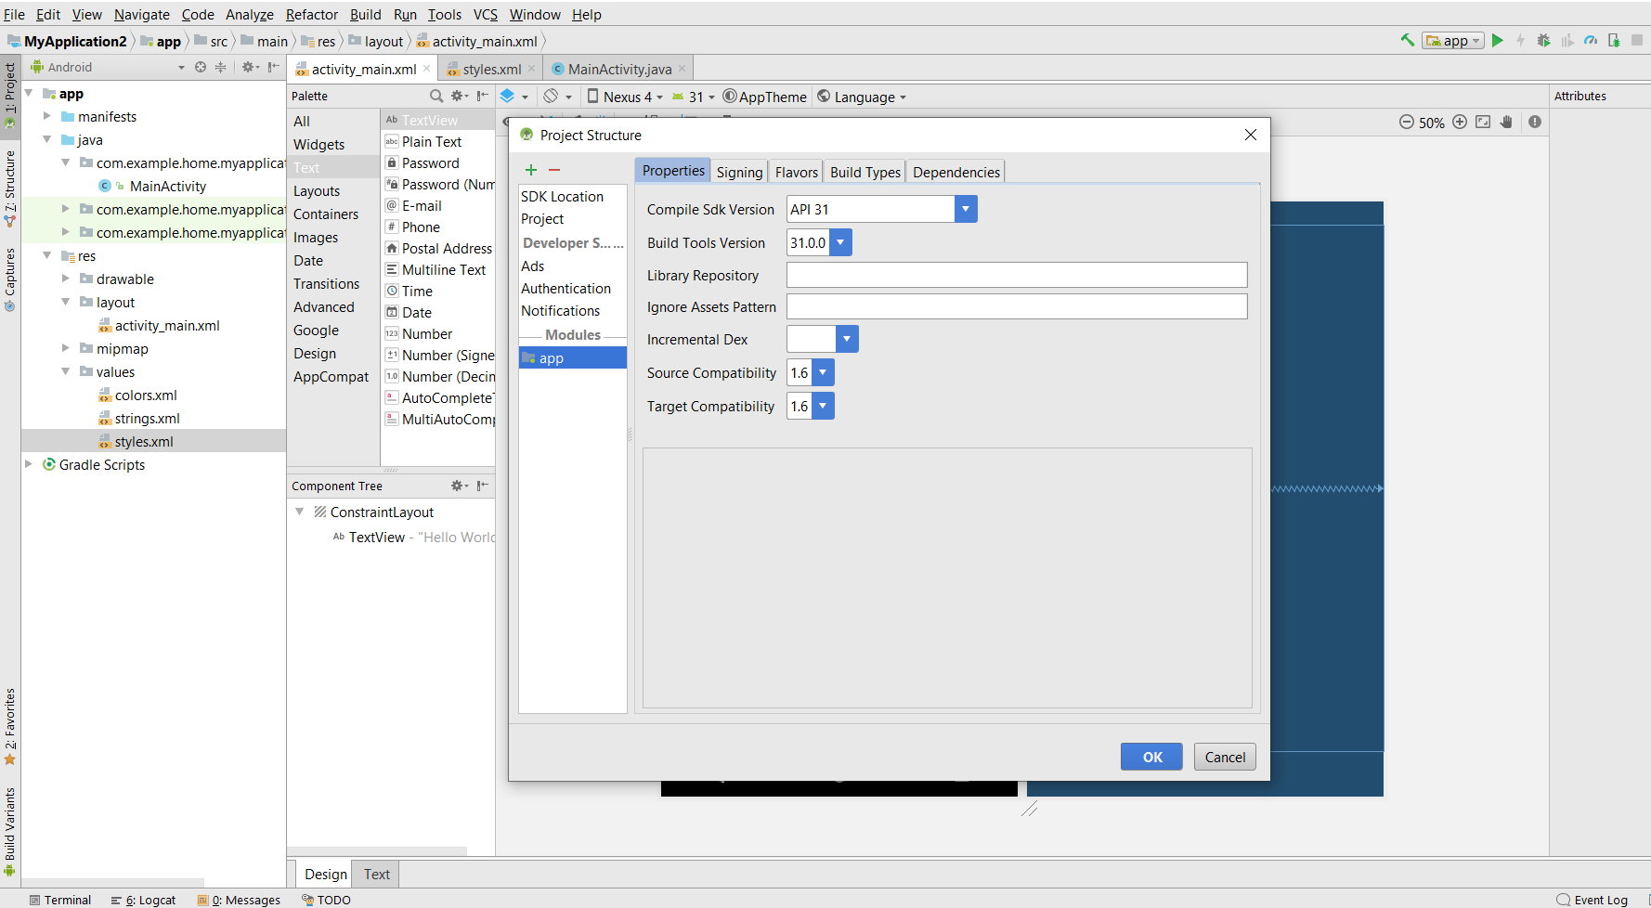
Problem 2: text view not appearing after successful build
<style name="AppTheme" parent="Base.Theme.AppCompat.Light.DarkActionBar">
In the styles.xml file Change the parent name to Base.Theme.AppCompat.Light.DarkActionBar
Difference between SP and DP http://www.differencebetween.info/difference-between-sp-and-dp-android

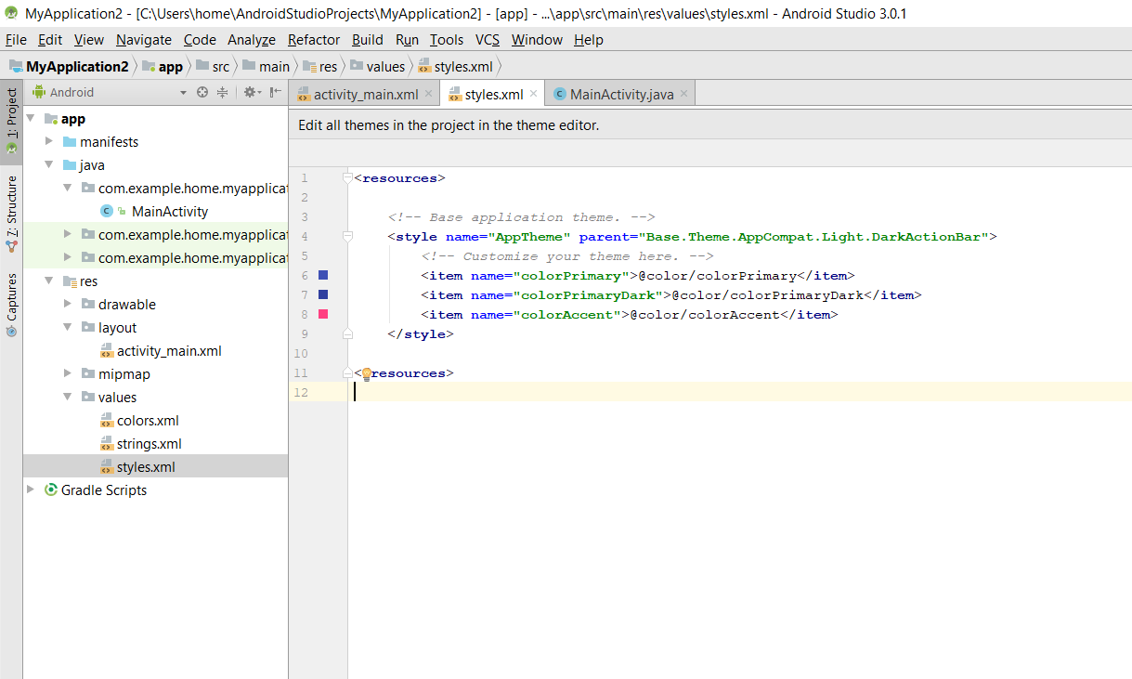

Code:on click function
package com.example.myapplication3;
import androidx.appcompat.app.AppCompatActivity;
import android.os.Bundle;
import android.util.Log;
import android.view.View;
public class MainActivity extends AppCompatActivity {
public void clickFunction(View view){
Log.i("info","Button Clicked!");
}
@Override
protected void onCreate(Bundle savedInstanceState) {
super.onCreate(savedInstanceState);
setContentView(R.layout.activity_main);
}
}

Code: reading input from Text field
public void clickFunction(View view){
EditText name = (EditText) findViewById(R.id.editTextTextPersonName);
EditText password = (EditText) findViewById(R.id.editTextTextPassword);
Log.i("Info","Clicked button Message!");
Log.i("Info","userName:"+name.getText().toString()+ "Password:"+password.getText().toString());
}

Problem: click event triggering even when click out side the button
Remove these two attributes from XML

android:focusable="false"
android:onClick="clickFunction"

code: images Dynamically changing
package com.example.imagesapp;
import androidx.appcompat.app.AppCompatActivity;
import android.os.Bundle;
import android.view.View;
import android.widget.ImageView;
import android.widget.Toast;
public class MainActivity extends AppCompatActivity {
String flag= "image1";
public void changeImage(View view){
ImageView imgV = (ImageView) findViewById(R.id.imageView1);
if(flag=="image1"){
imgV.setImageResource(R.drawable.cat4);
Toast.makeText(this, "Image Changed1!", Toast.LENGTH_SHORT).show();
flag= "image2";
}else if(flag=="image2"){
imgV.setImageResource(R.drawable.cat3);
Toast.makeText(this, "Image Changed2!", Toast.LENGTH_SHORT).show();
flag= "image1";
}
}
@Override
protected void onCreate(Bundle savedInstanceState) {
super.onCreate(savedInstanceState);
setContentView(R.layout.activity_main);
}
}

