# MII Query Template Documentation

# Contents

1. Project set up

Step 1: Downloading Project

Step 2: Deploying Project files to MII Work bench

Step 3: Configurations

Step 4: Running the App

Step 5: Testing the App

1. Features
2. Support

# Project set up

## Step 1: Downloading Project

Download the Project zip from the git gub repository ([git link](https://github.com/subrahmanyam-pampana/MII-Query-Template-project/tree/main/version-2.0/miiQuerytemplate))

You can use the website <https://download-directory.github.io/> to download github project.

Got to the above website and enter the github repository link then hit enter it will download the project as zip file.

Github repository link: <https://github.com/subrahmanyam-pampana/MII-Query-Template-project/tree/main/version-2.0>

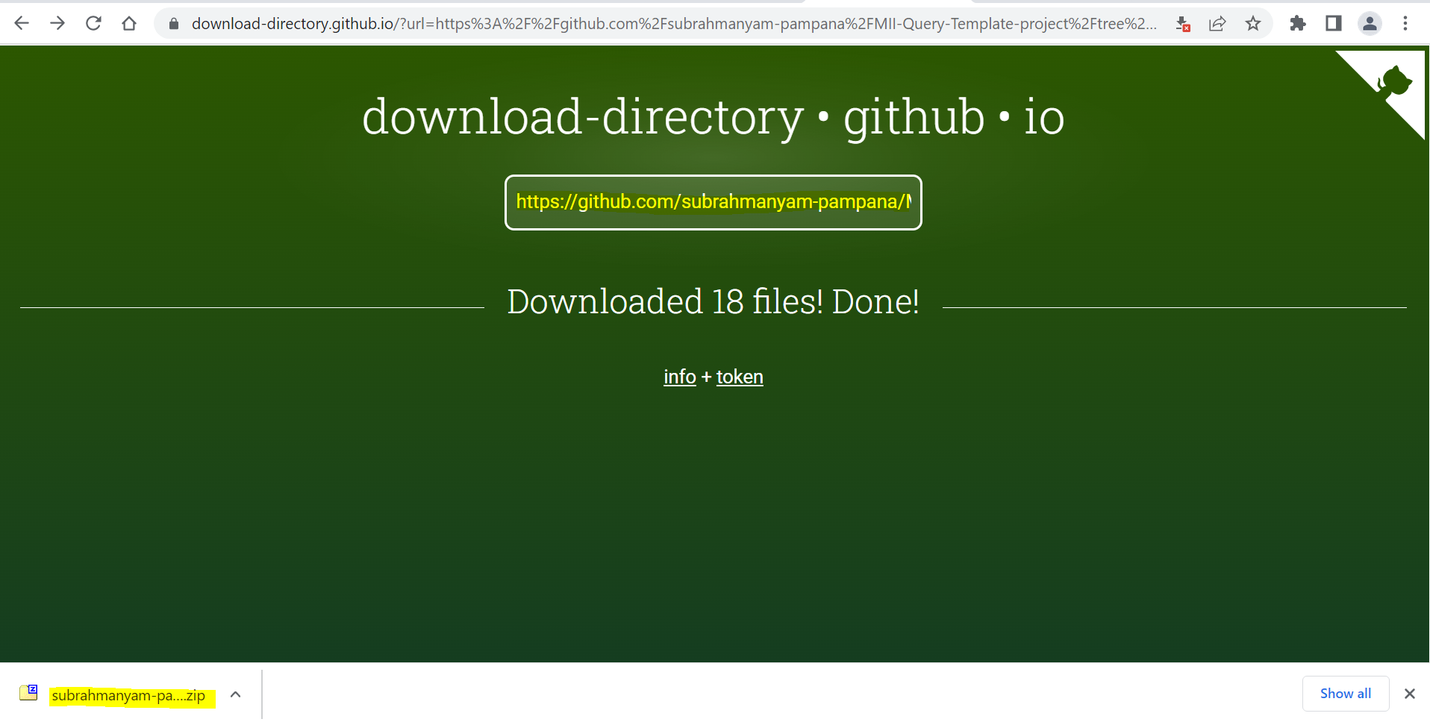

After download, Extract the zip file.This folder contains 3 sub folders

1. MiiQuerytemplate
2. Quries
3. transactions

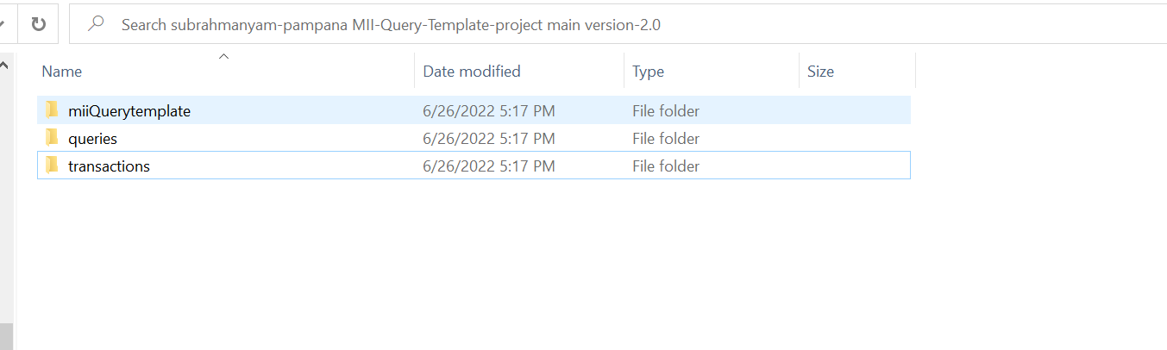

## Step 2: Deploying Project files to MII Work bench

1. Open the MII work bench and got to web tab.Import the MiiQuerytemplate folder to your desired project.
2. Go to the catalog tab and import the queries and transactions folders

## Step 3: Configurations

Open queries and transactions folders in the catalog tab\

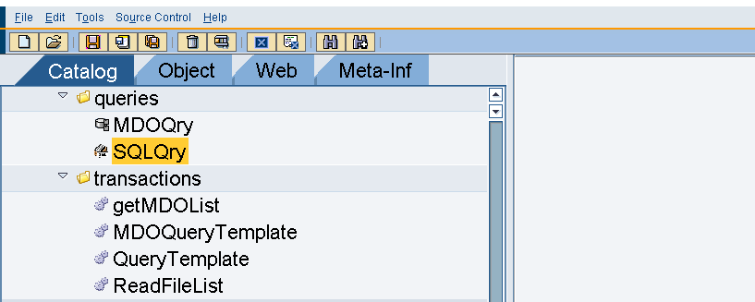

1. Copy all the queries and transctions paths and notedown for later use. Fill all the blanks below with their file paths.

sqlQuery path: ________________

QueryTemplate path:________________

Mdoquery path:______________

getMdoList path:______________

MDOQueryTemplate path: _______________

ReadFileList path:_______________

1. Open the MiiQuerytemplate and got to model/BLSTransactions.json

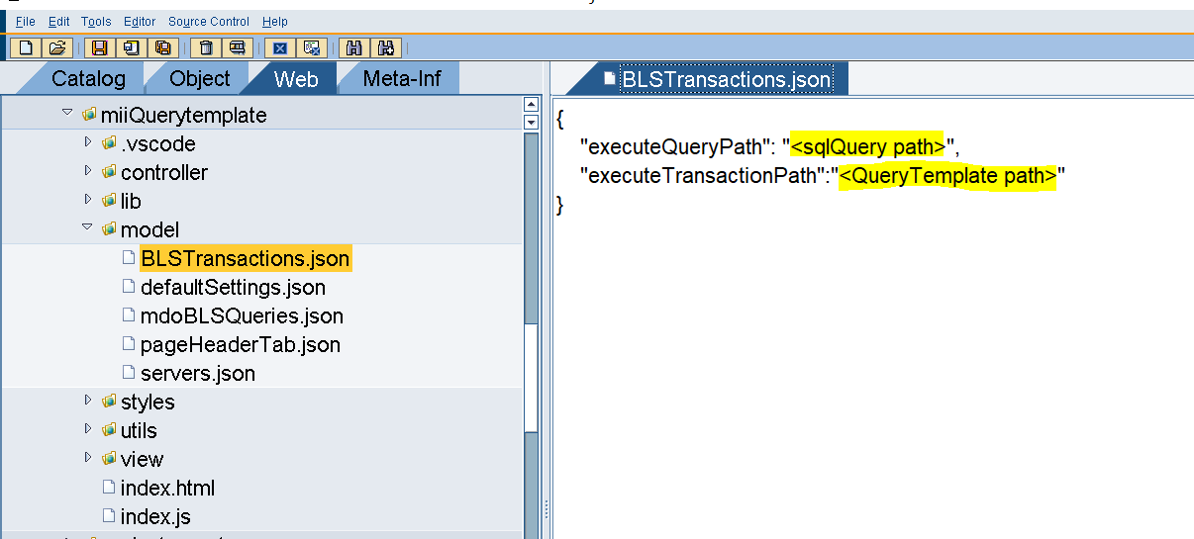

Replace highlighted text with their paths that we note down in above step.

Example:

After replacing it looks like below image. File paths may vary according to your file path.

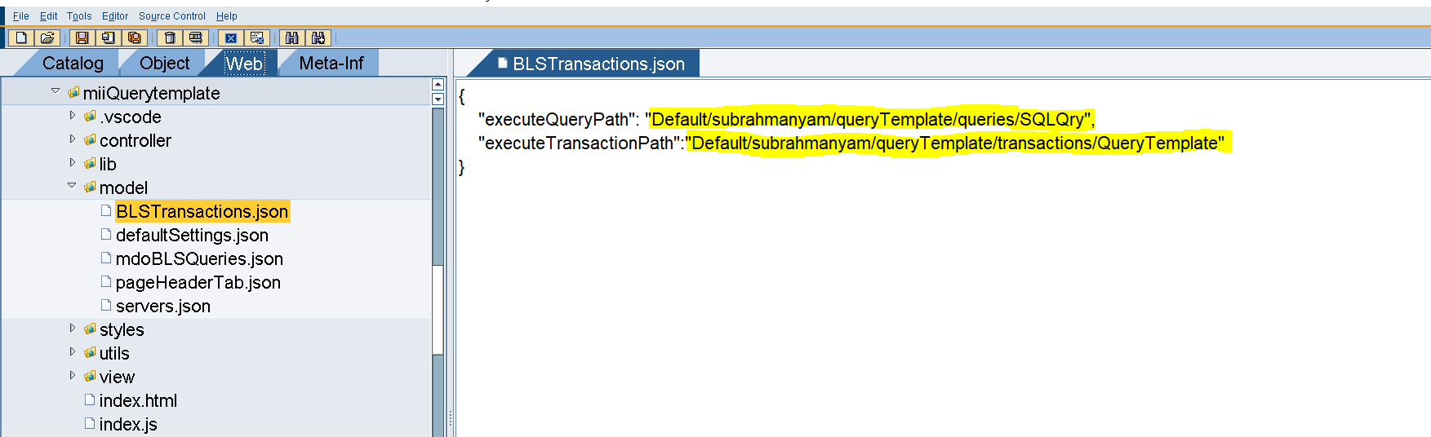

1. Open miiQuerytemplate/model/mdoBLSQueries.json of miiQuerytemplate folder and replace file path highlighted in the below image with their paths.

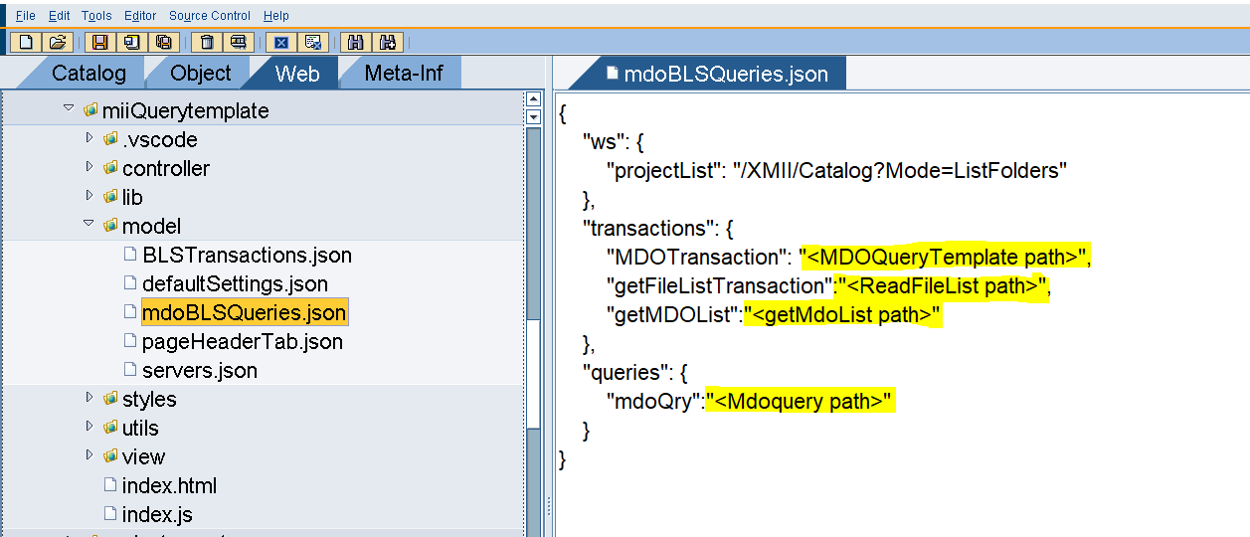

1. Open miiQuerytemplate/model/servers.json file and Configure serverName and respective url. If you have more than two servers then add their configurations by addign new object {“name”:””, “ur”:””} in the array servers.

Here name is the custom name providing to the server that will display in the UI

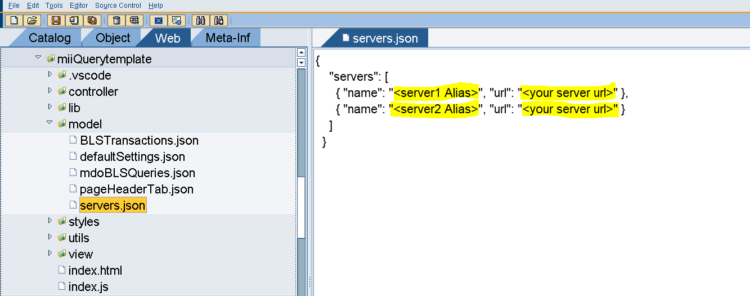

Example:

After configuring the serves and their name it looks like below image

Note: here given fake server url’s. but you need to give here your server url’s

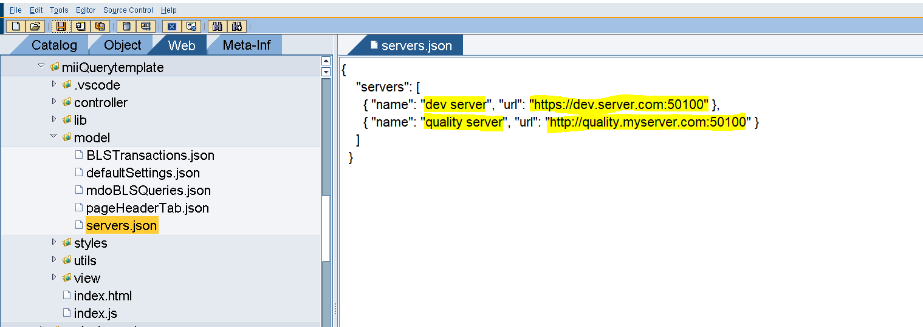

1. Open miiQuerytemplate/model/defaultSettings.json file. This Contains the default settings.

Its not manditory to configure these settings. If you don’t want to put any defaults then leave the setting as blank or remove the settings.

Attributes and their explanation:

|  |  |
| --- | --- |
| Attribute | desciption |
| defaultDataServer | This is the default data server that will select automatically on selection of server in the UI |
| <daserver-1> …. <dataserver-n> | Default table that willl select automatically after selecting the Data server  Note: replace <daserver-1> with respective data source name. see the example below |
| restrictedQueries | List of restricted Queries. You can control the restriced queries by configuring this. |

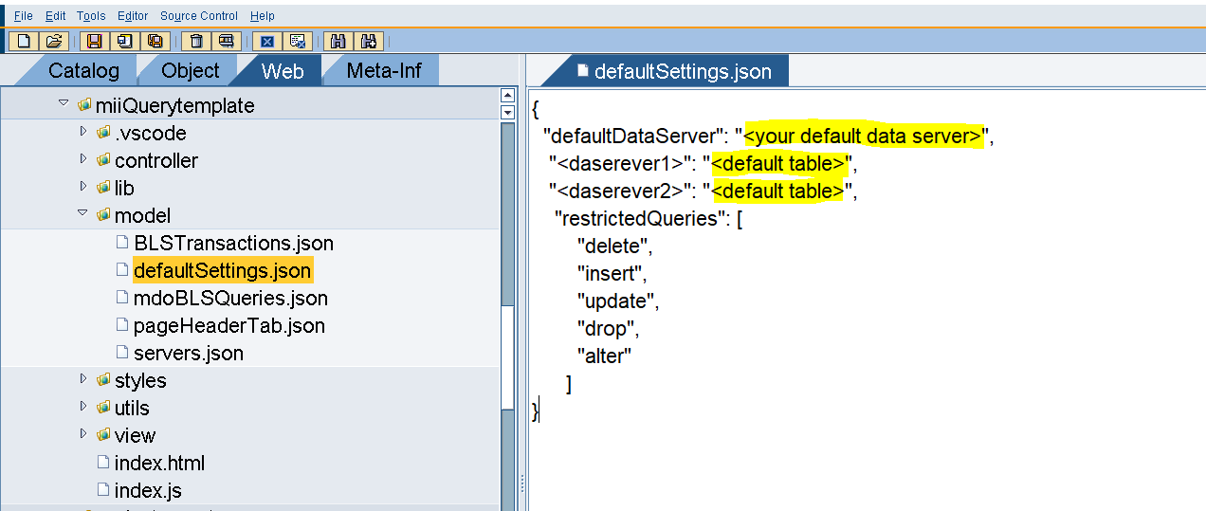

Example:

Lets say we want to select **XMIIDATASOURCE** as my Default Data server and XMII_JCOMESSAGE as Default Table when ever I select This data souce then give the configurations like below.

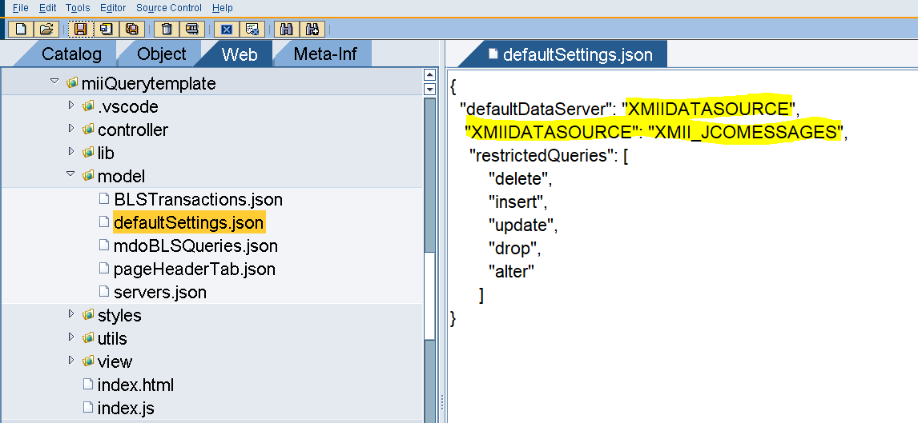

Now I want to Configure Default Table “MYTABLE” for my another data source “MYMIIDATASOURCE” . Then configurations will looks like below

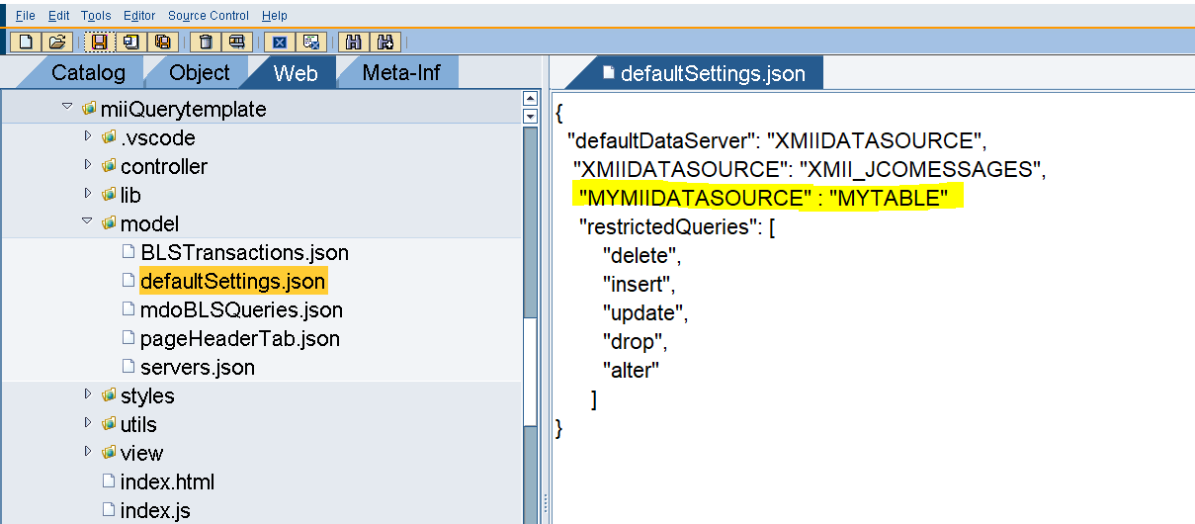

1. We sucessfuly Configured all the Settings

## Step 4: Running the App

1. Open the miiQuerytemplate/index.html file and run the file.it will ask for the credentials.

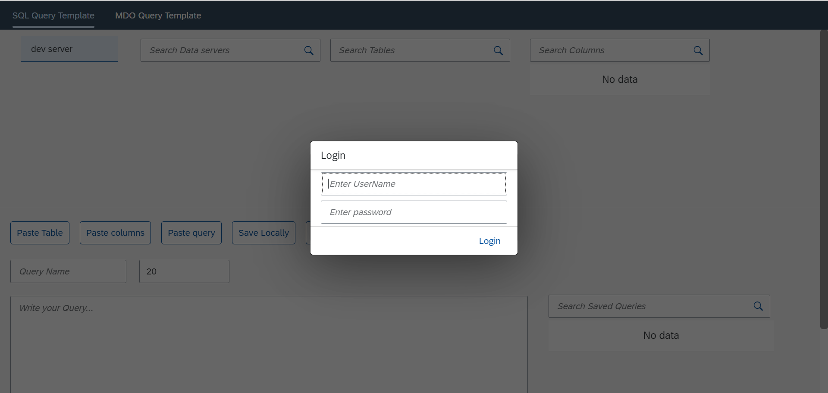

1. Enter your user name and password and click on login button.
2. If Login success it will show below screen

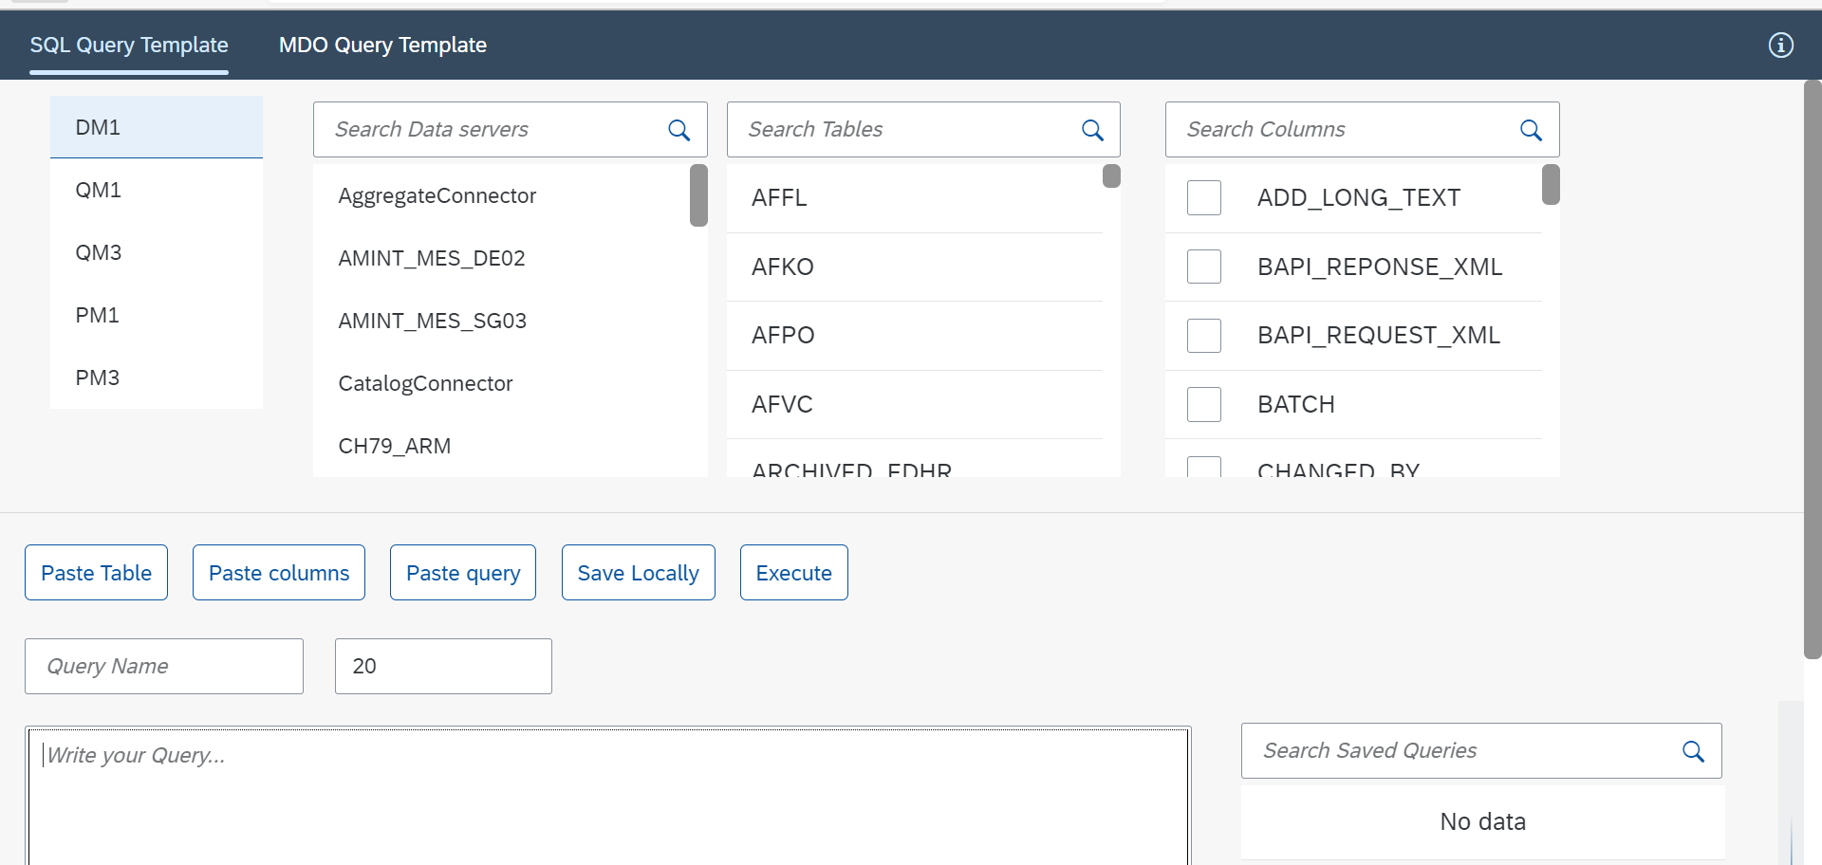

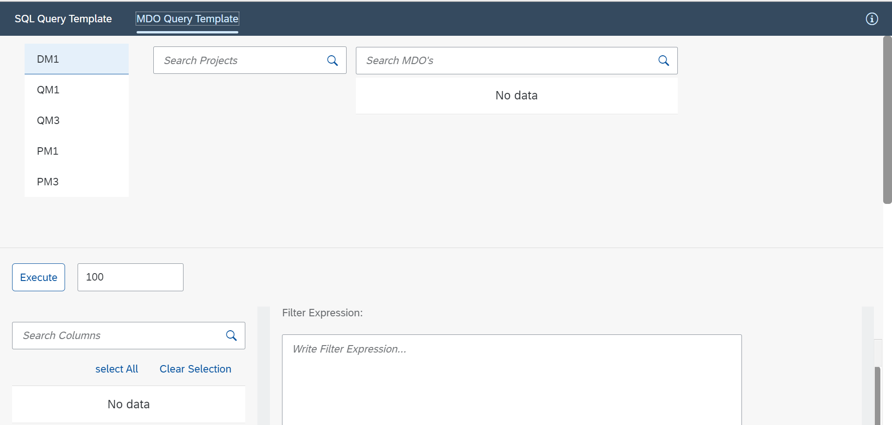

## Step 5: Testing the App

1. Select the server from servers list. App retrieves the Data sources for selected Server
2. Select Data source from the data source list. App retrieves the available tables for the selected data source
3. Select the table from the tables list. App retrieves the columns of the selected table.

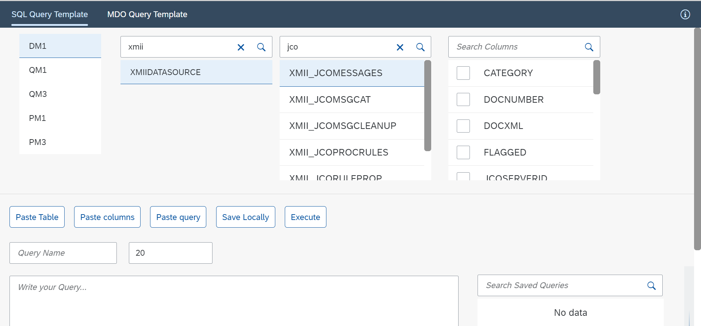

1. Write your Query in the text Area and click on Execute button or press Ctrl+ Enter. App fetches the Data.

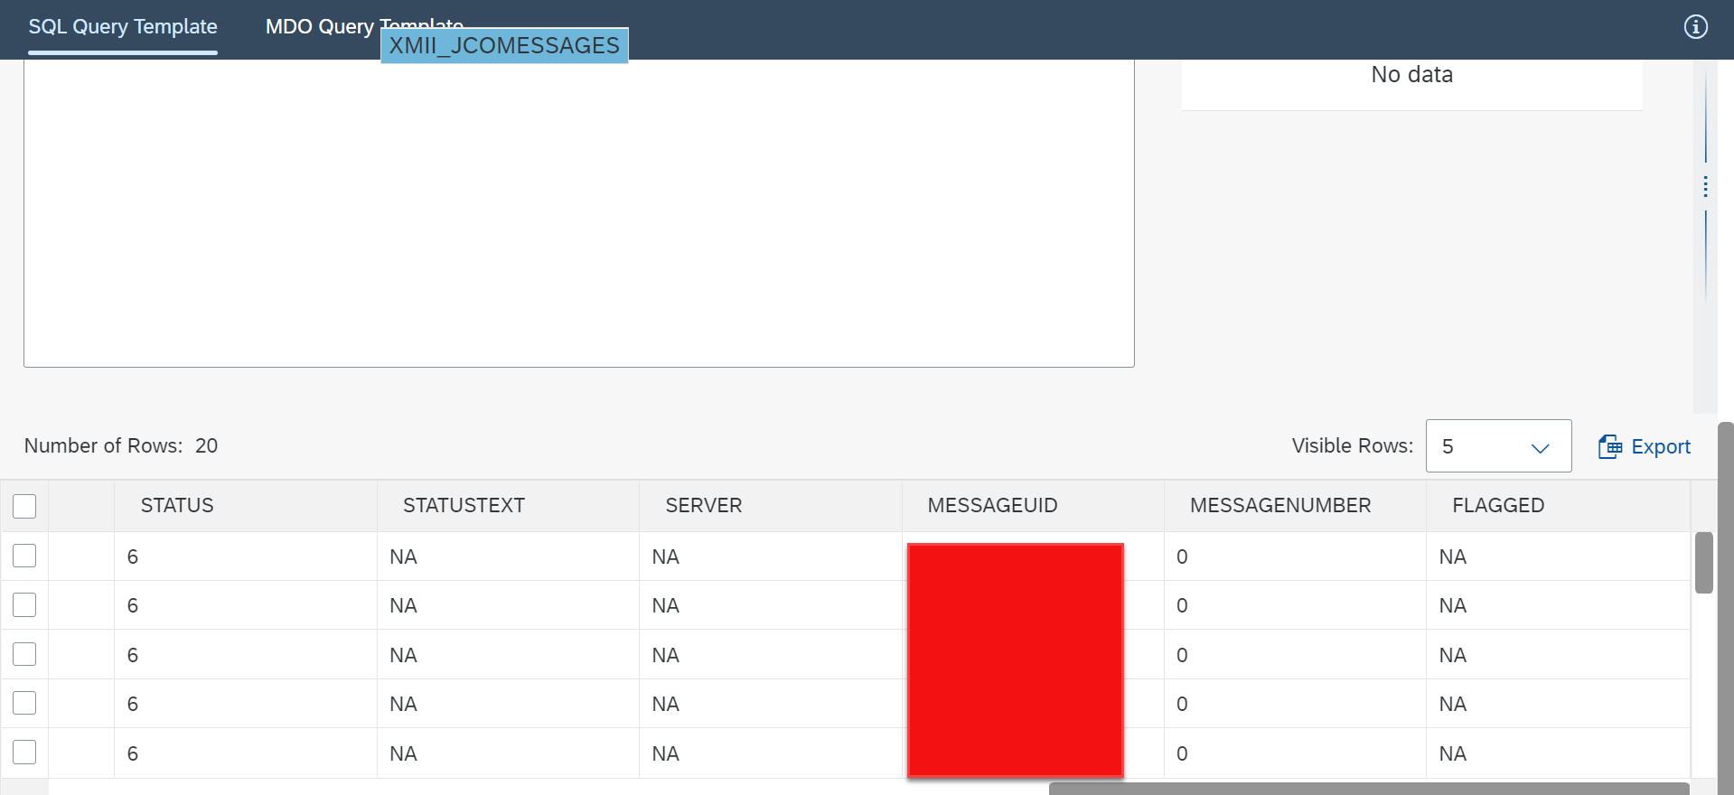

1. Open the MDO Query template Screen and selected the server. App Retrieves the List of Project the Available in MII.
2. Select the Project from the List. App retrieves the available list of MDO’s of selected Project.
3. Select the MDO. App retrieves the Attributes of selected MDO.
4. Select the required Attributes and if required write the Filter expression and Sort expression in their respective text areas.
5. Click on Execute button or Press CTRL + Enter to Execute the Query.

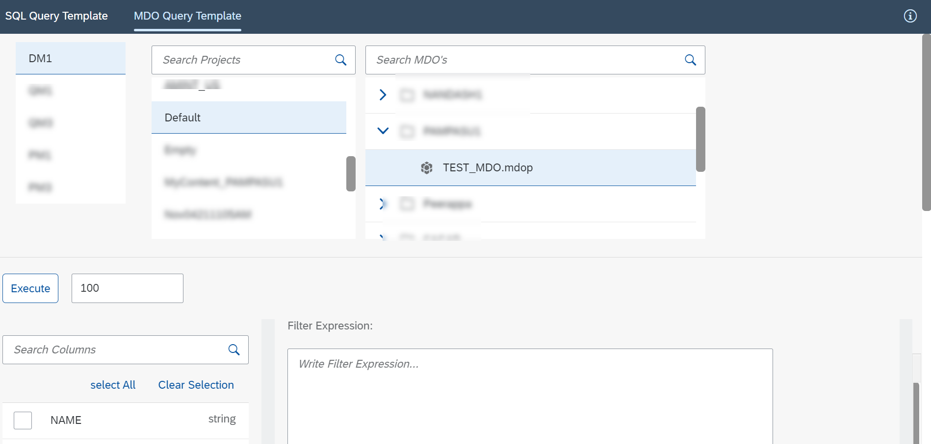

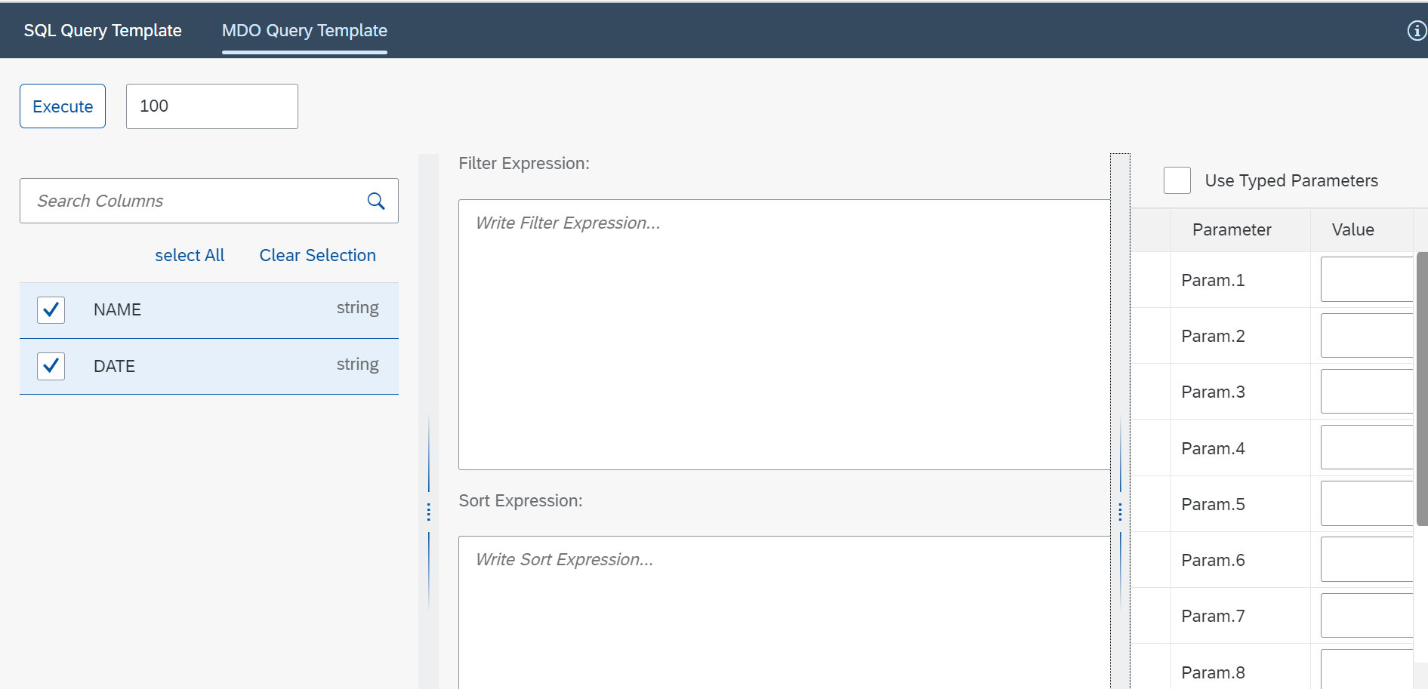

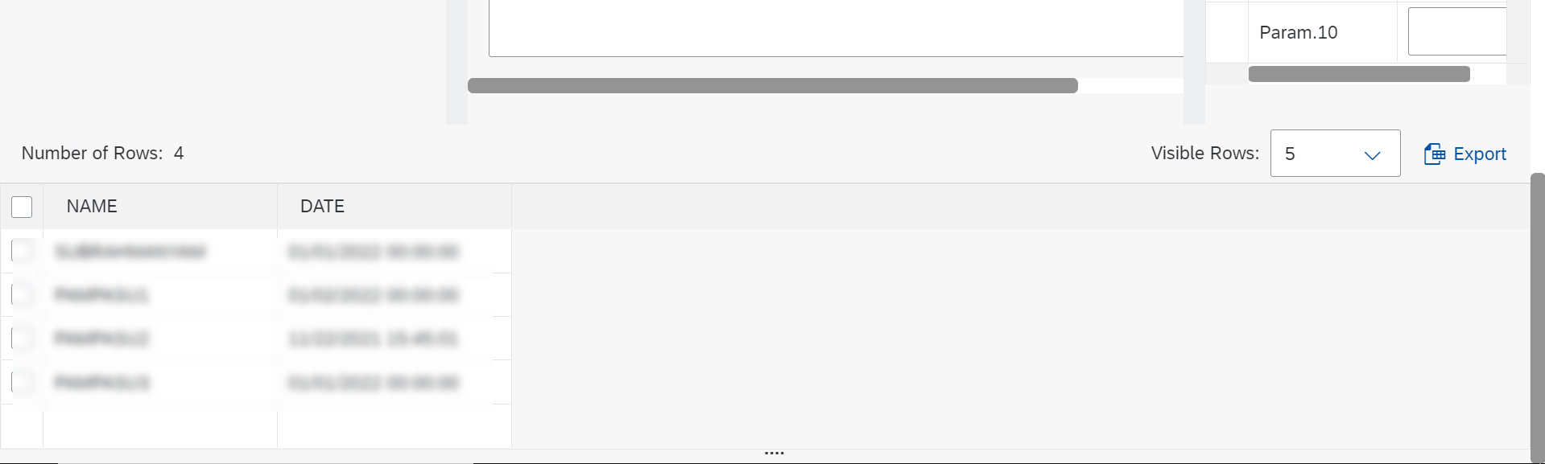

# Features

1. We can also export the data by clicking on the export button. App will download xslx file.

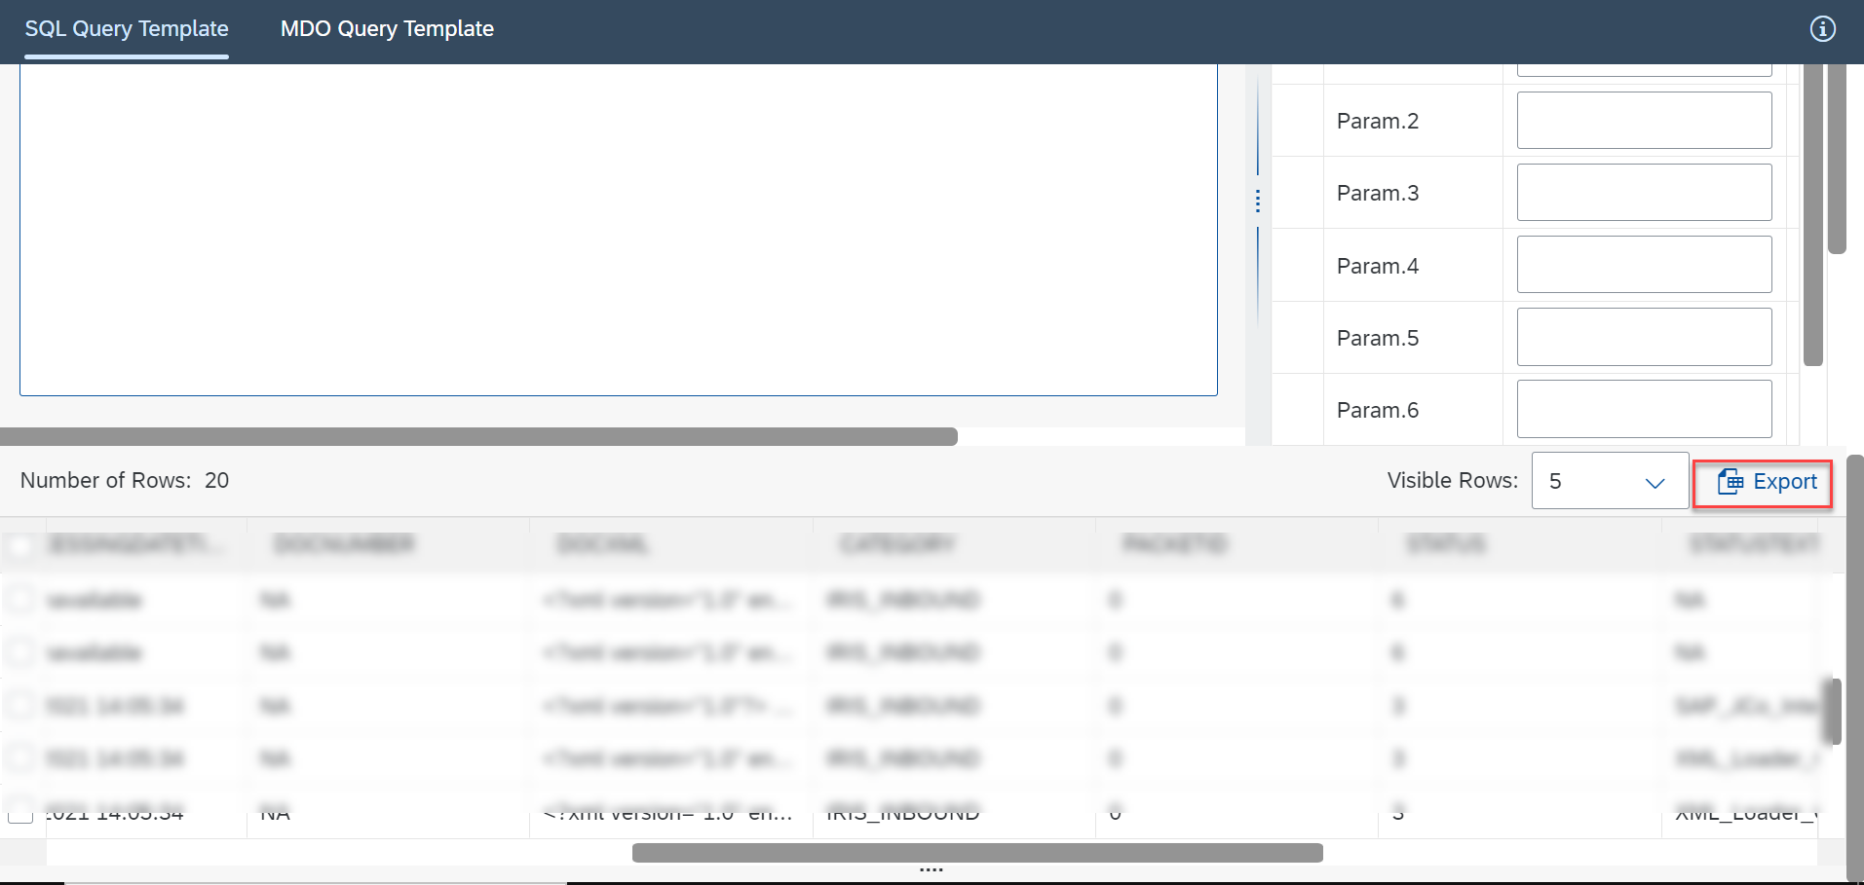

1. Auto suggestions, while writing the Query press CTRL+ Space to view the code suggestions.

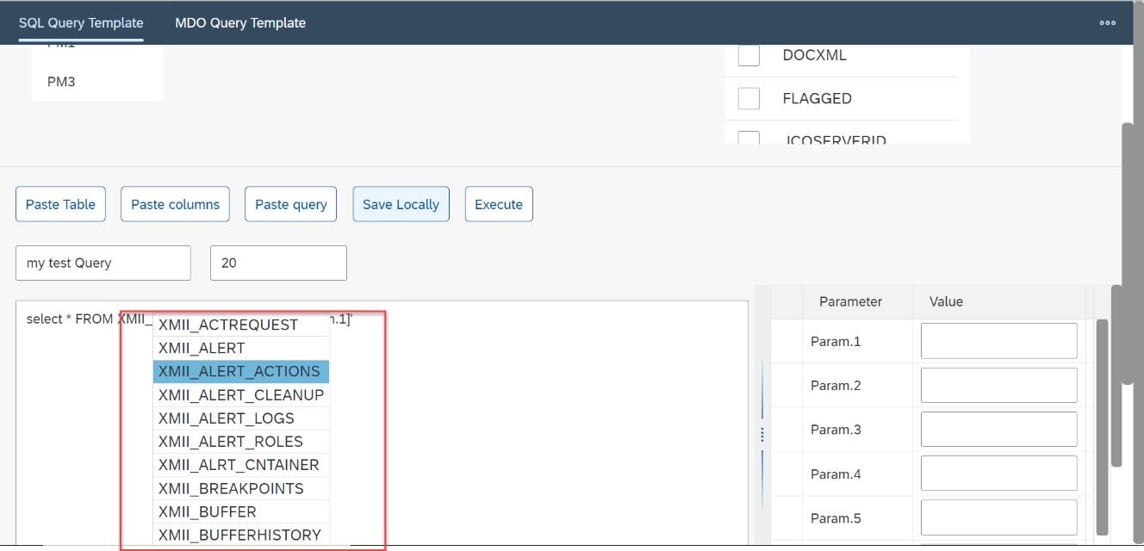

1. We can Change the visible Row count select drop down the change the visible rows.

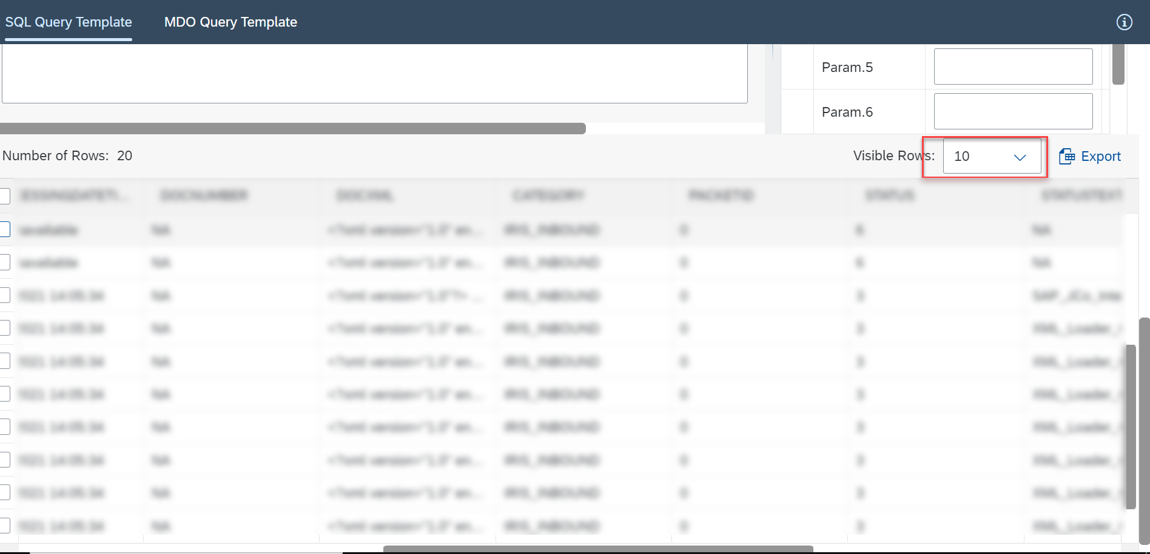

1. We can Control the number of records by changing the row count text box.

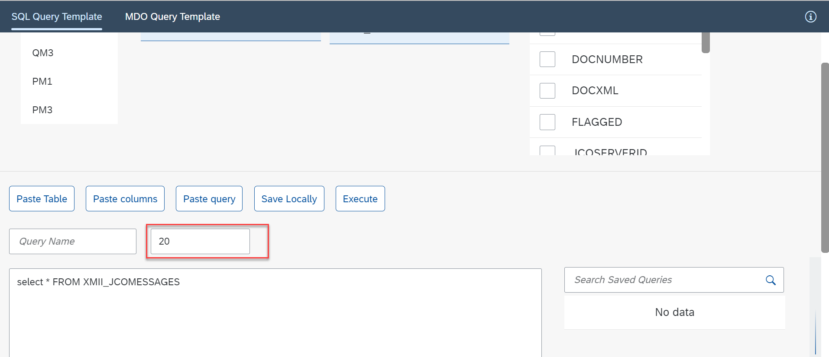

1. We can Save the Query locally in browser.

For saving the Query , enter the Query name and press Save locally button.

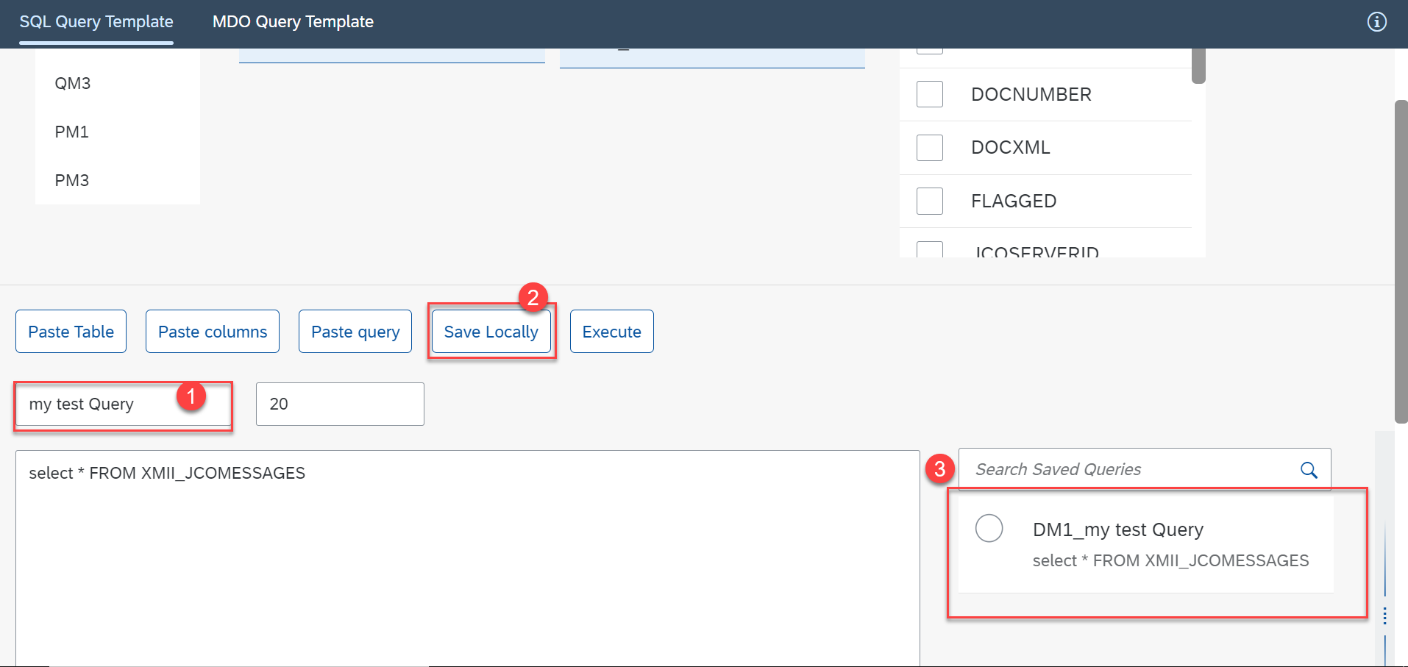

1. We can add the Parameters to Query like we do in MII queries

For adding the Parameters,

1. drag the right panel

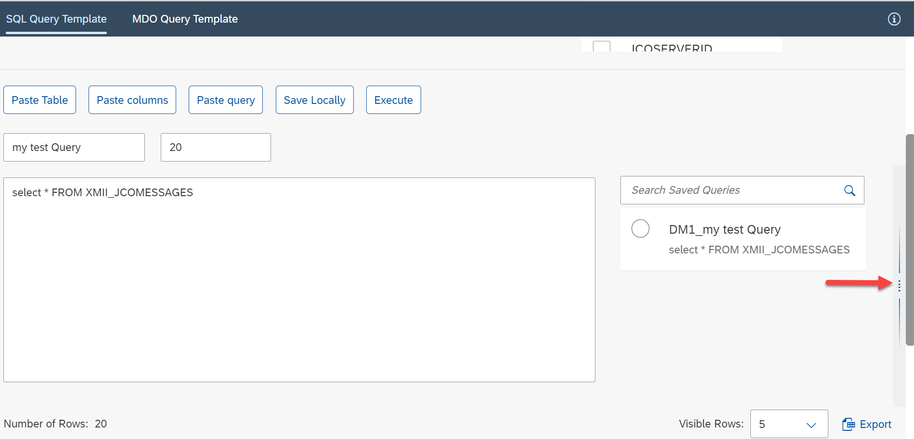

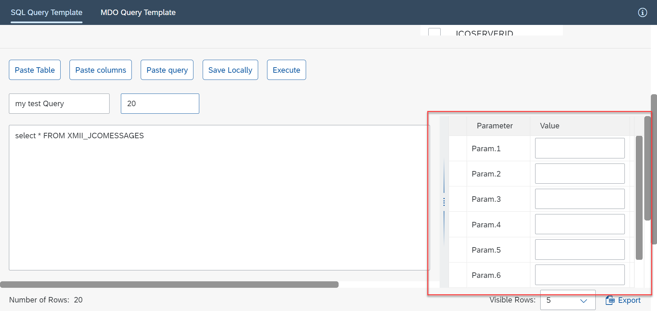

1. type [Param.1] or drag the parameter from the table drop in text area. If the filed is text then put single quotes around the [Param.1] like I did in the below screenshot

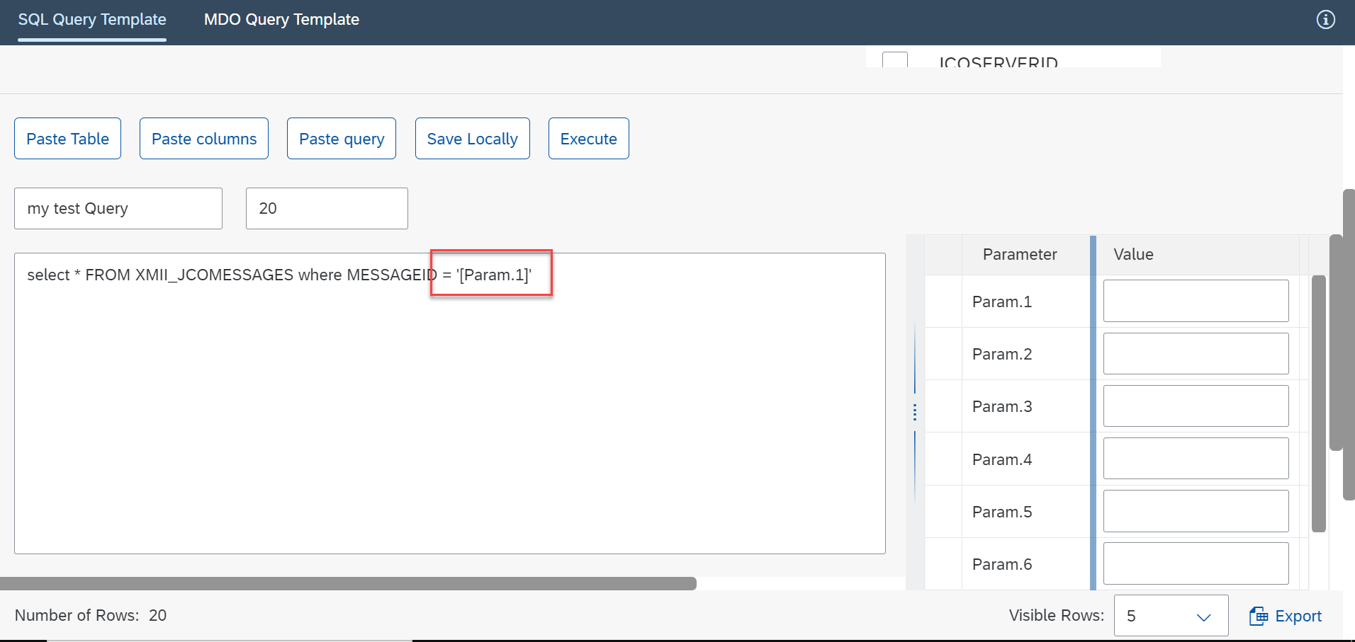

1. We can Drag and drop below fields from the respective lists to query text area.
2. Table
3. Column
4. Parameters
5. Saved Queries

# Support

1. Please Click on information icon on top right corner to view the short cuts and application documentation links.

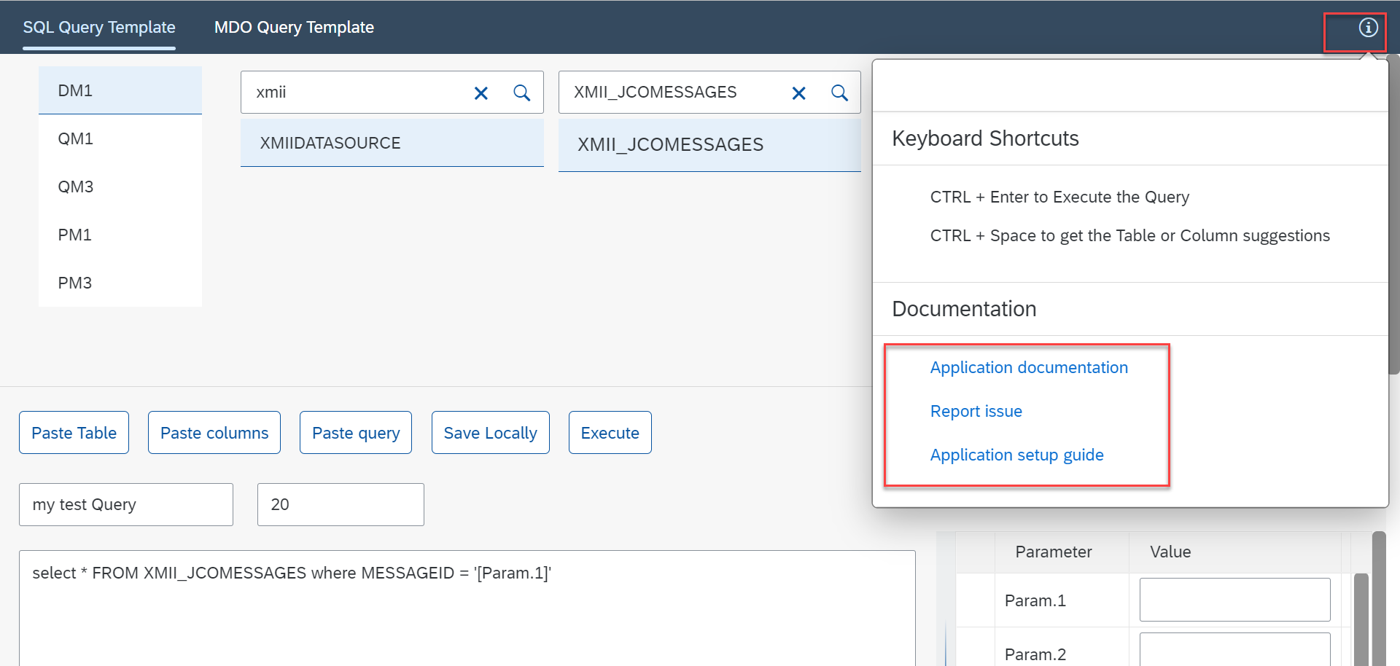

1. You can report an issue by clicking on Report issue link. it will take you to git hub where this code hosted.