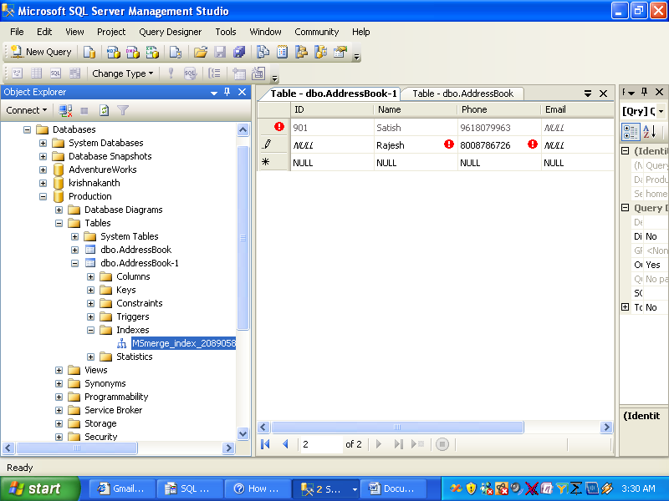

On the options page

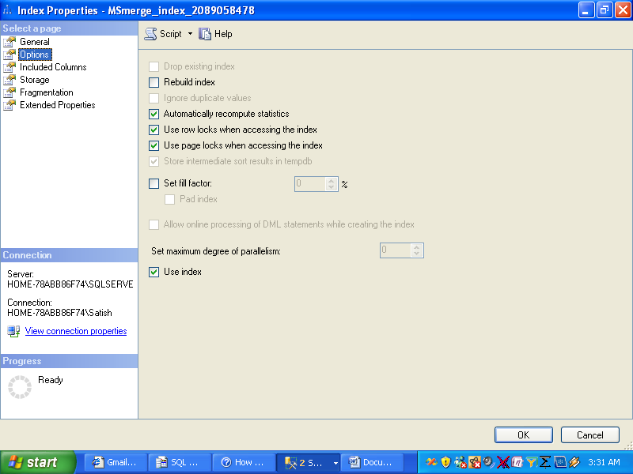

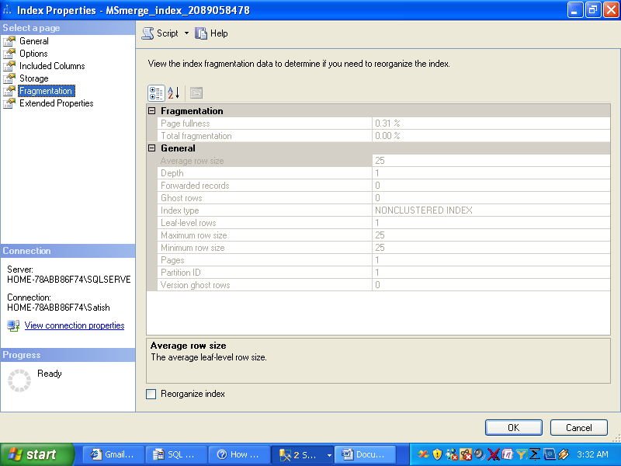

**To rebuild an index**

1. In Object Explorer, connect to an instance of the SQL Server 2005 Database Engine and then expand that instance.
2. Expand **Databases**, expand the database that contains the table with the specified index, and then expand **Tables**.
3. Expand the table in which the index belongs and then expand **Indexes**.
4. Right-click the index to rebuild and then click **Rebuild**.
5. To start the rebuild operation, click **OK**.

**To rebuild all indexes on a table**

1. In Object Explorer, connect to an instance of the SQL Server 2005 Database Engine and then expand that instance.
2. Expand **Databases**, expand the database that contains the table with the specified indexes, and then expand **Tables**.
3. Expand the table in which the indexes belong.
4. Right-click **Indexes** and then click **Rebuild All**.
5. To start the rebuild operation, click **OK**.

Source:How DO I Help

