**Steps for viewing the quorum configuration of a failover cluster**

When you install a failover cluster, the cluster software automatically chooses an appropriate quorum configuration for that cluster, based mainly on the number of nodes (even or odd). You can easily view the quorum configuration of an existing cluster using either the Failover Cluster Management snap-in or the command line.

**To view the quorum configuration of an existing cluster using the Failover Cluster Management snap-in**

1. To open the failover cluster snap-in, click **Start**, click **Administrative Tools**, and then click **Failover Cluster Management**. (If the **User Account Control** dialog box appears, confirm that the action it displays is what you want, and then click **Continue**.)
2. In the console tree, if the cluster that you want to view is not displayed, right-click **Failover Cluster Management**, click **Manage a Cluster**, and then select the cluster you want to view.
3. In the center pane, find **Quorum Configuration**, and view the description.

In the following example, the quorum mode is **Node and Disk Majority** and the disk witness is **Cluster Disk 2**.

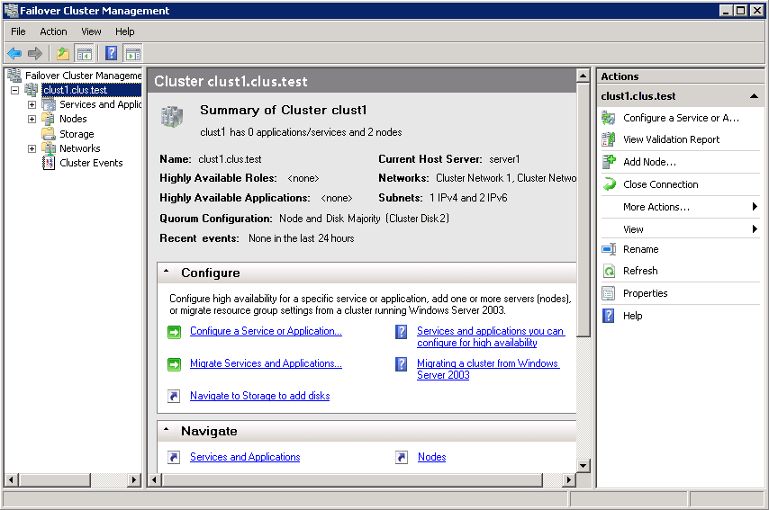

**To view the quorum configuration of an existing cluster using the Command Prompt window**

1. To open a Command Prompt window, on a cluster node, click **Start**, right-click **Command Prompt**, and then either click **Run as administrator** or click **Open**.
2. If the **User Account Control** dialog box appears, confirm that the action it displays is what you want, and then click **Continue**.
3. Review the configuration of the quorum by typing:

**cluster /quorum**

**Steps for changing the quorum configuration in a failover cluster**

You must complete the following steps to change the quorum configuration in a failover cluster.

|  |
| --- |
| **ImportantImportant** |
| Unless you have changed the number of nodes in your cluster, it is usually best to use the quorum configuration recommended by the quorum configuration wizard. We only recommend changing the quorum configuration if you have determined that the change is appropriate for your cluster. |

Membership in the local **Administrators** group on each clustered server, or equivalent, is the minimum permissions required to complete this procedure. Also, the account you use must be a domain user account. Review details about using the appropriate accounts and group memberships at <http://go.microsoft.com/fwlink/?LinkId=83477>.

**To change the quorum configuration in a failover cluster**

1. To open the failover cluster snap-in, click **Start**, click **Administrative Tools**, and then click **Failover Cluster Management**. (If the **User Account Control** dialog box appears, confirm that the action it displays is what you want, and then click **Continue**.)
2. In the Failover Cluster Management snap-in, if the cluster you want to configure is not displayed, in the console tree, right-click **Failover Cluster Management**, click **Manage a Cluster**, and select or specify the cluster you want.
3. With the cluster selected, under **Actions**, click **More Actions**, and then click **Configure Cluster Quorum Settings**.

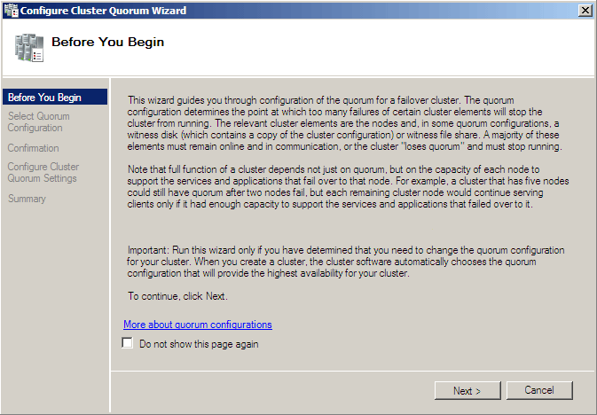

1. Click **Next**. The following illustration shows the wizard page that displays for a cluster with an even number of nodes. Note that the text on this page varies, depending on whether the cluster has an even number or odd number of nodes. To view more information about the selections on this page, at the bottom of the page, click **More about quorum configurations**.

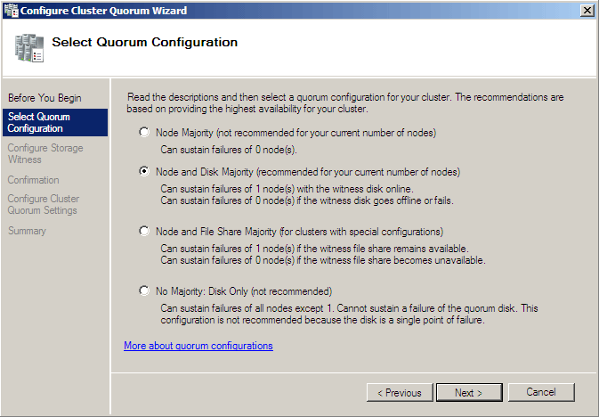

1. Select a quorum mode from the list. For more information, see [Choosing the quorum mode for a particular cluster](http://technet.microsoft.com/en-us/library/cc770620(WS.10).aspx#BKMK_choosing), earlier in this guide.
2. Click **Next** and then go to the appropriate step in this procedure:
   * If you chose **Node Majority**, go to the last step in this procedure.
   * If you chose **Node and Disk Majority** or **No Majority**, go to the next step in this procedure.
   * If you chose **Node and File Share Majority**, skip to step 8 in this procedure.
3. If you chose **Node and Disk Majority** or **No Majority**, a wizard page similar to the following appears. (For **No Majority**, the title of the page is **Select Storage Resource**.) Select the storage volume that you want to use for the disk witness (or if you chose **No Majority**, for the quorum resource), and then skip to step 9. For information about the requirements for the disk witness, see [Requirements and recommendations for clusters using Node and Disk Majority](http://technet.microsoft.com/en-us/library/cc770620(WS.10).aspx#BKMK_requirementsNandD).

If you change disk assignments on this page, the former storage volume is no longer assigned to the core **Cluster Group** and instead goes back to **Available Storage**.

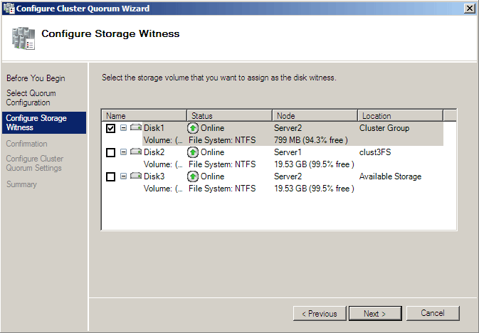

1. If you chose **Node and File Share Majority**, the following wizard page appears. Specify the file share you want to use, or click the **Browse** button and use the standard browsing interface to select the file share. For information about the requirements for the file share, see [Requirements and recommendations for clusters using Node and File Share Majority](http://technet.microsoft.com/en-us/library/cc770620(WS.10).aspx#BKMK_RequirementsNandFS).

Source :http://technet.microsoft.com/en-us/library/cc770620(WS.10).aspx

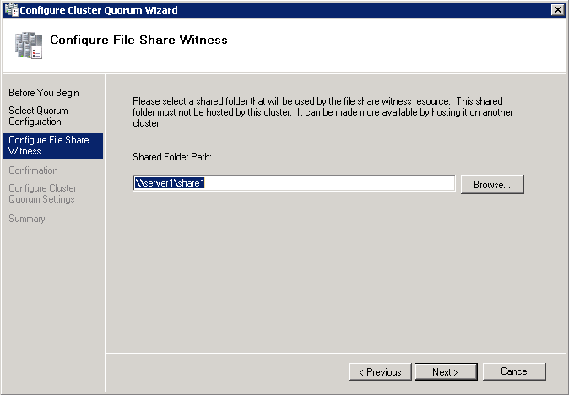

1. Click **Next**. Use the confirmation page to confirm your selections, and then click **Next**.
2. After the wizard runs and the **Summary** page appears, if you want to view a report of the tasks that the wizard performed, click **View Report**.

|  |
| --- |
| **noteNote** |
| The most recent report will remain in the *systemroot***\Cluster\Reports** folder with the name **QuorumConfiguration.mht**. |

**Troubleshooting: how to force a cluster to start without quorum**

When troubleshooting, you might be in a situation where the cluster is offline because it does not have quorum, but you want to bring it online. The first thing to understand is your quorum mode and why you no longer have quorum. This may provide some insight into how the cluster can achieve quorum and come online automatically. If you need to force the Cluster service to start, you can make all nodes which can communicate with each other begin working together as a cluster by running the **net start clussvc** command with an option for forcing quorum. The cluster will use the copy of the cluster configuration that is on the node on which you run the command, and replicate it to all other nodes. To force the cluster to start, on a node that contains a copy of the cluster configuration that you want to use, type the following command:

**net start clussvc /fq**

The command can also be typed as **net start clussvc /forcequorum**. In Windows Server 2008, the **net start clussvc** command no longer includes the **/resetquorumlog** or **/fixquorum** options.**Forcing a cluster to start that does not have quorum may be especially useful in an unbalanced multi-site cluster. If you have a five-node multi-site cluster and three nodes at Site A fail, then the two nodes at Site B will go offline since they no longer have quorum.** If there is a genuine disaster at Site A, then it may take a significant amount of time for the site to come online, and so you would likely want to force Site B to come online, even though it does not have quorum.

When a cluster is forced to start without quorum it continually looks to add nodes to the cluster and is in a special “forced” state. Once it has majority, the cluster moves out of the forced state and behaves normally, which means it is not necessary to rerun the cluster command without a startup switch. If the cluster then loses a node and drops below quorum, it will go offline again because it is no longer in the forced state. At that point, to bring it online again while it does not have quorum would require running **net start clussvc /fq** again.