CSCI 6441 – Project Proposal Group 2:
Stock Trend Analysis Web App Samuel Crowell
Ibou Diallo
David Liu
Aaron Woods

Objective
The objective of our group project is to provide a web application to analyze and visualize stock performance over time. Our project will allow users to get a visual history of a single stock's performance as a graph. In addition, users can identify performance parameters for a stock and find stocks that fit those parameters. We also intend to do automated grouping and display of similarly performing stocks.

High Level Overview
Our web app will lead with a typical summary and login or register page. A logged on user will be presented with a list of all the stock ticker IDs that we currently track.
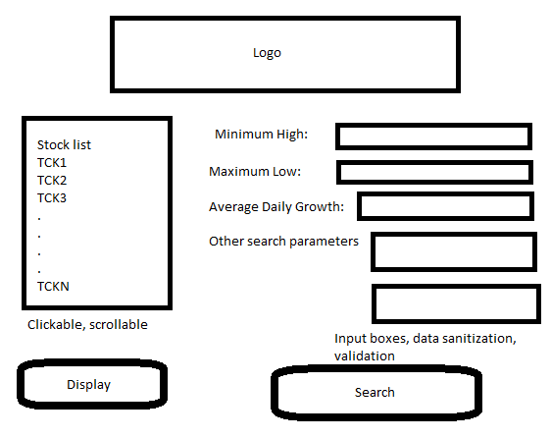Illustration 1: Search Page Mockup
Users interested in looking at a specific stock can click it's ticker ID to see a line graph showing the highs, lows, and percentage growth/loss over time. From there they can use a “Find Others Like This” button to cause the web app to search the database and analyze performance of stocks to find matching ones. This analysis may be cached for performance reasons. Transaction data and company data will both be stored in the database.
Users can also specify search parameters and find stocks that match their specifications. The searches themselves may be cached as a “Recent searches” feature. These cached searches will be in the database.
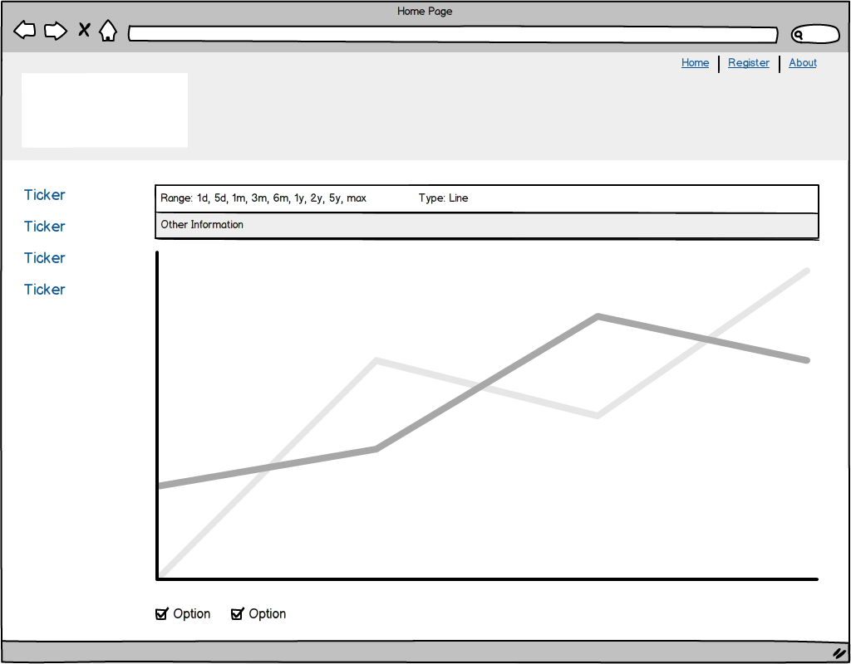Illustration 2: Stock Performance Page Mockup
The site will also have user registration and authentication. If time permits we plan to make the database administration features available through the web app itself for an Administrator user. We also intend for the user account data to be stored in the database.

Use Case Definitions

Actors
Unauthenticated User – An unregistered or unauthenticated user
Authenticated User – A user registered with and logged into the app.
Stock Viewer – A user using the app to view or search stock data
Administrator – A user allowed to update the database through the web application

Use Case Index
ID | Name/Action | Actor
1 | Views single stock performance | Stock Viewer
2 | Searches stocks by single/multiple parameters | Stock Viewer
3 | Finds stocks with similar performance as specified stock | Stock Viewer
4 | Registers for the site | Unauthenticated User
5 | Logs into the site | Unauthenticated User
6 | Cancels account | Authenticated User

Use Cases
ID | 1
Name | Stock viewer views single stock performance
Description | A Stock Viewer identifies a stock ticker symbol he/she wants to examine more closely.
Basic Flow | - Stock Viewer clicks Ticker Symbol in Stock List  - Stock Viewer clicks Display  - New web page loads with multi-line graph displaying trend data of stock over time: Opening, High, Low, Closing
ID | 2
Name | Stock viewer searches stocks by single/multiple parameters
Description | A Stock Viewer inputs search parameters and searches for matching stocks.
Basic Flow | - Stock Viewer inputs parameters into parameter input boxes  - Stock Viewer clicks Search  - New web page loads with a Stock List containing only stocks that match the parameters specified.  - Stock Viewer can follow steps of Use Case 1 with new Stock List.
ID | 3
Name | Stock viewer finds stocks with similar performance as specified stock
Description | A stock Viewer has identified a stock he/she likes and wishes to find other stocks that perform similarly.
Basic Flow | - Stock Viewer has already performed Use Case 1.  - Stock Viewer clicks “Find Others Like This” button.  - New web page loads with a Stock List containing stocks that match performance of the originally chosen stock.  - Stock Viewer can follow steps of Use Case 1 with new Stock List
ID | 4
Name | Unauthenticated user registers for site
Description | An Unauthenticated User wishes to register for the site to view stock data.
Basic Flow | - Unauthenticated User clicks “Register” on landing page.  - New web page loads with input boxes for Email Address, First Name, Last Name, Password, Confirm Password.  - User inputs information and clicks “Register”.  - User is logged in and forwarded to the stock selection/search page
ID | 5
Name | Unauthenticated user logs into the site
Description | An Unauthenticated User wishes to authenticate him/herself to the site.
Basic Flow | - Unauthenticated User fills in the Email and Password boxes on the landing page.  - User clicks Login.  - User is logged in and forwarded to the stock selection/search page
ID | 6
Name | Authenticated user cancels account
Description | An Authenticated User wishes to delete his account from the site.
Basic Flow | - Authenticated User clicks Admin button at top of stock selection/search page.  - New web page loads with information about the user: First Name, Last Name, email.  - User clicks Cancel account.  - User confirms account cancellation through Dialog box.  - User is logged out, account deleted, and forwarded to the landing page.

