Amazon Sales Analysis Using Excel and Power BI
Presented by: G Subramani

Problem Statement
The objective of this project is to analyze Amazon sales data to identify:
- Top-selling product categories
- Region-wise performance
- Monthly sales trends
- Customer purchase patterns
The goal is to convert raw data into meaningful insights using Excel and Power BI.

Solution Overview
- Cleaned and prepared data using Microsoft Excel
- Applied formulas to structure and enrich the dataset
- Created pivot tables for detailed analysis
- Built an interactive Power BI dashboard
- Visualized key performance metrics and insights

Tools Used in the Project
Microsoft Excel:
• Used for data cleaning, formatting, formulas (IF, CONCAT, LEFT, LEN, ROUND)
• Applied conditional formatting
• Created pivot tables and charts for analysis
Microsoft Power BI:
• Used for building interactive dashboards
• Included KPIs, bar charts, line charts, and slicers
• Developed insights from category, city, and monthly performance
Pivot Tables:
• Summarize and analyze large datasets
• Provide category-wise and region-wise insights

Excel Output (Data Cleaning & Formulas)
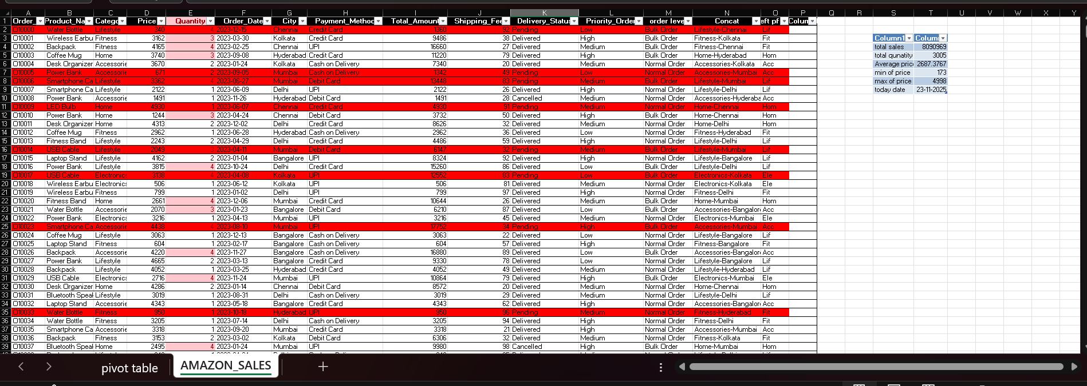

Pivot Table Output (Excel Analysis)
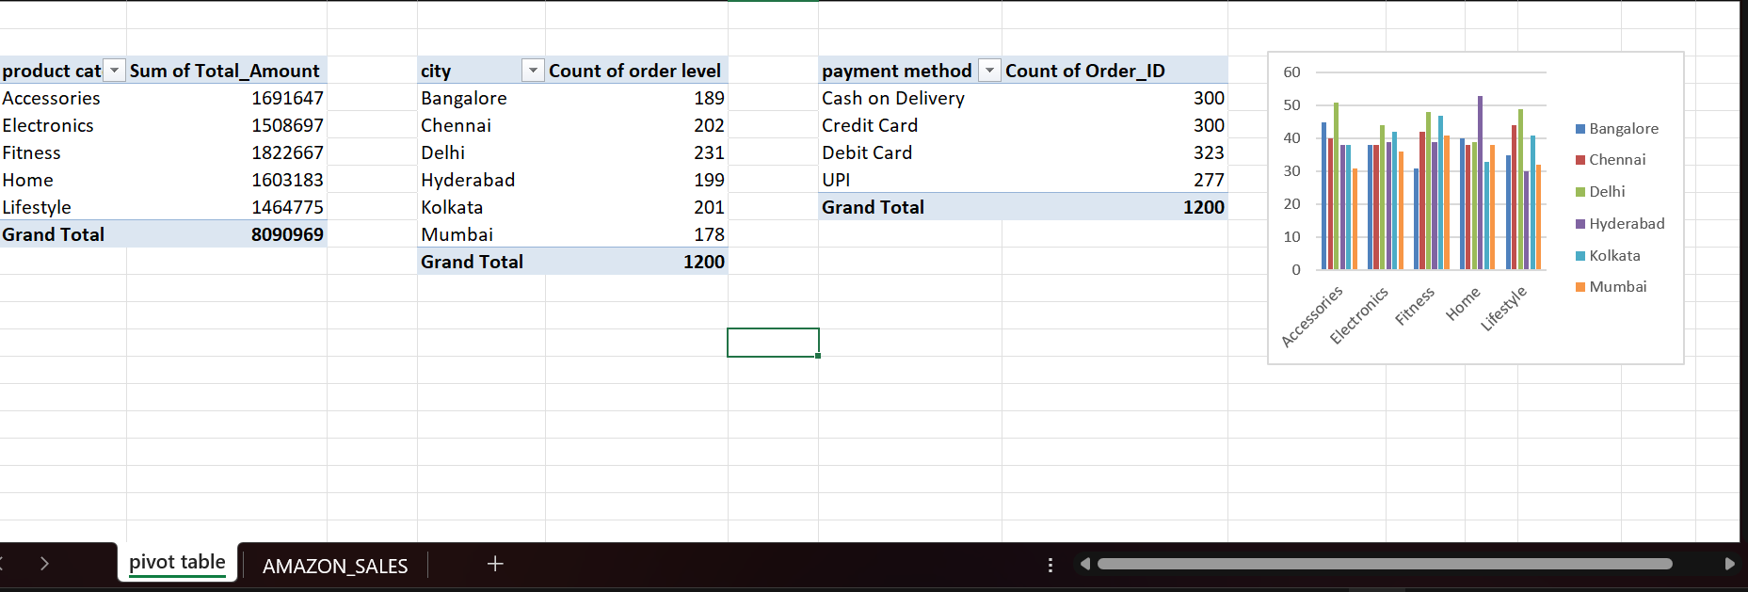

Power BI Dashboard Output
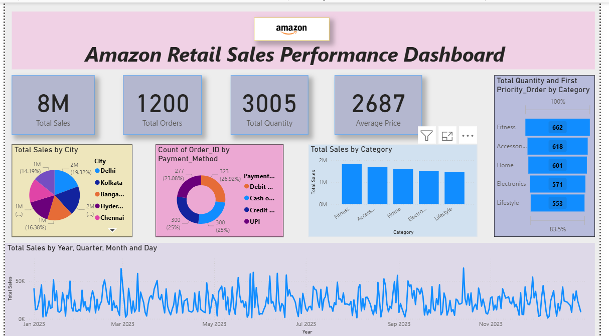

Conclusion
The project demonstrates the successful use of Excel and Power BI to transform raw sales data into actionable insights. Data was cleaned, analyzed using formulas and pivot tables, and visualized in Power BI through KPI cards and graphical dashboards.
Key insights include:
- Top-performing categories
- Region-wise sales distribution
- Monthly and seasonal sales performance
This analysis supports informed business decision-making and strategic planning.

