EX.NO:10  DATE:20/03/25 | SEGMENTATION

AIM:
To segment an image into meaningful regions by distinguishing objects from the background using different techniques.

THRESHOLDING:
ALGORITHM:
- Convert the given image into a grayscale image.
- Create a binary image of the same shape as the grayscale image.
- Compare each pixel value in the grayscale image with a predefined threshold value.
- If the pixel value is greater than or equal to the threshold, set it to 255 (white).
- If the pixel value is less than the threshold, set it to 0 (black).
- Return the binary thresholded image.
CODE SNIPPET:

def thresholding(img, threshold_value=128):
gray_image = cv2.cvtColor(img, cv2.COLOR_BGR2GRAY)
binary_image = np.zeros_like(gray_image)

binary_image[gray_image >= threshold_value] = 255
binary_image[gray_image < threshold_value] = 0

return binary_image

threshold_value = 128
segmented_image = thresholding(image, threshold_value)

plt.figure(figsize=(10, 5))

plt.subplot(1, 2, 1)
plt.title("Original Image")
plt.imshow(image)
plt.axis('off')
plt.subplot(1, 2, 2)
plt.title("Thresholded Image")
plt.imshow(segmented_image, cmap='gray')
plt.axis('off')
plt.show()

OUTPUT:

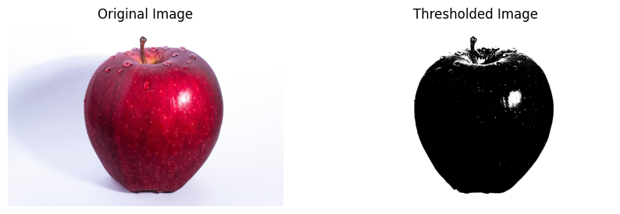

GRAPH CUT:
ALGORITHM:
- Initialize a mask of the same size as the image and set all pixel values to zero.
- Define a rectangular region containing the foreground object.
- Initialize background and foreground models.
- Apply the GrabCut algorithm:
- Iterate through the image and classify pixels as foreground or background using energy minimization.
- Update the background and foreground models accordingly.
- Convert the final mask into a binary form where foreground pixels are assigned 1 and background pixels are assigned 0.
- Multiply the original image with the binary mask to extract the segmented foreground.
CODE SNIPPET:
mask = np.zeros(image.shape[:2], np.uint8)

bg_model = np.zeros((1, 65), np.float64)
fg_model = np.zeros((1, 65), np.float64)

rect = (50, 50, image.shape[1] - 100, image.shape[0] - 100)

cv2.grabCut(image, mask, rect, bg_model, fg_model, 5, cv2.GC_INIT_WITH_RECT)

mask_final = np.where((mask == 2) | (mask == 0), 0, 1).astype("uint8")

segmented_image = image * mask_final[:, :, np.newaxis]

plt.figure(figsize=(10, 5))
plt.subplot(1, 2, 1)
plt.imshow(image)
plt.title("Original Image")
plt.axis("off")

plt.subplot(1, 2, 2)
plt.imshow(segmented_image)
plt.title("Segmented Image (Graph Cut)")
plt.axis("off")

plt.show()

OUTPUT:

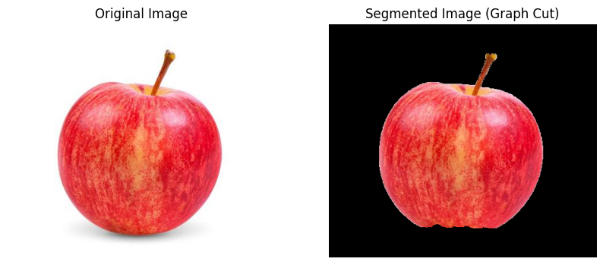
MEAN SHIFT:

ALGORITHM:
- Define spatial and color radius parameters.
- Apply the pyrMeanShiftFiltering function:
- Shift pixel values iteratively based on spatial and color proximity.
- Pixels with similar color intensities are clustered together.
- Return the segmented image, where objects with similar color intensities are grouped together.

CODE SNIPPET:

spatial_radius = 100
color_radius = 30
segmented_image = cv2.pyrMeanShiftFiltering(image, spatial_radius, color_radius)

plt.figure(figsize=(10, 5))
plt.subplot(1, 2, 1)
plt.imshow(image)
plt.title("Original Image")
plt.axis("off")

plt.subplot(1, 2, 2)
plt.imshow(segmented_image)
plt.title("Segmented Image (Mean Shift)")
plt.axis("off")

plt.show()

OUTPUT:

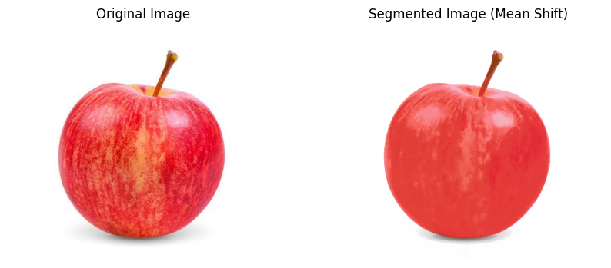

K MEANS CLUSTERING:

ALGORITHM:
- Reshape the image into a 2D array where each pixel is treated as a data point.
- Define the number of clusters KKK and the termination criteria.
- Apply the K-Means clustering algorithm:
- Assign each pixel to the nearest cluster based on color similarity.
- Compute the new cluster centers by averaging the assigned pixels.
- Repeat the process until convergence or the maximum number of iterations is reached.
4.Replace pixel values with their corresponding cluster center values.
5.Reshape the clustered data back to the original image shape.
6.Return the segmented image.

CODE SNIPPET:

def k_means_segmentation(image, K=3, max_iter=10):

pixels = image.reshape((-1, 3)).astype(np.float32)
criteria = (cv2.TERM_CRITERIA_EPS + cv2.TERM_CRITERIA_MAX_ITER, max_iter, 1.0)
_, labels, centers = cv2.kmeans(pixels, K, None, criteria, 10, cv2.KMEANS_RANDOM_CENTERS)

centers = np.uint8(centers)
segmented_pixels = centers[labels.flatten()]

# Reshape back to the original image shape
segmented_image = segmented_pixels.reshape(image.shape)

return segmented_image

K = 3
segmented_image = k_means_segmentation(image, K=K, max_iter=10)

plt.figure(figsize=(10, 5))
plt.subplot(1, 2, 1)
plt.imshow(image)
plt.title("Original Image")
plt.axis("off")

plt.subplot(1, 2, 2)
plt.imshow(segmented_image)
plt.title(f"K-Means Segmentation (K={K})")
plt.axis("off")

plt.show()

OUTPUT:

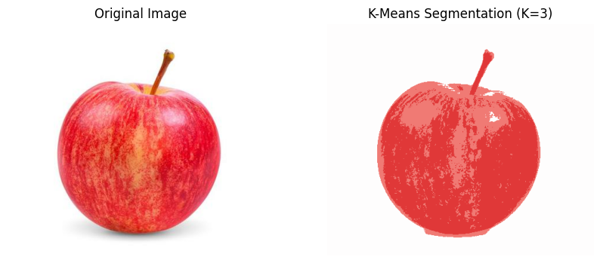

REGION GROWING:

ALGORITHM:
- Initialize empty region and visited masks.
- Set the seed pixel in the region mask and mark it as visited.
- Use a queue to check neighboring pixels within the threshold.
- If a neighbor meets the criteria, add it to the region and queue.
- Repeat until all connected pixels are processed.

CODE SNIPPET:
from collections import deque
image_path = r"C:\Users\student\Pictures\Saved Pictures\apple.jpg"
image_gray = cv2.imread(image_path, cv2.IMREAD_GRAYSCALE)

threshold = 4
seed_x, seed_y = 80, 50

def region_growing_seed(image, seed_x, seed_y, threshold):

region = np.zeros_like(image, dtype=np.uint8)
visited = np.zeros_like(image, dtype=np.uint8)

queue = deque([(seed_y, seed_x)])
region[seed_y, seed_x] = 255
visited[seed_y, seed_x] = 1

while queue:
current_y, current_x = queue.popleft()

for dy, dx in [(-1, 0), (1, 0), (0, -1), (0, 1)]:
ny, nx = current_y + dy, current_x + dx

if 0 <= ny < image.shape[0] and 0 <= nx < image.shape[1] and visited[ny, nx] == 0:

if abs(int(image[ny, nx]) - int(image[current_y, current_x])) < threshold:
region[ny, nx] = 255
visited[ny, nx] = 1
queue.append((ny, nx))

return region

region = region_growing_seed(image_gray, seed_x, seed_y, threshold)

plt.figure(figsize=(12, 6))

plt.subplot(1, 2, 1)
plt.imshow(image_gray, cmap='gray')
plt.title('Original Image')
plt.axis('off')

plt.subplot(1, 2, 2)
plt.imshow(region, cmap='gray')
plt.title('Region Growing from Seed')
plt.axis('off')

plt.show()

OUTPUT:

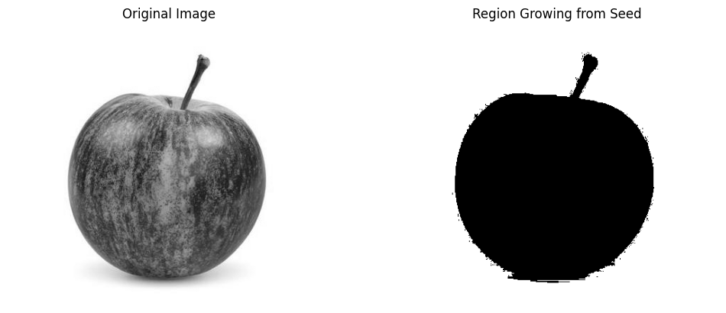

RESULT:

Each method segments the image differently: thresholding creates a binary image, graph cut isolates objects, mean shift clusters colors, and K-means simplifies regions. These techniques improve feature extraction and image analysis.

