Contents

Architecture 2

Data Model 3

Mockups 5

# Architecture

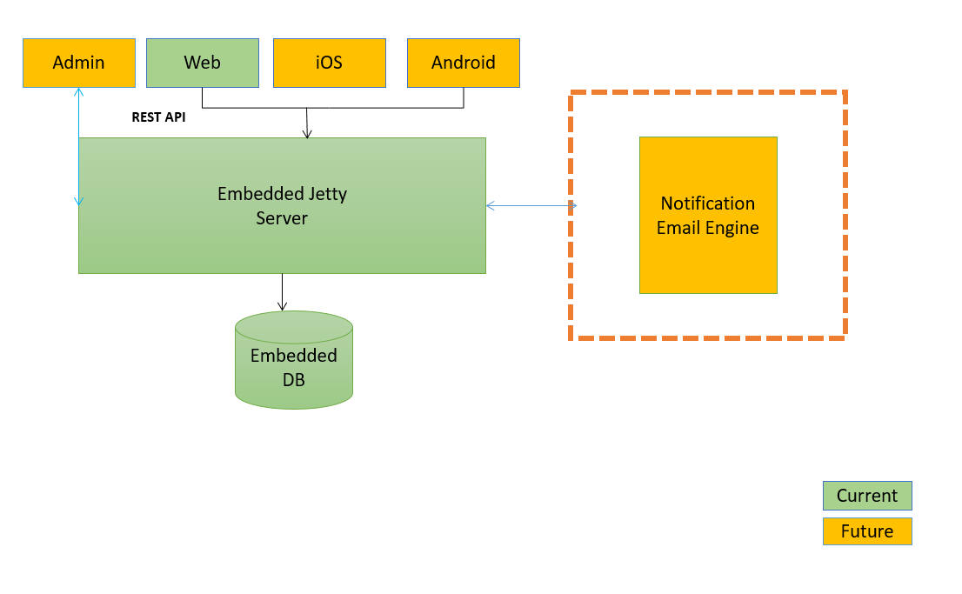

# Data Model



User Status = “INVITED”,“ACTIVE”,”INACTIVE”

Group Status = “ACTIVE”,”INACTIVE”

Expense Status = “PAID”,”PENDING”

Event Status = “ACTIVE”,”EXPIRED”

Group Status = “ACTIVE”,”SUSPENDED”

|  |  |  |  |
| --- | --- | --- | --- |
| **Table Name** | **user** | |  |
| **Column Name** | **Type** | **Reference** | **Comment** |
| ident | int |  | PRIMARY KEY |
| phoneNumber | varchar | Phone number | Mobile number |
| userStatus | varchar | User status | Ex: “INVITED”,”OTPSENT”,“ACTIVE”,”INACTIVE” |
| createdDate | datetimeoffset |  |  |
| otp | Varchar |  |  |
|  |  |  |  |
| **Table Name** | **group** | |  |
| **Column Name** | **Type** | **Reference** | **Comment** |
| ident | int |  | PRIMARY KEY |
| groupName | varchar | Group Name |  |
| groupStatus | varchar | Group Status | “ACTIVE”,”INACTIVE” |
| createdDate | datetimeoffset |  |  |
| Admin | Int | Admin reference (FKEY) user(ident) |  |

|  |  |  |  |
| --- | --- | --- | --- |
|  |  |  |  |
| **Table Name** | **event** | |  |
| **Column Name** | **Type** | **Reference** | **Comment** |
| ident | int |  | PRIMARY KEY |
| eventName | varchar | Event Name | Ex: College Reunion |
| noOfUsers | int | Total Users | Ex: 20 |
| cost | double | Cost for event | Rs 20000 /- |
| createdDate | datetimeoffset |  |  |
| evnetStatus | Varchar | Event Status | Ex: “ACTIVE”,”EXPIRED |
|  |  |  |  |
| **Table Name** | **groupUser** | |  |
| **Column Name** | **Type** | **Reference** | **Comment** |
| ident | int |  | PRIMARY KEY |
| userId | int | user(ident) |  |
| groupId | int | Group(ident) |  |
| createdOn | datetimeoffset |  |  |
| Status | Varchar |  |  |
|  |  |  |  |
|  |  |  |  |
| **Table Name** | **expense** | |  |
| **Column Name** | **Type** | **Reference** | **Comment** |
| id | int |  | PRIMARY KEY |
| userId | int | user (ident) fkey |  |
| Eventid | Int | Event(ident) FKEY |  |
| groupId | Int | Group(ident) |  |
| amountToPay | Int |  |  |
| createdOn | datetimeoffset |  |  |
| expenseStatus | Varchar |  |  |
| payDate | datetimeoffset |  |  |
|  |  |  |  |
|  |  |  |  |

# Mockups

**Sign Up:**

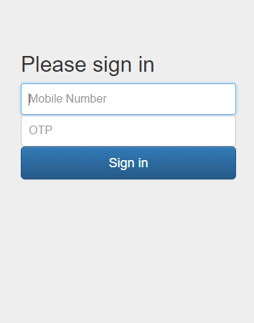

**Reports:**

