**Dependency Injection**

* Create a new dynamic web project and name it as “DependencyInjection”
* Version 3.0 and generate the xml
* Copy the new set of libraries folder named “jsfspringjpa” from share folder and put the files under the lib folder.
* Copy the faces-congig,listener package,web.xml from previous project
* Create a package com.hexa.entity an dpaste the student class from hibernategrid application
* Copy and paste the hibernate.cfg.xml file under src folder
* Create a package com.hexa.dao and paste the dao and daoimpl java files
* Create a package com.hexa.web and a class StudentBean under it
* Create a jsp “StudentView” under web content folder
* Add another managed bean in faces-config.xml

**IDao.java**

**package** com.hexa.dao;

**import** java.util.List;

**import** com.hexa.entity.Student;

**public** **interface** IDao {

**public** **int** addStudent(Student student);

**public** Student getStudent(**int** sid);

**public** **int** updateStudent(**int** sid, **int** marks);

**public** **int** updateStudent(Student student);

**public** **int** deletStudent(**int** sid);

List<Student> getStudents();

List<Student> getStudents(String dept);

}

**IdaoImpl.java**

package com.hexa.dao;

import java.util.List;

import org.hibernate.HibernateException;

import org.hibernate.Query;

import org.hibernate.Session;

import org.hibernate.SessionFactory;

import org.hibernate.Transaction;

import org.hibernate.cfg.AnnotationConfiguration;

import org.hibernate.cfg.Configuration;

import org.hibernate.sql.Delete;

import com.hexa.entity.Student;

public class DaoImpl implements IDao {

private static SessionFactory sfac;

static {

Configuration cfg = new AnnotationConfiguration();

cfg.configure();

sfac = cfg.buildSessionFactory();

}

@Override

public int addStudent(Student student) {

Session sess = null;

Transaction tx = null;

try {

sess = sfac.openSession();

tx = sess.beginTransaction();

sess.save(student);

tx.commit();

return 1;

} catch (HibernateException e) {

System.out.println(e.getMessage());

if (tx != null) {

tx.rollback();

}

} finally {

if (sess != null) {

sess.close();

}

}

return 0;

}

@Override

public Student getStudent(int sid) {

Session sess = sfac.openSession();

Student stu = (Student) sess.get(Student.class, sid);

sess.close();

return stu;

}

@Override

public int updateStudent(int sid, int marks) {

Session sess = sfac.openSession();

Student stu = (Student) sess.get(Student.class, sid);

Transaction tx = sess.beginTransaction();

stu.setMarks(marks);

tx.commit();

sess.close();

return 1;

}

@Override

public int deletStudent(int sid) {

Session sess = sfac.openSession();

Student stu = (Student) sess.get(Student.class, sid);

Transaction tx = sess.beginTransaction();

try {

sess.delete(stu);

tx.commit();

System.out.println(stu);

sess.close();

return 1;

} catch (HibernateException e) {

System.out.println(e.getMessage());

}

return 0;

}

@Override

public int updateStudent(Student student) {

Student stu = getStudent(student.getStuId());

Session sess = sfac.openSession();

Transaction tx = sess.beginTransaction();

sess.saveOrUpdate(stu);

tx.commit();

sess.close();

return 0;

}

@Override

public List<Student> getStudents() {

Session sess = sfac.openSession();

Query qry = sess.createQuery("from Student s");

List<Student> lst = qry.list();

sess.close();

return lst;

}

@Override

public List<Student> getStudents(String dept) {

Session sess = sfac.openSession();

Query qry = sess.createQuery("from Student s where dept=?");

qry.setParameter(0, dept);

List<Student> lst = qry.list();

sess.close();

return lst;

}

}

package com.hexa.entity;

import java.util.Date;

import javax.persistence.Column;

import javax.persistence.Entity;

import javax.persistence.Id;

import javax.persistence.Table;

@Entity

@Table(name = "student")

public class Student {

@Id

@Column(name = "stu_id")

private int stuId;

@Column(name = "stu_name", length = 45)

private String stuName;

@Column(name = "dept", length = 20)

private String dept;

@Column(name = "stu_dob")

private Date dob;

@Column(name = "stu_marks")

private int marks;

public int getStuId() {

return stuId;

}

public void setStuId(int stuId) {

this.stuId = stuId;

}

public String getStuName() {

return stuName;

}

public void setStuName(String stuName) {

this.stuName = stuName;

}

public String getDept() {

return dept;

}

public void setDept(String dept) {

this.dept = dept;

}

public Date getDob() {

return dob;

}

public void setDob(Date dob) {

this.dob = dob;

}

public int getMarks() {

return marks;

}

public void setMarks(int marks) {

this.marks = marks;

}

@Override

public String toString() {

return stuId + " " + stuName + " " + marks + " " + dept + " " + dob;

}

}

package com.hexa.listener;

import javax.faces.event.PhaseEvent;

import javax.faces.event.PhaseId;

import javax.faces.event.PhaseListener;

public class MyPhaseListener implements PhaseListener {

@Override

public void afterPhase(PhaseEvent event) {

System.out.println("after "+ event.getPhaseId());

if(event.getPhaseId()== PhaseId.RENDER_RESPONSE){

System.out.println(event.getFacesContext().

getViewRoot().getViewId());

}

}

@Override

public void beforePhase(PhaseEvent event) {

System.out.println("before " + event.getPhaseId());

}

@Override

public PhaseId getPhaseId() {

return PhaseId.ANY_PHASE;

}

}

package com.hexa.web;

import java.util.List;

import com.hexa.dao.IDao;

import com.hexa.entity.Student;

public class StudentBean {

private List<Student> slist;

private IDao dao;

// setter for injection by jsf

public void setDao(IDao dao) {

this.dao = dao;

}

public List<Student> getSlist() {

this.slist = dao.getStudents();

return slist;

}

}

<?xml version=*'1.0'* encoding=*'utf-8'*?>

<!DOCTYPE hibernate-configuration PUBLIC

"-//Hibernate/Hibernate Configuration DTD//EN"

"http://hibernate.sourceforge.net/hibernate-configuration-3.0.dtd">

<hibernate-configuration>

<session-factory>

<property name=*"hibernate.connection.driver_class"*>

com.mysql.jdbc.Driver</property>

<property name=*"hibernate.connection.url"*>

jdbc:mysql://localhost:3306/test</property>

<property name=*"hibernate.connection.username"*>root</property>

<property name=*"hibernate.connection.password"*>root</property>

<property name=*"hibernate.connection.pool_size"*>5</property>

<property name=*"hibernate.show_sql"*>true</property>

<property name=*"hibernate.format_sql"*>true</property>

<property name=*"hibernate.dialect"*>org.hibernate.dialect.MySQLDialect</property>

<property name=*"hibernate.hbm2ddl.auto"*>update</property>

<!-- <mapping resource="product.hbm.xml" /> -->

<mapping class=*"com.hexa.entity.Student"*/>

</session-factory>

</hibernate-configuration>

<?xml version=*"1.0"* encoding=*"UTF-8"*?>

<faces-config xmlns=*"http://java.sun.com/xml/ns/javaee"*

xmlns:xsi=*"http://www.w3.org/2001/XMLSchema-instance"*

xsi:schemaLocation=*"http://java.sun.com/xml/ns/javaee*

*http://java.sun.com/xml/ns/javaee/web-facesconfig_2_0.xsd"*

version=*"2.0"*>

<managed-bean>

<managed-bean-name>studao</managed-bean-name>

<managed-bean-class>com.hexa.dao.DaoImpl</managed-bean-class>

<managed-bean-scope>application</managed-bean-scope>

</managed-bean>

<managed-bean>

<managed-bean-name>sbean</managed-bean-name>

<managed-bean-class>com.hexa.web.StudentBean</managed-bean-class>

<managed-bean-scope>request</managed-bean-scope>

<managed-property>

<property-name>dao</property-name> <!-- Setter name in StudentBean -->

<value>#{studao}</value>

</managed-property>

</managed-bean>

<lifecycle>

<phase-listener> com.hexa.listener.MyPhaseListener</phase-listener>

</lifecycle>

</faces-config>

<%@ page language=*"java"* contentType=*"text/html; charset=UTF-8"*

pageEncoding=*"UTF-8"*%>

<%@taglib uri=*"http://java.sun.com/jsf/core"* prefix=*"f"*%>

<%@taglib uri=*"http://java.sun.com/jsf/html"* prefix=*"h"*%>

<!DOCTYPE html>

<html>

<f:view>

<head>

<title>Search Student</title>

<style type=*"text/css"*>

**table** {

margin: *0 auto*;

border-collapse: *collapse*;

}

*.css1* {

background-color: *orange*;

}

**tfoot,** **thead** {

background-color: *red*;

text-align: *center*;

}

</style>

</head>

<body>

<h1 align=*"center"*>Search Student</h1>

<hr size=*"2"* />

<h:form id=*"frm"*>

<h:panelGrid id=*"pg"* columns=*"3"* cellpadding=*"10"* bgcolor=*"wheat"*>

<f:facet name=*"header"*>

<h:outputText value=*"Student Search"*></h:outputText>

</f:facet>

<h:outputText value=*"Enter Student Id"*></h:outputText>

<h:inputText id=*"id"* value=*"*#{sbean.stuId}*"* required=*"true"*

requiredMessage=*"Id is Mandatory"* converterMessage=*"Must be number"*>

</h:inputText>

<h:message for=*"id"*></h:message>

<f:facet name=*"footer"*>

<h:commandButton value=*"Search"*

actionListener=*"*#{sbean.getStuById}*"*></h:commandButton>

</f:facet>

</h:panelGrid>

</h:form>

<hr size=*"3"* />

<h:panelGrid id=*"pg"* columns=*"2"* columnClasses=*"css1"* cellpadding=*"10"*

bgcolor=*"wheat"* rendered=*"*#{sbean.student ne null}*"*>

<f:facet name=*"header"*>

<h:outputText value=*"Student details"*></h:outputText>

</f:facet>

<h:outputText value=*"Student Id"*></h:outputText>

<h:outputText value=*"*#{sbean.student.stuId}*"*></h:outputText>

<h:outputText value=*"Student Name"*></h:outputText>

<h:outputText value=*"*#{sbean.student.stuName}*"*></h:outputText>

<h:outputText value=*"Department"*></h:outputText>

<h:outputText value=*"*#{sbean.student.dept}*"*></h:outputText>

<h:outputText value=*"Date Of Birth"*></h:outputText>

<h:outputText value=*"*#{sbean.student.dob}*"*>

<f:convertDateTime pattern=*"dd-MMM-yyyy"*/></h:outputText>

<h:outputText value=*"Marks"*></h:outputText>

<h:outputText value=*"*#{sbean.student.marks}*"*>

</h:outputText>

</h:panelGrid>

<h:panelGrid bgcolor=*"wheat"* rendered=*"*#{sbean.panelFlag}*"*>

<f:facet name=*"header"*>

<h:outputText value=*"Student details"*></h:outputText>

</f:facet>

<h:outputText value=*"No such Student Found"*></h:outputText>

</h:panelGrid>

</body>

</f:view>

</html>

**package** com.hexa.web;

**import** java.util.List;

**import** javax.faces.event.ActionEvent;

**import** com.hexa.dao.IDao;

**import** com.hexa.entity.Student;

**public** **class** StudentBean {

**private** List<Student> slist;

**private** Student student;

**private** **int** stuId;

**private** **boolean** panelFlag;

**private** IDao dao;

**public** **boolean** isPanelFlag() {

**return** panelFlag;

}

**public** **void** setPanelFlag(**boolean** panelFlag) {

**this**.panelFlag = panelFlag;

}

**public** Student getStudent() {

**return** student;

}

**public** **void** setStudent(Student student) {

**this**.student = student;

}

**public** **int** getStuId() {

**return** stuId;

}

**public** **void** setStuId(**int** stuId) {

**this**.stuId = stuId;

}

// setter for injection by jsf

**public** **void** setDao(IDao dao) {

**this**.dao = dao;

}

**public** List<Student> getSlist() {

**this**.slist = dao.getStudents();

**return** slist;

}

**public** **void** getStuById(ActionEvent ae) {

**this**.student = dao.getStudent(stuId);

**if**(**this**.student != **null**) {

**this**.panelFlag = **false**;

} **else** {

**this**.panelFlag = **true**;

}

}

}

* Now copy the new lib folder gibven by trainer jsfHibernate and delete all the old jars in lib folder
* Create new class under com.hexa.web as DepartmentBean
* Add the bean in faces-config.xml

<managed-bean>

<managed-bean-name>dbean</managed-bean-name>

<managed-bean-class>com.hexa.web.DeptBean</managed-bean-class>

<managed-bean-scope>request</managed-bean-scope>

<managed-property>

<property-name>dao</property-name> <!-- Setter name in DepartmentBean -->

<value>#{studao}</value>

</managed-property>

* </managed-bean>
* Add the method

List<String> getDepartments(); in IDao

* Implement the method in IdaoImpl

@Override

**public** List<String> getDepartments() {

Session sess = *sfac*.openSession();

Query qry = sess.createQuery("select distinct dept from Student");

List<String> lst = (List<String>)qry.list();

**return** lst;

}

package com.hexa.web;

import java.util.ArrayList;

import java.util.List;

import javax.faces.context.ExternalContext;

import javax.faces.context.FacesContext;

import javax.faces.event.ValueChangeEvent;

import javax.faces.model.SelectItem;

import javax.servlet.http.HttpServletRequest;

import com.hexa.dao.IDao;

import com.hexa.entity.Student;

public class DeptBean {

private IDao dao;

//setter for injection

public void setDao(IDao dao) {

this.dao = dao;

}

public List<SelectItem> getDepts(){

List<SelectItem> lst = new ArrayList<>();

List<String> dNames = dao.getDepartments();

for(String dname : dNames) {

lst.add(new SelectItem(dname,dname)); // value and label

}

return lst;

}

public void viewStudentsByDept(ValueChangeEvent e) {

FacesContext fctx = FacesContext.getCurrentInstance();

ExternalContext ectx = fctx.getExternalContext();

HttpServletRequest req = (HttpServletRequest) ectx.getRequest();

String dname = (String) e.getNewValue();

List<Student> lst = dao.getStudents(dname);

if(lst.size() > 0) {

req.setAttribute("slist", dao.getStudents(dname));

} else {

req.setAttribute("slist", null);

}

}

}

<%@ page language=*"java"* contentType=*"text/html; charset=UTF-8"*

pageEncoding=*"UTF-8"*%>

<%@taglib uri=*"http://java.sun.com/jsf/core"* prefix=*"f"*%>

<%@taglib uri=*"http://java.sun.com/jsf/html"* prefix=*"h"*%>

<!DOCTYPE html>

<html>

<f:view>

<head>

<title>View By department</title>

<style type=*"text/css"*>

**table** {

margin: *0 auto*;

border-collapse: *collapse*;

}

*.head* {

background-color: *red*;

color: *white*;

}

*.odd* {

background-color: *orange*;

}

*.even* {

background-color: *wheat*;

}

</style>

</head>

<body>

<h1 align=*"center"*>View By Department</h1>

<hr size=*"2"* />

<div align=*"center"*>

<h:form id=*"frm"*>

<h:outputText value=*"Choose Department"*></h:outputText>

<h:selectOneMenu onchange=*"this.form.submit()"*

valueChangeListener=*"*#{dbean.viewStudentsByDept}*"*>

<f:selectItem itemLabel=*"Select Department"* itemValue=*""* />

<f:selectItems value=*"*#{dbean.depts}*"* />

</h:selectOneMenu>

</h:form>

<hr size=*"2"* />

<h:dataTable value=*"*#{requestScope.slist}*"* var=*"s"* cellpadding=*"10"*

headerClass=*"head"* rowClasses=*"even,odd"*

rendered=*"*#{requestScope.slist ne null}*"*>

<h:column>

<f:facet name=*"header"*>

<h:outputText value=*"StudentId"* />

</f:facet>

<h:outputText value=*"*#{s.stuId}*"* />

</h:column>

<h:column>

<f:facet name=*"header"*>

<h:outputText value=*"Student Name"* />

</f:facet>

<h:outputText value=*"*#{s.stuName}*"* />

</h:column>

<h:column>

<f:facet name=*"header"*>

<h:outputText value=*"Marks"* />

</f:facet>

<h:outputText value=*"*#{s.marks}*"* />

</h:column>

<h:column>

<f:facet name=*"header"*>

<h:outputText value=*"Department"* />

</f:facet>

<h:outputText value=*"*#{s.dept}*"* />

</h:column>

<h:column>

<f:facet name=*"header"*>

<h:outputText value=*"Date of birth"* />

</f:facet>

<h:outputText value=*"*#{s.dob}*"*>

<f:convertDateTime pattern=*"dd-MMM-yyyy"* />

</h:outputText>

</h:column>

</h:dataTable>

</div>

</body>

</f:view>

</html>

**Internationalization**

* Copy the message properties from spring mvc project and paste it under src folder
* In faces-config.xml add the following code
  + <application>
  + <resource-bundle>
  + <base-name>messages</base-name>
  + <var>msg</var>
  + </resource-bundle>
  + <locale-config>
  + <supported-locale>de</supported-locale>
  + <supported-locale>hi</supported-locale>
  + <supported-locale>ta</supported-locale>
  + </locale-config>
  + </application>

Whole Screenshot

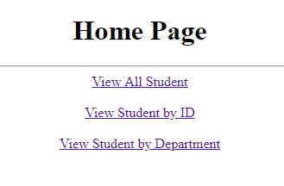

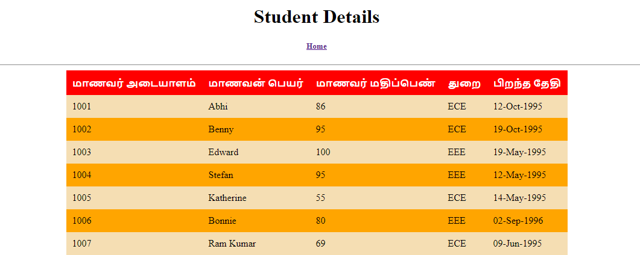

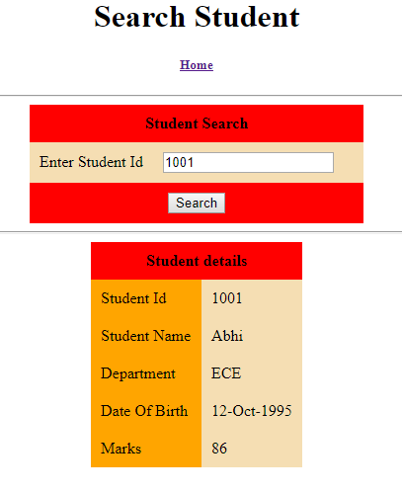

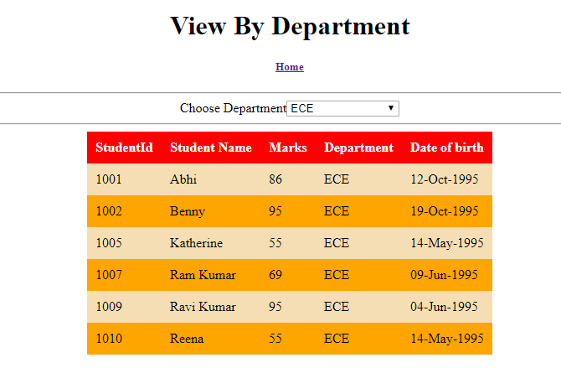

Create dynamic web project “Dynamic Annotation”

Add library

Add the value in web.xml

Copy and paste the jsps from dynamic navigation project

Copy and paste com.hexa.bean and com.hexa.listener from dynamic navigation project

Copy and paste the face-config

Add annotations appropriately

**package** com.hexa.bean;

**import** javax.faces.bean.ManagedBean;

**import** javax.faces.bean.RequestScoped;

@ManagedBean(name="ibean")

@RequestScoped

**public** **class** IBean {

**private** **double** result;

**private** **double** amount;

**private** **double** rate;

**private** **double** years;

**private** String resCaption;

**public** **double** getAmount() {

**return** amount;

}

**public** **void** setAmount(**double** amount) {

**this**.amount = amount;

}

**public** String getResCaption() {

**return** resCaption;

}

**public** **void** setResCaption(String resCaption) {

**this**.resCaption = resCaption;

}

**public** **double** getResult() {

**return** result;

}

**public** **void** setResult(**double** result) {

**this**.result = result;

}

**public** **double** getRate() {

**return** rate;

}

**public** **void** setRate(**double** rate) {

**this**.rate = rate;

}

**public** **double** getYears() {

**return** years;

}

**public** **void** setYears(**double** years) {

**this**.years = years;

}

// Action Method which ll return String

**public** String calcSimpleInterest() {

**this**.resCaption = "Simple Interest";

result = amount * years * rate / 100;

**return** "InterestResult"; // View Name

}

// Action Method which ll return String

**public** String calcCompInterest() {

**this**.resCaption = "Compound Interest";

result = amount * Math.*pow*((1+rate/100), years) - amount;

**return** "InterestResult"; // View Name

}

}

**package** com.hexa.bean;

**import** javax.faces.bean.ManagedBean;

**import** javax.faces.bean.RequestScoped;

@ManagedBean(name="tbean")

@RequestScoped

**public** **class** TaxBean {

**private** String ename;

**private** **double** income;

**private** **double** tax;

**public** TaxBean() {

System.***out***.println("Tax Bean constructor is invoked");

}

**public** String getEname() {

System.***out***.println("Ename getter");

**return** ename;

}

**public** **void** setEname(String ename) {

System.***out***.println("Ename setter");

**this**.ename = ename;

}

**public** **double** getIncome() {

System.***out***.println("Income getter");

**return** income;

}

**public** **void** setIncome(**double** income) {

System.***out***.println("Income Setter");

**this**.income = income;

}

**public** **double** getTax() {

System.***out***.println("Tax getter");

**return** tax;

}

**public** **void** setTax(**double** tax) {

System.***out***.println("Tax Setter");

**this**.tax = tax;

}

// Action Method which ll return String

**public** String calcTax() {

System.***out***.println("Inside CalcTax Method");

**if** (income > 1000000) {

**this**.tax = 750000 * 0.1 + (income - 1000000) * 0.15;

} **else** **if** (income > 250000) {

**this**.tax = (income - 250000) * 0.1;

}

**return** "TaxSubmit";

}

}

**Custom Convertors and Validators**

* Create new dynamic web project “customValidators”
* Add library
* Add the value in web.xml
* Faces-config.xml in the Web-INF folder
* Create package com.hexa.web and create class userBean
* Create a jsp file userFrm under web content

**package** com.hexa.web;

**import** java.time.LocalDate;

**import** javax.faces.bean.ManagedBean;

**import** javax.faces.bean.RequestScoped;

@ManagedBean(name="ubean")

@RequestScoped

**public** **class** UserBean {

**private** String email;

**private** LocalDate dt;

**public** String getEmail() {

**return** email;

}

**public** **void** setEmail(String email) {

**this**.email = email;

}

**public** LocalDate getDt() {

**return** dt;

}

**public** **void** setDt(LocalDate dt) {

**this**.dt = dt;

}

//Action Method

**public** String processFrm() {

**return** "UserView";

}

}

<%@ page language=*"java"* contentType=*"text/html; charset=UTF-8"*

pageEncoding=*"UTF-8"*%>

<%@taglib uri=*"http://java.sun.com/jsf/core"* prefix=*"f"*%>

<%@taglib uri=*"http://java.sun.com/jsf/html"* prefix=*"h"*%>

<!DOCTYPE html>

<html>

<f:view>

<head>

<title>User Form</title>

<style type=*"text/css"*>

**table** {

margin: *0 auto*;

border-collapse: *collapse*;

}

*.css1* {

background-color: *orange*;

}

*.css2* {

background-color: *wheat*;

}

*.css3* {

color: *red*;

}

**tfoot,** **thead** {

background-color: *red*;

text-align: *center*;

}

</style>

</head>

<body>

<h1 align=*"center"*>User Form</h1>

<hr size=*"2"* />

<h:form id=*"frm"*>

<h:panelGrid id=*"pg1"* columns=*"3"* columnClasses=*"css1,css2,css3"*

cellpadding=*"10"* bgcolor=*"wheat"*>

<f:facet name=*"header"*>

<h:outputText value=*"User Form"*></h:outputText>

</f:facet>

<h:outputText value=*"Email"*></h:outputText>

<h:inputText id=*"email"* value=*"*#{ubean.email}*"*>

<f:validator validatorId=*"emailid"*/>

<h:message for=*"email"*></h:message>

</h:inputText>

<f:facet name=*"footer"*>

<h:commandButton value=*"Submit"* action=*"*#{ubean.processFrm}*"*></h:commandButton>

</f:facet>

</h:panelGrid>

</h:form>

</body>

</f:view>

</html>

* Create new class EmailValidator and implement Validator

**package** com.hexa.web;

**import** javax.faces.application.FacesMessage;

**import** javax.faces.component.UIComponent;

**import** javax.faces.context.FacesContext;

**import** javax.faces.validator.Validator;

**import** javax.faces.validator.ValidatorException;

**public** **class** Emailvalidator **implements** Validator{

@Override

**public** **void** validate(FacesContext fctx, UIComponent ui, Object obj) **throws** ValidatorException {

String str = (String) obj;

**if**(!str.matches("[a-zA-Z]+[@][a-z]+[.](com || co.in)")) {

FacesMessage msg = **new** FacesMessage("Invalid Email.");

**throw** **new** ValidatorException(msg);

}

}

}

In faces-config

<validator>

<validator-id>emailid</validator-id>

<validator-class>com.hexa.web.Emailvalidator</validator-class>

</validator>

Create a new jsp file under web content

<%@ page language=*"java"* contentType=*"text/html; charset=UTF-8"*

pageEncoding=*"UTF-8"*%>

<%@taglib uri=*"http://java.sun.com/jsf/core"* prefix=*"f"*%>

<%@taglib uri=*"http://java.sun.com/jsf/html"* prefix=*"h"*%>

<!DOCTYPE html>

<html>

<f:view>

<head>

<title>User Form</title>

<style type=*"text/css"*>

**table** {

margin: *0 auto*;

border-collapse: *collapse*;

}

*.css1* {

background-color: *orange*;

}

*.css2* {

background-color: *wheat*;

}

*.css3* {

color: *red*;

}

**tfoot,** **thead** {

background-color: *red*;

text-align: *center*;

}

</style>

</head>

<body>

<h1 align=*"center"*>User Form</h1>

<hr size=*"2"* />

<h:panelGrid id=*"pg1"* columns=*"3"* columnClasses=*"css1,css2,css3"*

cellpadding=*"10"* bgcolor=*"wheat"*>

<h:outputText value=*"Email"*></h:outputText>

<h:outputText id=*"name"* value=*"*#{ubean.email}*"*>

</h:outputText>

</h:panelGrid>

</body>

</f:view>

</html>

Custom Converter

**package** com.hexa.web;

**import** java.time.LocalDate;

**import** java.time.format.DateTimeFormatter;

**import** javax.faces.application.FacesMessage;

**import** javax.faces.component.UIComponent;

**import** javax.faces.context.FacesContext;

**import** javax.faces.convert.Converter;

**import** javax.faces.convert.ConverterException;

**import** javax.faces.convert.FacesConverter;

@FacesConverter(value="dobid")

**public** **class** MyConverter **implements** Converter{

/* This method is */

@Override

**public** Object getAsObject(FacesContext arg0, UIComponent arg1, String str) {

// **TODO** Auto-generated method stub

System.***out***.println("Get as Object");

**try** {

DateTimeFormatter dtf = DateTimeFormatter.*ofPattern*("dd-MM-yyyy");

LocalDate dt = LocalDate.*parse*(str, dtf);

**return** dt;

} **catch** (Exception e) {

FacesMessage msg = **new** FacesMessage("Pattern must be dd-MM-yyyy");

**throw** **new** ConverterException(msg);

}

}

//this method is invoked when sending data from UI to browser

@Override

**public** String getAsString(FacesContext arg0, UIComponent arg1, Object obj) {

LocalDate dt = (LocalDate)obj;

DateTimeFormatter dtf = DateTimeFormatter.*ofPattern*("dd-MM-yyyy");

String str = dtf.format(dt);

**return** str;

}

}

<?xml version=*"1.0"* encoding=*"UTF-8"*?>

<faces-config xmlns=*"http://java.sun.com/xml/ns/javaee"*

xmlns:xsi=*"http://www.w3.org/2001/XMLSchema-instance"*

xsi:schemaLocation=*"http://java.sun.com/xml/ns/javaee*

*http://java.sun.com/xml/ns/javaee/web-facesconfig_2_0.xsd"*

version=*"2.0"*>

<validator>

<validator-id>emailid</validator-id>

<validator-class>com.hexa.web.Emailvalidator</validator-class>

</validator>

<!-- <converter>

<converter-id>dobid</converter-id>

<converter-class>com.hexa.web.MyConverter</converter-class>

</converter> -->

<lifecycle>

<phase-listener> com.hexa.listener.MyPhaseListener</phase-listener>

</lifecycle>

</faces-config>