IACSD https://lh4.googleusercontent.com/b32gJufX1mzpywCjJPGGKwBUB49UfykRHg7AFbaRocJNzTV4p-cVtxoHZsnw1IXPBRysWme-_GWq4RDcBxQuQgUWOk-oGvaTbnC3tBZEvZruJKewiBh9Q1FA8FJ8VQ2XNgZEbuxKtBiFJnddOXCKcOchttps://lh6.googleusercontent.com/UVuqgrrnij4nZQvX5hC24X5YJD9WRPPY1oNWl3ViBr9MhadwpNMoFN6ffjA2Y0jpFJeORMVxjgAWeQYGKARO8ziW6sAy77zXvyfE1WZ7RUMthNQP2JLYxWB39cKlu5Qm1503T6bYX6Uttj62Z7ylIVw

**INSTITUTE FOR ADVANCED**

**COMPUTING AND SOFTWARE**

**DEVELOPMENT  AKURDI, PUNE**

Documentation On

**“BLUESKY- (ONLINE SERVICES)”**

PG-DAC SEPT 2022

**Submitted By:**

**Group No. 101**

**Roll no. Name**

**229216** **SUBRAT GUPTA**

**229228 SWAPNIL VAIDYA**

**Mr. Shivprasad Dondiparge Mr. Rohit Puranik**

**Project Guide Center Coordinator**

Table of Contents

**1. Introduction........................................................................................................................** 1

     Document Purpose

     Problem Statement

     Product Scope

     Aim & Objectives

**2. Overall Description ............................................................................................................**4

      Product Perspective

      Benefits of Bluesky

      User and Characteristics

      Operating Environment

      Design and Implementation Constraints

**3. Requirements Specification ...............................................................................................**9

      External Interface Requirements

      Non-Functional Requirements

**4. System Diagram..................................................................................................................**10

      Activity Diagram

      Data Flow Diagram

      Class Diagram

      Use Case Diagram

      ER Diagram

**5. Table Structure..................................................................................................................** 19

     Admin  
     Booking

Category

Customer

Services

Payment

Service Provider

sp_category

sp_services

cat_services

**6. Screenshots.........................................................................................................................**22

**7. Conclusion..........................................................................................................................**32

**8. Future Scope......................................................................................................................**33

**9. References..........................................................................................................................**34

IACSD

**ACKNOWLEDGEMENT**

I take this occasion to thank God, almighty for blessing us with his grace and taking our endeavour to a successful culmination. I extend my sincere and heartfelt thanks to our esteemed guide, Mr. ShivPrasad for providing me with the right guidance and advice at the crucial juncture sand for showing me the right way. I extend my sincere thanks to our respected Centre Coordinator Mr.Rohit Puranik, for allowing us to use the facilities available. Also I am very

thankful to our Course Coordinator Mr. Narendra Pawar for guiding me throughout this CDAC journey and I would like to thank all the Lab Faculty Members because this project is the result of their full dedication they gave us during this CDAC journey. Last but not the least, I would like to thank my Family and Friends for the support and encouragement they have given me during the course of our work.

Subrat Gupta (229216)

Swapnil Vaidya (229228)

IACSD

**ABSTRACT**

The aim of this project report is to analyze the concept and implementation of online services for mechanics, plumbers, and electricians. This report presents an in-depth analysis of the challenges faced by consumers in availing these services, such as lack of reliability, accessibility, and quality assurance. The report also provides an overview of various online service platforms that have emerged to address these challenges.

The report discusses the features, working model, and benefits of these platforms, such as ease of booking, transparent pricing, and quick response time. It also highlights the strategies adopted by these platforms to ensure customer satisfaction and loyalty, such as providing trained and verified professionals, offering service warranties, and collecting customer feedback.

Furthermore, the report examines the market size, growth potential, and competitive landscape of the online services industry in India. It identifies the key trends and drivers that are fueling the growth of this industry, such as increasing digitalization, rising disposable income, and changing consumer preferences.

In conclusion, this report provides a comprehensive understanding of the online services industry for mechanics, plumbers, and electricians, and its impact on the traditional service providers. It also offers insights into the challenges and opportunities for new entrants in this industry and provides recommendations for their sustainable growth and success.

**Introduction:**

In today's fast-paced world, people are always on the go and do not have the time to fix their household problems themselves. This has led to a surge in demand for online services like mechanic, plumber, and electrician. These services are now readily available at the click of a button, making it easier for people to get their problems fixed without leaving the comfort of their homes.

The purpose of this project report is to analyze the online services for mechanic plumber, and electrician, their impact on society, and their future potential.

The report will explore the benefits of online services, the challenges faced by service providers, and the role of technology in enhancing the service experience.

The report will begin by providing an overview of the current landscape of online services for mechanic, plumber, and electrician. It will then delve into the advantages of these services, such as convenience, accessibility, and cost-effectiveness.

The report will also discuss the challenges faced by service providers, such as maintaining quality standards, managing customer expectations, and building trust.

The report will then examine the role of technology in enhancing the service experience.

It will look at the use of AI and machine learning algorithms to improve service quality and reduce response times.

Finally, the report will conclude by discussing the future potential of online services for mechanic, plumber, and electrician. It will highlight the increasing demand for these services, driven by the rise of the gig economy and the increasing reliance on technology. The report will also touch upon the challenges and opportunities that lie ahead for service providers in this industry.

Overall, this project report aims to provide a comprehensive analysis of online services for mechanic, plumber, and electrician, and their impact on society. It will offer insights into the benefits, challenges, and potential of these services, providing a valuable resource for service providers, policymakers, and researchers.

**Problem Statement:**

While online services for mechanic, plumber, and electrician offer convenience and accessibility, they also pose some challenges for both service providers and customers. One of the key problems faced by service providers is maintaining quality standards and building trust with customers. Due to the nature of the work, customers may have concerns about the expertise and reliability of service providers they find online, which can impact their willingness to use these services.

Another challenge is managing customer expectations, particularly in terms of response times and availability. Customers expect prompt and reliable service, and service providers may struggle to keep up with demand, leading to delays and customer dissatisfaction.

Additionally, service providers may face challenges related to pricing and competition. With the rise of the gig economy and increasing competition in the service industry, providers may need to lower prices to remain competitive, which can impact their profitability and sustainability.

On the customer side, the main issue is the risk of fraud and scams. Customers may be hesitant to use online services for fear of falling victim to fraudulent or untrustworthy service providers. They may also be concerned about the safety and security of their personal information when using online platforms to find service providers.

Therefore, the problem statement for online services for mechanic, plumber, and electrician is how to maintain quality standards, build trust with customers,

manage customer expectations, and mitigate the risk of fraud and scams, while

remaining competitive and profitable in a rapidly evolving market.

**Aim:**

The primary aim of this project is to examine the landscape of online services for mechanic, plumber, and electrician and to provide insights into the benefits, challenges, and potential of these services.

Objectives:

To achieve the primary aim, the following objectives will be addressed in this project report:

1. To examine the current landscape of online services for mechanic, plumber, and electrician and to identify the major players in the market.
2. To analyze the benefits of online services, including their convenience, accessibility, and cost-effectiveness, and to provide examples of successful implementations of these services.
3. To explore the challenges faced by service providers, including maintaining quality standards, managing customer expectations, building trust, and remaining competitive in a rapidly evolving market.
4. To assess the impact of online services on society, including their potential to create job opportunities, improve the efficiency of service delivery, and reduce environmental impact.
5. To provide recommendations for service providers, policymakers, and researchers to address the challenges and opportunities in the online services industry.
6. To evaluate the future potential of online services for mechanic, plumber, and electrician, including the potential for expansion into new markets and the impact of emerging technologies on the industry.

By achieving these objectives, this project report aims to provide a comprehensive analysis of online services for mechanic, plumber, and electrician, and their impact on society, offering valuable insights and recommendations for service providers, policymakers, and researchers.

**Overall Description:**

This project report aims to analyze the landscape of online services for mechanic, plumber, and electrician and to provide insights into the benefits, challenges, and potential of these services. The report will examine the current market for these services, the benefits of online services, the challenges faced by service providers, the role of technology in enhancing the service experience, and the impact of these services on society.

The report will begin with an overview of the online services industry for mechanic, plumber, and electrician, including a review of the major players in the market. It will then explore the benefits of online services, including convenience, accessibility, and cost-effectiveness. The report will also examine the challenges faced by service providers, including maintaining quality standards, managing customer expectations, building trust, and remaining competitive in a rapidly evolving market.

The report aims to contribute to the ongoing discussion on the role of technology in the service industry and its potential to transform traditional service delivery models. By providing a detailed analysis of the benefits and challenges of online services for mechanic, plumber, and electrician, the report aims to inform stakeholders on how to leverage technology to improve service delivery and enhance customer satisfaction.

Furthermore, the report aims to highlight the importance of maintaining quality standards and building trust with customers in the online services industry. It will provide insights into how service providers can establish and maintain quality standards to improve customer satisfaction and retain customer loyalty.

Overall, this project report aims to provide a comprehensive analysis of the online services industry for mechanic, plumber, and electrician, and its potential to transform traditional service delivery models. It will offer valuable insights and recommendations for service providers, policymakers, and researchers on how to navigate the challenges and opportunities presented by this rapidly evolving industry.

**Benefits of BlueSky(online services):**

* BlueSky(online services) solution is fully functional and flexible.
* It is very easy to use.
* This Project helps in back office administration by streamlining and standardizing the procedures.
* It saves a lot of time, money and man-power.
* Eco-friendly: The monitoring of Project and the overall business becomes easy and includes the least of paper work.
* The application acts as an office that is open 24/7.
* It increases the efficiency of the management at offering quality services to the customers.
* It provides custom features development and support with the application.

**Users And Characteristics :-**

**Admin :-**

Admin can login to the system

View the list of all Bookings.

Delete Customer record.

Delete Service Provider record.

View History of the Customers

View History of the Service Providers.

Manages all the users.

**Customer :-**

Customer can register and create his own account

Can See all the services for booking

Customer can Login

Customer can book a service

Customer can update their profile

Customer can view booking details.

**Service Provider :-**

Service Provider can register

Service Provider can login

Service Provider can accept the booking

Service Provider can reject the booking

Service Provider can update their profile

**Operating Environment :-**

**Server Side:**

Processor :- Intel Xeon Processor 3500 series

HDD :- Minimum 500 GB Disk Space

RAM :- Minimum 2 GB

OS : Windows 8.1,Linux 6

Database : MySQL

**Client Side :**

Processor :- Intel Dual core

HDD :- Minimum 80 GB Disk Space

RAM :- Minimum 1 GB

OS :- Windows 7,Linux

**Design and Implementation Constraints**

The application will use Ajax, JavaScript, jQuery and css as main web technologies.

HTTP and FTP protocols are used as communication protocols. FTP is used to upload the web application in live domain and the client can access it via HTTP protocol.

Several types of validations make this web application a secured one and SQL Injections can also be prevented.

Since BlueSky(online services) is a web-based application, internet connection must be established.

The BlueSky(online services) will be used on PCs and will function via internet or intranet in any web browser.

**Requirement Specification:**

**External Interface Requirements:**

**User Interfaces:**

All the users will see the same page when they enter in this website. This page asks the users a username and a password.

After being authenticated by correct username and password, user will be redirect to their corresponding profile where they can do various activities.

The user interface will be simple and consistence, using terminology commonly understood by intended users of the system. The system will have simple interface, consistence with standard interface, to eliminate need for user training of infrequent users.

**Hardware Interfaces:**

No extra hardware interfaces are needed.

The system will use the standard hardware and data communication resources.

This includes, but not limited to, general network connection at the server/hosting site, network server and network management tools.

**System Diagram :**

**Activity Diagrams :-**

**Admin Activity Diagram:-**

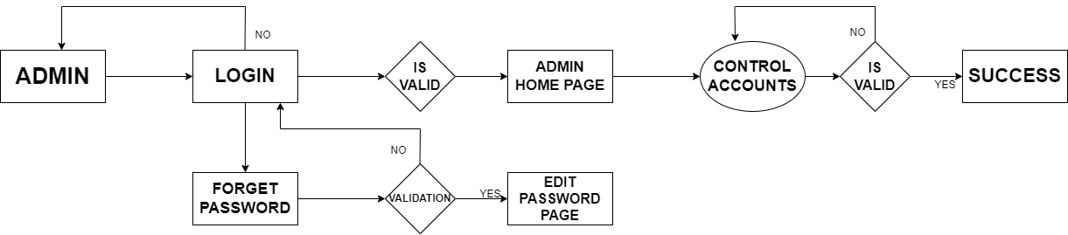

**Customer activity Diagram:**

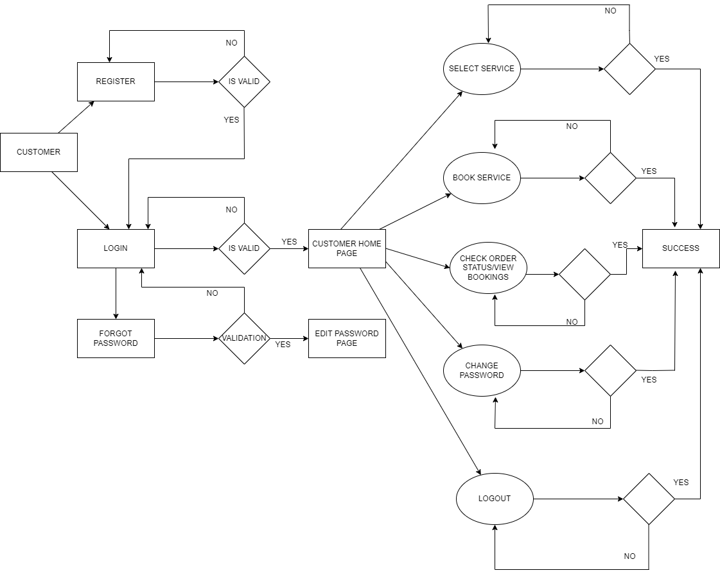

**Service Provider Activity Diagram:-**

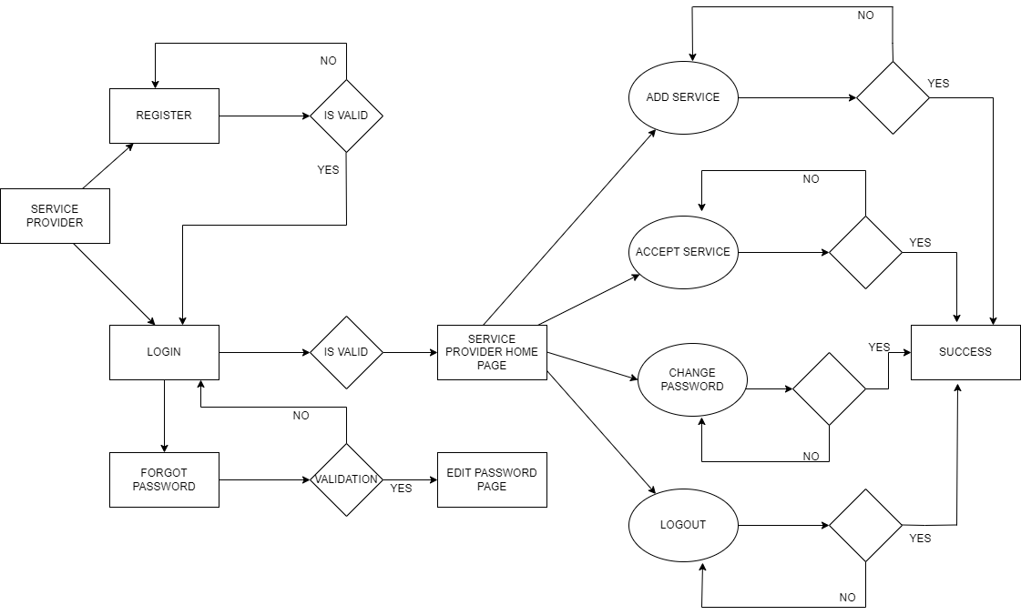

**Data Flow Diagram(Zero Level):**

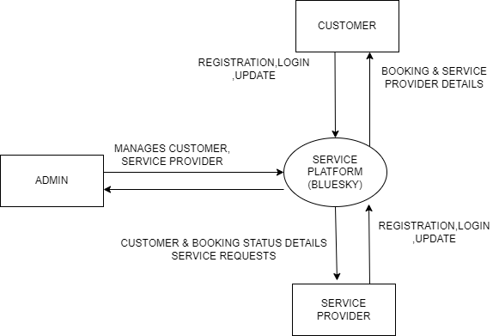

**E-R Diagram:**

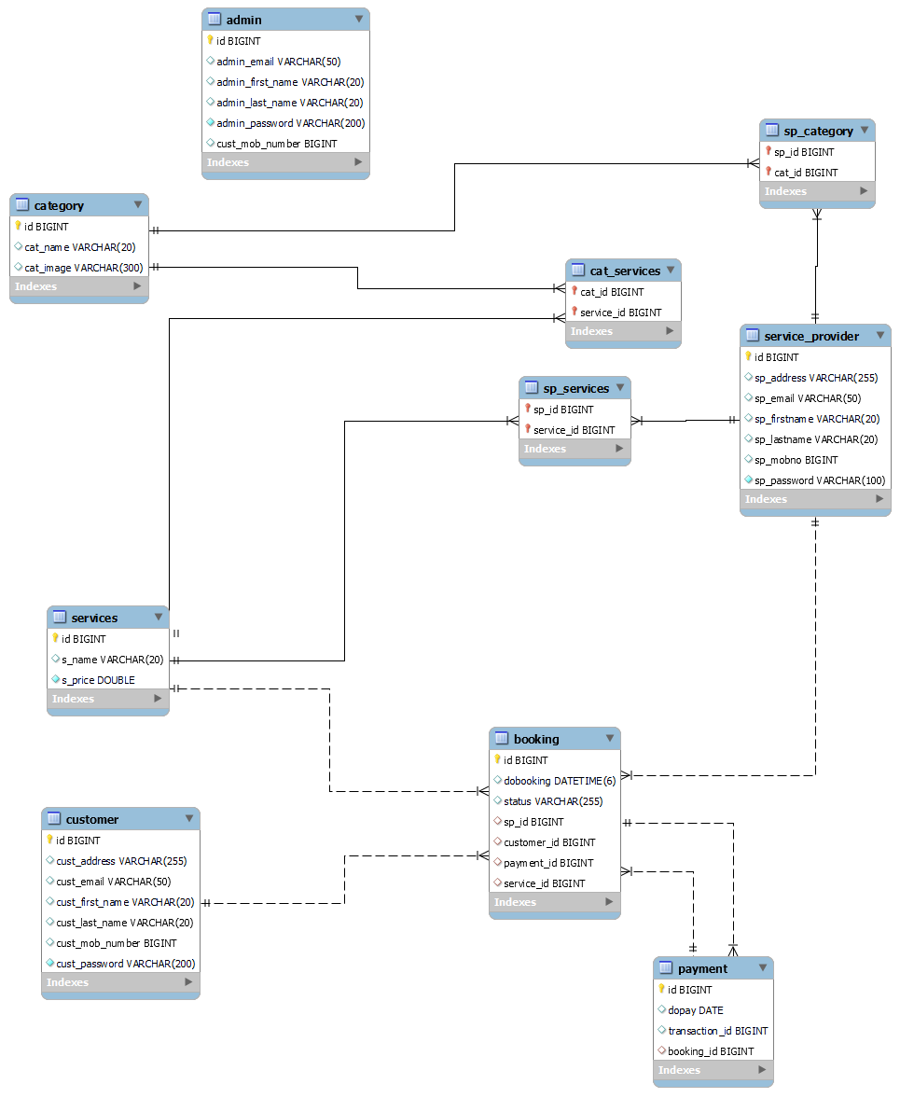

**Admin Use Case Diagram:**

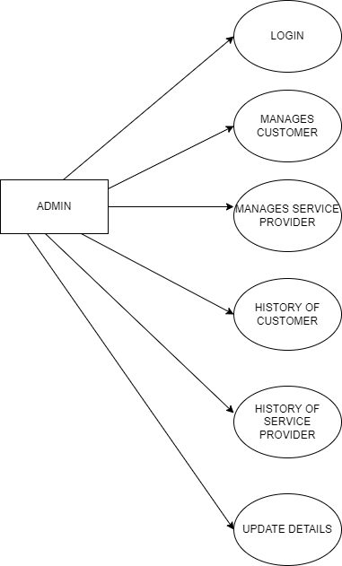

**Customer Use Case Diagram:**

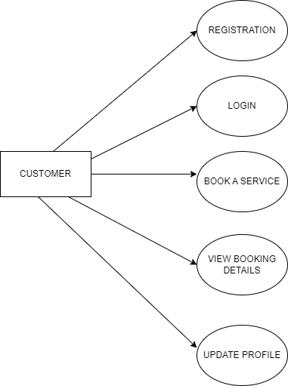

**Service Provider Use Case Diagram:**

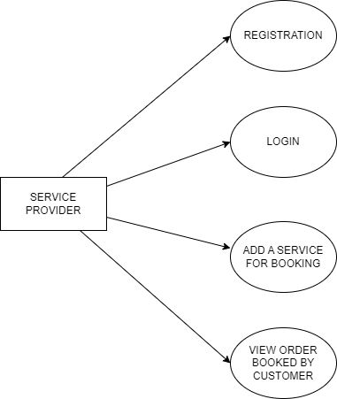

**E-R Diagram:**

**Table Structure:**

**Admin table:**

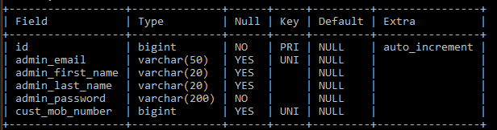

**Booking table:**

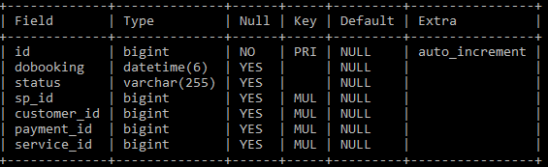

**Category table:**

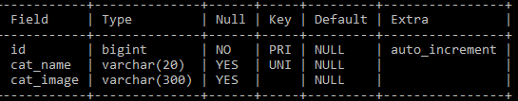

**Customer table:**

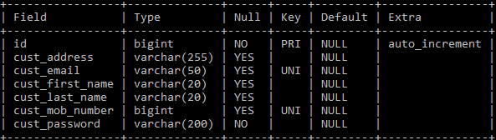

**Services table:**

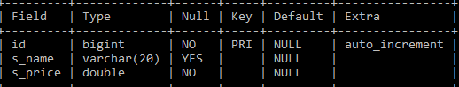

**Payment table:**

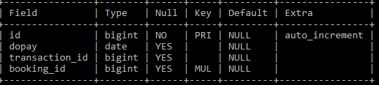

**Service Provider table:**

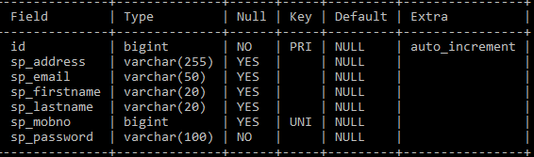

**sp_category:**

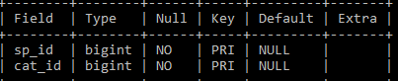

**sp_services:**

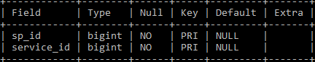

**cat_services:**

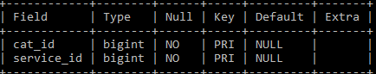

**Screenshots:**

**Welcome Page:**

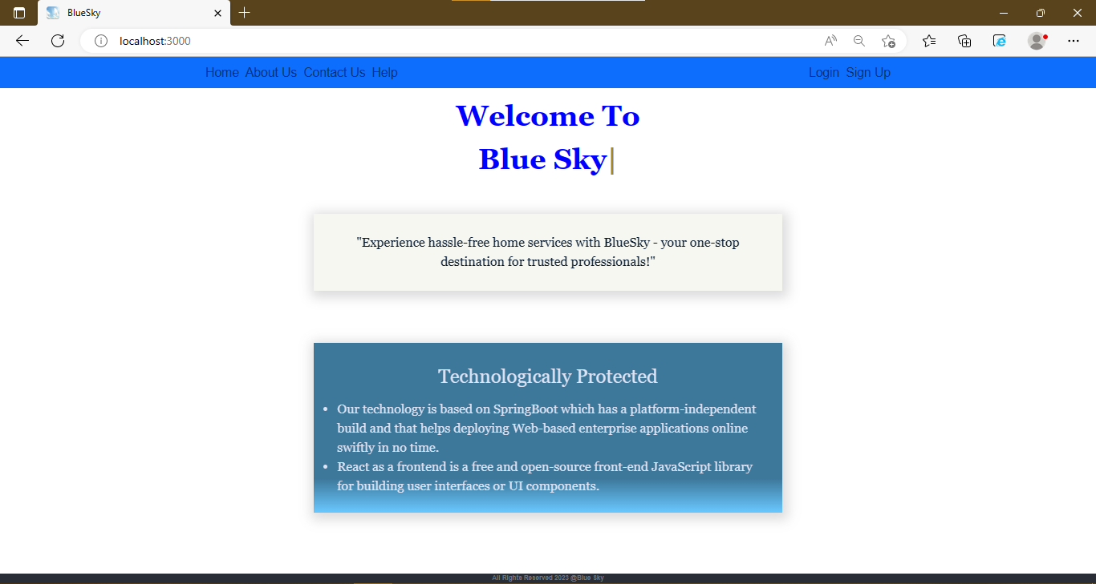

**About:**

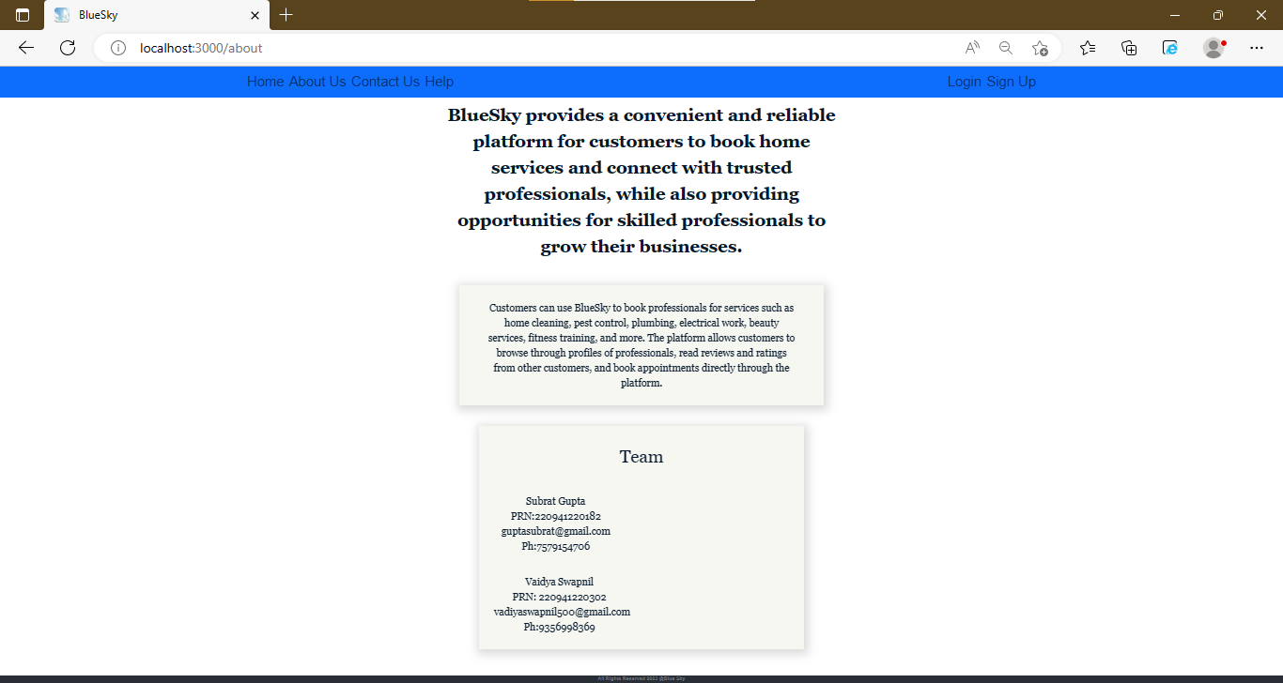

**Customer Login Page:**

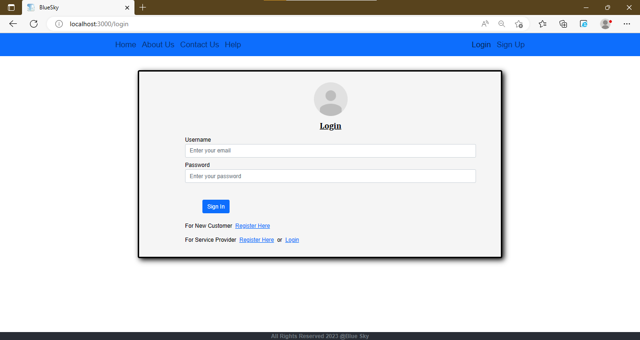

**Customer Registration Page:**

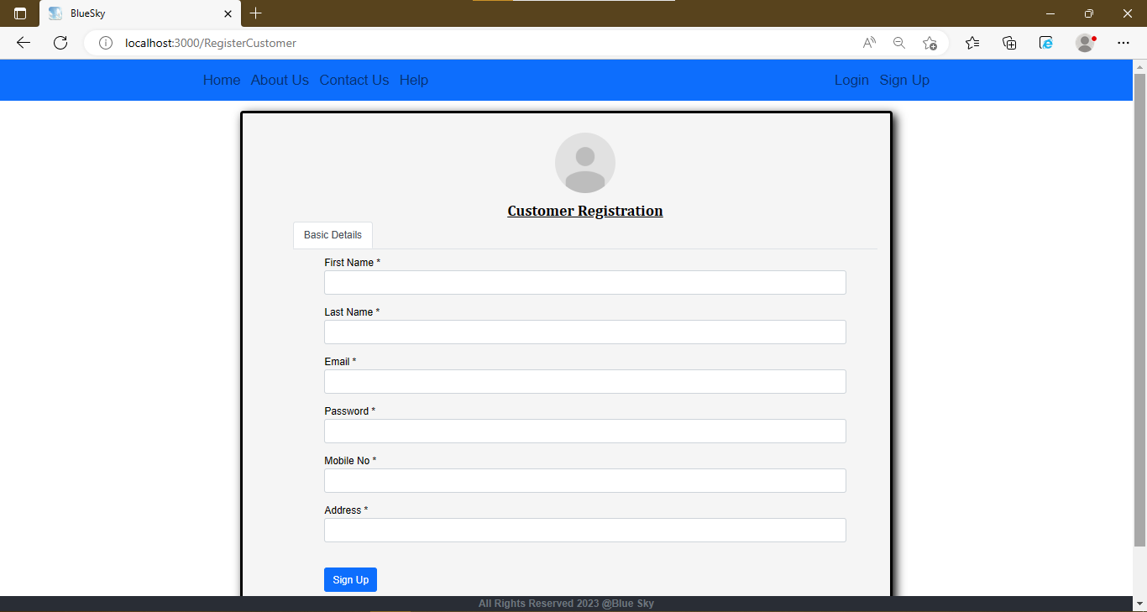

**Registration Page:**

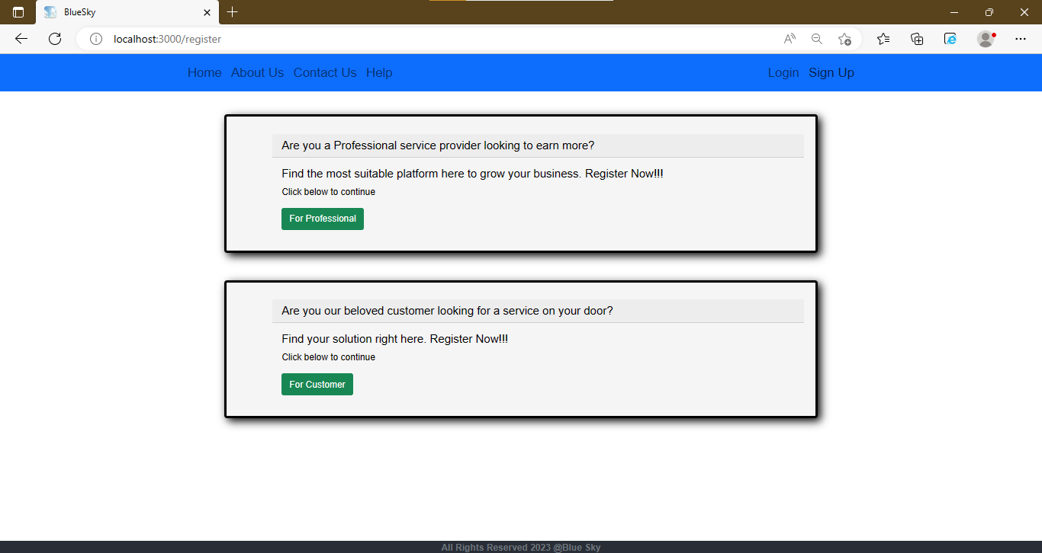

**Service Provider Login Page:**

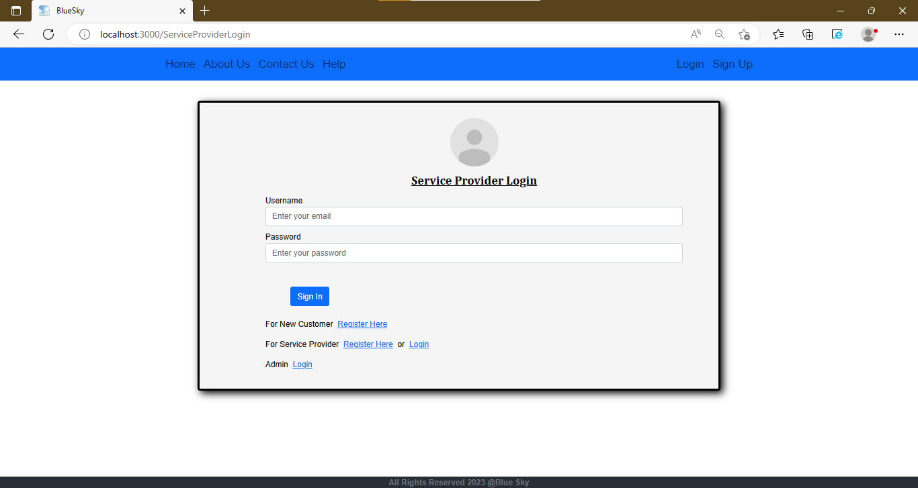

**Service Provider Registration Page:**

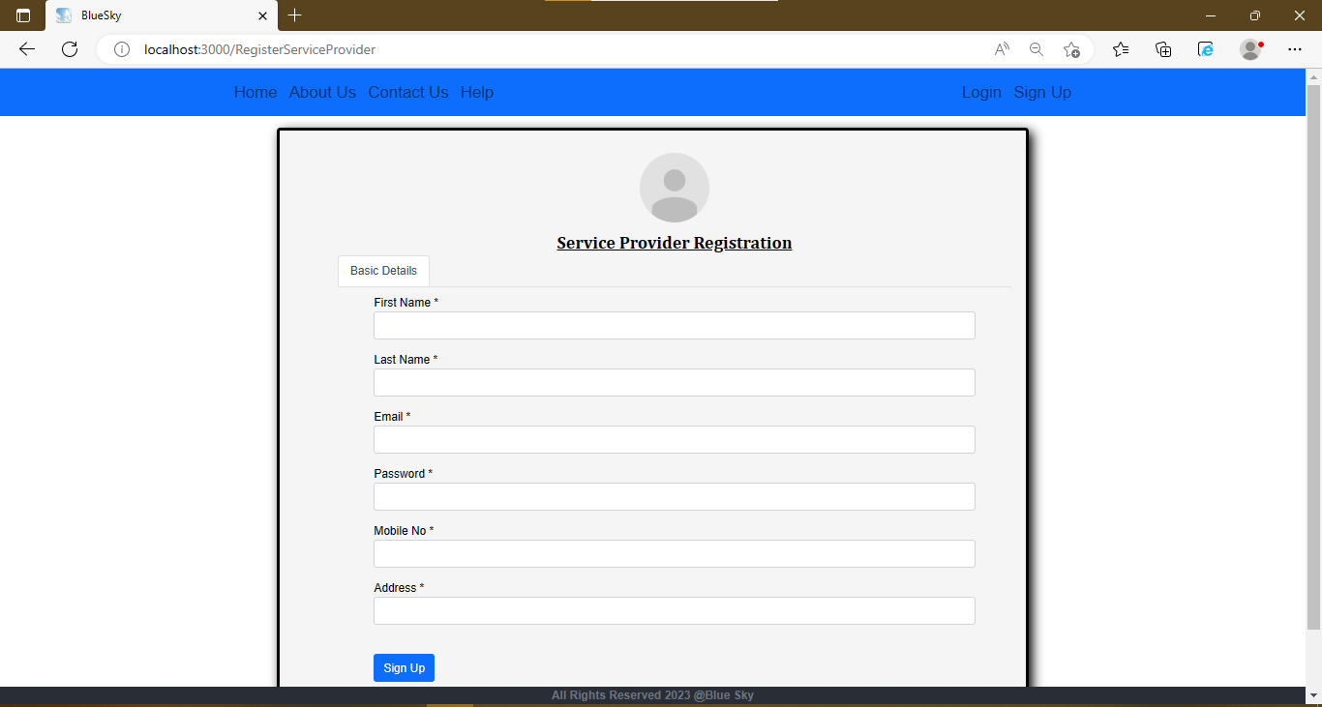

**Customer Dashboard Page:**

**Services Available Page:**

**Bookings Page:**

**Service Provider Dashboard with Real Time Service Request Interface Page:**

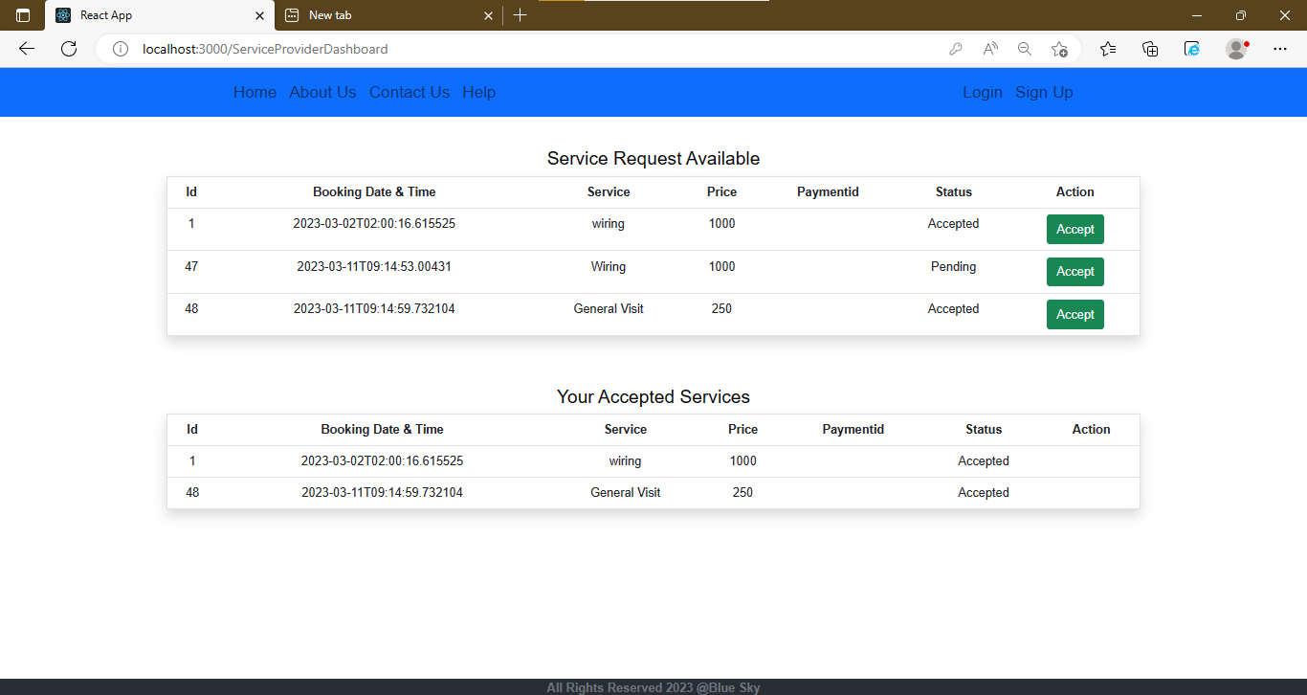

**Admin Dashboard:**

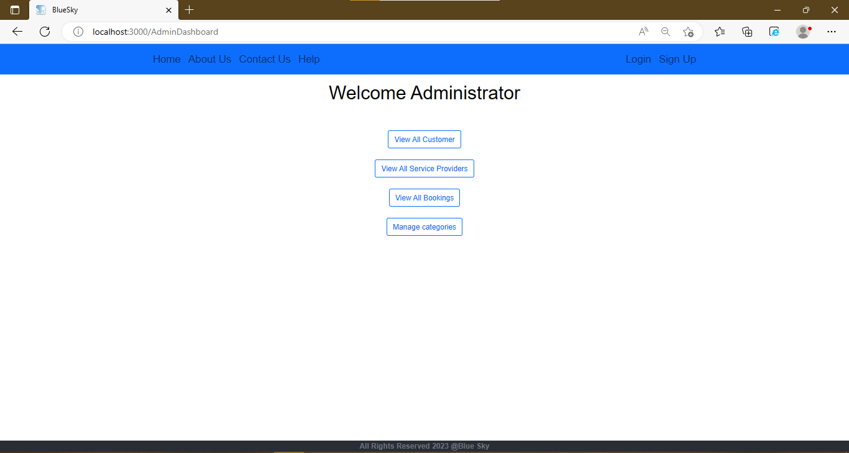

**Admin can manage all Customer:**

**Admin can manage all Service Provider:**

**Admin can view all Bookings:**

**Admin Dashboard:**

**Admin can add categories:**

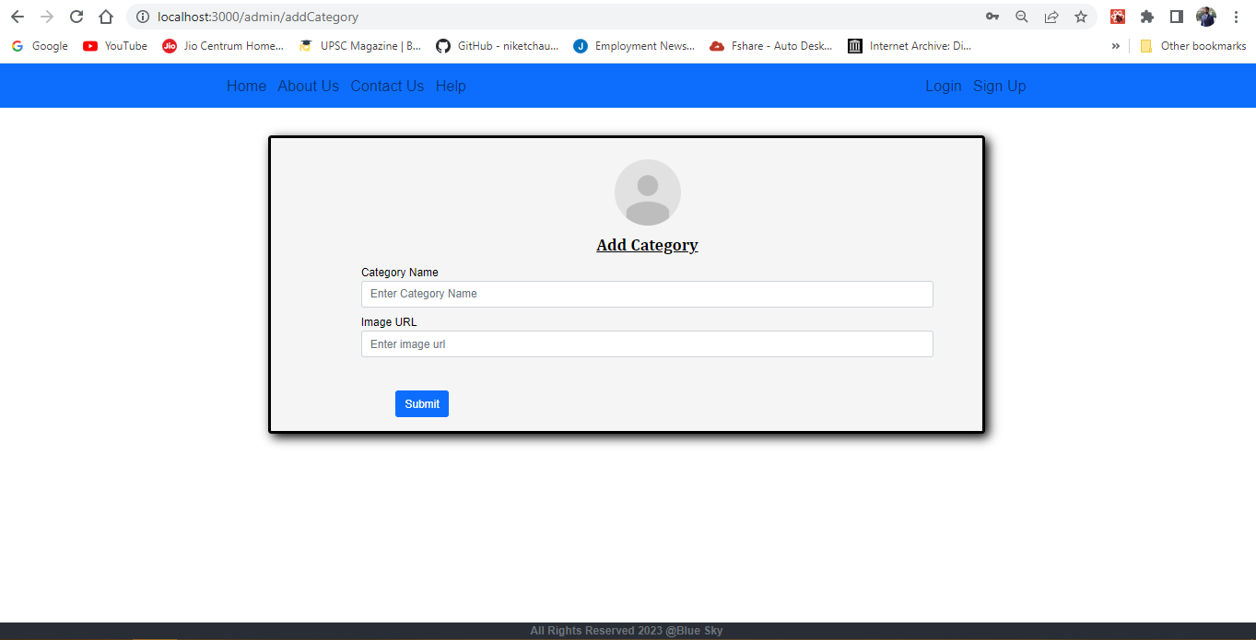

**Admin can manage services:**

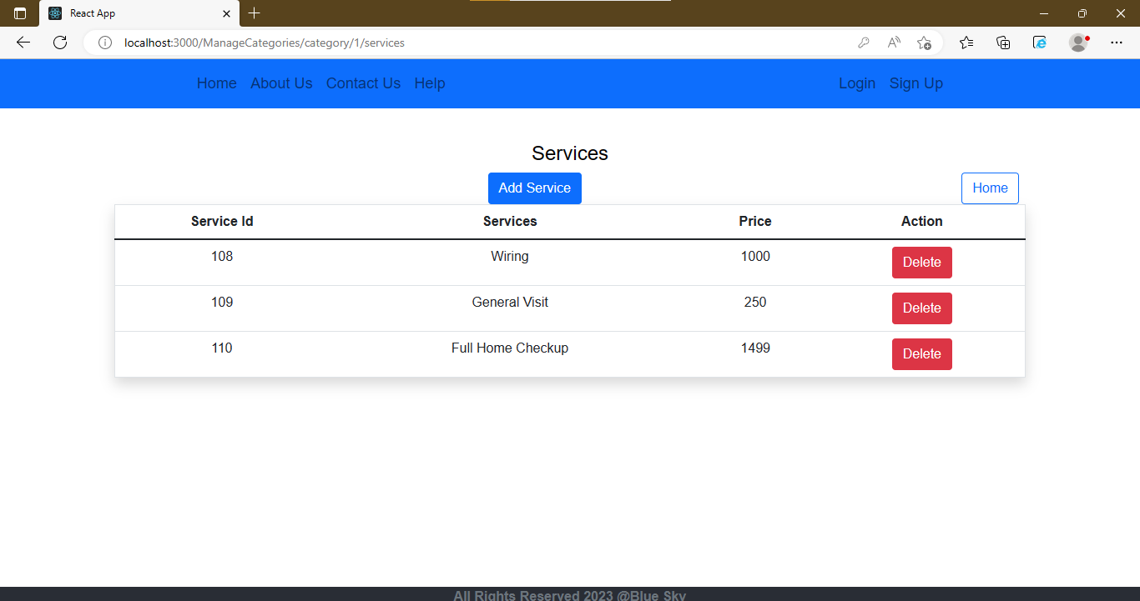

**Admin can add services:**

**Conclusion:**

In conclusion, the online services for mechanics, plumbing, and electricians have revolutionized the traditional way of availing services. With the increasing use of smartphones and the internet, customers are finding it easier to book services online rather than physically visiting the service provider. The online services have not only made it more convenient for customers but have also opened up new opportunities for service providers to expand their business.

The advantages of online services include easy booking, quick response, and availability of a variety of service providers to choose from. Moreover, the online service providers offer competitive pricing, transparency in pricing, and quality assurance, which ensures customer satisfaction. The service providers also benefit from increased visibility, enhanced reputation, and efficient management of resources.

However, there are some challenges associated with online services such as managing customer expectations, ensuring timely service, and dealing with customer complaints. The service providers need to have a robust system in place to address these challenges and provide an excellent customer experience.

Overall, the online services for mechanics, plumbing, and electricians have disrupted the traditional service industry and have provided a new and convenient way for customers to avail themselves of services. As technology continues to evolve, we can expect more innovative solutions to emerge in the future.

**Future Scope:**

The future scope for online services like mechanic, plumbing, and electrician is vast, and there are several opportunities to explore. Here are some of the potential areas for growth:

Expansion to new geographical areas: Online service providers can expand their services to new geographical areas and tap into new markets. This can be achieved by partnering with local service providers or hiring new professionals.

Integration with smart home devices: With the increasing adoption of smart home devices, online service providers can integrate their services with these devices. This will enable customers to book services automatically when a device detects a problem.

Offering new services: Online service providers can expand their offerings and include new services that complement their existing services. For example, a plumbing service provider can offer water quality testing services.

Implementing advanced technologies: Online service providers can leverage advanced technologies like Artificial Intelligence (AI) and Machine Learning (ML) to improve their services. For instance, AI-powered chatbots can help customers book services and resolve their queries.

Offering subscription-based services: Online service providers can offer subscription-based services to customers, which will ensure recurring revenue and increase customer loyalty.

Building partnerships with other online service providers: Online service providers can build partnerships with other service providers such as car wash or house cleaning services, which will create cross-selling opportunities.

Overall, the online service industry for mechanics, plumbing, and electricians is still in its infancy, and there are ample opportunities to innovate and grow. Service providers who can adapt to the changing market dynamics and provide excellent customer experiences will stand to benefit in the long run.

**References:**

https://www.w3schools.com/html/

https://stackoverflow.com/questions/tagged/reactjs

https://stackoverflow.com/questions/tagged/mysql

https://stackoverflow.com/questions/tagged/spring-b