A. KPI’S
1.TOTAL SALES
QUARY:
select cast(sum(sales)/1000000 as decimal(10,2)) as total_sales_in_million from blinkit_db
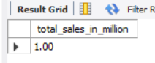
2.AVG SALES
QUARY:
SELECT CAST(AVG(SALES) AS DECIMAL(10,2)) AS AVG_SALES FROM blinkit_db;
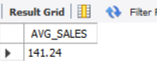
3. NO OF ITEMS
QUARY:
SELECT COUNT(`ITEM TYPE`) AS NO_OF_ITEMS FROM blinkit_db;
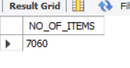
4.AVG RATING
QUARY:
SELECT CAST(AVG(RATING) AS DECIMAL(10,2)) AS AVG_RATING FROM blinkit_db
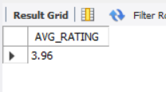

B.GRANULAR REQUIREMENTS
1.TOTAL SALES BY FAT CONTENT
QUARY:
SELECT `ITEM FAT CONTENT`,
CAST(SUM(SALES) AS DECIMAL(10,2))AS TOTAL_SALES,
CAST(AVG(SALES) AS DECIMAL(10,2))AS AVG_SALES,
CAST(AVG(RATING) AS DECIMAL(10,2))AS AVG_RATING
FROM BLINKIT_DB
GROUP BY(`ITEM FAT CONTENT`)
ORDER BY TOTAL_SALES DESC;
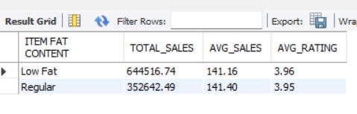
2.TOP 5 SALING ITEM ON BLINKIT
QUERY:
SELECT `ITEM TYPE`,
CAST(SUM(SALES) AS DECIMAL(10,2))AS TOTAL_SALES,
CAST(AVG(SALES) AS DECIMAL(10,2))AS AVG_SALES,
CAST(AVG(RATING) AS DECIMAL(10,2))AS AVG_RATING
FROM BLINKIT_DB
GROUP BY(`ITEM TYPE`)
ORDER BY TOTAL_SALES DESC LIMIT 5;
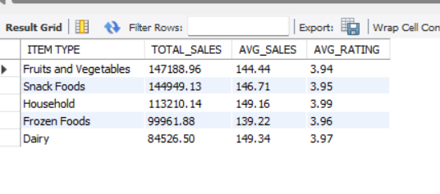
3.FAT CONTENT BY OUTLATE FOR TOTAL SALES
QUARY:
SELECT `Outlet Location Type`,`Item Fat Content`,
CAST(SUM(SALES) AS DECIMAL(10,2))AS TOTAL_SALES,
CAST(AVG(SALES) AS DECIMAL(10,2))AS AVG_SALES,
CAST(AVG(RATING) AS DECIMAL(10,2))AS AVG_RATING
FROM BLINKIT_DB
GROUP BY `Item Fat Content`,`Outlet Location Type`
ORDER BY TOTAL_SALES DESC ;
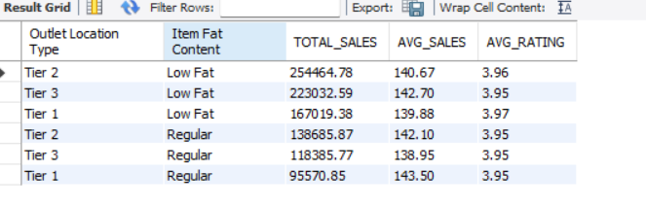

4. SELECT `Outlet Establishment Year`,
CAST(SUM(SALES) AS DECIMAL(10,2))AS TOTAL_SALES,
CAST(AVG(SALES) AS DECIMAL(10,2))AS AVG_SALES,
CAST(AVG(RATING) AS DECIMAL(10,2))AS AVG_RATING
FROM BLINKIT_DB
GROUP BY(`Outlet Establishment Year`)
ORDER BY `Outlet Establishment Year` DESC;
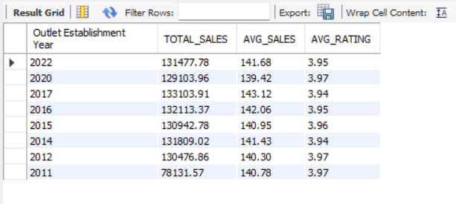
5.SALES BY OUTLATE LOCATION
QUARY:
SELECT `Outlet Location Type`,
CAST(SUM(SALES) AS DECIMAL(10,2))AS TOTAL_SALES,
CAST(AVG(SALES) AS DECIMAL(10,2))AS AVG_SALES,
CAST(AVG(RATING) AS DECIMAL(10,2))AS AVG_RATING
FROM BLINKIT_DB
GROUP BY(`Outlet Location Type`)
ORDER BY TOTAL_SALES DESC;
