- Which city has the highest number of job postings?
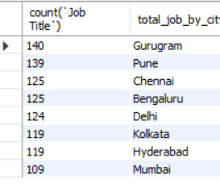
Query: select count(`Job Title`),city as total_job_by_city from india_jobmarket group by city order by count(`Job Title`) desc;

- Which department has the maximum hiring? / Which department is hiring the most?
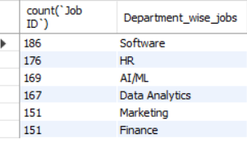
Query: select count(`ï»¿Job ID`),Department as Department_wise_jobs from india_jobmarket group by Department order by count(`ï»¿Job ID`) desc;

- Which are the top 5 hiring companies?
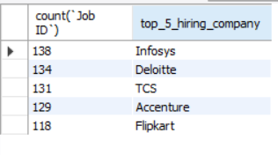
Query: select count(`Job ID`),Company as top_5_hiring_company from india_jobmarket group by Company order by count(`Job ID`) desc limit 5;

- What is the average salary (LPA)?
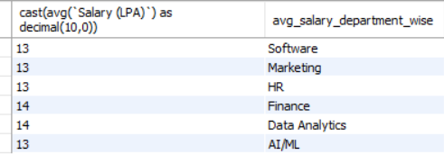
Query: select cast(avg(`Salary (LPA)`) as decimal(10,0)),Department as avg_salary_department_wise from india_jobmarket group by Department order by avg_salary_department_wise desc;

- Which job role has the highest salary?
Query: SELECT `Job Title`,MAX(`Salary (LPA)`) AS Highest_Salary FROM india_jobmarket group by `Job Title` ORDER BY Highest_Salary DESC LIMIT 1;
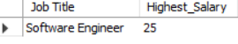

- What is the total count of remote, hybrid, and on-site jobs?
Query: select count(`Job ID`),`Work Mode` as job_by_Work_Mode from india_jobmarket group by `Work Mode` order by count(`Job ID`) desc;
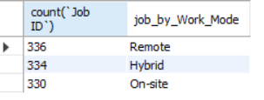

- In which month were the highest number of jobs posted?
Query: select `Posted Month`,count(`Job ID`) as total_job_by_month from india_jobmarket group by `Posted Month` order by count(`Job ID`) desc limit 1 ;
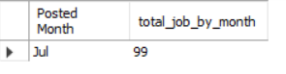

- How many jobs are there for freshers (0–1 years)?
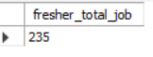
Query: select count(*) as fresher_total_job from india_jobmarket where Experience="0-1";

