Application Screenshots.

Open the application by using http://localhost:2900/mainview

This gives the pagination data in the grid with groping based on User Name and and Quantity.
I am not considering the transaction id here to keep it simple as it is demo system. In place of that used user name based system.
Paging data can be displayed by navigating between the pages using the paging button. Each page has 5 records which is enough for demo purpose.

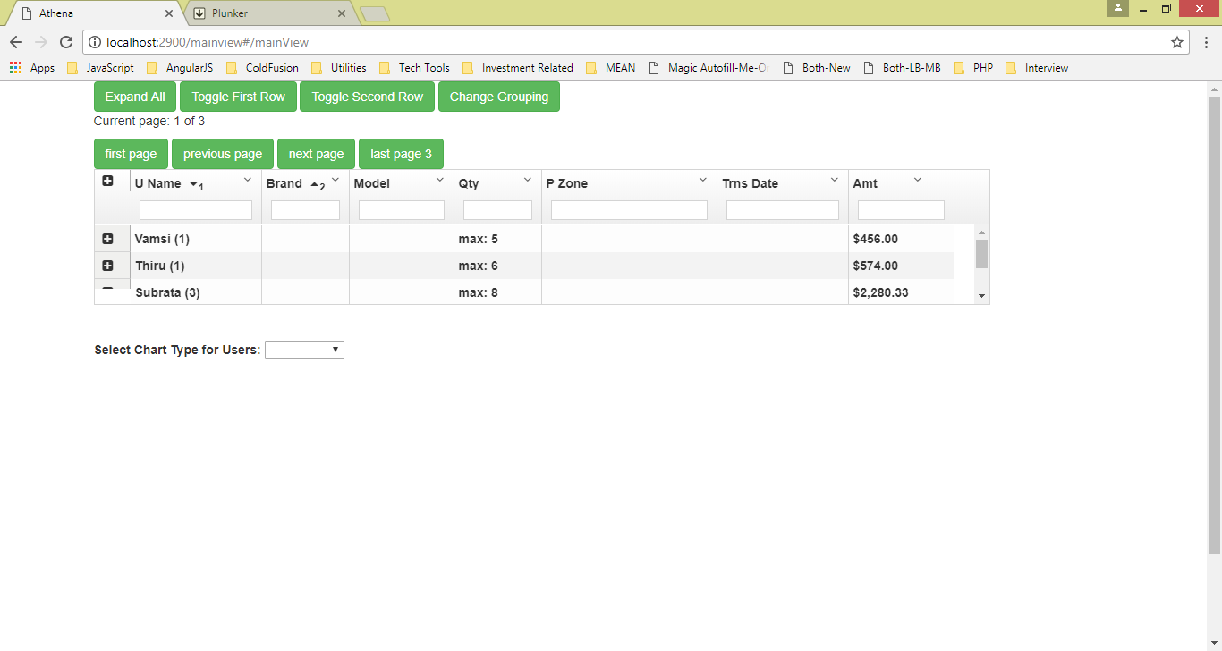
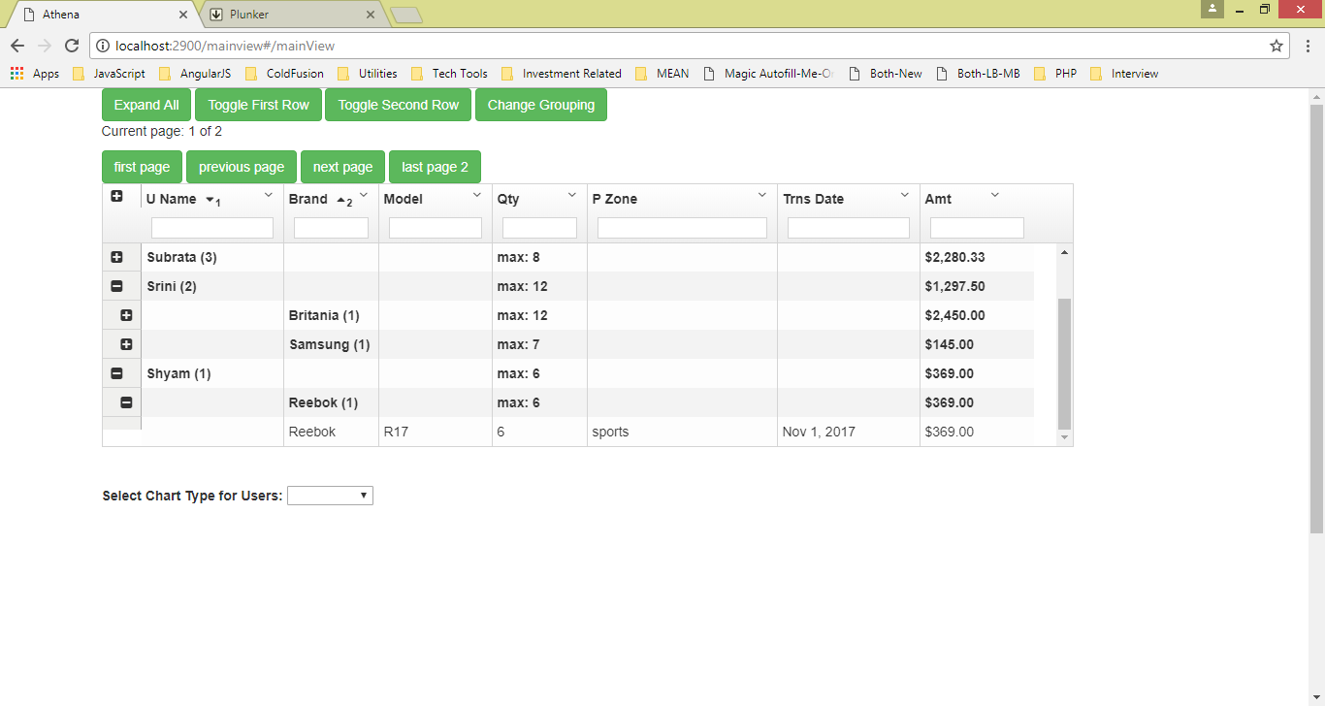

Now select a chart type for user. I have kept two type of charts for demo.
Chart is used for displaying user names along with total purchased amount, total quantity, and max quantity bought for a transaction.
Below are the screenshots.

