RESULT

The loss and accuracy curves need to be plotted separately

Fig-1 : Loss_GRU_ws_5, Loss_GRU_ws_10, Loss_GRU_ws_15, Loss_GRU_ws_20, Loss_GRU_ws_25, Loss_GRU_ws_30.

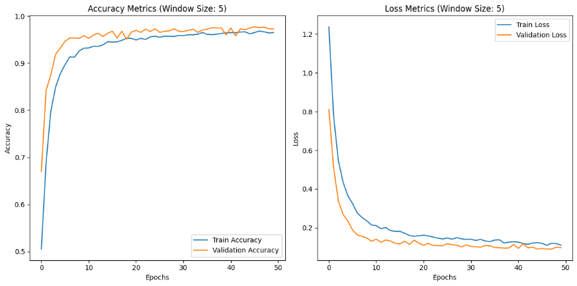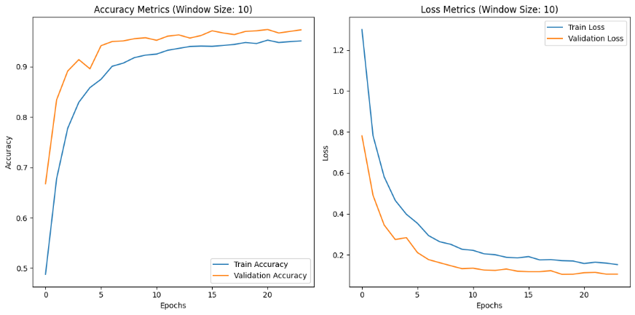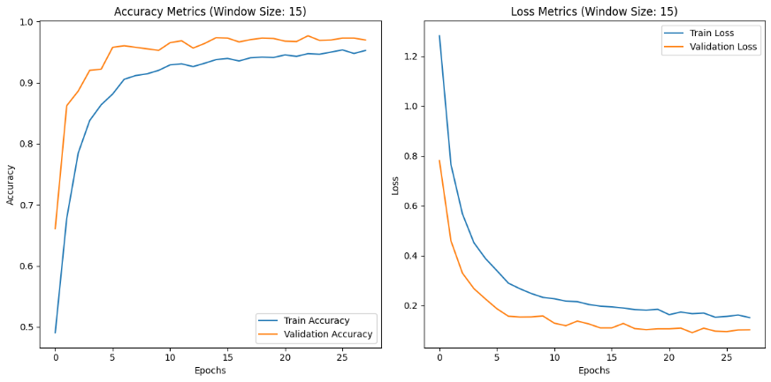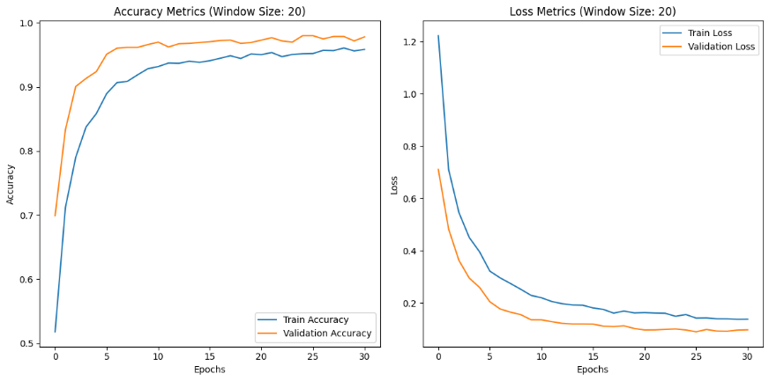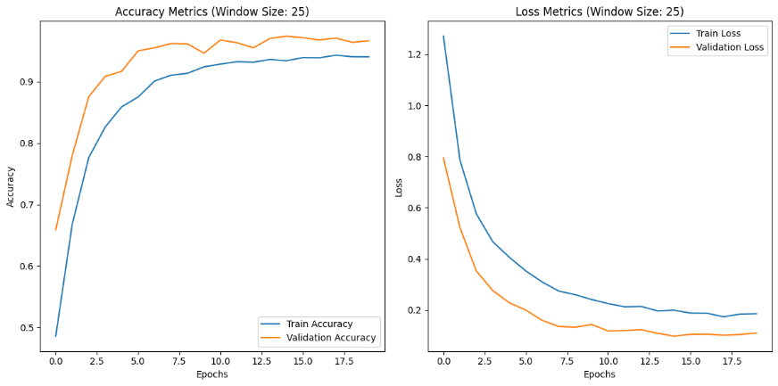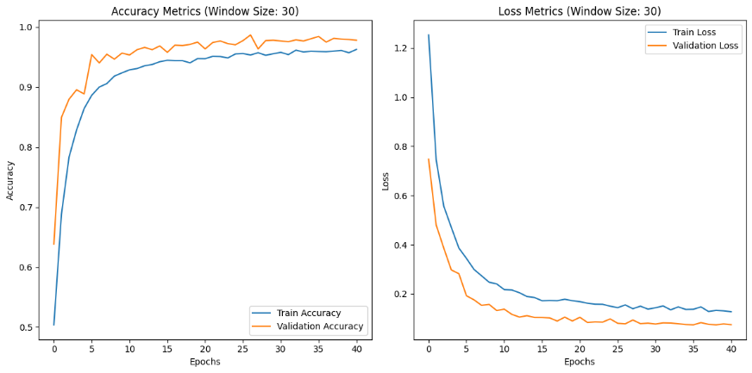

Fig-2 : Acuracy_GRU_ws_5, Acuracy_GRU_ws_10, Acuracy_GRU_ws_15, Acuracy_GRU_ws_20, Acuracy_GRU_ws_25, Acuracy_GRU_ws_30.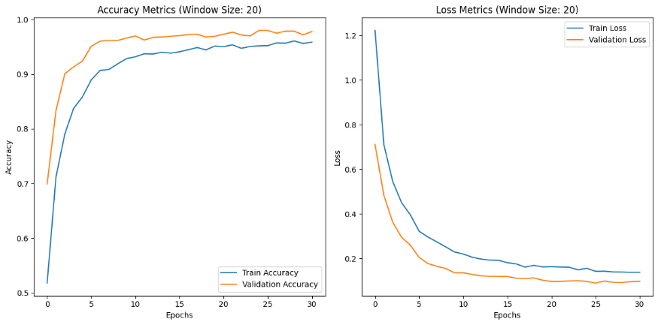

Fig-3 : Loss_RNN_ws_5, Loss_RNN_ws_10, Loss_RNN_ws_15, Loss_RNN_ws_20, Loss_RNN_ws_25, Loss_RNN_ws_30.

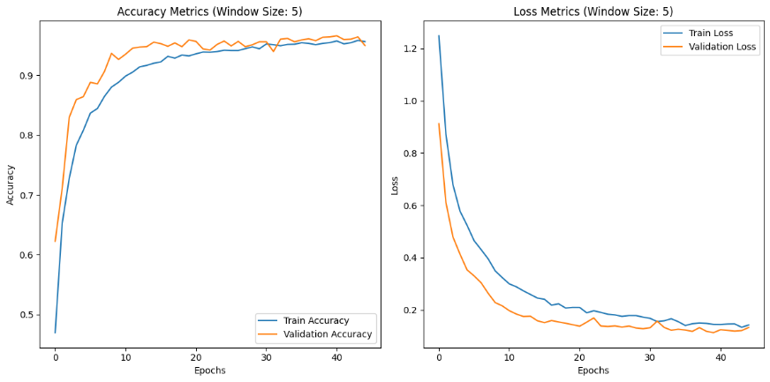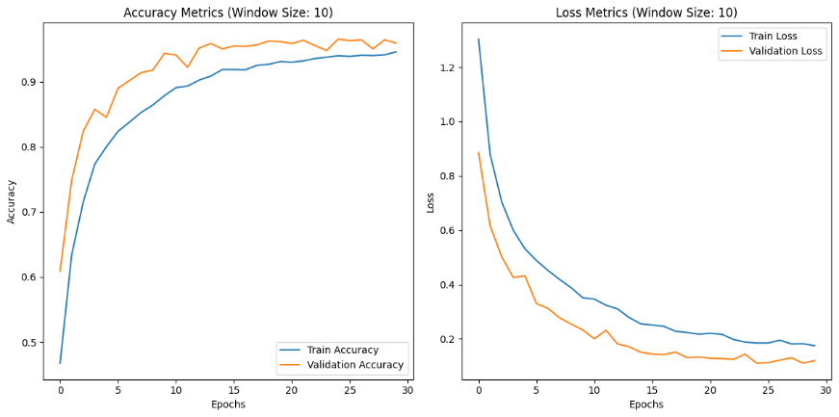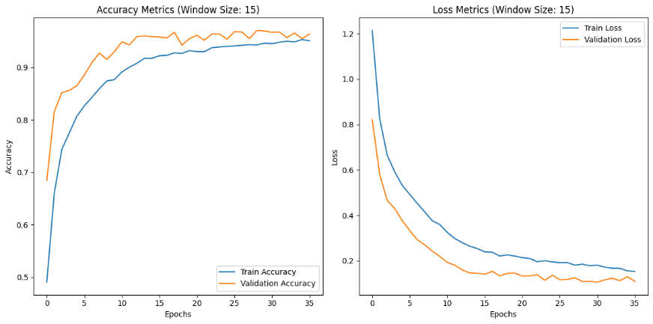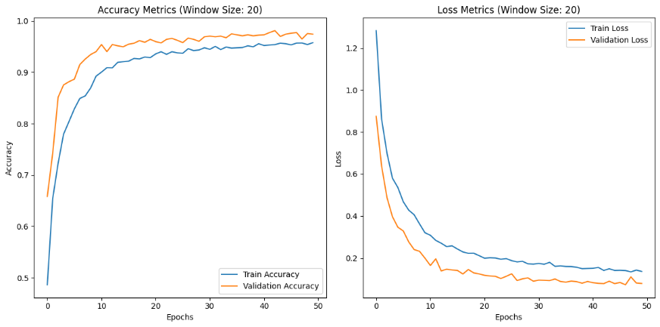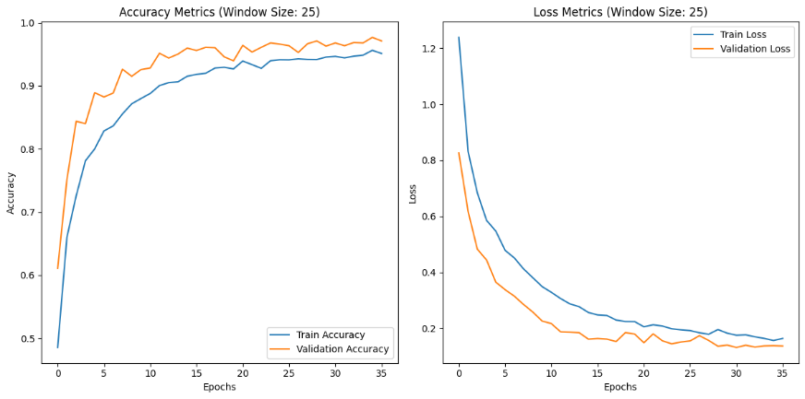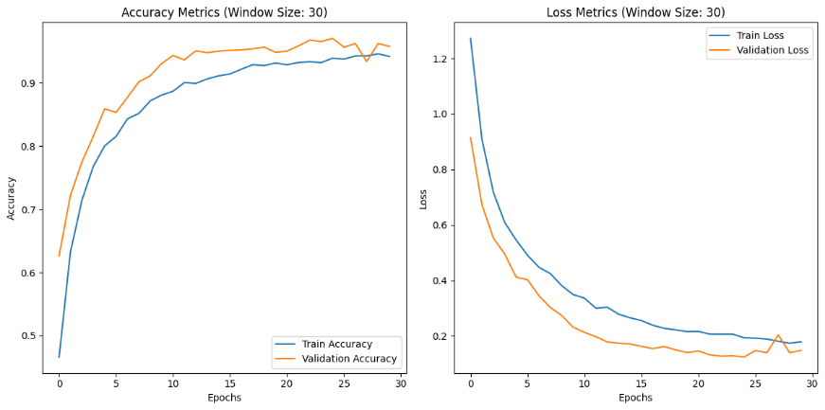

Fig-4 : Acuracy_RNN_ws_5, Acuracy_RNN_ws_10, Acuracy_RNN_ws_15, Acuracy_RNN_ws_20, Acuracy_RNN_ws_25, Acuracy_RNN_ws_30.



Fig-5 : Loss_LSTM_ws_5, Loss_LSTM_ws_10, Loss_LSTM_ws_15, Loss_LSTM_ws_20, Loss_LSTM_ws_25, Loss_LSTM_ws_30.

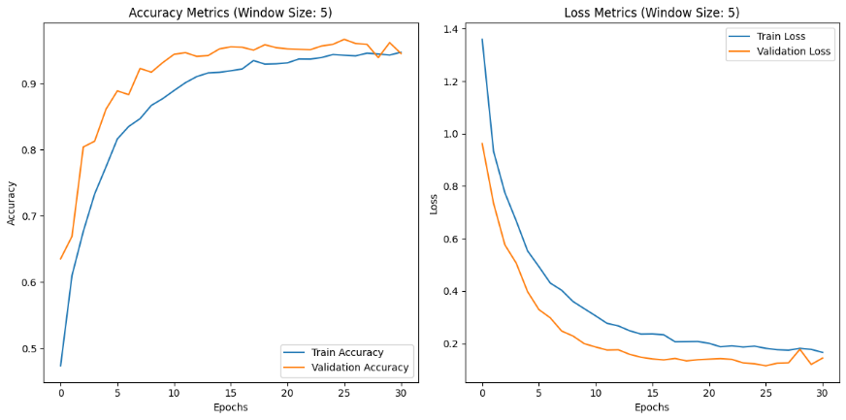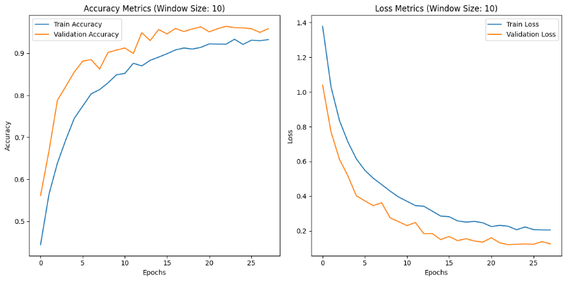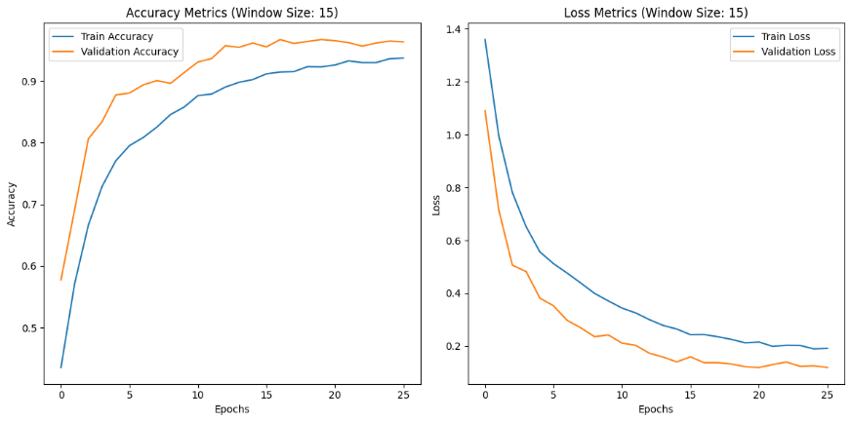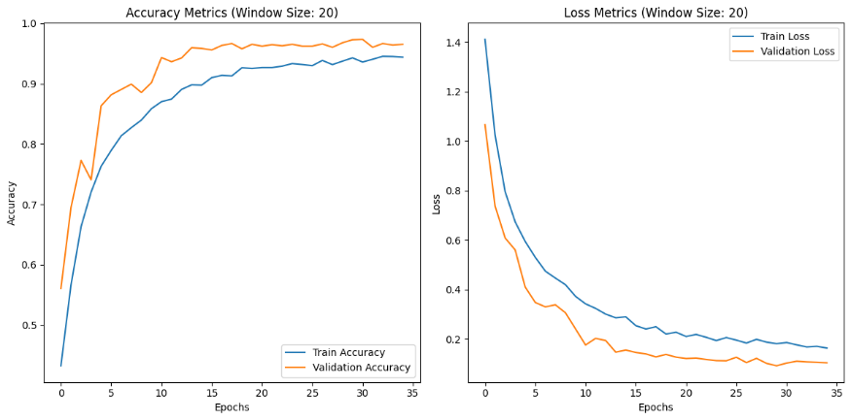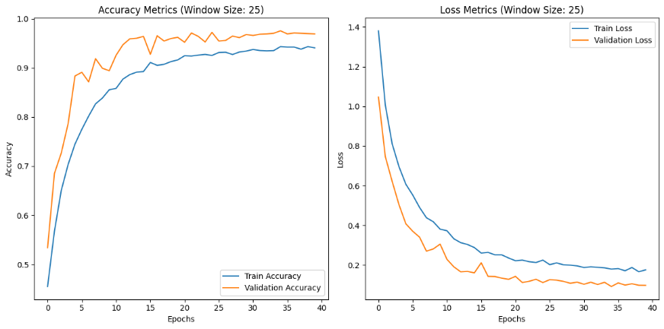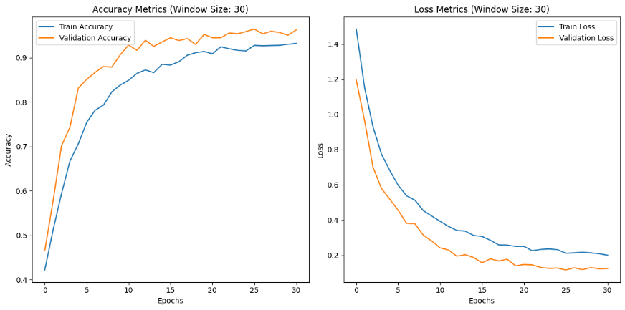

Fig-6 : Acuracy_LSTM_ws_5, Acuracy_LSTM_ws_10, Acuracy_LSTM_ws_15, Acuracy_LSTM_ws_20, Acuracy_LSTM_ws_25, Acuracy_LSTM_ws_30.



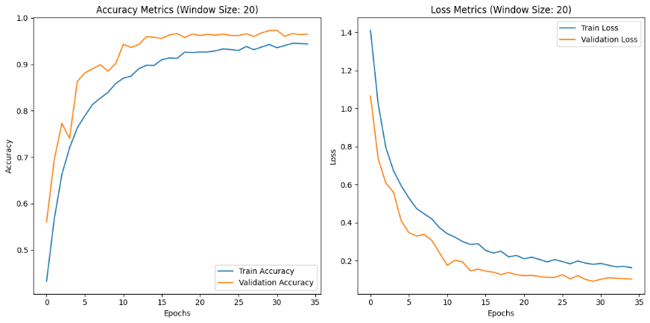

RNN(window size:5)

|  |  |  |  |  |
| --- | --- | --- | --- | --- |
| **Category** | **precision** | **recall** | **f1-score** | **support** |
| CS | 0.99 | 0.98 | 0.99 | 312 |
| D | 0.98 | 0.99 | 0.99 | 646 |
| DD | 0.97 | 0.95 | 0.96 | 310 |
| SCS | 0.95 | 0.88 | 0.91 | 138 |
| SuCS | 0.86 | 0.95 | 0.91 | 66 |
| VSCS | 0.86 | 0.89 | 0.88 | 120 |

RNN(window size:10)

|  |  |  |  |  |
| --- | --- | --- | --- | --- |
| **Category** | **precision** | **recall** | **f1-score** | **support** |
| CS | 0.98 | 0.98 | 0.98 | 310 |
| D | 0.98 | 0.99 | 0.98 | 671 |
| DD | 0.96 | 0.94 | 0.95 | 298 |
| SCS | 0.95 | 0.95 | 0.95 | 136 |
| SuCS | 0.94 | 0.89 | 0.91 | 66 |
| VSCS | 0.92 | 0.91 | 0.91 | 110 |

RNN(window size:15)

|  |  |  |  |  |
| --- | --- | --- | --- | --- |
| **Category** | **precision** | **recall** | **f1-score** | **support** |
| CS | 0.98 | 0.98 | 0.98 | 335 |
| D | 0.98 | 0.99 | 0.99 | 650 |
| DD | 0.95 | 0.96 | 0.96 | 298 |
| SCS | 0.96 | 0.91 | 0.94 | 120 |
| SuCS | 0.88 | 0.94 | 0.91 | 68 |
| VSCS | 0.91 | 0.90 | 0.91 | 119 |

RNN(window size:20)

|  |  |  |  |  |
| --- | --- | --- | --- | --- |
| **Category** | **precision** | **recall** | **f1-score** | **support** |
| CS | 0.97 | 0.99 | 0.98 | 306 |
| D | 0.99 | 0.99 | 0.99 | 665 |
| DD | 0.98 | 0.97 | 0.97 | 320 |
| SCS | 0.96 | 0.93 | 0.94 | 118 |
| SuCS | 0.95 | 0.97 | 0.96 | 64 |
| VSCS | 0.95 | 0.94 | 0.94 | 116 |

RNN(window size:25)

|  |  |  |  |  |
| --- | --- | --- | --- | --- |
| **Category** | **precision** | **recall** | **f1-score** | **support** |
| CS | 0.96 | 0.98 | 0.97 | 311 |
| D | 0.99 | 0.99 | 0.99 | 658 |
| DD | 0.98 | 0.96 | 0.97 | 313 |
| SCS | 0.93 | 0.92 | 0.92 | 125 |
| SuCS | 0.96 | 0.81 | 0.88 | 58 |
| VSCS | 0.89 | 0.94 | 0.91 | 123 |

RNN(window size:30)

|  |  |  |  |  |
| --- | --- | --- | --- | --- |
| **Category** | **precision** | **recall** | **f1-score** | **support** |
| CS | 0.95 | 1.00 | 0.97 | 291 |
| D | 0.99 | 1.00 | 0.99 | 648 |
| DD | 0.99 | 0.96 | 0.98 | 323 |
| SCS | 0.98 | 0.88 | 0.93 | 145 |
| SuCS | 0.89 | 0.93 | 0.91 | 71 |
| VSCS | 0.88 | 0.92 | 0.90 | 109 |

GRU(window size:5)

|  |  |  |  |  |
| --- | --- | --- | --- | --- |
| **Class** | **Precision** | **Recall** | **F1-Score** | **Support** |
| CS | 0.98 | 0.98 | 0.98 | 312 |
| D | 0.98 | 0.99 | 0.99 | 646 |
| DD | 0.97 | 0.95 | 0.96 | 310 |
| SCS | 0.93 | 0.99 | 0.96 | 138 |
| SuCS | 0.93 | 0.97 | 0.95 | 66 |
| VSCS | 0.98 | 0.92 | 0.95 | 120 |

GRU(window size:10)

|  |  |  |  |  |
| --- | --- | --- | --- | --- |
| **Class** | **Precision** | **Recall** | **F1-Score** | **Support** |
| CS | 0.98 | 0.98 | 0.98 | 310 |
| D | 0.99 | 0.99 | 0.99 | 671 |
| DD | 0.96 | 0.96 | 0.96 | 298 |
| SCS | 0.97 | 0.92 | 0.94 | 136 |
| SuCS | 0.98 | 0.89 | 0.94 | 66 |
| VSCS | 0.88 | 0.96 | 0.92 | 110 |

GRU(window size:15)

|  |  |  |  |  |
| --- | --- | --- | --- | --- |
| **Class** | **Precision** | **Recall** | **F1-Score** | **Support** |
| CS | 0.99 | 0.99 | 0.99 | 335 |
| D | 0.98 | 0.99 | 0.99 | 650 |
| DD | 0.97 | 0.96 | 0.96 | 298 |
| SCS | 0.97 | 0.93 | 0.95 | 120 |
| SuCS | 0.93 | 0.99 | 0.96 | 68 |
| VSCS | 0.96 | 0.94 | 0.95 | 119 |

GRU(window size:20)

|  |  |  |  |  |
| --- | --- | --- | --- | --- |
| **Class** | **Precision** | **Recall** | **F1-Score** | **Support** |
| CS | 0.99 | 0.98 | 0.99 | 306 |
| D | 0.99 | 0.99 | 0.99 | 665 |
| DD | 0.98 | 0.97 | 0.98 | 320 |
| SCS | 0.95 | 0.97 | 0.96 | 118 |
| SuCS | 0.93 | 0.97 | 0.95 | 64 |
| VSCS | 0.96 | 0.93 | 0.95 | 116 |

GRU(window size:25)

|  |  |  |  |  |
| --- | --- | --- | --- | --- |
| **Class** | **Precision** | **Recall** | **F1-Score** | **Support** |
| CS | 0.96 | 0.98 | 0.97 | 311 |
| D | 0.99 | 1.00 | 0.99 | 658 |
| DD | 0.98 | 0.96 | 0.97 | 313 |
| SCS | 0.93 | 0.92 | 0.93 | 125 |
| SuCS | 0.98 | 0.95 | 0.96 | 58 |
| VSCS | 0.96 | 0.94 | 0.95 | 123 |

GRU(window size:30)

|  |  |  |  |  |
| --- | --- | --- | --- | --- |
| **Class** | **Precision** | **Recall** | **F1-Score** | **Support** |
| CS | 0.97 | 1.00 | 0.98 | 291 |
| D | 0.99 | 1.00 | 0.99 | 648 |
| DD | 0.99 | 0.95 | 0.97 | 323 |
| SCS | 0.99 | 0.98 | 0.99 | 145 |
| SuCS | 0.99 | 0.96 | 0.97 | 71 |
| VSCS | 0.96 | 0.98 | 0.97 | 109 |

LSTM(window size:5)

|  |  |  |  |  |
| --- | --- | --- | --- | --- |
| **Class** | **Precision** | **Recall** | **F1-Score** | **Support** |
| CS | 0.97 | 0.99 | 0.98 | 312 |
| D | 0.98 | 0.99 | 0.99 | 646 |
| DD | 0.97 | 0.95 | 0.96 | 310 |
| SCS | 0.93 | 0.93 | 0.93 | 138 |
| SuCS | 0.95 | 0.89 | 0.92 | 66 |
| VSCS | 0.89 | 0.92 | 0.91 | 120 |

LSTM(window size:10)

|  |  |  |  |  |
| --- | --- | --- | --- | --- |
| **Class** | **Precision** | **Recall** | **F1-Score** | **Support** |
| CS | 0.97 | 0.98 | 0.98 | 310 |
| D | 0.98 | 0.99 | 0.99 | 671 |
| DD | 0.95 | 0.95 | 0.95 | 298 |
| SCS | 0.94 | 0.94 | 0.94 | 136 |
| SuCS | 0.95 | 0.86 | 0.90 | 66 |
| VSCS | 0.90 | 0.90 | 0.90 | 110 |

LSTM(window size:15)

|  |  |  |  |  |
| --- | --- | --- | --- | --- |
| **Class** | **Precision** | **Recall** | **F1-Score** | **Support** |
| CS | 0.96 | 0.99 | 0.97 | 335 |
| D | 0.98 | 0.99 | 0.99 | 650 |
| DD | 0.96 | 0.95 | 0.95 | 298 |
| SCS | 0.95 | 0.88 | 0.91 | 120 |
| SuCS | 0.97 | 0.91 | 0.94 | 68 |
| VSCS | 0.93 | 0.93 | 0.93 | 119 |

LSTM(window size:20)

|  |  |  |  |  |
| --- | --- | --- | --- | --- |
| **Class** | **Precision** | **Recall** | **F1-Score** | **Support** |
| CS | 0.98 | 0.98 | 0.98 | 306 |
| D | 0.99 | 0.99 | 0.99 | 665 |
| DD | 0.97 | 0.96 | 0.96 | 320 |
| SCS | 0.94 | 0.96 | 0.95 | 118 |
| SuCS | 0.98 | 0.89 | 0.93 | 64 |
| VSCS | 0.92 | 0.95 | 0.94 | 116 |

LSTM(window size:25)

|  |  |  |  |  |
| --- | --- | --- | --- | --- |
| **Class** | **Precision** | **Recall** | **F1-Score** | **Support** |
| CS | 0.96 | 0.98 | 0.97 | 311 |
| D | 0.99 | 1.00 | 0.99 | 658 |
| DD | 0.98 | 0.96 | 0.97 | 313 |
| SCS | 0.93 | 0.92 | 0.93 | 125 |
| SuCS | 0.97 | 0.98 | 0.97 | 58 |
| VSCS | 0.97 | 0.93 | 0.95 | 123 |

LSTM(window size:30)

|  |  |  |  |  |
| --- | --- | --- | --- | --- |
| **Class** | **Precision** | **Recall** | **F1-Score** | **Support** |
| CS | 0.94 | 0.99 | 0.97 | 291 |
| D | 0.99 | 0.99 | 0.99 | 648 |
| DD | 0.98 | 0.95 | 0.97 | 323 |
| SCS | 0.98 | 0.89 | 0.93 | 145 |
| SuCS | 0.90 | 0.92 | 0.91 | 71 |
| VSCS | 0.86 | 0.92 | 0.89 | 109 |

About the dataset

The dataset comprises **7,979 records** with **12 attributes**, providing meteorological data on tropical cyclones spanning multiple years, with records dating back to at least **1982**. It includes key parameters such as the **Serial Number of System During Year** (a unique cyclone identifier), **Basin of Origin** (e.g., Bay of Bengal), **Name** (where available), **Date and Time (UTC)** of observation, and **Cyclone Intensity Number (CI No.)**, which indicates the storm’s strength. The dataset also records the **Estimated Central Pressure (hPa) [E.C.P]**, **Maximum Sustained Surface Wind (kt)**, and **Grade (text)**, categorizing storms as Depression (D), Deep Depression (DD), Cyclonic Storm (CS), Very Severe Cyclonic Storm (VSCS), and Super Cyclonic Storm (SuCS). Additionally, it contains data on the **Outermost Closed Isobar (hPa)**, though many values are missing, and the **Year** of occurrence. Some data inconsistencies, such as duplicate column names and missing cyclone names, suggest a need for cleaning before analysis. Despite this, the dataset provides valuable insights into cyclone formation, intensity variations, and long-term trends, making it useful for **weather pattern analysis, disaster preparedness, and climate change studies**.

