VMS-ITANIUM Oracle 10g Install Steps:

Set Display to VNC:
$ SET DISPLAY/CREATE/TRANSPORT=TCPIP/NODE=usamkb02247.mkcorp.com
$ SET DISPLAY/TRANSPORT=TCPIP/NODE=unmkbdev12/SERVER=16/SCREEN=0

Set Java:
$ @SYS$COMMON:[JAVA$142.COM]JAVA$142_SETUP

Create Oracle Home:
$ exit
$ show def
ORACLE_DISK:[ORACLE]
$ create/dir [.10.2.0.3]
$ set def [.10_2_0_3]
$ show def
ORACLE_DISK:[ORACLE.10_2_0_3]
$
Mount CD Rom:
$ MOUNT/OVERRIDE=IDENTIFICATION DNA0:

Invoke Installer:
$ @DNA0:[DATABASE]RUNINSTALLER

Checking OpenVMS quota settings...
OpenVMS quota setting checked successfully.

Please specify the location to be used for ORACLE_HOME

ORACLE_HOME location: ORACLE_DISK:[ORACLE.10203]

Please specify the location for temporary files created during installation.
(this must be a directory on an ODS-5 formatted disk)

Enter scratchPath: ORACLE_DISK:[sys$scratch]
Copying runInstaller components to temporary location...

Follow GUI steps to install

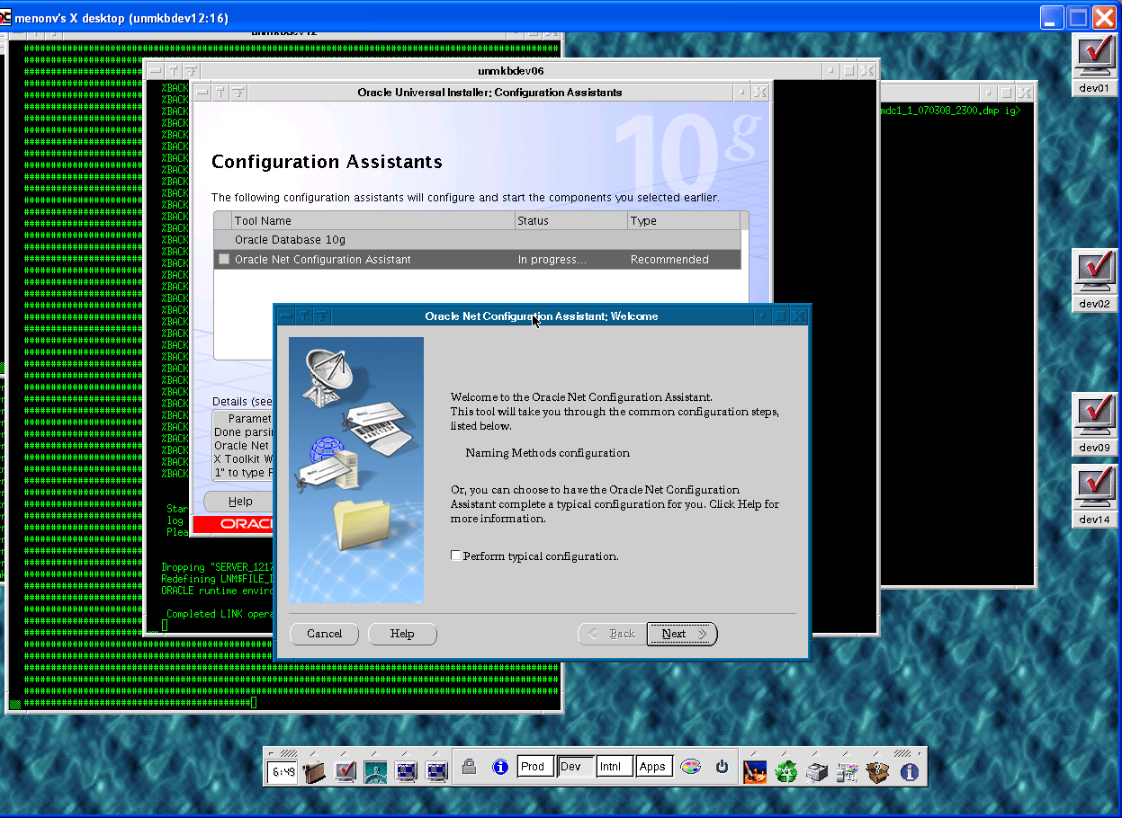

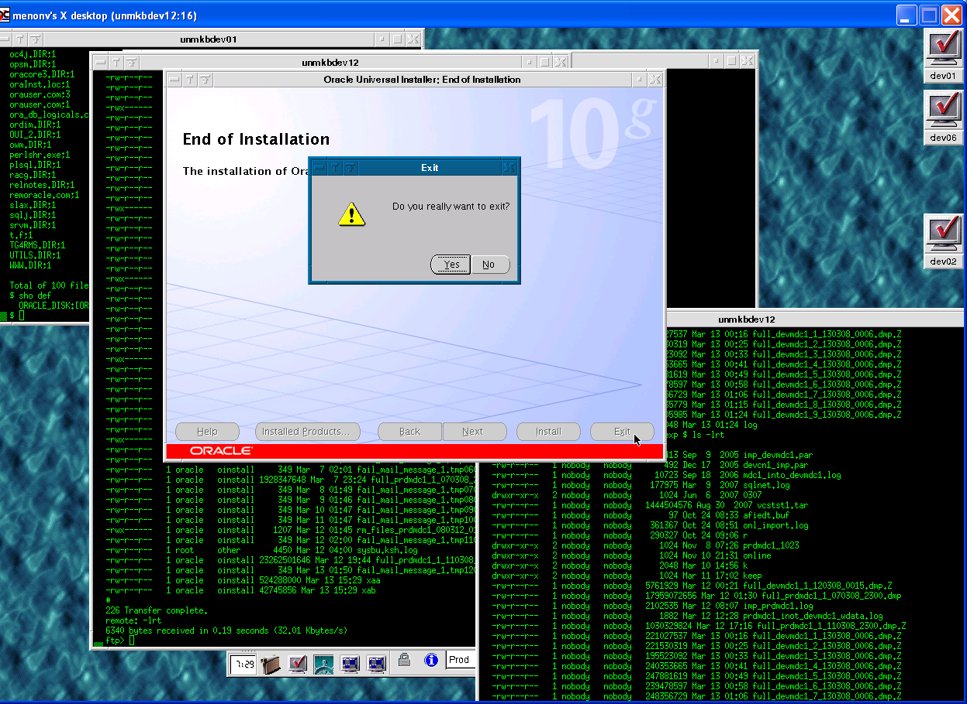

To set environment for Oracle.

$@DSA222:[ORACLE.10203]orauser.com -- This can be added to at system level or at each users login.com

If sqlplus is not found after Oracle install:

$ show log ora_root
"ORA_ROOT" = "DSA222:[ORACLE.10_2_0_3.]" (LNM$JOB_88D5E3C0)
"ORA_ROOT" = "ORACLE_DISK:[ORACLE.10_2_0_3.]" (SERVER_0512210520)
$ dir ora_root:[bin]sqlplus.exe
%DIRECT-W-NOFILES, no files found
$
$ @DSA222:[ORACLE.10203]orauser.com
$ @ora_root:[bin]relink all

ora_root:[install]make.log will show details of relinking. If sqlplus not found at ora_root:[bin]

Relink will fail if DISK70:[SSPRODUCTION.SSOLB]CL_LIBRARY.OLB application library is already installed or its logical defined before Oracle install. Phil needs to remove this library or disable it before relinking libraries again. LNK$LIBRARY logical needs to be removed by phil before next relink.

After relink and copy sqlnet.ora and tnsnames.ora files.
Files such as LISTENER.ORA, TNSNAMES.ORA, SQLNET.ORA, if configured manually, or copied and edited from earlier releases of Oracle Database may have record attributes that are incompatible with Oracle Database 10g release 1 (10.1.0.3.0). The software cannot read such files.
$ CONVERT/FDL=SYS$INPUT tnsnames.ora tnsnames.ora
RECORD
CARRIAGE_CONTROL carriage_return
FORMAT stream_LF
^Z

$
$ CONVERT/FDL=SYS$INPUT sqlnet.ora sqlnet.ora
RECORD
CARRIAGE_CONTROL carriage_return
FORMAT stream_LF
^Z
$

Oracle Net Configuration Files

https://metalink.oracle.com/metalink/plsql/f?p=130:3:6729166901247328387::::p3_database_id,p3_docid,p3_show_header,p3_show_help,p3_black_frame,p3_font:NOT,314309.1,1,1,1,helvetica

Files such as LISTENER.ORA, TNSNAMES.ORA, SQLNET.ORA, if configured manually, or copied and edited from earlier releases of Oracle Database may have record attributes that are incompatible with Oracle Database 10g release 1 (10.1.0.3.0). The software cannot read such files.

This may result in:

*

Inability to start the listener
*

Services not registered with the listener
*

Inability to connect to other databases
*

ORA-12154: TNS:could not resolve service name

Run the following command on each file affected:

$ DIR/FULL filename;0

An output similar to the following may be displayed:

Record format: Variable length, maximum 255 bytes
Record attributes: Carriage return carriage control

If the output includes the preceding entries, then run the following command:

$ CONVERT/FDL=SYS$INPUT filename filename
RECORD
CARRIAGE_CONTROL carriage_return
FORMAT stream_LF
^Z

Metalink Note: # 314309.1

