Table of Contents
EC2 1
EC2 Placement group: 2
S3 2
S3 Bucket policy: 2
S3 Storage classes: 4
S3 Event Notification: 5
S3 versioning: 5
Doubts- 5

EC2

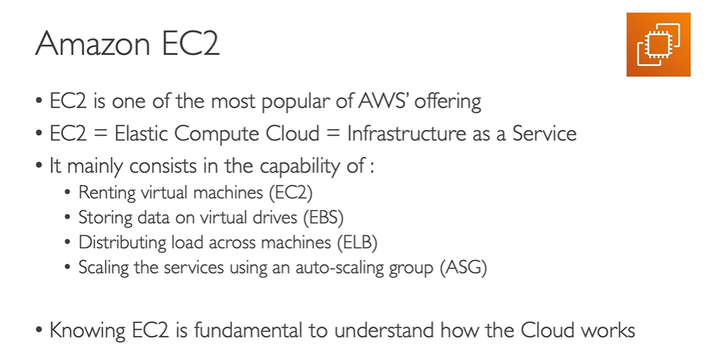
- EC2 - Amazon Elastic Compute Cloud
- EC2 is Server rented from AWS
- After EC2 instance starts it generates two Ip – Private and public ip
- Private Ip for internal use
- Public Ip for public use
- If you stop the instance and start instance again it changes the previous public ip but private ip remains unchanged.
Create new Instance in EC2-
- OS- Amazon linux(free tire)
- Instance type – t2.micro (free tire)

Port no –
- SSH – Secure Shell – 21
- FTP – File Transfer Protocol – 21
- SFTP – Secure FTP – 22
- HTTP – 80
- HTTPS- 443
- RDP – Remote desktop Protocol – 3389

EC2 Placement group:
- Placement group is a logical grouping or clusters of instances in a selected region.
- EC2 Placement Group in AWS is a logical grouping of instances within a single Availability Zone or across multiple Availability Zones
- Placement groups are used to control the placement of instances to meet specific workload requirements, such as reducing latency, increasing throughput, or achieving high availability.
- Three types of Placement group –
- Cluster PG – Logical grouping of instances in a single Availability zone.
- Spread PG - One instance in one rack of single availability zone.
- Partition PG - Multiple instances in same rack and creates one partition.

EBS – Elastic Block Storage
- EBS attached(extra memory) added to every instances.
- If instances got deleted, still EBS volume will be exist. If we don’t want to be exist, then we have to configure.
- Create a EBS volume and attach the EC2 instance.. both should be same Availability Zone
Snapshot of volume is like backup of volume

VPC:
VPC- Virtual Private Cloud
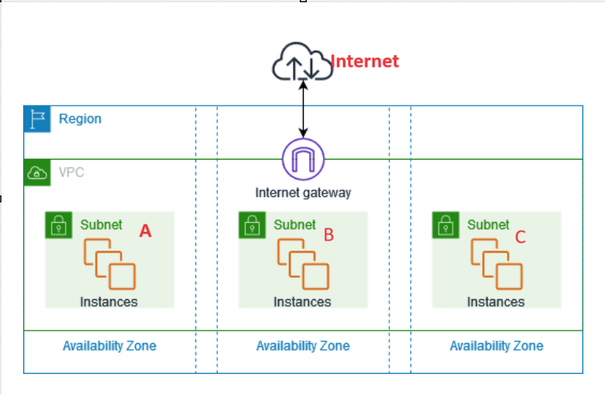
One region has VPC and VPC has subnets and one subnet can have multiple instances.
Subnet – Subnet is a range of IP addresses in your VPC. A subnet must reside in a single Availability Zone.
Subnet – A is private Subnet – it is not connected with Internet. Here we can keep databases for more security.
Subnet – B is public subnet – it is connected with internet via IG(Internet Gateway). Here we can how application for our world
Region –(1-n) Availability Zone –(1-n) subnets

S3
- IAM policies define what actions are allowed/denied on resources. IAM policy attached with User, Group and Roles
- Resources are the entities you create in AWS, i.e S3 bucket or objects, Lambda, EC2
- If for a same resource both Allow and Deny policy is there then Denay policy will win

S3 Bucket policy:
- Policy that gets attached to S3 buckets
- Permission applied to Principal (Person/Application) in the statement
- This policy directly attaches to the user.
- Bucket policies support larger sizes, 20KB vs 4 KB with IAM
- We can add conditions in bucket policy
Ex-Deny download if condition apply for a particular IP

Resource based Policy – it for a particular resource
Ex- Lets say a global user giving IAM policy to a user, who can access to all the buckets except one bucket. This case we can use Iam and Resource based Policy.

IAM Policy JSON:
{
"Version": "2012-10-17",
"Statement": [
{
"Effect": "Allow",
"Action": [
"s3:ListBucket",
"s3:GetObject",
"s3:PutObject"
],
"Resource": [
"arn:aws:s3:::your-bucket-name",
"arn:aws:s3:::your-bucket-name/*"
]
},
{
"Effect": "Deny",
"Action": [
"ec2:TerminateInstances"
],
"Resource": "*"
}
]
}

S3 Bucket Policy JSON:

{
"Version": "2012-10-17",
"Statement": [
{
"Effect": " Allow ",
"Principal": {
"AWS": "arn:aws:iam::123456789012:user/UnauthorizedUser"
},
"Action": "s3:*",
"Resource": ["arn:aws:s3:::your-bucket-name",
“arn:aws:s3:::your-bucket-name/*" ]
}
]

- "AWS": "arn:aws:iam::123456789012:user/UnauthorizedUser"
This is user details, who can access S3 Bucket

- "Resource": ["arn:aws:s3:::your-bucket-name",
“arn:aws:s3:::your-bucket-name/*" ]
"arn:aws:s3:::your-bucket-name" – ARN of s3 bucket. It access to s3 bucket but not inside content
“arn:aws:s3:::your-bucket-name/*" – ARN of s3 bucket and it access to s3 bucket insde

S3 Storage classes:

What is S3 storage class?
S3 storage is categorized based on use cases and cost

Different types of Storage Classes-
- S3 Standard – this is default storage class. S3 Standard offers high durability, availability, and performance.
Use Case: Ideal for data that is accessed frequently, such as websites, content distribution, or big data analytics.
- S3 Standard-IA (Infrequent Access) - For data that is accessed less frequently but requires rapid access when needed.
Ideal for backups, disaster recovery, and long-term storage of data.
- S3 Intelligent-Tiering- Automatically moves data between two access tiers (frequent and infrequent access) based on changing access patterns.
Use Case: Best for data with unknown or unpredictable access patterns.
- S3 One Zone-IA - Lower-cost option for infrequently accessed data stored in a single Availability Zone.
Use Case: Suitable for infrequently accessed data that can be easily recreated, like backups or secondary copies of data.
- S3 Glacier - Low-cost storage for archival data that is rarely accessed.
Use Case: Ideal for long-term backups, digital archives, and compliance data.
- S3 Glacier Deep Archive- The lowest-cost storage class for data that is rarely accessed (once or twice a year).
- S3 Reduced Redundancy Storage (RRS) - Lower-cost option for non-critical, reproducible data that can be easily replaced.

S3 storage class Summary
- Frequent Access: S3 Standard.
- Infrequent Access: S3 Standard-IA, S3 Intelligent-Tiering.
- Archival: S3 Glacier, S3 Glacier Deep Archive.
- Single Availability Zone: S3 One Zone-IA.
- Non-Critical Data: S3 Reduced Redundancy Storage (RRS).

S3 Event Notification:
- S3 share notification if any upload, download or delete operation happens in S3 bucket.
- Notification happens through SQS, SNS and Lambda
- Ex- to detect any fraud transaction in protected files

S3 versioning:
- Protects against accidental deletions or overwrites.
- Maintains an audit trail of changes to objects.
- Bydefault versioning not enabled
- Prior versioning, loaded files in S3 will not be considered versioning. Versioning will enable only new files.

Doubts-

- Region and Availability Zone

Points-

