Replication-

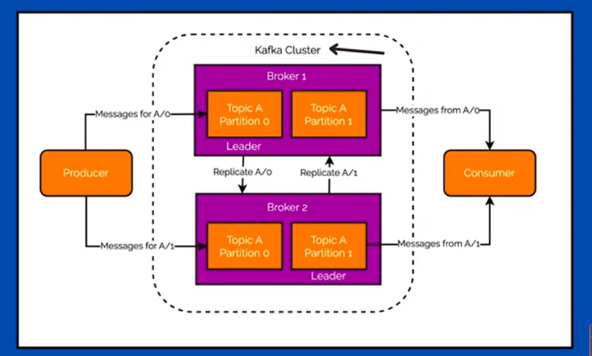

Why Partition Replication required?
- Producer produce message and send to kafka distrubted system.
- Kafka topic receive the messages
- Kafka topic is inside Kafka broker
- Messages store in partitions
- If message store in one broker, and if broker got down or shut down then message will be lost. To protect message topic partitions copies store in multiple brokers.
If one broker goes down other broker can provide the data

- Partition which gets message from producer is known as Leader.
- Partitions which are copied from leader partition known as followers
- If leader partition goes down, one partition from followers converted to Leader.

In-Sync Replicas and Out of Sync Replicas
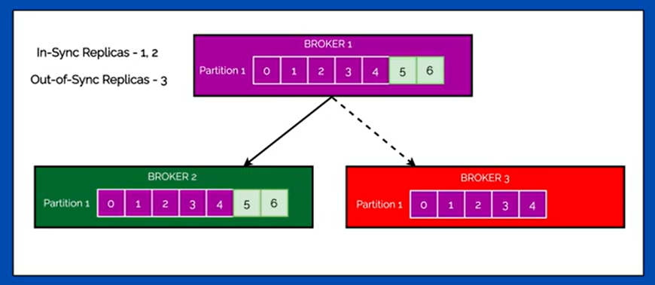

- Broker1 and Broker 2 Partitions has complete data but some reason Broker 3 partition has incomplete data.
- Broker1 Partition and Broker2 Partition are In-Sync Replicas
- Broker3 Partition is Out of sync Replicas

If Partition is out of sync, what to do for that partition. How to make that partition to sync again ?

Partition, Offset, Segment

  - Partition –
A partition is a division of a Kafka topic and is a fundamental unit of parallelism and scalability in Kafka. Each topic can have multiple partitions, which are distributed across Kafka brokers.
  - Offset –
An offset is a unique identifier for each record within a partition. It is a sequential number that Kafka assigns to each record as it is produced to a partition.
  - Segment –
A segment is a smaller, manageable chunk of data within a Kafka partition. Partitions are split into segments to make data management more efficient. Each segment is typically a file on disk, and Kafka manages these files to provide efficient read and write operations. Segments help with:

Retention and deletion policies: Older segments can be deleted based on configured retention policies to manage disk space.
Indexing: Kafka maintains an index for each segment, allowing quick lookups of records by their offsets.
Compaction: Segments can be compacted to remove redundant records and reduce storage usage.

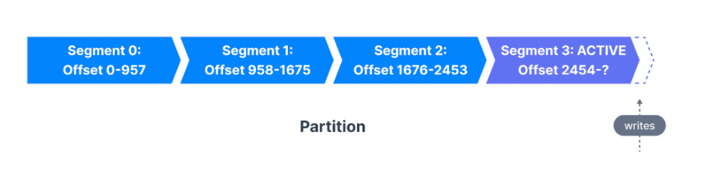

Kafka Retention
Retention refers to the policy that determines how long Kafka retains the data (messages) in a topic.
Types:
- Time-Based Retention: Messages are retained for a specified amount of time. Default time is 7days.
Configured using the retention.ms property.
log.retention.ms
log.retention.minutes
log.retention.hours

- Size-Based Retention: Messages are retained until the log size reaches a specified threshold. Default size is 1GB
Configured using the retention.bytes property.
log.segment.bytes
log.retention.check.interval.ms

- Log Compaction: Instead of deleting old messages, Kafka retains the latest version of each key.
Configured using the cleanup.policy=compact property.

Default size of segment file is – 1GB of Data or 1 week data
Partition Offset is 64bit integer- like 0000,0001,0002

Apache Kafka – Producer Acknowledgement

The ‘acks’ parameter can be set to three different values, each providing a different level of guarantee:
- acks=0:
  - Description: The producer does not wait for any acknowledgment from the broker.
This is also call fire and forget
  - Behavior: The message is considered sent as soon as it is placed on the network.
  - Use Case: High throughput is required, and data loss is acceptable.
  - Risk: Messages can be lost if the broker goes down before it processes the message.
- acks=1:
  - Description: The producer gets an acknowledgment after the leader broker has written the message to its local log.
  - Behavior: The leader broker will send an acknowledgment to the producer once it has received the message.
  - Use Case: Balance between performance and durability.
  - Risk: If the leader broker fails after acknowledging but before replicating the message to followers, the message may be lost.
- acks=all (or acks=-1):
  - Description: The producer gets an acknowledgment after all in-sync replicas (ISRs) have received the message.
  - Behavior: The message is considered committed when all the in-sync replicas confirm receipt.
  - Use Case: High durability and data consistency are required.
  - Risk: Higher latency compared to other acks settings, as the producer must wait for multiple acknowledgments.

