SVB --

SVB Round 1 Questions :
Spring boot 3.x - Features
Spring boot - Annotations you used till now
How to create pagination using JPA (extends with PaginationAndSortingRepository)
how to update column using JPA - (Native SQL)
what is idempotent and if it is post how to avoid idempotent
After receiving request to controller then how to update headers of request
how many ways we can call two microservcies -> (Http Client, Rest Template, Web Client, Feign client, @HTTPExchange -> spring 3.x version)

Kafka ->
how to avoide duplicate messages while publishing it
how to avoide reading duplicate messages
kafka architecture
how to integrate kafka with spring boot -> annotations and configration
How to test kafka applicatoin (testContainers)

Core java Code 1 ->
input output
square56([3, 1, 4]) → [19, 11]
Impelement it using Java 8
square it and add no 10 to it and if last digit is 5 or 6 then skip the no

Core java Code 2 -> (Use recursive method)
[16,18,19] -> if nearest is near by 20 then return 60
[12,14,11] -> if nearest is near by 10 then return 30
[4,5,7] -> -> if less than 10 then return 10

SVB Round 2 ->
What is rate Limitter
how to secure rest API
how many ways we can secure rest API
how to ensure that JWT token is expired
how overriding is working with Interfaces
How to resolved below exception:

Nested exception is org.springframework.beans.factory.NoUniqueBeanDefinitionException:
No qualifying bean of type [com.payment] is defined: expected single matching bean but found 2: abc,xyz

what is api contract?
how to resolved cycling dependency in sping boot
difference between setter injuction vs constructor injection
when to use bean annotation vs component annotation

Wite post api with versioning for payment ->
need to create whole structor like -> controller, service, repository, entity,

################################################################

SVB Round 1 Questions :
## Spring boot 3.x - Features
- Support at least Java 17
- GraalVM native image support
- Support for Jakarta EE 10( Jakarta EE previously known as JEE)
- Web Flux enhancements
- Micrometer metrics and tracing updates

##- Spring boot - Annotations you used till now
- SpringBootApplication(@Configuration + @EnableAutoConfiguration + @ComponentScan)
- RestController
- RequestMapping ( @GetMapping, @PostMapping, @PutMapping, @DeleteMapping)
- @Autowired
- @Component, @Service, @Repository
- @Configuration

## How to create pagination using JPA (extends with PaginationAndSortingRepository)
- Entiy class - Class Item
- Repository interface
public interface ItemRepository extends PagingAndSortingRepository<Item, Long> {
// No need to define methods for pagination and sorting explicitly
}
- Service class for pagination
import org.springframework.data.domain.Page;
import org.springframework.data.domain.PageRequest;
public class ItemService {

@Autowired
private ItemRepository itemRepository;

public Page<Item> getAllItems(int pageNo, int pageSize) {
// Create PageRequest for pagination
PageRequest pageable = PageRequest.of(pageNo, pageSize);

// Fetch paginated items from repository
return itemRepository.findAll(pageable);
}
}

## how to update column using JPA - (Native SQL)

public interface ItemRepository extends JpaRepository<Item, Long> {

@Transactional
@Modifying
@Query(value = "UPDATE item SET price = :newPrice WHERE id = :itemId", nativeQuery = true)
void updateItemPriceNativeQuery(Long itemId, double newPrice);
}

##

## After receiving request to controller then how to update headers of request
- Using HttpServletRequest
@GetMapping("foo")
public String foo (HttpServletRequest request) {
String operator = request.getHeader("operator");
return "hello, " + operator;
}

- Using @RequestHeader
@GetMapping("bar")
public String bar(@RequestHeader("operator") String operator) {
return "hello, " + operator;
}
## how many ways we can call two microservcies -> (Http Client, Rest Template, Web Client, Feign client, @HTTPExchange -> spring 3.x version)

Kafka

## How to avoid duplicate messages while publishing it

Ref Link -
https://www.linkedin.com/pulse/avoiding-message-losses-duplication-lost-multiple-kafka-mahesh-abnave

Producer side – why a message may get logged multiple times

This happens when producer fails to receive acknowledgement before resending the message. So, the message is already persisted in leader replica, but producer did not receive any acknowledgement from leader or the acknowledgement is received after the producer resend timer is expired and hence producer resends the message causing duplication. Its easy to avoid this kind of message duplication. We just have to set producer property `enable.idempotence=true`.

Producer side – what if message fails to get logged or any exception occurs

As stated above, a message may get failed to log after max re attempts or some other exception may occur. In this scenario, we may opt to persist the message to some other data store (which is what we opted for). This can be done by specifying a callback in send(), which gets invoked in such error scenarios.

Consumer side – what causes messages getting processed multiple times?

Consider consumer consumes messages, completed its processing and commits its offset. But an exception occurs while committing message offset. Next time poll() is called, the same message will be obtained from Kafka topic and will be reprocessed. This causes a single message to get processed multiple times.

Consumer side – how to ensure a message gets processed exactly once?

As can be understood from above, we need to ensure that either both committing message offset and message processing need to be done successfully or none. How can we achieve this? One might think that auto commit is the culprit, which is true. With auto message offset commit, we don’t have any control on how message offsets are committed. If any message gets committed before its processing is done and if processing fails, then that particular message will never be processed again. So, one might think we should manually commit message offset after processing is completed. But that is not the case either. What if error occurs during Consumer.commit() call itself? Next call to poll() will return the same message, which will get processed second time.

Best approach is to not to depend on Kafka’s commit mechanism! We can store processing result and message offset to external data store in the same database transaction. So, if the database transaction fails, both commit and processing will fail and will be redone again. Otherwise, both will succeed. The table containing offset information can have schema {topic_name, partition_id, offset}.

Consumer side – how to make consumers read from the offset stored in the external data store?

Whenever consumer subscribes to any topic, Kafka assigns a partition of that topic to consumer. Consumer then reads the messages from the assigned partition from the latest offset stored in the Kafka (internally Kafka stores offsets in the topic named __consumer_offsets).

SKS Note:
- Producer uses ACKs from leader to get acknowledgement of message send to kafka toppics
- After retry, if message does not send to topic, we can use to callback method on send()
- Kafka automatically store processed partition offsets
- If some reason partition offset stored but data might not consumed
- We can us data transaction to store message and partition offset. If transactions success both will store else both will fail.

## kafka architecture

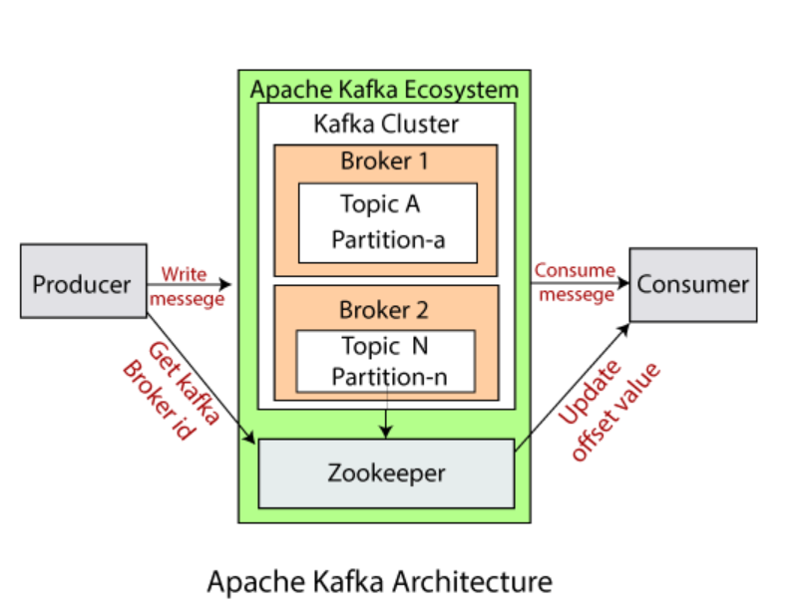

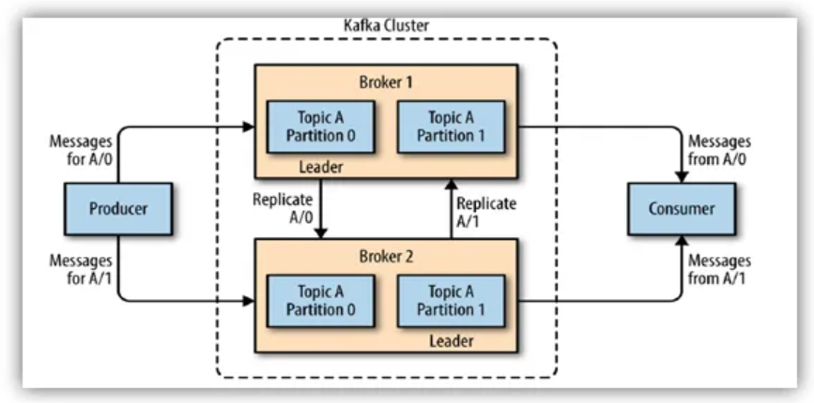

## How to integrate kafka with spring boot -> annotations and configuration

##
kafka Producer and consumer annontationa in spring
public class KafkaProducer {
@Autowired
private KafkaTemplate<String, String> kafkaTemplate;

public void sendMessage(String message){
LOGGER.info(String.format("Message sent -> %s", message));
kafkaTemplate.send(AppConstants.TOPIC_NAME, message);
}
}

@EnableKafka
public class KafKaConsumer {

@KafkaListener(topics = AppConstants.TOPIC_NAME,
groupId = AppConstants.GROUP_ID)
public void consume(String message){
LOGGER.info(String.format("Message received -> %s", message));
}
}

properties file-
# Producer properties
spring.kafka.producer.bootstrap-servers=127.0.0.1:9092
spring.kafka.producer.key-serializer=org.apache.kafka.common.serialization.StringSerializer
spring.kafka.producer.value-serializer=org.apache.kafka.common.serialization.StringSerializer
spring.kafka.producer.group-id=console-consumer-97824
topic.name.producer=testTopic

# Common Kafka Properties
auto.create.topics.enable=true

SVB Round 2 Questions :

## What is rate Limitter
Rate limiting is a technique to limit network traffic to prevent users from exhausting system resources.
APIs that use rate limiting can throttle or temporarily block any client that tries to make too many API calls. It might slow down a throttled user’s requests for a specified time or deny them altogether. Rate limiting ensures that legitimate requests can reach the system and access information without impacting the overall application’s performance.

how to secure rest API
how many ways we can secure rest API
how to ensure that JWT token is expired
## how overriding is working with Interfaces

## How to resolved below exception:
Nested exception is org.springframework.beans.factory.NoUniqueBeanDefinitionException:
No qualifying bean of type [com.payment] is defined: expected single matching bean but found 2: abc,xyz
Solution:
@Autowired
@Qualifier("xyz")
private ABC abc;

## what is api contract?
API contract is a document that describes how the API works. Yep that's it. But it's importnat to know that it's also an agreement from API developers that the product they put out works how they say it does.
Ex- Swagger documentation – Used for a documentation to client

## how to resolved cycling dependency in sping boot
difference between setter injuction vs constructor injection

how can you resolve cyclic dependency in spring.

- Refactoring

One way to fix circular dependency is to refactor your code to remove the circular
reference. This can be done by extracting the shared functionality into a separate class
or interface, which can be injected into both classes that previously had the circular
reference.

- Setter Injection
Another way to fix circular dependency is to use setter injection instead of constructor
injection. With setter injection, Spring Boot will first create the object
and then set the required dependencies using the setter method.
- Lazy Initialization

Another way to fix circular dependency is to use lazy initialization.
With lazy initialization, Spring Boot will create the object only when it is first used,
instead of creating it immediately at application startup.
This can help break the circular reference
by delaying the creation of one or more of the objects until they are actually needed.

The most preferred technique for fixing circular dependency in Spring Boot is
Method 2: Interface-based programming. This technique allows you to break the circular
dependency by introducing an interface between the two classes that depend on each other.
This method is preferred because it allows for better separation of concerns, promotes
loose coupling between components, and makes the code more testable.
However, the choice of technique ultimately depends on the specific use case and
requirements of your application. In some cases, using lazy initialization or refactoring
may be a better fit for your particular situation.

when to use bean annotation vs component annotation

Wite post api with versioning for payment ->
need to create whole structor like -> controller, service, repository, entity,

