SMART GARBAGE VEHICLES AND PUSH CARTS

**Technology Bucket**: Smart Vehicles

**Company Name**: Robert Bosch Engineering & Business Solutions Private Limited

**Category:** Hardware

**Team Leader** Name**:** Ishan Kashyap

**Problem Code:** DG3

**College Code:** 1-3510626477

**Problem statement type:** Industry Personnel

SOLUTION:

In this we have designed a plan, where we have divided the wards in two categories

i)local and ii)commercial . Each ward is considered as a node.

In local wards the garbage will be collected by electronic carts. These carts will have GPS

tracking system and a smart dustbin to segregate the dry, wet and metallic waste. The

municipal trucks used to collect garbage from these electronic carts will be compartmentalised

and will have GPS tracking system on them.

In commercial wards, the municipal truck will collect the garbage. A smart dustbin will be placed

at the municipal dumping ground which will segregate the dry, wet and metallic waste.

**NODE:**

A ward is a node. It will monitor the garbage collection from door to door with the electronic carts.

It will send message to the municipality in case of any emergency or when the carts are

occupied to a considerate level.

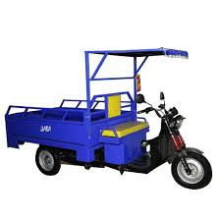 

**NODE**



[This Photo](http://commons.wikimedia.org/wiki/File:Home_font_awesome.svg) by Unknown Author is licensed under [CC BY-SA](https://creativecommons.org/licenses/by-sa/3.0/)



[This Photo](http://commons.wikimedia.org/wiki/File:Home_font_awesome.svg) by Unknown Author is licensed under [CC BY-SA](https://creativecommons.org/licenses/by-sa/3.0/)

**WARD**

**SMART GARBAGE STORAGE:**

It will be installed at the electronic push carts and at the municipal dumping ground. This

storage system will have three compartments namely dry, wet and metallic compartment.

**Stage I:** Here the rotating drums with spikes will segregate the dumped garbage into

single components. The drums will be rotated using high power D.C motors which has

high frequency torque and relatively less rpm (around 75-100). It will also slow down the speed

so that the garbage enters the next stage one by one.

**Stage II:** This stage contains an electromagnetic field which is powered by 220V AC

supply operated by a relay switch using microcontroller’s signal. While the garbage travels

through this part all the metallic and non- metallic garbage will be separated and stored in

the compartment marked as stage II.

**Stage III:** In this stage the garbage will now fall one by one on a low resistive metallic plate.

There will a gap in between these plates. When the garbage comes in contact with the plates

the dry waste will act as insulators and the wet waste will complete the circuit which is

externally created using a 5V battery supply from the microcontroller Node MCU. One of the

plate will be connected to a GPIO pin of the microcontroller and the other plate to the 5V

supply pin. If the material is a dry waste then the output state will be low and hence the

servo motor on the dry waste plate will operate, which will open and then will allow the waste to

fall in their respective components. The same procedure will take place with wet waste, which

will complete the circuit and the output will be high.

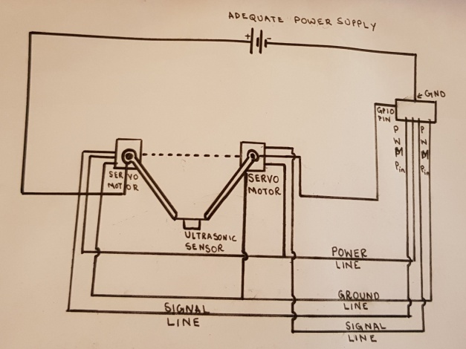 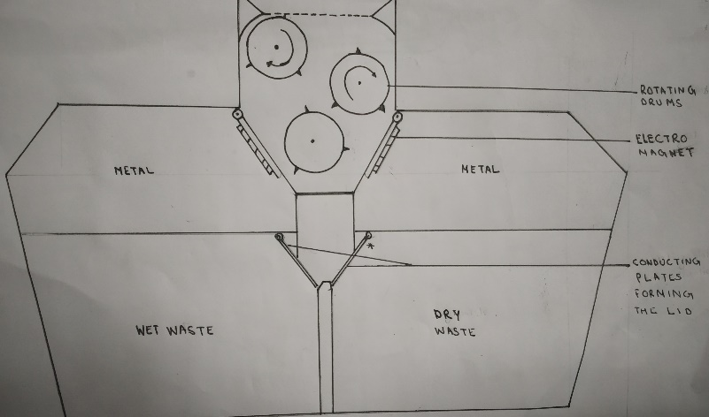

**Mechanism For Segregation Of Waste Smart garbage storage**

**ELECTRONIC CART:**

The backside of the electronic cart will be changed to a smart storage system with

a lid at the top with proper locking system which can be operated by the worker. The

main collecting compartment will have holes at the bottom through which the unnecessary

liquids will flow down to a tray which will collect the drained water from the garbage collected

from door to door. The cart will be GPS compatible which will help public to access its

location through a mobile application so that they can estimate the arrival time of the cart.

**NODE**



**PUBLIC**



[This Photo](https://commons.wikimedia.org/wiki/File:Ic_location_on_48px.svg) by Unknown Author is licensed under [CC BY-SA](https://creativecommons.org/licenses/by-sa/3.0/)

**MUNICIPALITY:**

The municipality will be at the top of this chain. It will look after the regular collection of

garbage by the truck from the node. The truck will be divided into three compartments for

dry, wet and metallic waste respectively for local wards and a simple truck for

commercialised wards. The truck will have lids to avoid spilling of garbage all

over the place. Transfer of the sorted garbage to the truck will take place under

manual supervision. The trucks will be GPS and ultrasonic sensor enabled, through

which municipality can track the location of the truck and the sensor will notify

the driver about the occupancy of the truck.

**MUNICIPALITY**

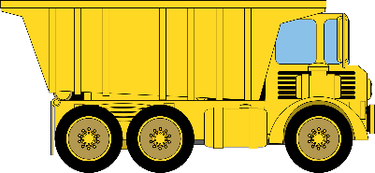

**ULTRA SONIC**

**SENSOR**



[This Photo](https://commons.wikimedia.org/wiki/File:Ic_location_on_48px.svg) by Unknown Author is licensed under [CC BY-SA](https://creativecommons.org/licenses/by-sa/3.0/)

**NODE**

**NOTE:**

1.During our study with the help of municipality we found that in most of the cities NGOs run

the garbage collection system and most of the municipal trucks collect garbage early in

the morning. So they can have places to park the electronic cart from where the

municipal truck can easily collect the garbage from the nodes.

2. We also found that it is not possible to assign electronic carts for each and every ward as

the garbage produced from a wards can vary from 2000kg to 10,000 kg . So it is not possible

to assign a single plan for every wards.

3.Considering the security , the smart dustbins present in the cart will be under the

supervision of the NGOs and the other will be under the supervision of the municipality.

4.Our project is **cost- effective**, **user friendly**, **garbage and Route Optimized.**

**TECHNOLOGICAL STACK**

**For the Mobile App:**

1.Java

2.Android Studio

3.Google Maps API

**For the Central Server:**

1.MySQL

2.JavaScript

**For the Web App:**

1.HTML/CSS/JS

2.Google Map API

3.Django(Python Framework)

**Hardware Requirements:**

1.NodeMcu

2.Ultrasonic Sensor

3.DC Motors

4.High Torque Servo

5.GSM Module

6.LED

7.GPS Module

8.Relay

9.An Electromagnet

**USE CASE DIAGRAM**:

SMART GARBAGE VEHICLES AND PUSH CARTS

Movement of message between node and e-cart

Movement of garbage

Movement of information through the application.



MUNICIPALITY’S DUMPING AREA

SPECIAL MESSAGE FOR THE e-CART

MUNICIPALITY TRUCK

NODE



GARBAGE STORED TILL TRUCK’S ARRIVAL

SMART GARBAGE STORAGE

NODE ACCESS THE LOCATION OF THE e-CART THROUGH THE APPLICATION

 MUNICIPALITY

SORTING OF GARBAGE

LOCATION OF THE e-CARTS

DRIVERCAT

e-CART DRIVER AND ITS

FUNCTIONING

APPLICATION

WET

WASTE

DRY

WASTE

METAL

WASTE

MESSAGE FROM THE NODE

GARBAGE



USES THE GARBAGE AS PER THEIR UTILITY.

PUBLIC ACCESS THE LOCATION OF THE e-CART THROUGH THE APPLICATION

PUBLIC

**WORKING OF MOBILE APPLICATION**



Public

Contact the Node for special requirement of e-cart in any occasion



Node



Driver

(Garbage

Vehicle)

**DEPENDENCIES**

To run the microcontroller we will require minimum of 5V DC power supply. Rest we will use

AC power supply side by side we would be having an Android app and also a Web app for

monitoring .