API = Application Programming Interface
It is an interface/component that enables data transfer across multiple modules in an enterprise application using descriptive languages such as HTML/XML/TEXT/JSON/YAML etc.
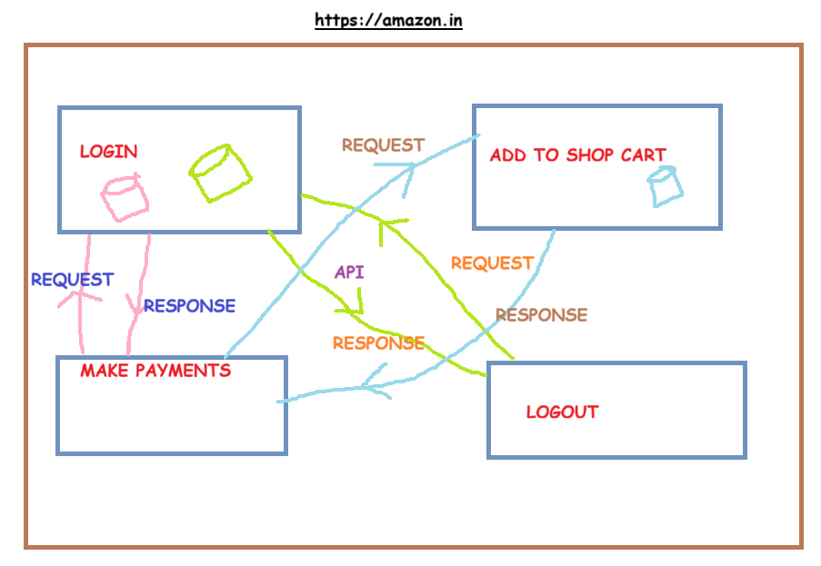
JSON
- Java script object notation
- It uses key-value pair structure
{
“key” : “value”,
“key” : “value”
}
{
“trainerName” : “Kiran”,
“participantsCount” : “14”
}
CLIENT & SERVER ARCHITECTURE
- A client is any application/device that sends request to the server
- A server is any application/device that receives client request to analyze it + process it + give response to the client
- A protocol is a set of rules/guidelines that abides how client & server shall communicate with each other
  - HTTP
    - Hypertext transfer protocol
    - Web 1.0 era
    - Unsecured protocol by design
    - It transfers the client request or server response in plain/clear text format
  - HTTPS
    - Hypertext transfer protocol with security
    - Web 2.0 era
    - Secured protocol by design
    - It transfers the client request or server response in encrypted format
    - It uses cryptographic protocols such as SSL or TLS to encrypt the client request or server response
    - SSL = Secure socket layer
    - TLS = Transport layer security
    - HTTP + SSL = HTTPS [outdated]
    - HTTP + TLS = HTTPS [latest]
    - TLS v1.0 [outdated]
    - TLS v1.1 [outdated]
    - TLS v1.2 [outdated]
    - TLS v1.3 [latest]
  - Verify if API request doesn’t use HTTP
  - Verify if API request uses HTTPS
  - Verify if API request doesn’t use SSL cryptographic protocol
  - Verify if API request uses TLS v1.3 cryptographic protocol
  - Verify if API request doesn’t uses TLS v1.0 to TLS v1.2 cryptographic protocol
- HTTP METHODS/HTTP VERBS: It describes ‘the type of client request’ being sent to server
  - GET > It is used to fetch/read/retrieve the existing data from the server/database. It is like SELECT query in RDBMS.
    - Eg. browsing web-page, file download, opening an email/message
  - POST > It is used to create new data/resource/object on the server/database. It is like INSERT query in RDBMS.
    - Eg. File upload, sending an email/message, user sign-up, make an order
  - PUT > It is used to update/modify/replace existing data (full data/partial data) in the server/database. It is like UPDATE query in RDBMS.
    - Eg. change password, profile settings, whatsapp dp, edit your sent messages
  - PATCH > It is used to update/modify/replace existing data (partial/selective data) in the server/database. It is like UPDATE query in RDBMS.
    - Eg. change password, profile settings, whatsapp dp, edit your sent messages
  - DELETE > It is used to delete existing data in the server/database. It is like DELETE query in RDBMS.
    - Eg. deleting emails/messages, deactivating social media accounts, cancel order
  - CRUD operations testing
    - C=Create [POST]
    - R=Retrieve [GET]
    - U=Update [PUT/PATCH]
    - D=Delete [DELETE]
- REQUEST HEADERS: It is the additional meta-data sent by client to the server, along with client request
  - Connection : keep-alive ; close
  - User-Agent : origin of client request
  - Content-Type : type of format in which client request is sent to the server
  - Accept : type of format that client will accept the response from the server
  - Accept-Lang : type of language in which server response will be accepted by client
  - Authorization : user-credentials/api key/access token/basic auth details etc
- RESPONSE HEADERS : It is the additional meta-data sent by server to the client, along with server response
  - Date:
  - Content-Type: type of format in which server response is sent to the client
  - Server:
  - Cookies:
  - Cache:
  - Accept-Lang:
- RESPONSE CODE: It is a 3 digit status code sent by server to the client, to reveal client request status
  - Range: { 100 – 599 }
  - 100-199=1xx > Informational responses
  - 200-299=2xx > Successful responses
    - 200 OK // GET, POST, PUT, PATCH, DELETE
    - 201 Created // POST
    - 202 Accepted // PUT/PATCH
    - 204 No Content // DELETE
  - 300-399=3xx > Re-directional responses
  - 400-499=4xx > Client-side errors
    - 400 Bad request
    - 401 Unauthorized
    - 403 Forbidden
    - 404 Not found
    - 405 Method not allowed
    - 415 Unsupported media type
    - 429 Too many requests
  - 500-599=5xx > Server-side errors
    - 500 Internal server error
    - 503 Service unavailable
During API positive testing, we always expect 2xx response code
During API negative testing, we always expect 4xx response code

3 TIER ARCHITECTURE MODEL
- FRONT-END-SYSTEM
  - It is the presentation layer
  - It is always rendered via GUI such as browser, mobile devices
  - It is exposed to end users
  - UI developers work on the FE system development
  - FE system consumes the APIs to provide end user functionality
  - UI validations happen here
- BACK-END-SYSTEM
  - It is the middleware or business intelligence layer
  - It is not exposed to end users
  - API developers work on the BE system development
  - BE system produces the APIs so that FE system can consume
  - API validations happen here
- SERVER-SIDE-SYSTEM
  - It is the database layer
  - It is not exposed to end users
  - Database level validations happen here
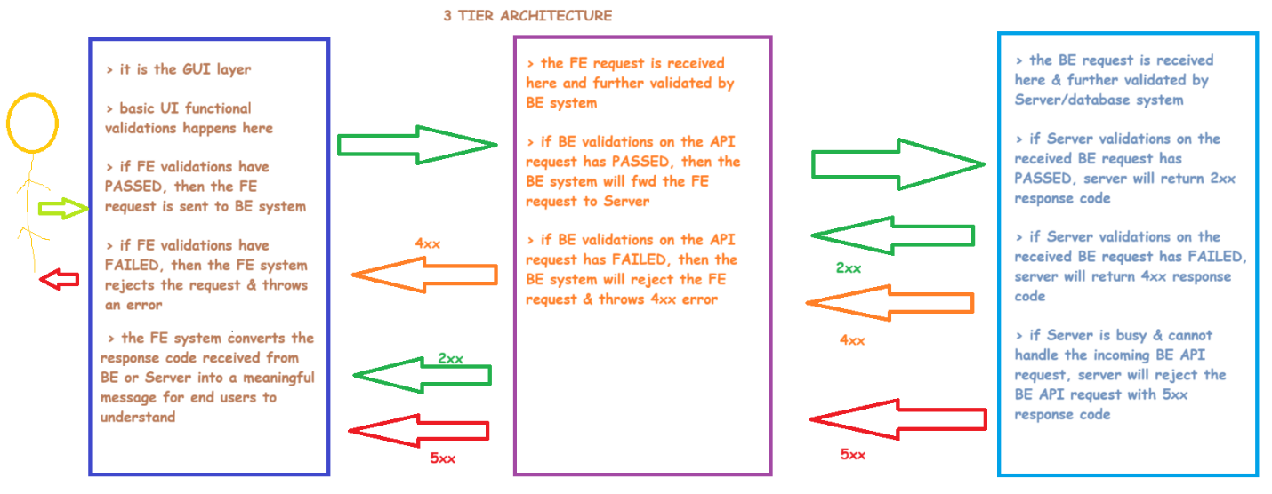

CHAPTER#2
EVOLUTION OF APIs
- XML-RPC APIs
  - Extensible markup language-Remote procedure calls
  - Content-Type = xml
  - 100% outdated
- SOAP APIs
  - Simple object access protocol
  - Content-Type = xml
  - HTTP method used = POST
  - 90% outdated ; 10% usage
- REST APIs OR RESTful APIs
  - Representational state transfer
  - Content-Type=any format [text, html, xml, json, yaml]
  - HTTP methods used = all [get, post, put, patch, delete]
  - Google is the founder of REST APIs
  - 100% usage
- GRAPH-QL APIs
  - Query Language based APIs
  - It is an advanced version of REST APIs
  - Facebook is the founder of Graph-QL APIs
  - 40% usage
XML-RPC-APIs >> SOAP APIs >> REST APIs >> GRAPH-QL APIs
Q1: What type of APIs are we developing ?
CLASSIFICATION OF APIs
- PUBLIC APIs
  - These APIs are accessible to all users across the globe
  - These APIs are accessible using any type of internet connectivity
  - These APIs are also referred to as Consumer APIs
    - Eg. Google location APIs, Twitter APIs, WhatsApp APIs, Facebook APIs, YouTube APIs
    - https://httpbin.org/json
- PRIVATE APIs
  - These APIs are accessible to restricted users across the globe
  - These APIs are accessible using limited type of internet connectivity such as VPN
  - These APIs are also referred to as Enterprise APIs
    - Eg. https://bmw.co.uk/cars/auto?model=x5
Q2: Are the developed APIs Public or Private ?
- AUTHORIZED/SECURED APIs
  - These APIs are protected with an authorization layer which adds up the required layer of security
  - Algorithms such as Basic-Auth, Digest-Auth, Bearer Access Token Auth, OAuth2, API-Key, JWT auth are used in these types of APIs
    - Eg. https://httpbin.org/basic-auth/user/passwd
    - Eg. https://api.openweathermap.org/data/2.5/weather?q={city name}&appid={API key}
- UNAUTHORIZED/UNSECURED APIs
  - These APIs are not protected with any authorization layer and hence they are accessible directly to all the users
  - Eg. https://httpbin.org/xml ; https://httpbin.org/json
Q3: Are the developed APIs secured or unsecured ?
 | PUBLIC | PRIVATE | SECURED | UNSECURED
SOAP API | Yes | Yes | Yes | Yes
REST API | Yes | Yes | Yes | Yes
GRAPH-QL API | Yes | Yes | Yes | Yes

 | PUBLIC | PRIVATE | SECURED | UNSECURED
SOAP API | 2nd preference | Recommended | Recommended | 2nd preference
REST API | 2nd preference | Recommended | Recommended | 2nd preference
GRAPH-QL API | 2nd preference | Recommended | Recommended | 2nd preference

- A Public API can be Secured
- A Public API can be Unsecured
- A Private API can be Secured
- A Private API can be Unsecured
API SYNTAX/STRUCTURE
httpMethod-protocol-baseURL-endPoint-queryParameter-payload-requestHeaders-authorization
- httpMethod : it describes ‘the type of client request’ being sent to server using GET, POST, PUT, PATCH, DELETE
- protocol : it is a set of rules/regulations that explains how client & server communicate with each other. Eg. HTTP (unsecured), HTTPS (secured)
- baseURL : it is the domain name/host name/server name/ip-address where the user request navigates to. Eg. www.google.com www.icfai.edu www.amazon.in
- endPoint/pathParameters : it is the path/page/resource/file the user is accessing on the baseURL and it always starts with a forward slash /
  - Eg. www.google.com/news www.icfai.edu/mba/finance www.amazon.in/electronics/mobiles
- queryParameter : it is the filter/search criteria applied on an endPoint in the baseURL and it always starts with a question mark ?
  - www.google.com/news?q=goldRate https://www.udemy.com/courses/search/?q=python
- payload : this is the request body/client input data being supplied to the server and it is mandatory for POST, PUT, PATCH http methods & optional for GET, DELETE http methods. It is either in JSON or XML format.
- requestHeaders : it is the additional meta-data supplied by client to the server, along with request such as connection, user-agent, content-type, accept, accept-lang, authorization etc
- authorization : it provides additional layer of security to the API request
EXAMPLES OF APIs ON THE INTERNET
SOAP APIs
http://www.dneonline.com/calculator.asmx?WSDL
http://webservices.oorsprong.org/websamples.countryinfo/CountryInfoService.wso?WSDL
REST APIs
https://reqres.in/
https://gorest.co.in/
http://testfire.net/swagger/index.html
GRAPH-QL APIs
https://gorest.co.in/
https://countries.trevorblades.com/

CHAPTER#3
API TESTING TECHNIQUES
POSITIVE TESTING
- Response code testing : Verify if the server responds with 2xx success response code, when the API request is submitted
- Response body testing : Verify if the response body is received from server in expected content-type format and the received response is valid
- Response time testing : Verify if the response from server is received at client side, within acceptable & agreed benchmark/SLA defined in the project
- Response headers testing : Verify if the response headers such as Connection, Content-Length, Content-Type are received with valid values alongside ensuring no sensitive data is returned in response headers such as Server, OS details, Programming language details, framework details, database details etc
- JSON schema testing : Verify if the JSON response body has expected array structure & data types, as defined in the API documentation
- Interoperability testing : Verify if the server responds with 2xx success code when the API request is tested on various OS, various browser(s) version(s)
- Data driven automation testing : Verify if the server responds with 2xx success response code, when the API request is tested with multiple sets of test data supplied through .csv file or .json file or postman built-in Java functions
- Performance testing : Verify if the server responds with 2xx success response code alongside returning valid response body with expected content-type within acceptable benchmark/SLA, when the API request(s) are continuously sent to the server from various user-agents or vUsers clients
- API chaining automation testing : Extracting the response of an API & supplying it as request to another dependent API using java-scripts is called API chaining automation testing
- Assertions based testing using Java scripts : Assertions are functional checks conducted on the API response received from server & these assertions are written in java-scripts using Chai JS library
- E2E API automation testing : Identifying the user journey paths/business workflow paths & automating the API endPoints using API chaining is called E2E API automation testing
- Continuous testing of APIs : Automating the API automation test execution to run at scheduled day/time using Postman Monitors OR Jenkins is called Continuous testing of APIs
- CLI based testing of APIs : Using Newman add-on from Postman, we can execute API automation tests from command-prompt to generate test reports in various formats such as CLI, XML, JSON, CSV, HTML-EXTRA
NEGATIVE TESTING
- Unsupported HTTP methods testing : Here, we test the given API with an invalid HTTP method & the exp response code is 405 Method not allowed
- Broken endPoints testing : Here, we test the given API with an invalid endPoint & the exp response code is 404 Not found
- Payload tampering testing : Here, we test the given API with an invalid payload such as invalid data-type, invalid data-length, invalid field, missing field & the exp response code is 400 Bad request
API-REUSABLE TEST PLAN
API-REUSABLE TEST CASES
CHAPTER#4
WHAT IS POSTMAN ?
- Postman is used by
  - Developers to develop APIs & also to document APIs
  - Test Engineers to test APIs
  - DevOps Engineers to do version control mgmt, back-up & health check of deployed APIs
- Postman is available as
  - Desktop application for Windows OS, Mac OS, Linux OS
  - Web application on all browsers
- Postman is
  - Free tool
  - Paid tool
- Download Postman > Install Postman > Sign up as a new user > Sign in to Postman tool
- A Workspace is a project repository
- Postman supports 5 different Workspaces
  - Personal workspace
    - Free
    - This workspace is accessible only to the person who created it ; There is no scope of having a 2nd person in this workspace
  - Team workspace
    - Free
    - This workspace is accessible to the invited team along with the person who created it
    - This is a recommended workspace for enterprise projects
  - Public workspace
    - Free
    - This workspace is accessible to all logged in users into Postman tool
    - This is not recommended for enterprise projects due to security reasons
  - Private workspace
    - Paid
  - Partner workspace
    - Paid
- Actions possible with Workspaces
  - Create a Workspace – DONE
  - Rename the workspaces – DONE
  - Invite team members to the workspace - DONE
  - Conversion of workspaces
    - Personal workspace to Team workspace – DONE
    - Team workspace to Personal workspace - DONE
    - Personal workspace to Public workspace - DONE
    - Team workspace to Public workspace - DONE
    - Public workspace to Team workspace – DONE
  - Deletion of workspace – DONE
PROJECT#1
- Project Name: Banking application
  - https://demo.testfire.net/
- Type of APIs: REST APIs + Public APIs + Authorized APIs [Bearer access token algorithm]
- API documentation format: Swagger
  - https://demo.testfire.net/swagger/index.html
- Functionalities developed:
  - Login
  - Get the list of accounts
  - View account details
  - View all recent transactions
  - View transactions for the specific period
  - Transfer funds
  - Change password
  - Add a new user
  - Feedback
  - Logout
- RESTful APIs are developed for all the above listed functionalities, and these APIs use HTTP methods such as GET, POST
- Executed the APIs in Swagger tool and found these RESTful APIs are working
LET’S START WITH POSTMAN TOOL & API AUTOMATION
- Launch Postman tool
- Login to Postman tool
- Create a new Workspace [Personal or Team]
- Import the Swagger.json file into Postman tool to create the Postman hierarchy
  - Collections
    - Folders
      - API requests
        - Test Scripts/Assertions [Chai JS]
- Below are the expected results for each of the REST API developed:
  - Login API – Expected Result
    - Verify if response code=200 OK
    - Verify if response time < 3 seconds
    - Verify if response body is received
    - Verify if response body received is in JSON format
    - Verify if response body is valid i.e., it contains Authorization & success
    - Verify if success= jsmith is now logged in
    - Verify if response headers do not display project sensitive data
  - Get accounts API – Expected Result
    - Verify if response code=200 OK
    - Verify if response time < 3 seconds
    - Verify if response body is received
    - Verify if response body received is in JSON format
    - Verify if response body is valid i.e., it contains Accounts, Name & id
    - Verify if response headers do not display project sensitive data
  - View account details API – Expected Result
    - Verify if response code=200 OK
    - Verify if response time < 3 seconds
    - Verify if response body is received
    - Verify if response body received is in JSON format
    - Verify if response body is valid i.e., it contains accountId, balance, credits & debits
    - Verify if response headers do not display project sensitive data
  - View last 10 transactions API – Expected Result
    - Verify if response code=200 OK
    - Verify if response time < 3 seconds
    - Verify if response body is received
    - Verify if response body received is in JSON format
    - Verify if response body is valid i.e., it contains last_10_transactions, date, transaction_type & ammount
    - Verify if response headers do not display project sensitive data
  - View transactions for the specific period API – Expected Result
    - Verify if response code=200 OK
    - Verify if response time < 3 seconds
    - Verify if response body is received
    - Verify if response body received is in JSON format
    - Verify if response body is valid i.e., it contains transactions, date, amount, id, type & account
    - Verify if response headers do not display project sensitive data
  - Transfer funds API – Expected Result
    - Verify if response code=200 OK
    - Verify if response time < 3 seconds
    - Verify if response body is received
    - Verify if response body received is in JSON format
    - Verify if response body is valid i.e., it contains success
    - Verify if response headers do not display project sensitive data
  - Change password API – Expected Result
    - Verify if response code=200 OK
    - Verify if response time < 3 seconds
    - Verify if response body is received
    - Verify if response body received is in JSON format
    - Verify if response body is valid i.e., it contains success
    - Verify if response headers do not display project sensitive data
  - Add a new user API – Expected Result
    - Verify if response code=200 OK
    - Verify if response time < 3 seconds
    - Verify if response body is received
    - Verify if response body received is in JSON format
    - Verify if response body is valid i.e., it contains success
    - Verify if response headers do not display project sensitive data
  - Submit Feedback API – Expected Result
    - Verify if response code=200 OK
    - Verify if response time < 3 seconds
    - Verify if response body is received
    - Verify if response body received is in JSON format
    - Verify if response body is valid i.e., it contains comments, subject, name & email
    - Verify if response headers do not display project sensitive data
  - Logout API – Expected Result
    - Verify if response code=200 OK
    - Verify if response time < 3 seconds
    - Verify if response body is received
    - Verify if response body received is in JSON format
    - Verify if response body is valid i.e., it contains LoggedOut
    - Verify if response headers do not display project sensitive data
- Execute the APIs one by one manually & verify the above expected results
- Write java-scripts/assertions to validate the above expected results
  - Using built-in snippets in Postman tool
  - Writing the java-scripts using auto-suggestions
  - Using AI (Postbot) built into Postman tool
- Export the collection to have a local backup on your computer
- You can later import this collection into Postman
- Run the entire collection & generate test report (.json)
JAVA SCRIPTS TO CAPTURE RESPONSE ATTRIBUTES
- Response code
- Response message
- Response time
- Response headers
- Response body size
- Response body-JSON
- Response body-text
pm.response.code; // captures the response status code
pm.response.status; // captures the response status text
pm.response.responseTime; // captures the response time in milliseconds
pm.response.size; // captures the response size in bytes
pm.response.headers; // captures the response headers
pm.response.json(); // parses the response body as JSON
pm.response.text; // capture the response body as text
// JAVA SCRIPTS TO PRINT RESPONSE ATTRIBUTES

console.log("The response code received from server is "+pm.response.code);
console.log("The response message received from server is "+pm.response.status);
console.log("The response code received from server is "+pm.response.code+" "+pm.response.status);
console.log("The response time received from server is "+pm.response.responseTime+" ms");
console.log("The response size received from server is");
console.log(pm.response.size());
console.log("The response headers received from server are");
console.log(pm.response.headers);
console.log("The response body received from server is ");
console.log(pm.response.json());
console.log(pm.response.text());

JAVA SCRIPTS TO CAPTURE REQUEST ATTRIBUTES
- API http method
- API url
- API request name
- Request headers
- Request body
- Request size
pm.request.method; // GET, POST, PUT, DELETE, etc.
pm.request.url; //full URL
pm.request.headers; //all headers
pm.request.body; //body of the request
pm.request.size; //size of the request
pm.info.requestName; //name of the request
// JAVA SCRIPTS TO PRINT REQUEST ATTRIBUTES

console.log("The API name is "+pm.info.requestName);
console.log("The HTTP method used is " +pm.request.method);
console.log("The API URL is "+pm.request.url);
console.log("The request headers are ");
console.log(pm.request.headers);
console.log("The request body/payload is ");
console.log(pm.request.body);
console.log("The request body size is ");
console.log(pm.request.size());

JAVA SCRIPTS TO CAPTURE DATA-TYPES
console.log("The data type of LoggedOut key in response body is "+typeof (pm.response.json().LoggedOut));

POST-BOT >> AI IN POSTMAN TOOL
- It is available inside the API request editor
- It is also available while running the collection
INTEROPERABILITY TESTING
- Windows 10 OS + Edge browser
- Linux OS + Firefox browser
- Mac OS + Safari browser
- Android OS + Chrome browser
- iPhone (iOS) + Safari browser
- iPad (iOS) + Safari browser

DATA DRIVEN AUTOMATION TESTING-CSV
Syntax of a variable: {{variableName}}
DATA DRIVEN AUTOMATION TESTING-POSTMAN JAVA-SCRIPT FAKER LIBRARY/FUNCTIONS
https://learning.postman.com/docs/tests-and-scripts/write-scripts/variables-list/
$randomUserAgent
API CHAINING AUTOMATION TESTING
  - Extract the response from LOGIN API
  - Store the required field value in a local variable
  - Convert the local variable to global variable
  - Refer the global variable in other dependent APIs
E2E USER JOURNEY AUTOMATION TESTING
A user journey is a business workflow where different API endPoints are called
POSTMAN WORKFLOWS & CONDITIONAL STATEMENTS
If the current API (test step) passes, then execute the next API (test step)
If the current API (test step) fails, then stop the overall test execution
PERFORMANCE TESTING
- Postman tool supports performance testing of APIs only and not web applications or mobile apps
- 4 strategies are supported by Postman tool for Performance testing:
  - Fixed
  - Ramp up
  - Spike
  - Peak
- In Postman tool,
  - we can simulate up to 100 virtual users
  - Test duration cannot exceed 60 minutes
  - All the vUsers will run parallelly
  - The API execution will be sequential
- How is average response time & p90 calculated?
vUser1 = 10
vUser2 = 8
vUser3 = 5
vUser4 = 6
vUser5 = 11
vUser6 = 12
vUser7 = 2
vUser8 = 4
vUser9 = 5
vUser10 = 6
p100 > Average Response time: 6.9 seconds
p90 > arrange all response times in increasing/ascending order = 6.3 seconds
vUser7 = 2
vUser8 = 4
vUser3 = 5
vUser9 = 5
vUser10 = 6
vUser4 = 6
vUser2 = 8
vUser1 = 10
vUser5 = 11
vUser6 = 12 // ignored

NEGATIVE TESTING
- Unsupported HTTP methods testing
 | GET | POST | PUT | PATCH | DELETE
API#1_GET | 2xx | 405 | 405 | 405 | 405
API#2_POST | 405 | 2xx | 405 | 405 | 405
API#3_PUT | 405 | 405 | 2xx | 405 | 405
API#4_PATCH | 405 | 405 | 405 | 2xx | 405
API#5_DELETE | 405 | 405 | 405 | 405 | 2xx

- Broken endPoints testing
- Payload tampering testing
  - Invalid data type
  - Invalid data length
  - Invalid data value
  - Invalid field name
  - Missing field name
CONTINOUS TESTING OF APIs-POSTMAN MONITORS
- It is like, outsourcing the API test execution process to Postman tool, during the absence of QA engineer
- This can be achieved using Postman monitors feature as well as Jenkins feature
- Postman monitors are always executed on Postman servers (AWS)

POSTMAN VARIABLES
- A variable acts as a container/placeholder to store the value of an object
  - Kiran > ATM > Cash > Wallet/Handbag/Laptop bag > Cash/paper/visiting card/id card
- A variable is used to store sensitive or reusable data such as UN, PWD, api-token, payload details etc
- Syntax: {{variableName}}
- There are 3 types of variables in Postman tool:
  - Collection variables : scope = collection only
  - Global variables : scope = across all the collections ; variable value is static
  - Environment variables : scope = across all the collections ; variable value changes based on the environment chosen
- There are 3 ways to create above variables:
  - Step by step wizard
  - Manual process
  - Using java-scripts in pre-request scripts tab
- Let us create collection variables using
  - Step by step wizard
  - Manual process
  - Using java-scripts
    - SET > used to create a variable
    - GET > used to fetch the variable value
    - CLEAR > used to delete the variable
- Let us create global variables using
  - Step by step wizard
  - Manual process
  - Using java-scripts
    - SET > used to create a variable
    - GET > used to fetch the variable value
    - CLEAR > used to delete the variable
- Let us create environment variables
  - By pointing to Dev-Environment
  - By pointing to QA-Environment
 | DEV-ENV | QA-ENV
envProtocol | http | https
envURL | demo.testfire.net | 65.61.137.117
envUN | jsmith | admin
envPWD | demo1234 | admin
envTransferAmt | 2 | 4

INTEGRATION WITH GIT & GITHUB
- Version control management
  - Git is the distributed VCS
- Backup of automation code
  - GitHub is the remote online repository service from Microsoft, where we can backup our automation code
- Download all your automation code to the local PC [collections, variables, test data, test results]
- We need to install Git from https://git-scm.com/ on the local PC to track all the changes made to the automation framework such as changes related to adding content, deleting content, modifying content, renaming files/folders etc
- Navigate to the project path in the command prompt
- Initialize Git repo in the project path by executing git init
- To know the status of git, execute git status
- To track the untracked files, execute
  - git add filename
  - git add fileName1 fileName2 fileName3
  - git add *.*
  - git add .
- To commit the tracked files, execute
  - git commit -m “short message”

INTEGRATION WITH NEWMAN-CLI TOOL
INTEGRATION WITH JENKINS-CI/CD/CT TOOL
----------------------------
PROJECT#2: SOAP APIs
PROJECT#3: AUTHORIZATION REST APIs
IMPORT WIZARD
POSTMAN LEARNING CENTER
POSTMAN SETTINGS & TROUBLESHOOTING

