1. I tried to automate a simple happy path with a popular ecomm website, and selenium is successfully recognizing the webelements, e.g. textboxes, button etc with already existing settings of the IE, but same is not happening even with Standard Home page(<http://home.standard.com/>).

* **Hence there could have been a possibility that, it’s might not be the IE settings issue, the issue is with source code of the AUT developed by developers. Probably selenium is not able to identify the webelements of the Standard AUT, the way developer coded backend into the application.**

1. The browser zoom level must be set to 100% so that the native mouse events can be set to the correct coordinates.

* **Done**

1. "Enhanced Protected Mode" must be disabled for IE 10 and higher. This option is found in the Advanced tab of the Internet Options dialog.

* **Done**

1. For IE 11 only, we need to set a registry entry on the target computer so that the driver can maintain a connection to the instance of Internet Explorer it creates. For 32-bit Windows installations, the key you must examine in the registry editor is HKEY_LOCAL_MACHINE\SOFTWARE\Microsoft\Internet Explorer\Main\FeatureControl\FEATURE_BFCACHE. For 64-bit Windows installations, the key is **HKEY_LOCAL_MACHINE\SOFTWARE\Wow6432Node\Microsoft\Internet Explorer\Main\FeatureControl\FEATURE_BFCACHE**. Please note that the FEATURE_BFCACHE subkey may or may not be present, and should be created if it is not present. Important: Inside this key, create a DWORD value named iexplore.exe with the value of 0.

* **Done**

1. Navigate to HKEY_LOCAL_MACHINE\SOFTWARE\Policies\Microsoft\Internet Explorer\Control Panel

Set the DWORD value of Connections Tab to 0.

* **Done**

1. The IEDriverServer executable must be [downloaded](http://selenium-release.storage.googleapis.com/index.html) and placed in your [PATH](http://en.wikipedia.org/wiki/PATH_(variable)).

* **We have tried with 32 bit and 64 bit also**

1. Tried with **Latest selenium .jar 3.0**
2. Changes the levels In the “Security” tab for “Internet Options”, all the option for “Security Zone”

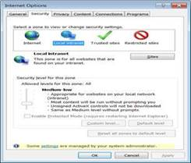

1. Checked/Unchecked the “Pop-Up” blocker. **Adhoc checking Done**

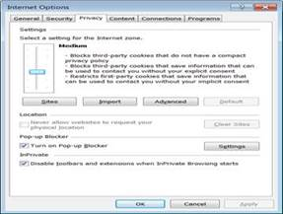

1. Use of “Desired Capability” with “Native Evenets”

* capabilities.setCapability(CapabilityType.***BROWSER_NAME***, "IE");
* capabilities.setCapability(InternetExplorerDriver.***NATIVE_EVENTS***, **true**);
* capabilities.setCapability("platform", "WINDOWS 8.1");
* capabilities.setCapability(InternetExplorerDriver.***INTRODUCE_FLAKINESS_BY_IGNORING_SECURITY_DOMAINS***,**true**);   \
* capabilities.setCapability(InternetExplorerDriver.***IE_ENSURE_CLEAN_SESSION***, **true**);
* capabilities.setCapability(InternetExplorerDriver.***REQUIRE_WINDOW_FOCUS***, **true**);
* capabilities.setCapability(CapabilityType.***ACCEPT_SSL_CERTS***,**true**);
* capabilities.setCapability(InternetExplorerDriver.***IGNORE_ZOOM_SETTING***, **true**);

1. In windows 7 machine, the application URL was opening, but in windows 2012(**Remote server**), selenium is not able to open the app URL, even standard home page url was also not getting recognized by selenium.

Tried to find out the solution by googling, seems to me that, selenium does not support windows latest version (2012),

Ref : <https://github.com/seleniumhq/selenium-google-code-issue-archive/issues/7516>