**Problem**- Customer Onboarding Application Test Automation.

**Solution Designed by**: Senthilkumar Subramanian

**Date**: 24-06-2018.

**Solution**

To test this application requirement, we need to do both functional testing and also performance testing of the application scenarios.

Some sample scenarios like below

1. Tenant upload bulk customer data file in to system.
2. Verify the uploaded file with expected content and file extension.
3. Process the uploaded file in to system
4. Verify the content is as per Tenant configurations.
5. Performance test for bulk customer upload by Tenants in parallel.

So JMeter is the right choice. Through which we can do both automated function and automation testing.

**Functional Testing**

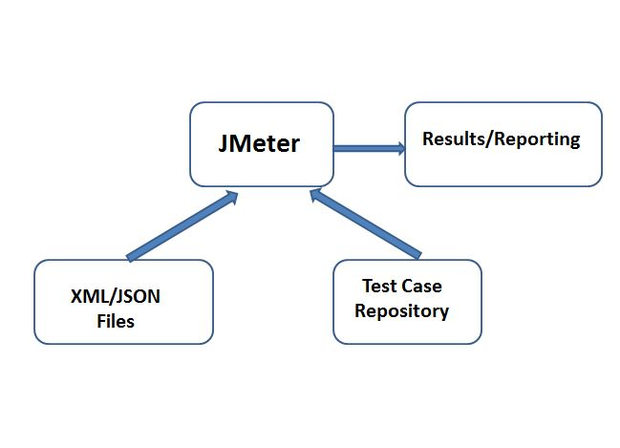

**Performance Testing**

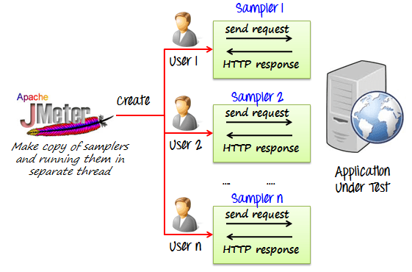

**Automation Framework**

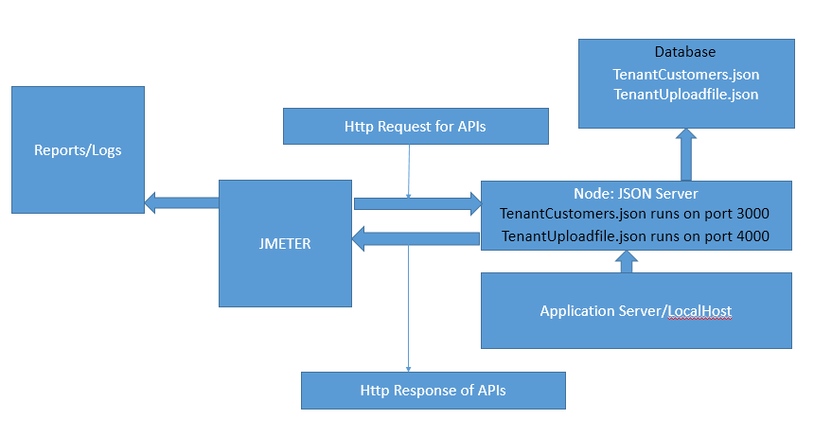

1. Node: Jenkin-server is running on my local machine to act as server for the required APIs.
2. Test plan with Functional and performance test cases can design in JMETER using Thread groups, Http Request Samplers and Groovy Assertions.
3. Test execution results are stored as CSV files.
4. The customer upload file, tenant config files are stored in my local machine. JMETER Groovy script read date directly.

Note: we can use Extent report, nice reporting tool. Right now jar not available with me. Refer <http://extentreports.com/>

Working Solution.

**To Mock the API calls.**

1.Tentant Customer File upload API

2.Tentant Customer creation API.

3. Tenant Configuration API

Npm install json-server on local machine, and start watch in different port for the JSON files.

 

Refer the below , running on my localhost.

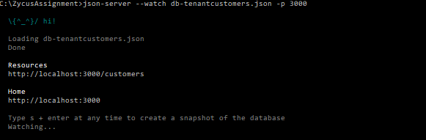

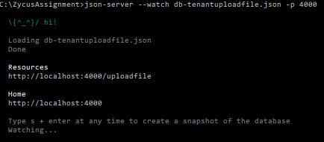

**Test Plan-Test Cases-Assertion Design in JMETER.**

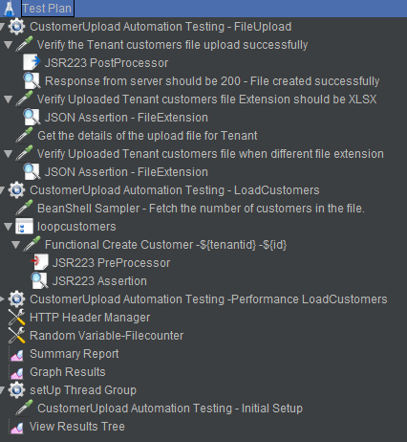

**PerformanceTesting in JMETER**

