SuM upgrade guide
2025-04-14
www.subseapulse.com

TARGET: This guide is intended for owners of SubSeaPulse SuM devices
- shipped before 2025-04-14
OR
- shipped after 2025-04-14 that chose not to buy the USB soundcard and Push-To-Talk (PTT) button
and want to use the modem’s new analog audio transmission features.
Modems shipped after 2025-04-14 already support analog audio transmission software-wise. Hence, these users must skip section 1 of this guide and directly proceed with section 2 (hardware upgrade).

SECTION 1: SOFTWARE UPGRADE
Only applies to SuM devices shipped before 2025-04-14

In order to use the new features, the modem’s software must be updated. SubSeaPulse will provide updated binaries upon request: refer to the company website for contact information.
New binaries must be placed in the modem’s SD card overwriting all previous files when prompted.
After this step is completed, you may proceed with the hardware upgrade.

SECTION 2: HARDWARE UPGRADE
- Push-To-Talk (PTT) button
In order to use the analog audio communication features it is necessary to install a button on the modem for PTT functions: it will be used to toggle between reception and transmission mode.
The button must be wired between PIN GPIO 17 (pin 11) and Ground (pin 9). Open circuit between the pins makes the modem work as a receiver while shorting the two pins (i.e. pushed button) makes the modem transmit.
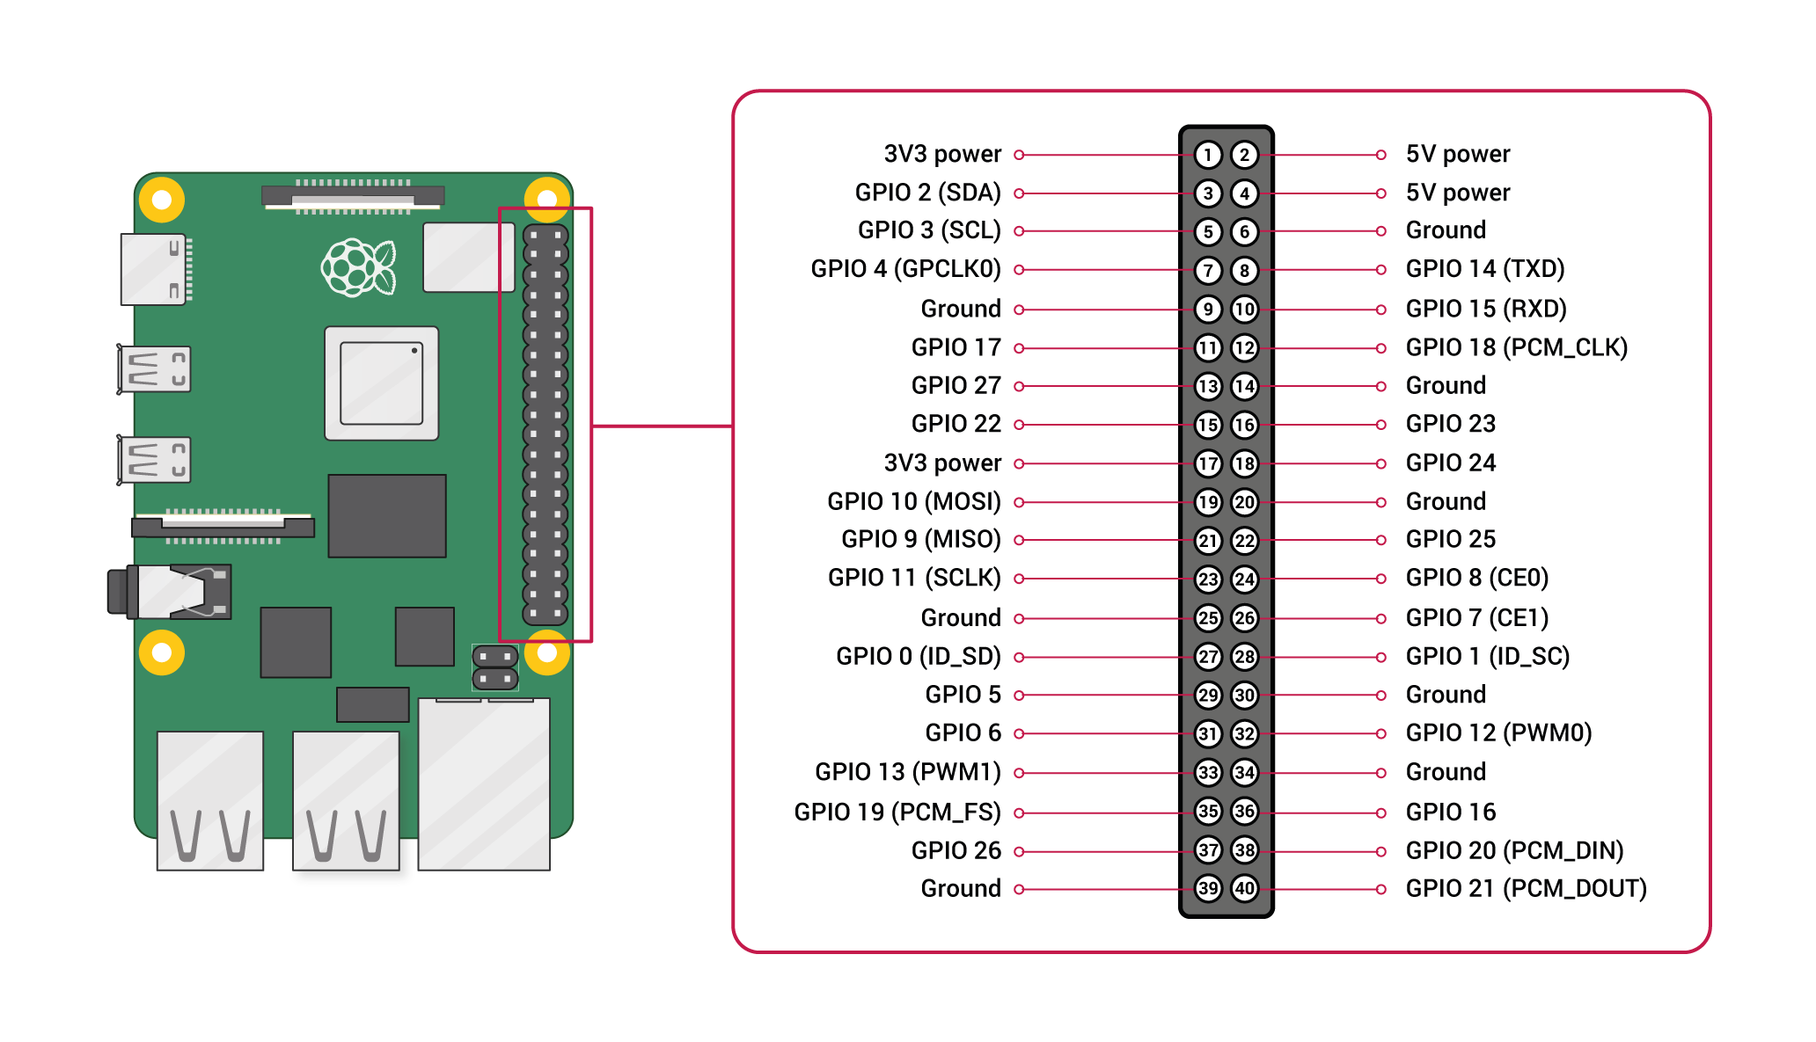Raspberry PI pinout. Image taken from the official Raspberry PI documentation at https://www.raspberrypi.com/documentation/computers/raspberry-pi.html
- USB soundcard installation
COMPLETARE COMPLETARE COMPLETARE CON SCREENSHOTS.

