tiffwriter; version 0.31
may 2004

Markus Enders
enders@mail.sub.uni-goettingen.de

Göttinger DigitalisierungsZentrum
Niedersächische Staats- und Universitätsbibliothek
Papendiek 14
37073 Göttingen

Table of Content

What it does 2
Installation 3
Installation on Windows 3
Installation on Linux 3
Installation on MacOS 3
Successful installation 3
Run tiffwriter 5
Advanced settings 6
Tiff-Tags 7
Show tiff-header 8
ToDo 9
History 9

What it does
tiffwriter is a small perl-script which allows easy manipulation of metadata in the so called TIFF-header of a TIFF file. It was developed to fit own needs in the scanning production of retrodigitized books. For archiving purposes, metadata is captured in each TIFF-file. The following TIFF-tags are used for storing Metadata:
- document name (tiff tag 269))
- page name (tiff tag 285)
- image description (270)

The perl script modifies only the so-called tiff header. It does not manipulate the image data – it doesn’t even read the image data. This special featues makes the script quite fast. Even when dealing with large colour images, only the tiff-tags are read and written. tiffwriter never reads the whole image data. A slow computer with very few memory should be sufficient for tiffwriter.

Besides the tiff tags mentioneed above, tiffwriter can modify the following tiff tags as well:
- ResolutionX (tiff tag 282)
- ResolutionY (tiff tag 283)
- Artist (tiff tag 315)

Information about allowed values for the TIFF-tags can be found in the apporpriate chapter.
Tiffwriter is designed to run by dragging and dropping folders onto the script. The script will modify all tiff files in this folder. If the naming fits the naming rules (8 + 3; e.g. 00000001.tif), the program can check, if an image is missing and will write the page name into the tiff header automatically.

Installation
Because tiffwriter is as simple perl-script you need some version of perl installed. It should work with all version from 5.6. on – maybe even with earlier versions of 5.x.
At this point was only tested with ActivePerl 5.6 on windows platform. It neither uses special modules nor any other important platform depended software. It should really work on every platform

Installation on Windows
To provide drag and drop you need a small batch file on windows which calls the perl-script. Such a file comes with tiffwriter – tiffwriter.bat. Before you can run tiffwriter you have to modify tiffwriter.bat according to your installation path of perl and tiffwriter itself. Please do not modify or change “%1” at the end of the line.
After modifiy tiffwriter.bat, try to run tiffwriter from the command line. If you get any error message, one of your paths (to perl or to tiffwriter) is not set correctly.
If your installation is successful, you should see the start screen shown above (chapter Successful installation)

Installation on Linux
Make sure, that the path to your perl installation is currectly set in the first line of tiffwriter.pl. Just run it.

Installation on MacOS
At this point tiffwriter has neither been tested on MacOS (classic) nor on MacOS X.

Successful installation

After successful installation you should see the start screen of tiffwriter.

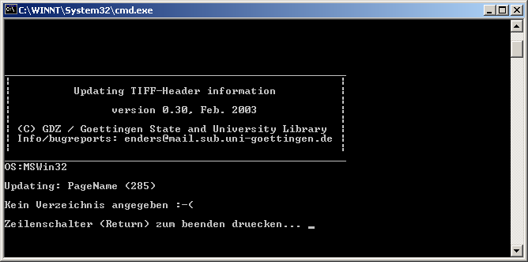

After each run of tiffwriter (if successfuil or not), you have to press “return”.

Run tiffwriter
To run tiffwriter, simple drop an image-folder onto tiffwriter.pl (or tiffwriter.bat for windows users). If tiffwriter should check for image filenames, only these image named in a special way are processed. The naming conventions are 8+3, which means 3 characters for the "tif"-extension and 8 characters for the image number (may only contain arabic letters) with leading zeros (e.g. 00000001.tif). If tiff writer checks the image filenames, it writes the page-name into the tiffheader automatically.
If tiffwriter should check for image filesnames, can be configured in the tiffwriter.conf configuration file. The default setting is "yes", which means, that tiffwriter checks for filenames.

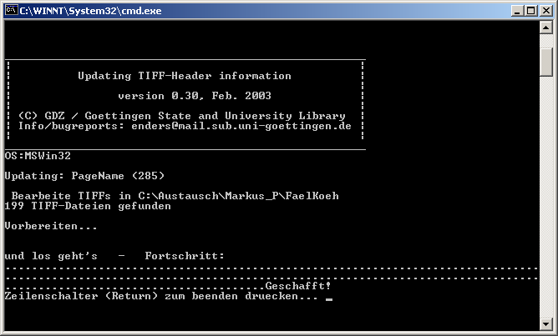
tiffwriter output, if run was successful

Tiffwriter gives some information about the progress. and parameters it uses.
Under the start screen of tiffwriter you can find information about your opertating system on which tiffwriter is running. If you find any bugs or have any questions, please provide this information too.
After this, it prints all the tiff-tags which will be updated. By default this is only the page name. How to update other tiff-tags, see “Advanced settings”. You can check, if the data displayed is correct.
After scanning the folder/directory, if gives information about the number of tiff-images found in the folder.
These images are checked in the next step, which tiffwriter calls “Vorbereiten” (preparing). In this step, it checks, if the numbering of the image files is coninously, or if any images are missing. If an image is missing, tiffwriter will output a warning and continue with its work.
After a successful preparation, tiffwriter begins with the modification of tiff-images and output its progress. Each dot represents one image.

At the end of the run you have to press return, to quit the program.

Advanced settings
Tiffwriter allows the setting and modification of metadata in the so called “tiff-header”. The configuration file “tiffwriter.conf” stores the information, which metadata should be set. An example file comes with tiffwriter. Configuration is done by using key/value pairs, devided by a “=”. When using this file, please use the exact syntax as provided in the example (e.g. no spaces between name and “=”; the file is case sensitive etc).

The following tags (metadata) can be set:
- Artist
- Documentname
- ImageDescription
- ResolutionX
- ResolutionY

The configuration file must be put into the image folder, which shall be modified. After the start (before scanning the folder for images), tiffwriter tries to find and read the tiffwriter.conf file. It outputs the contents of the configuration file on the screen. During the run of tiffwriter, check this information, to make sure, the syntax of “tiffwriter.conf” is correct. Tiffwriter writes only the metadata which is displayed on screen. If you have defined more/other metadata in the configuration file, there may be an error in the file.

To get to know the meaning of the tags and the allowed values, please read the next chapter “Tiff-Tags”.

The behaviour of the tiffwriter script can also be changed using entries in the tiffwriter.conf file. Currently only one setting is available
- CheckNames
can be set to "yes" or "no" (case sensitive); if set to no, the filenamse of imagefiles won't be checked and the page name won't be written to the header.

Tiff-Tags

Page name (tag )
The page name contains the number of the image in a book – it is not the printed page number, but a number which identifiers each page. Usually the images are numbered from number one on, increased by one for each image. Based on this (physical) numbering, the image files are named 00000001.tif, 00000002.tif etc… (8 chars for the name, filled with zero and “.tif” for the suffix). Appropriate to the image filename, which contains information about the pyhsical (and unique) pagenumber, the page name is written for each page automatically (of course without leading zeros), when tiffwriter is run. It is the main aim of the tiffwriter to modifiy this information. Often this information is created and written to each image during the scan process.
The page name is always created automatically. It creation cannot be avoided/switched off.

Artist (tag 315)
This tag stores the artist of an image. All characters are allowed.

Document name (tag 269)
This tag stores the name of the document, to which this page belongs. Usually it is only a unique identifier (e.g. from library catalog). All characters are allowed

Image Description (tag 270)
This tag stores a description of an image or a work. Usually additional metadata for the complete set of images / book are stored here: title, author, year of publication. All characters are allowed.

Resolution X (tag 282)
The resolution in x-direction of the image is stored in this tag. Only integer values are allowed. A modification of this value will not change the image data. If you wish to cahnge the image data as well, you have to reduce the data together witht ehresolution in some kind of imaging-software (Adobe Photohop etc.).
The possibiliy to change the resolution is only offered to correct wrong values, which might be stored here by some scan-programms.

Resolution Y (tag 283)
The resolution in y-direction of the image is stored in this tag. Only integer values are allowed. (also see Resolution X).

Show tiff-header
Tiffwriter itself offers no possibility to have a look at the metadata in the “tiff-header”. There are several possibilies to check the results of tiffwriter:

ASCII-editor
Just load the tiff file to your favourite ASCII-editor and search for the appropriate information.
Because TIFF is a file format, which has an internal “directory” pointing to different locations for the metadata, it is hard to find and read metadata. Because tiffwriter does not delete the old directory, but writes the new one to the end of file, you may even find old metadata in the file without pointers to it. Reading TIFF-files with an ASCII-editor is not really a good solution – you need to be an expert and have to understand the internal TIFF structure.

tiffinfo
Tiffinfo is a small programm wich comes with the tifflib (http://www.tifflib.org). The program is a small command line program, which reads tifffiles and outputs metadata information. It is available for all common platforms.
It seems to be free from bugs.

TiffKit
A windows based program “TiffKit” http://www.informatik.com offers the possibility to have a look at the tiff tags. Unfortunately the program has some bad bugs:
- it can only handle INTEL-TIFFs; Motorola-TIFFs cannot be displayed
- The last character of character-based Metadata (Artist, DocumentName, ImageDescription) gets lost for display.
- Only the first 300 characters of metadata are displayed.

The reason why these bugs are mentioned here is, that the same program was used during development of tiffwriter. Everytime something funny was displayed, I assumed a bug in tiffwriter. After searching for it, it often became clear, that the bug was in the TiffKit.
If you ffind something funny, please check with tiffinfo.

Other
If you know some more software, please let me know.

ToDo

- better error handling; especially when image-files are corrupt
- handling of single files (drag single files onto tiffwriter)
- checking, if program works fine with motorola TIFF-Images
- more commands via command line interface

History
(sorry, just in German)

Version 0.31: Bug im Zusammenahng mit dem Überschreiben bereits vorhandener Tags behoben. In einigen, wenigen Fällen, wurden zuviel Bytes geschrieben, die somit wichtige Image-Informationen überschrieben (Datenstrom des Images war korrupt). Dies geschah nur, wenn das zu schreibende Tag vorher bereits vorhanden war, jedoch kürzer als der neue Inhalt war.

Version 0.30: Der TIFFWriter kann nun auch die Auflösung neu schreiben. Dazu wurden zwei neue Commandos in der Datei tiffwriter.conf eingeführt.
ResolutionX
ResolutionY
Für die Implementierung waren grössere Änderungen an den unterliegenden Klassen notwendig, da die Auflösung als rationale Zahl gespeichert wird (RATIONAL).

Version 0.23: Kleinere Fehlerbehebung: Beim einlesen der Konfigurationsdatei wurde immer das letzte Zeichen einer Zeile gelöscht; jetzt wird nur das letzte Zeichen gelöscht, wenn es sich um eine NewLine-Zeichen handelt (chop gegen chomp ersetzt).
Ferner musste in der Methode "CalculateCount" eine Zeile auskommentiert werden, die bei ASCII-Tags die Länge automatisch um eins erhöht hatte - angenommen wurde dies, aufgrund des NUL-Bytes (welches eigentlich nicht notwendig ist, da die Länge im TIFF-Tag (der Count) ja extra gespeichert wird. Dies hat zur Folge, dass das TIFF-Kit die ASCII-Werte immer um ein Zeichen zu wenig anzeigt. Dies scheint ein Problem des TIFF-Kits zu sein, da es scheinbar die richtige Länge ausliest und anzeigt; jedoch nicht alle Zeichen. Anere Programm, wie bspw. tiffinfo aus der TIFFLIB (von SGI) stellen den kompletten Inhalt eines Tags dar.
Es wurde überprüft, warum im TIFFKIT nur die ersten 300 Zeichen eines Tags angezeigt werden. Dies ist kein Problem des TIFFwriters. Scheinbar kann das TIFFKit nicht mehr Zeichen darstellen. TiffWriter schreibt definitiv alle Zeichen.

Version 0.22: Bugbehebung: Unter bestimmten Umständen wurden die Offset-Werte falsch errechnet. Dies ist jedoch nur bei ASCII-Tags (also Typ-2) Tags vorgekommen. Dies hatte die Auswirkung, dass teilweise vor dem eigentlich Tag-Inhalt vereinzelt ein Zeichen auftauchte. Dieses Problem wurde behoben.

Version 0.21: Dateinamensortierung erneut überarbeitet.
Intern wurde die Behandlung einzelner TIFF-Dateien optimiert. Jetzt wird nicht mehr für das Lesen oder Schreiben eines jeden Tags die Datei erneut geöffnet. Dies bringt erheblichen Geschwindigkeitsgewinn mit sich.
Ferner wurden einige interne Anpassungen vorgenommen, die die Portabilität erhöhen sollte. Trotzdem läuft das Skript immer noch nicht unter Mac OS (classic).
Wird ein Tag neu geschrieben (über tiffwriter.conf so konfiguriert), wird das Fehlen des Tags nicht mehr angemeckert.

Version 0.12: Sortiert Dateinamen; soll so unberechtigte Fehlermeldungen
vermeiden, die irrtümlich fehlende Seiten anmeckern.
Ausserdem wird nun TIFF-Tag 271 und 305 bei jedem Image geschrieben (nicht konfigurierbar)

Version 0.11: Jetzt kann auch ImageDescription optional geschrieben werden.

Version 0.1: erste Version: Schreiben von Motorola-TIFFs gerade bei den
Typen SHORT LONG und RATIONAL nicht ausführlich getestet; bei RATIONAL scheint
das Auslesen des Tags fehlerbehaftet zu sein (nur bei Motorla-TIFFs).

If there are problems accessing files on certain platforms, they may be caused by a wrong directory seperator. It can be set in the source file – lines 16ff.
The batch files contains only the follwing command: C:\Perl\bin\perl.exe C:\Daten\OWN\TIFFWRITER\tiffwriter.pl %1

