Knowledge Discovery from Local Principal Components Independent of Arbitrary Factors

Chi-Hyon Oh, Katsuhiro Honda, and Hidetomo Ichihashi
Graduate School of Engineering, Osaka Prefecture University, Gakuen-cho 1-1, Sakai, Japan

Abstract. In this paper, we propose a technique of extracting local principal components independent of arbitrary factors chosen by one. The proposed method takes advantage of Fuzzy c-Regression Models (FCRM) to estimate the parameters of regression models for fuzzy clusters. We decompose the fuzzy scatter matrix of each cluster into two matrices by using the partial regression coefficient matrix obtained by the FCRM. One is closely related to the arbitrary factors and the other is independent of them. Solving the eigen-value problem of the decomposed matrix enables us to extract the local principal components in which influences of arbitrary factors are neutralized. We apply our method to a POS transaction data set in order to discover useful knowledge from it.

1. Introduction

Principal component analysis (PCA) is a technique to compress multidimensional variables into a few indices. Through the observation of those indices, correlations among variables are extracted and we are able to discover some knowledge of the data set from them. Though we can gain knowledge of the data set by the PCA, sometimes it could be trivial or valueless because the PCA extract the indices, i.e. principal components, so as to have them include the dominant feature of the data set. It might be necessary to analyze data sets from several points of view if one wants to accumulate a lot of information of them. Yanai [1] proposed a technique which has capability of neutralizing influences of arbitrary factors chosen. In [1], Yanai extracted principal components independent of the factors by exploiting the regression analysis techinique.
Nonetheless it is possible not to be sufficient to only get rid of influences of arbitrary factors considering lots of real data sets have some substructures. Respective examination of each substructure could lead to appropriate analyses of data sets. Fuzzy clustering is an effective vehicle to partition data sets into some substructures and has a lot of varieties. Fuzzy c-Regression Models (FCRM) [2] proposed by Hathaway et al. is one of those algorithms in which parameters of regression models for clusters, i.e. partial regression coefficients, are estimated.
In this paper, we propose a technique of extracting local principal components independent of arbitrary factors. Firstly, we implement the FCRM to derive the parameters of c-regression models in our method. The fuzzy scatter matrix is decomposed into two matrices then in the same manner as Yanai’s approach. We can obtain local principal components independent of arbitrary factors by solving eigen-value problem of the decomposed fuzzy scatter matrix. We apply our method to a POS transaction data set in which each data point is composed of 18 attributes such as meteorological element and sales of two different supermarkets.
2. Extraction of Local Principal Components Independent of Arbitrary Factors

Yanai’s approach [1] to extract principal components independent of arbitrary factors takes advantage of the regression analysis technique. It decomposes the variance covariance matrix derived in principal component analysis into two parts by using the obtained partial regression coefficient. One is closely related to external criteria and the other is independent of them. In Yanai’s approach, the factors one intends to neutralize are regarded as the external criteria. To take substructures of data sets into consideration, the partial regression coefficient for each of them is estimated in our method. We employ Hathaway’s FCRM [2] for that purpose.
In Yanai’s approach, it is assumed that the mean value of the data set is zero. We, therefore, introduce the concept of cluster center to the original FCRM. Let 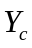and 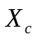be sets of response variables, external criteria, and explanatory variables for each cluster . They can be written as follows:

(1)

(2)
where denotes transposition. and are the dimensionalities of response and explanatory variables and is the number of data points. Note that 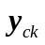 and 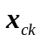 are represented row vectors for convenience sake of notation of the following equations.
Suppose we identify the following  linear models to extract local linear structures.

(3)

where 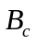 is the partial regression coefficient matrix for each cluster and can be written as follows:

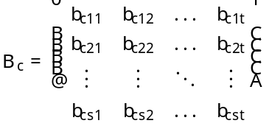. (4)

is calculated by least squares method in the general linear regression analysis.
The FCRM can be driven by optimization of an objective function. We use Lagrange's method of indeterminate multiplier to derive the objective function for the FCRM. We have the following objective function to be minimized.

(5)

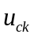 is membership of the data point to the cluster which represents degree of belonging to clusters. satisfies the following condition.

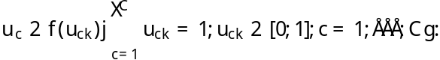 (6)

In (5), the first term represents residual sum of squares. The second term represents entropy maximization as regularization which was introduced in Fuzzy c-Means by Miyamoto et al. [3] for the first time. It enables us to obtain fuzzy clusters. 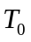 is the weighting parameter which specifies degree of fuzziness. The remaining terms describe the constraint of membership , i.e., (6). 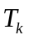 is the Lagrangian multiplier.
From the necessary condition 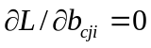 for the optimality of the objective function , can be derived as follows:

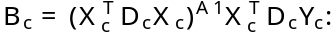 (7)

In (7), 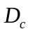 is a diagonal matrix, diagonal entries of which are memberships of data points.

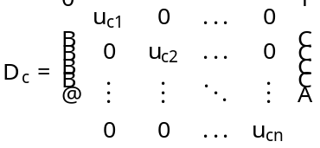. (8)

From the necessary conditions 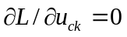, 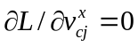 and 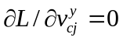 for , we also have the following equations for membership , cluster center of explanatory variable 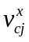 and cluster center of objective variable 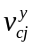.

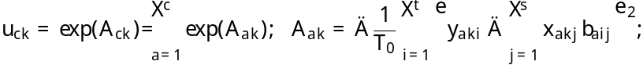 (9)

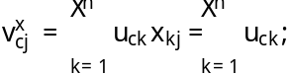 (10)

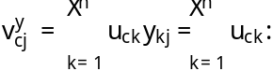 (11)

The solution algorithms for the FCRM are based on an iterative procedure. We remark them below.

FCRM Algorithms

Step 1: Set the number of clusters , the coefficient of the entropy term and the terminal condition . Initialize the membership randomly so as to follow the condition in (12).
Step 2: Update the cluster center and using (10) and (11).
Step 3: Calculate the partial regression coefficient matrix using (7).
Step 4: Update membership using (9).
Step 5: If 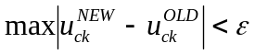, then stop. Otherwise, return to Step 2.

We can represent the set of responsible variables as in (12) by using partial regression coefficient matrix .

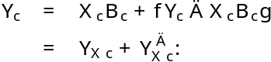 (12)

In (12), 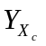 is the predicted value by . On the one hand, 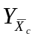 is the unaccountable part . It is, therefore, able to be said that is independent of . We can divide fuzzy scatter matrix 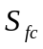 into two parts in the same manner as in (12).

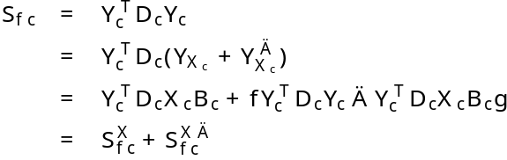 (13)

Using (6), we can denote and 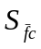 as follows:

(14)

(15)

These factor matrices are both symmetric matrices. We can extract principal components independent of a certain factors by solving eigen value problem of factor matrix .

3. Knowledge Discovery from POS Transaction Data Set

We applied the proposed method to a POS (Point of Sales) transaction data set of two different supermarkets to discover useful knowledge from it. The data set consists of 333 data, which have 18 items, the number of customers having come to the store, meteorological element and so on. We enumerate each item below.

Holyday, Friday, Saturday, Sunday, Average temperature of the day, Temperature at 6, 12, 15 or 18 o'clock, Humidity, Weather category during day or night, Precipitation, Precipitation during 9-12, 12-15 or 15-18 o’clock, the number of customers of supermarket A or B, Sales of perishables of supermarket A or B

The items of days of week, Holyday, Friday, Saturday, Sunday, are dummy variables and weather categories are represented by integer values.
We applied Fuzzy c-Varieties (FCV), which is one of the fuzzy clustering algorithm proposed by Bezdek, to the POS data set before applying our method to it. In the FCV, prototypes of clusters are multi dimensional linear varieties. Since the linear varieties are spanned by some local principal component vectors, the FCV can be regarded as a simultaneous algorithm of fuzzy clustering and principal component analysis. We can discover some knowledge of each cluster from the data set by the FCV. We set the number of clusters to two. Variables of cluster centers of some items are shown in Table 1. The underlined entries represent the characteristic features of the cluster. From Table 1, the data set was divided into two different seasons. The cluster 1 is cold season and the cluster 2 is warm season. After analysing the local principal components obtained by the FCV, we gain the knowledge which says precipitation and the sales of perishables have a close correlation.

Table1. Values of cluster centers of clusters by the FCV.

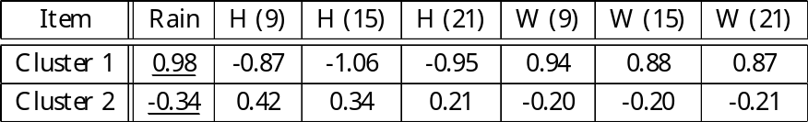

We applied our method to the POS transaction data set on the basis of the results of the FCV. Since we could obtain the relation with precipitation and the sales of perishables, we chose precipitation as the factor to be got rid of the influence. We show the value of fuzzy factor loading of each item in Table 2. The fuzzy factor loading quantifies the correlation between principal component and each item. When a certain item has the same sign of the fuzzy factor loading as the other items, it has positive correlation with others. Therefore, if an item increases, the other item which has the same sign with the fuzzy factor loading also increases and vice versa. The tradeoff parameter $\alpha_c$ and the weighting parameter of fuzziness $\beta$
were set to 0.5 and 2.0 respectively.
The results showed that the sales of milk had strong associations with the day of the week, though it was empirically obvious. We applied the proposed method in hopes of finding implicit associations with the sales and the meteorological elements. In the numerical example, the From Table \ref{tab:ff_load}, we see that the sales of milk has associations with the meteorological elements partly. For example, the higher the temperature rises, the larger the sales of milk increase.

Table 2. Values of cluster centers of clusters by the FCV.

4. Conclusions

In this paper, we have proposed a fuzzy clustering algorithm which extracts local principal components independent of subsidiary variables. A constraint such that the inner product of principal component and subsidiary variables should be zero is added to the objective function to be optimized. In the numerical example, we applied the proposed method to the POS data set consisting of sales of milk and meteorological data. Associations between the sales of milk and the meteorological elements after eliminating the effects of the days of week were found by using the proposed method. The proposed method provides us with the useful way to discover knowledge hiding behind the data.

References

[1] H. Yanai, Factor Analysis with External Criteria, Japanese Psychological Research 12, 4 (1970) 143-153.
[2] R. J. Hathaway and J. C. Bezdek, Switching Regression Models and Fuzzy Clustering, IEEE Trans. on Fuzzy Systems 1, 3 (1993) 195-204.
[3] S. Miyamoto and M. Mukaidono, Fuzzy c-Means as a Regularization and Maximum Entropy Approach, Proc. IFSA'97 2 (1997) 86-92.
[4] J.C.Bezdek, C.Coray, R.Gunderson, and J.Watson, Detection and Characterization of Cluster Substructure 2. Fuzzy c-Varieties and Convex Combinations Thereof, SIAM J. Appl. Math. 40, 2 (1981) 358-372.
[5] Y.Yabuuchi and J.Watada, Fuzzy Principal Compoment Analysis and Its Application, Biomedical Fuzzy and Human Sciences 3, 1 (1997) 83-92.

