Terraform

Terraform is the infrastructure as code offering from HashiCorp. It is a tool for building, changing, and managing infrastructure in a safe, repeatable way. Operators and Infrastructure teams can use Terraform to manage environments with a configuration language called the HashiCorp Configuration Language (HCL) for human-readable, automated deployments.

Ansible
Ansible is an IT automation tool. It can configure systems, deploy software, and orchestrate more advanced IT tasks such as continuous deployments or zero downtime rolling updates.

The primary difference for their community versions is that Ansible is an multi-purpose automation tool, whereas Terraform is an infrastructure as code tool.

Similarities between Terraform and Ansible

They are both capable of setting up the new cloud infrastructure and equipping it with the necessary application components.

On the freshly formed virtual machine, remote commands can be carried out by both Terraform and Ansible. This indicates that neither tool requires an agent. Agent deployment on the computers is not necessary for operational reasons.

Terraform builds infrastructure utilizing the APIs of cloud providers, and SSH is used for simple configuration operations. The same is true of Ansible; all necessary configuration activities are carried out over SSH. Both tools are masterless since the “state” information for neither requires a separate piece of infrastructure to manage.

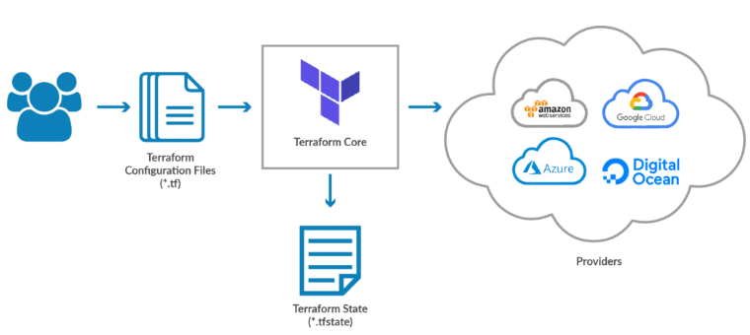

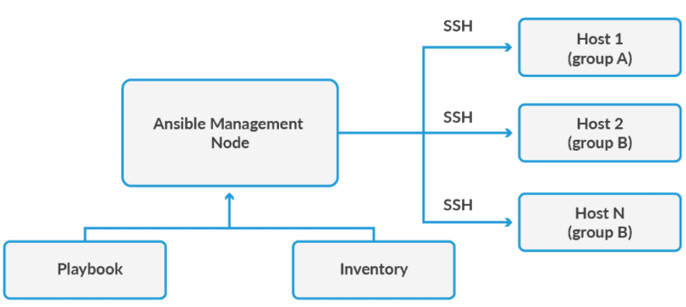

Difference between Terraform and Ansible Provisioning (Terraform vs. Ansible)

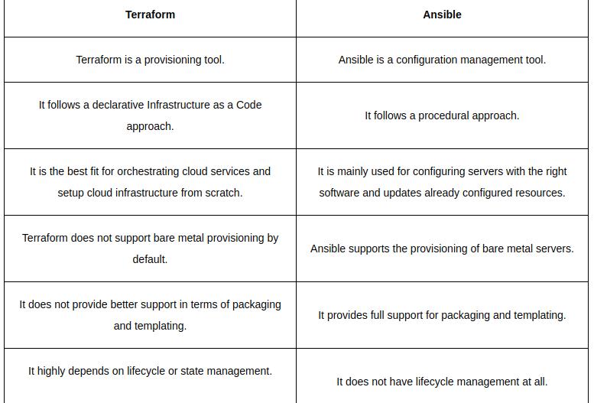

ARM Templates
Azure specific
Get the latest Azure resources as they are released
Does not maintain a state file
Written in JSON
Does not have a Destroy/Cleanup command
Terraform
Supports multiple cloud providers and on-prem resources
Can lag behind when new Azure resources are released
Relies on a state file that must be maintained
Written in HCL, a custom DSL from Hashicorp
Able to cleanup/destroy resources

