LSTM Architecture
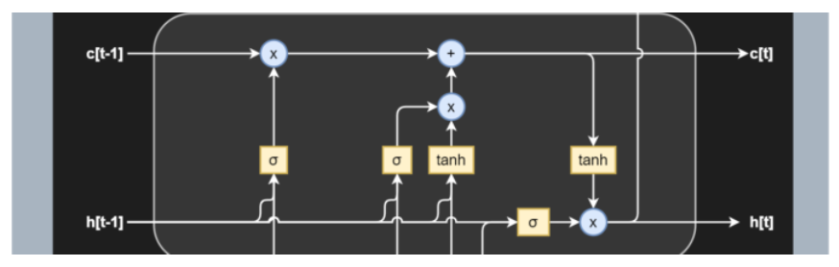

LSTM specific terms
- Cell — Every unit of the LSTM network is known as a “cell”. Each cell is composed of 3 inputs —
- x(t) — token at timestamp t​
- h(t−1) — previous hidden state
- c(t-1) — previous cell state,
and
2 outputs —
- h(t) — updated hidden state, used for predicting the output
- c(t) — current cell state

2. Gates — LSTM uses a special theory of controlling the memorizing process. Popularly referred to as gating mechanism in LSTM, what the gates in LSTM do is, store the memory components in analog format, and make it a probabilistic score by doing point-wise multiplication using sigmoid activation function, which stores it in the range of 0–1. Gates in LSTM regulate the flow of information in and out of the LSTM cells.
Gates are of 3 types —
- Input Gate — This gate lets in optional information necessary from the current cell state. It decides which information is relevant for the current input and allows it in.
- Output Gate — This gate updates and finalizes the next hidden state. Since the hidden state contains critical information about previous cell inputs, it decides for the last time which information it should carry for providing the output.
- Forget Gate — Pretty smart in eliminating unnecessary information, the forget gate multiplies 0 to the tokens which are not important or relevant and lets it be forgotten forever.

Why does LSTM outperform RNN?

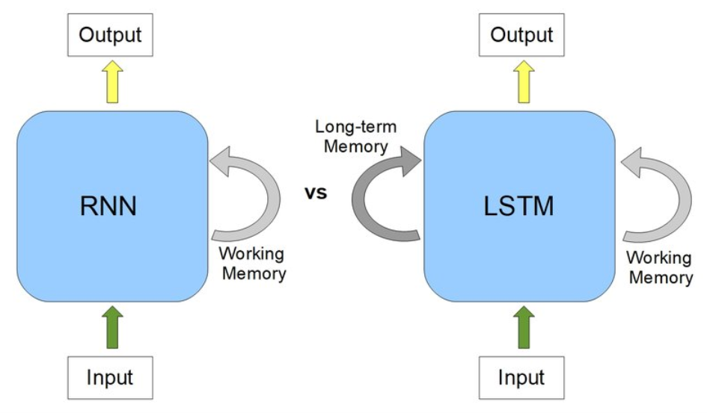

Deep Learning about LSTM gates

The Input Gate
As discussed earlier, the input gate optionally permits information that is relevant from the current cell state. It is the gate that determines which information is necessary for the current input and which isn’t by using the sigmoid activation function. It then stores the information in the current cell state. Next, comes to play the tanh activation mechanism, which computes the vector representations of the input-gate values, which are added to the cell state.
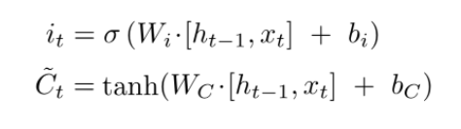
The Forget Gate
We already discussed, while introducing gates, that the hidden state is responsible for predicting outputs. The output generated from the hidden state at (t-1) timestamp is h(t-1). After the forget gate receives the input x(t) and output from h(t-1), it performs a pointwise multiplication with its weight matrix with an add-on of sigmoid activation which generates probability scores. These probability scores help it determine what is useful information and what is irrelevant.
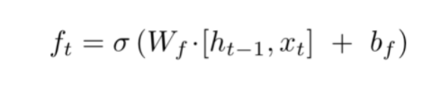

Cell State Update Mechanism
Replacing the new cell state with whatever we had previously is not an LSTM thing! An LSTM, as opposed to an RNN, is clever enough to know that replacing the old cell state with new would lead to loss of crucial information required to predict the output sequence.
That’s where LSTM beats RNN, remember?!
By now, the input gate remembers which tokens are relevant and adds them to the current cell state with tanh activation enabled. Also, the forget gate output, when multiplied with the previous cell state C(t-1), discards the irrelevant information. Hence, combining these two gates’ jobs, our cell state is updated without any loss of relevant information or the addition of irrelevant ones.
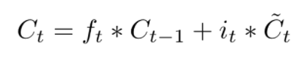
Output Gate
This gate, which pretty much clarifies from its name that it is about to give us the output, does a quite straightforward job. The output gate decides what to output from our current cell state. The output gate, also has a matrix where weights are stored and updated by backpropagation. This weight matrix, takes in the input token x(t) and the output from previously hidden state h(t-1) and does the same old pointwise multiplication task. However, as said earlier, this takes place on top of a sigmoid activation as we need probability scores to determine what will be the output sequence.
After we get the sigmoid scores, we simply multiply it with the updated cell-state, which contains some relevant information required for the final output prediction. A final tanh multiplication is applied at the very last, to ensure the values range from [-1,1], and our output sequence is ready!
